Additional file 1: Data S1
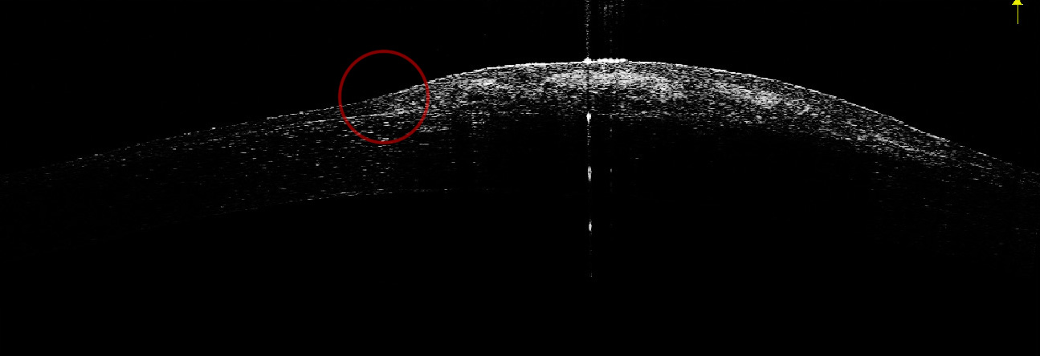
Adjusted brightness of figure 5. The red circle is the transitional zone from the flat to the elevated surface. No obvious abrupt transition is noted. This picture also clearly demonstrates the dense, limited, and hyper-reflective sub-epithelial lesion.

Data S2
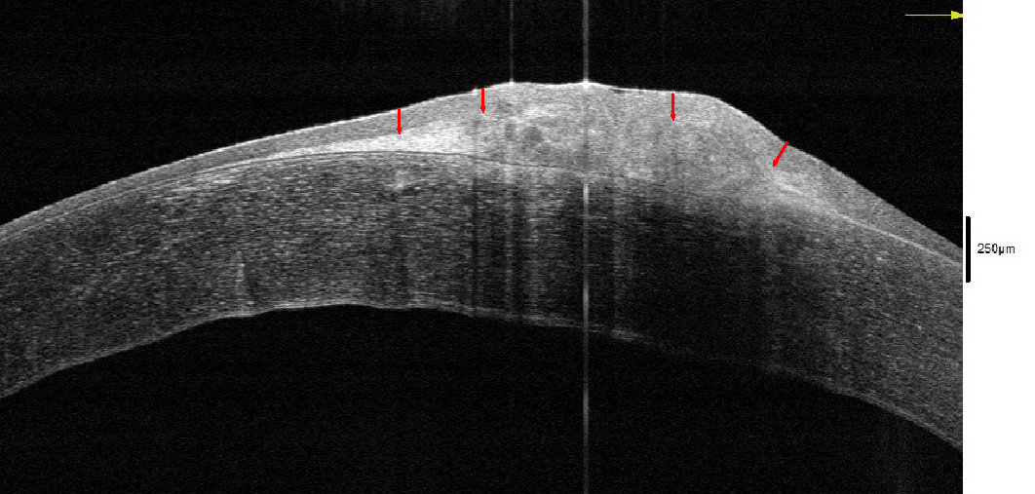
Manual measurement of figure 6. Given the reference of 250μm, the epithelial thickness, from right to left, was 94μm, 90μm, 101μm, 105μm, respectively. Though thicker than the epithelial map measured by anterior HR-OCT (range 65—86μm in our case), this still falls within the benign range (37—116μm).

