WEBAPPENDIX A

Further information on the sample and the study sites.
Table W1: Sociodemographic characteristics of the study sites
Characteristics | Altai Krai | Republic of Karelia
Total Population (in 2014) | 2,390,638 (1.66% of total Russian population)  Barnaul (capital): 632,848 | 634,402 (0.44% of total Russian population)  Petrozavodsk(capital): 272,101
Urban-rural population ratio (in 2014) | 55.76% urban, 44.24% rural | 79.18% urban,  20.82% rural
Death rate (in 2013) | 14,2 (per 1,000) | 14.7 (per 1,000)
Population decline (in 2013) | - 0.7% | - 2.7%
Ranking position of life quality ranking of Russian regions in 2014 (assessment of life quality was based on aggregated data) | 64 (out of 82) | 65 (out of 82)
 | Barnaul (capital) | Petrozavodsk (capital)
Living wage per capita and month | 6,565 RUB (2013)  7,423 RUB (2014) | 8,324 RUB (2013)  9,319 RUB (2014)
Average wage per capita and month | 14,752 RUB (2013)  17,134 RUB (2014) | 21,494 RUB (2013)  22,939 RUB (2014)
Percentage of people living below living wage | 17.6% (2013)  17.0% (2014) | 14.1% (2013)  14.2% (2013)
 | Market value of the Russian ruble for the assessment periods
August 2013 | 1 RUB ≈ 0.023 € ≈ 0.03 $
August 2014 | 1 RUB ≈ 0.021 € ≈ 0.028 $
September 2014 | 1 RUB ≈ 0.02 € ≈ 0.026$
 | Alcohol and foodstuff prices for Russia (third quarter of 2014)*
Vodka (40% ethanol, 0,5l) | 220-250 RUB (≈ 6.16- 7.0$) with an established fixed minimum price of 220 RUB (≈ 6.16$).
Beer (4-6% ethanol, 0,5l) | 40-50 RUB (≈ 1.12-1.4$).
Home-distilled samogon (0,5l, 50-80% ethanol) | 80-150 RUB (≈ 2.24-4.2$).
Medicinal tincture and antiseptic (100ml, 70% and 95% ethanol, respectively) | 15-25 RUB (≈ 0.42-0.70$)
Eau de cologne (86ml, 60-% ethanol) | 20 RUB (≈ 0.56$).
Bread (0,5kg) | 20-30 RUB (≈ 0.56-0.84$)
Milk | 40-60 RUB (≈ 1.12-1.68$)

Table W2: Prevalence and incidence of alcoholic psychoses and alcohol dependence for the researched regions.
 | Prevalence of alcoholic psychoses
 | Absolute number |  | Per 100,000
 | 2013 | 2014 | 2013 | 2014
Russian Federation | 75,756 | 72,180 | 52.79 | 49.41
Republic of Karelia | 619 | 789 | 97.38 | 124.55
Altai Region | 731 | 842 | 30.53 | 35.26
 | Prevalence of alcohol dependence (incl. alcoholic psychoses)
 | Absolute number |  | Per 100,000
 | 2013 | 2014 | 2013 | 2014
Russian Federation | 1,852,598 | 1,809,975 | 1290.95 | 1238.94
Republic of Karelia | 7,078 | 7,750 | 1113.48 | 1223.42
Altai Region | 36,251 | 34,560 | 1513.81 | 1447.40
 | Incidence of alcoholic psychoses
 | Absolute number |  | Per 100,000
 | 2013 | 2014 | 2013 | 2014
Russian Federation | 33,483 | 3,2056 | 23.33 | 21.94
Republic of Karelia | 304 | 345 | 47.82 | 54.46
Altai Region | 667 | 809 | 27.85 | 33.88
 | Incidence of alcohol dependence (incl. alcoholic psychoses)
 | Absolute number |  | Per 100,000
 | 2013 | 2014 | 2013 | 2014
Russian Federation | 112,218 | 10,9149 | 78.20 | 74.71
Republic of Karelia | 812 | 909 | 127.74 | 143.50
Altai Region | 2,518 | 2,669 | 105.15 | 111.78

Table W3: Sample characteristics
Sample characteristics | Barnaul (2013 and 2014) | Petrozavodsk (2014) | Total Sample Description
Sample size (n) | 18 | 7 | 25
Age (in years, mean, SD and range) | M: 41.33 SD; SD: 13.54; range 29-78 | M: 39.14; SD: 11.9; range: 24 - 60 | M: 38.72; SD: 15; range: 24 - 78
Female gender (in % of total sample size) | 94.4% (7) | 14.4% (1) | 32%(8)
Place of residence
Urban | 94.4% (17) | 85.7% (6) | 92% (23)
Rural | 4.4% (1) | 14.3% (1) | 8% (2)
Education
(in % of total sample size)
Primary school education, basic vocational training or less | 33.3%(6) | 71.4% (5) | 44% (11)
Secondary/ Secondary specialized | 50% (9) | 28.6% (2) | 44% (11)
Higher Education | 16.7% (3) | 0 | 12% (3)
Employment
(in % of sample size)
Unemployed | 38.9% (7) | 28.6% (2) | 36% (9)
Informal/occasional employment (unskilled labor) | 22.2% (4) | 42.9% (3) | 28%(7)
Formal employment (skilled labor) | 16.7% (3) | 14.3% (1) | 16% (4)
Self-employment | 11.1% (2) | 0 | 8% (2)
Retired | 11.1% (2) | 14.3% (1) | 12% (3)
Periods of unemployment reported | 61.1% (11) | 71.4% (5) | 64% (16)
Imprisonment reported | 18.2% (2) | 0 | 8% (2)

WEBAPPENDIX B

Thematic maps of analyzed material.
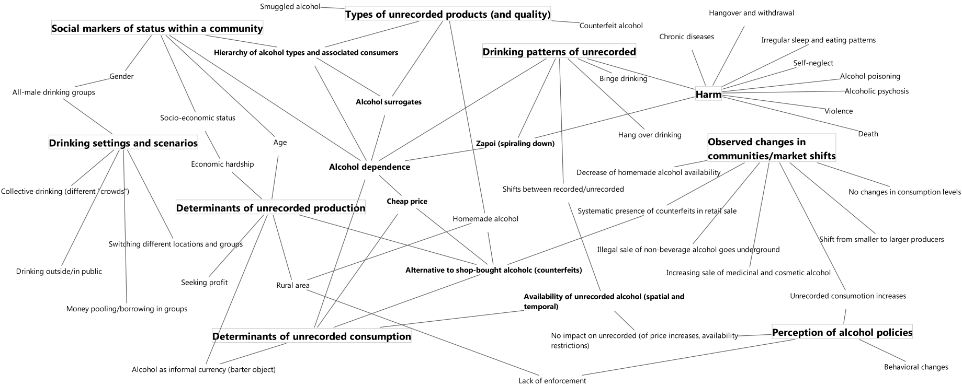

Figure W1. Full thematic map of the overall interview study (for the sub-study on unrecorded drinking patterns and harm see: Neufeld et al., 2017a).

