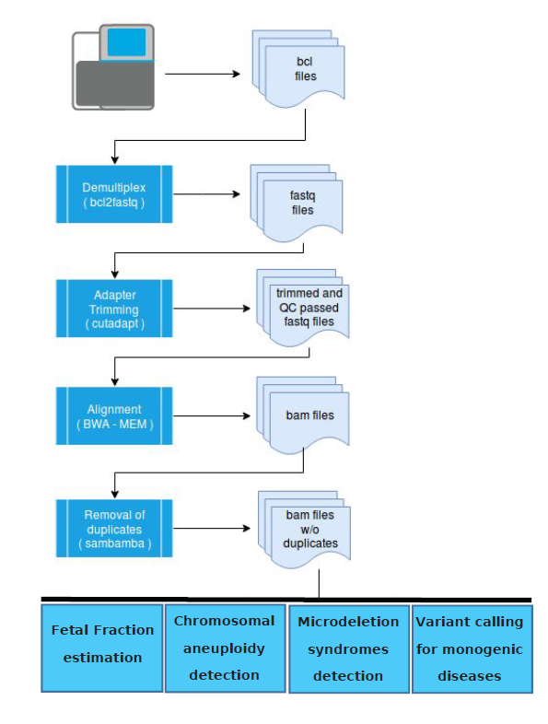
Flowchart illustrating the bioinformatics analysis pipeline for a typical sequencing run consisting of plasma samples. The same pipeline applies for paternal samples with the last step being performed for variant calling (monogenic diseases) only.

