**Additional data**

**Fig. S1.** Residuals from the gamma distributed GLMM of salinity versus days spent at sea. The apparent correlation is insignificant (P = 0.41) when applying a GAM to the residuals.

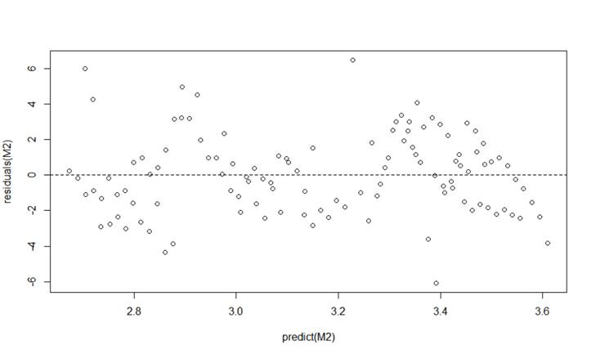

**Fig S2 – S8**. Pairwise comparisons of reconstructed migration tracks with or without endpoints (the track of Fish 4 was only reconstructed until day 71, and it is therefore not included). The reconstructed tracks are similar until the return migration that is poorly reconstructed. This is due to the scarce datapoints acquired during return migration through the warm surface waters where the fish avoided the surface and thus avoided generating data for the model.

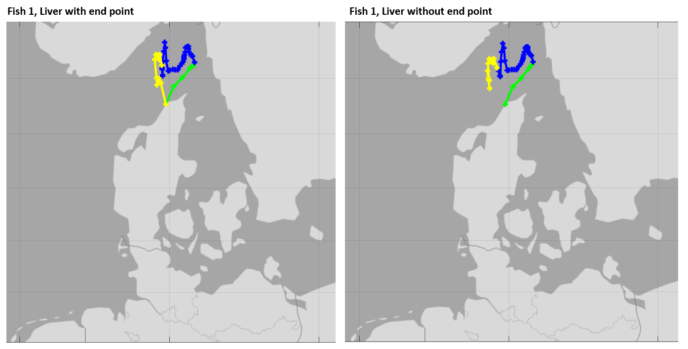

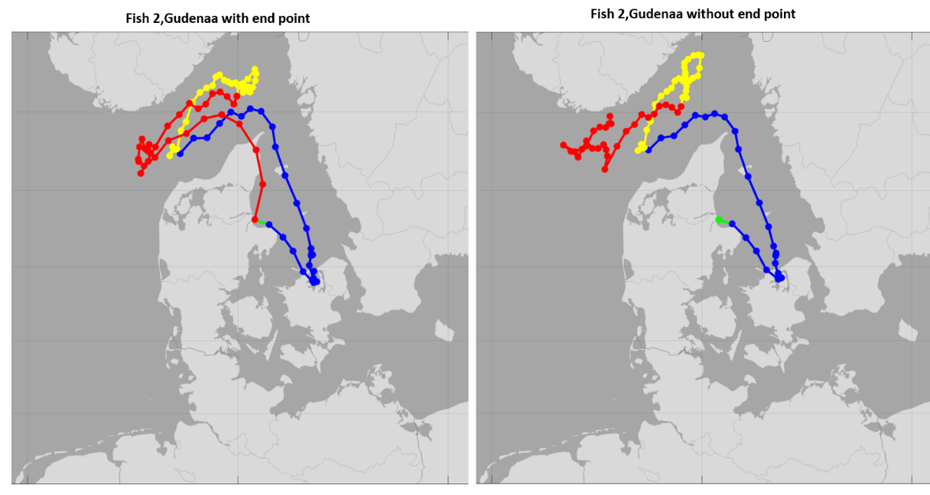

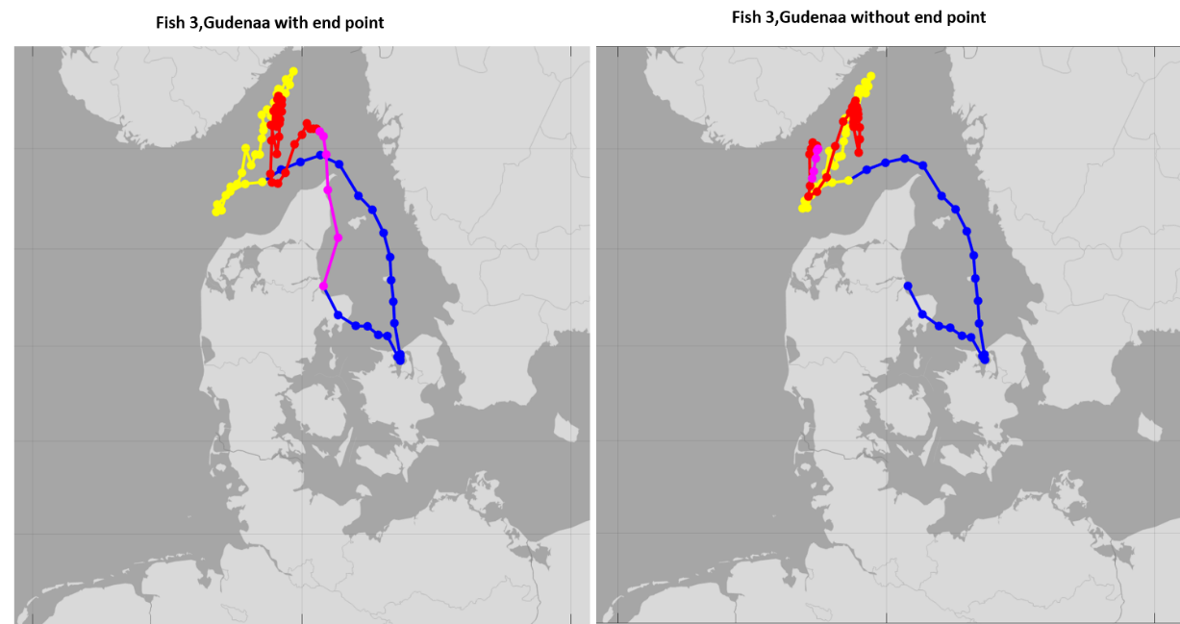

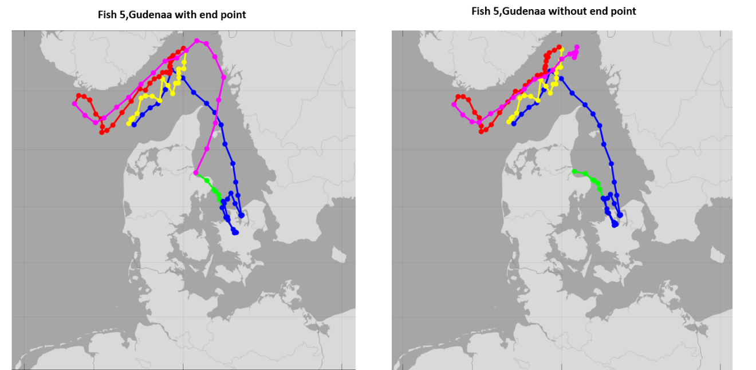

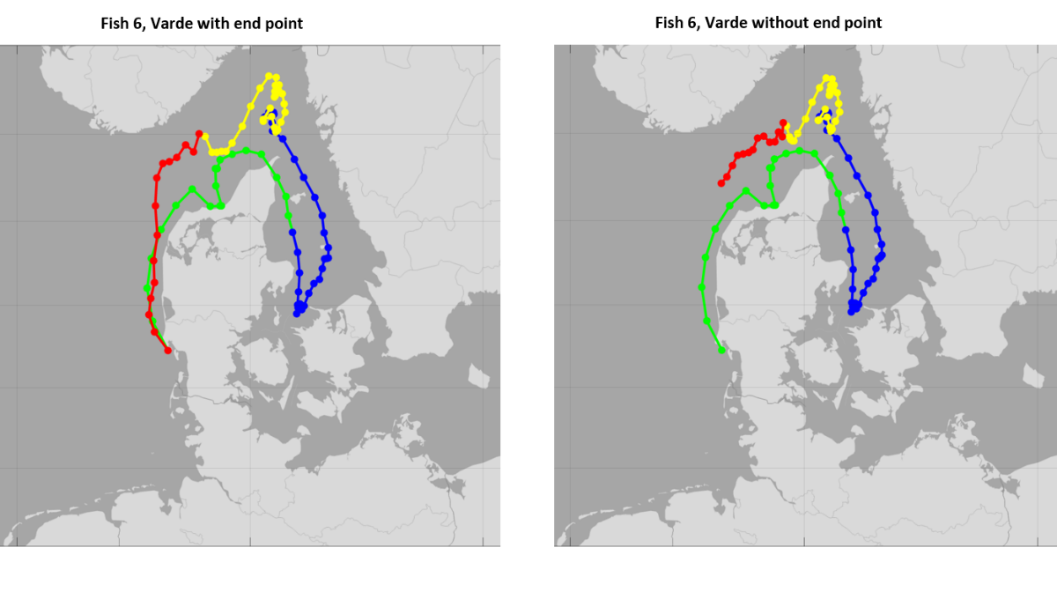

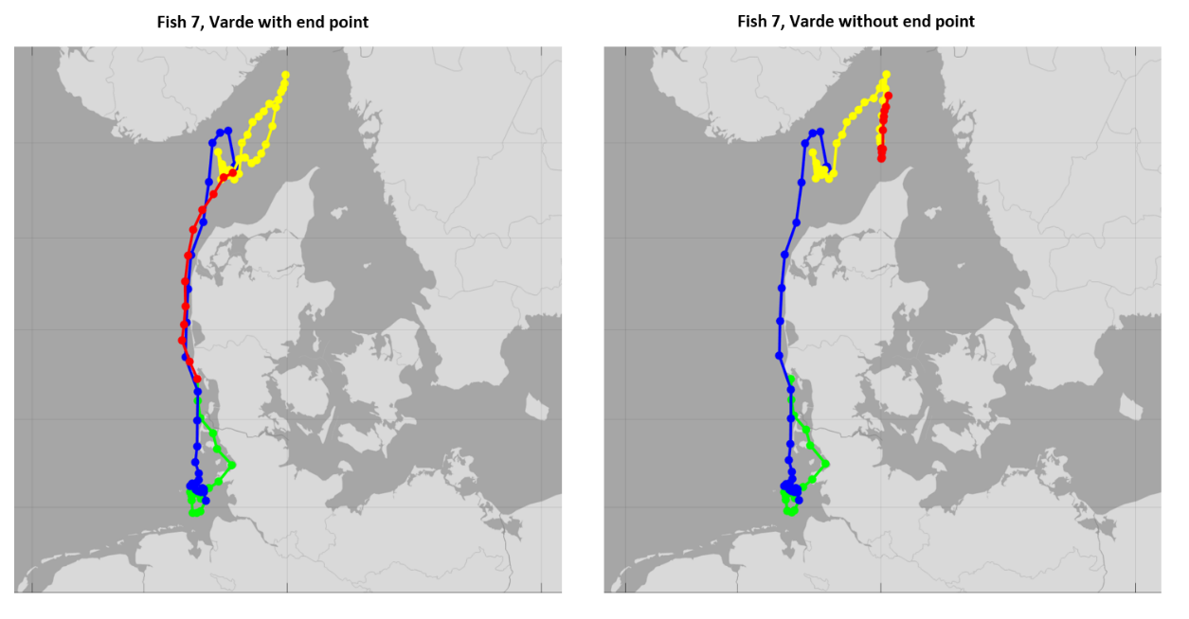

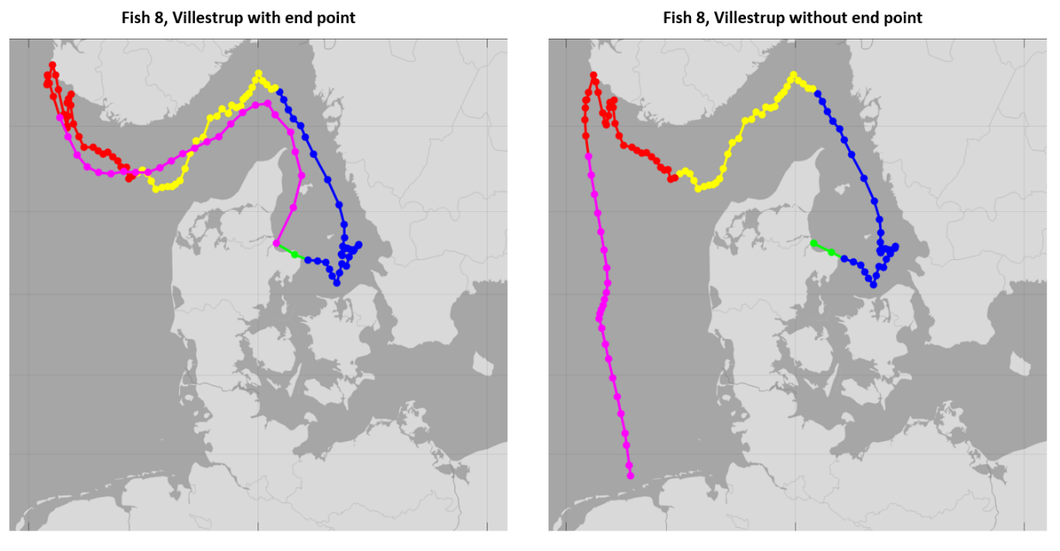

**Figure S9.** Tracks of Fish 2 with the temperature of the fish reduced by 0.5o C (left panel) and increased by 0.5o C (right panel). Increasing and decreasing the temperature had little effect on the overall track. This fish, however, experienced a bimodal likelihood distribution around the island of Zealand during the early migration period when fish temperatures were increased by 0.5o C as the Roskilde Fjord on Northern Zealand and a shallow area south of Zealand both heat up very fast during spring. Shifting the temperatures down mainly moved the fish a bit further into the colder North Sea during summer.

