Supplementary information
for article
Reflectance FT-IR spectroscopy as a viable option for textile fiber identification
Pilleriin Peets, Karl Kaupmees, Signe Vahur, Ivo Leito
University of Tartu, Institute of Chemistry, 14a Ravila str, 50411 Tartu, Estonia
Corresponding author: e-mail: pilleriin.peets@ut.ee

Table of contents
Example spectra of each fiber class recorded with FT-IR microspectrometer in reflectance mode 2
Case-study: Scarf from 20th century 13
Case-study: Very small fiber thread from painting on the textile from end of the 20th century 27

Spectra of each fiber class recorded with FT-IR microspectrometer in reflectance mode

All spectra below are original without any alteration or correction.
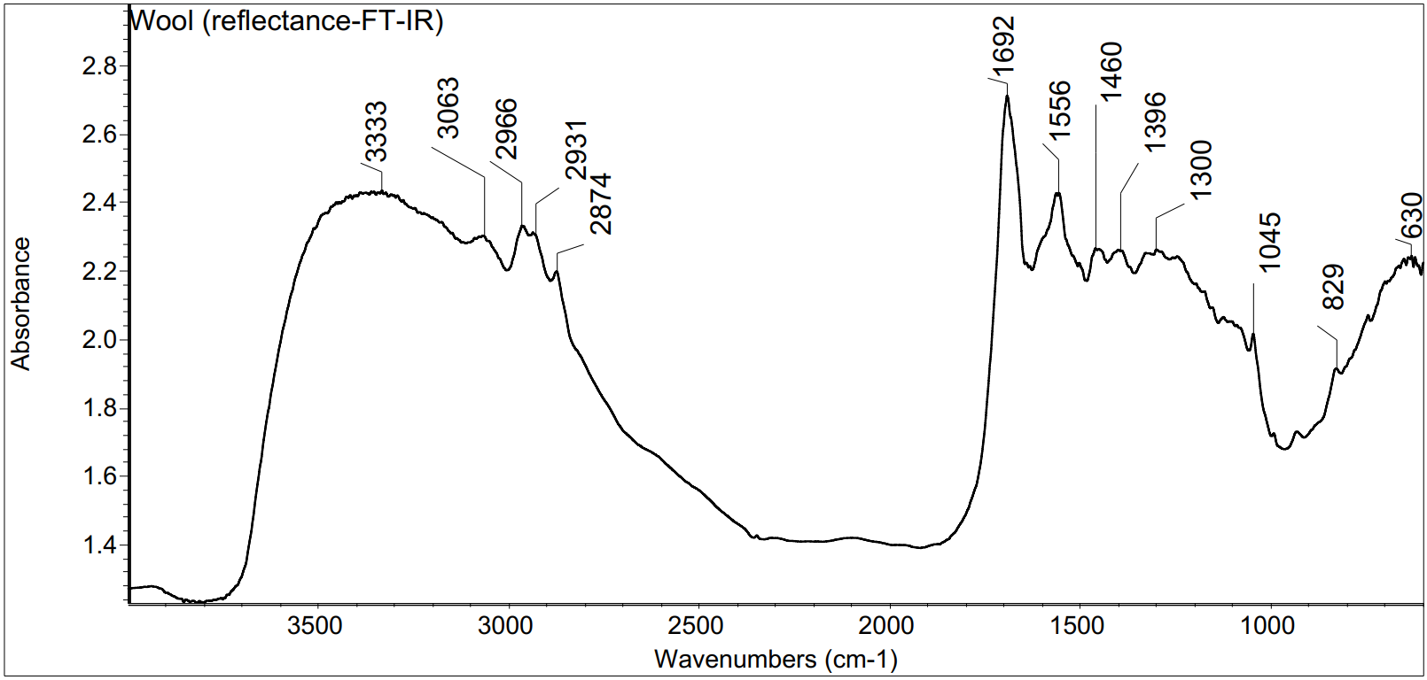
Figure S1. r-FT-IR spectrum of wool fiber

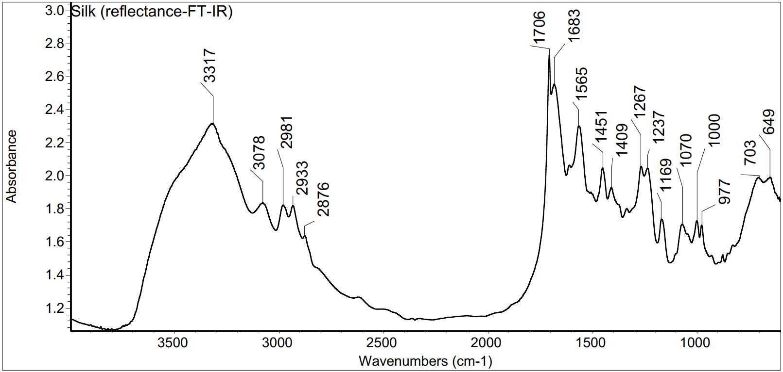
Figure S2. r-FT-IR spectrum of silk fiber
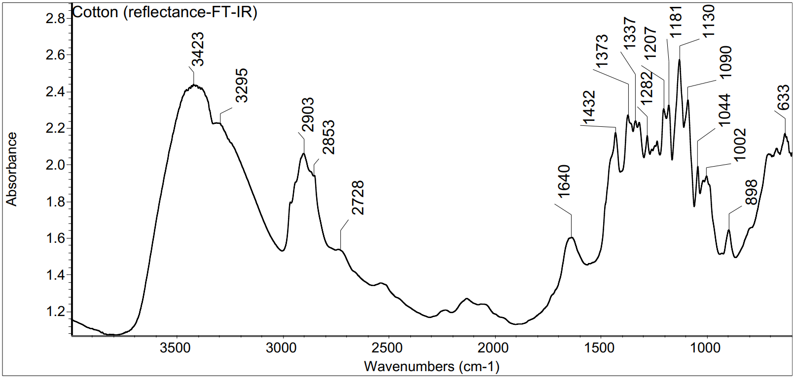
Figure S3. r-FT-IR spectrum of cotton fiber

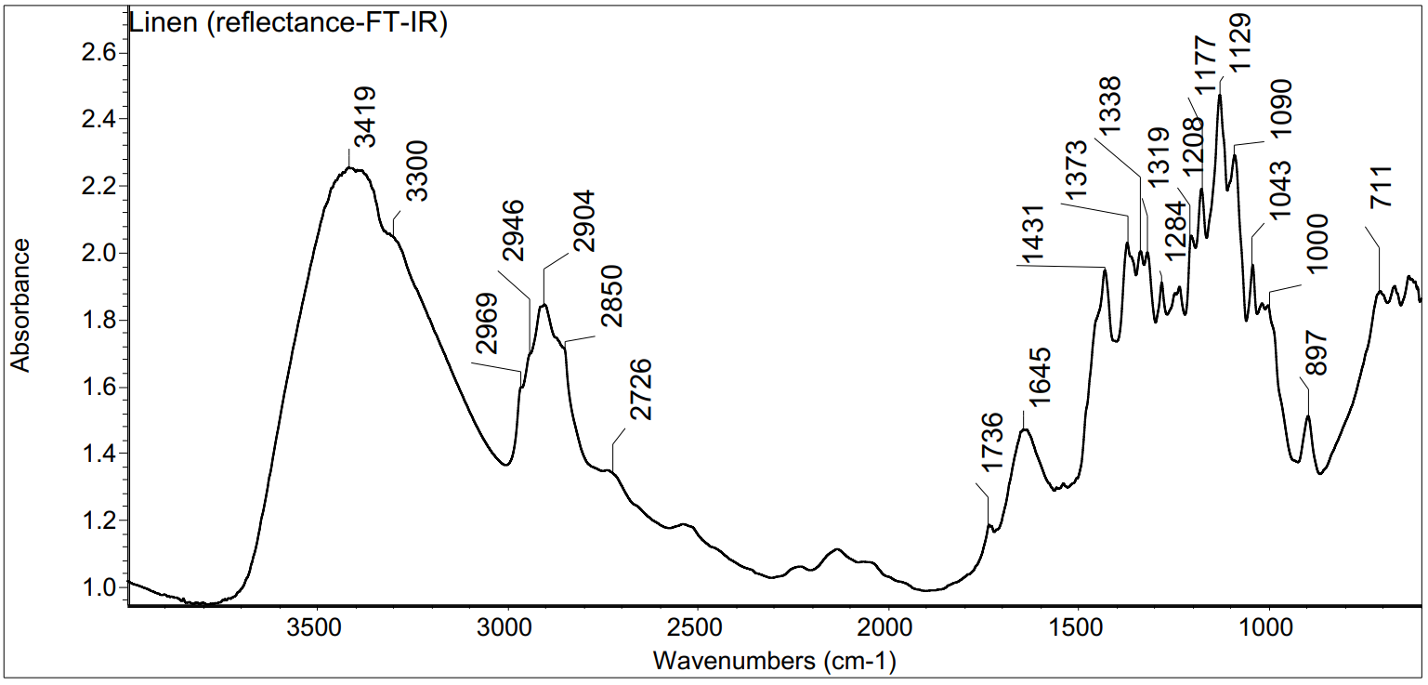
Figure S4. r-FT-IR spectrum of linen fiber
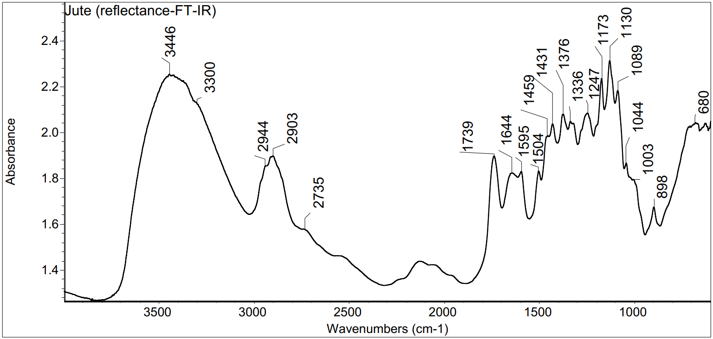
Figure S5. r-FT-IR spectrum of jute fiber

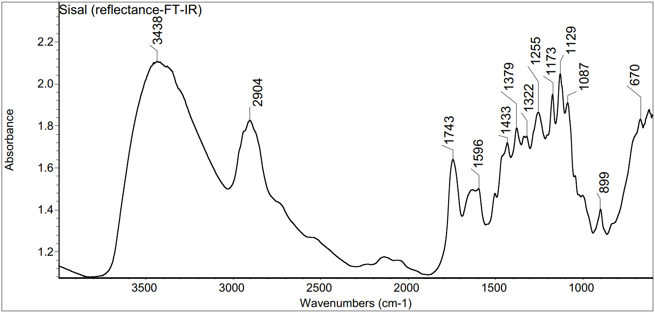
Figure S6. r-FT-IR spectrum of sisal fiber
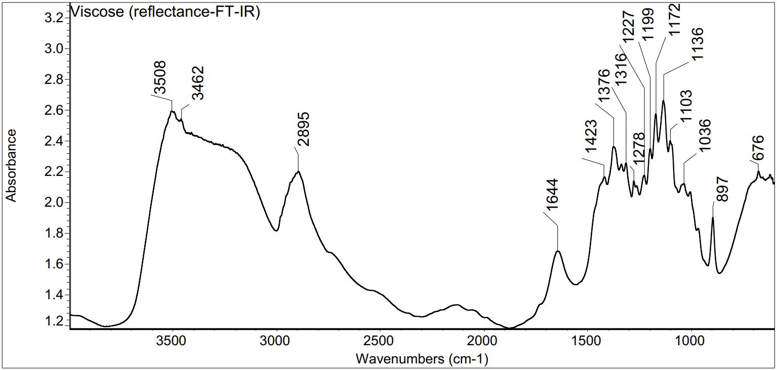
Figure S7. r-FT-IR spectrum of viscose fiber

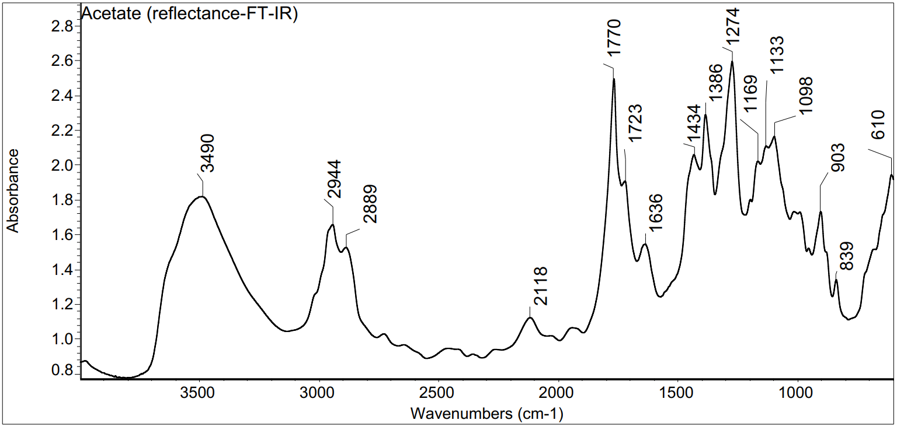
Figure S8. r-FT-IR spectrum of cellulose acetate fiber
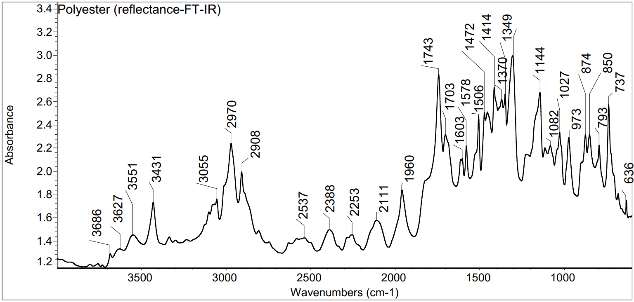
Figure S9. r-FT-IR spectrum of polyester fiber

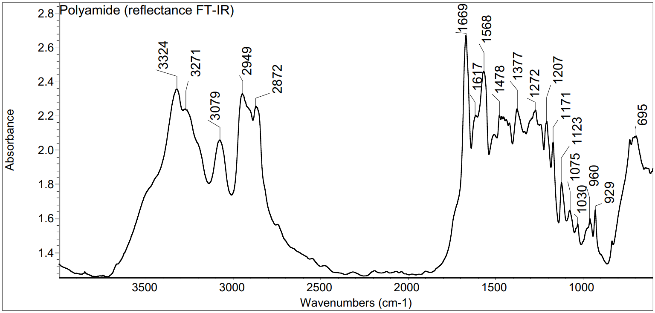
Figure S10. r-FT-IR spectrum of polyamide fiber
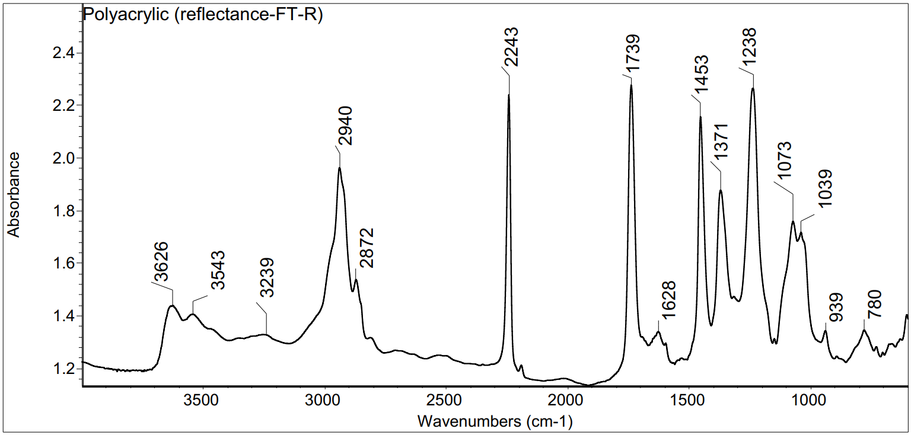
Figure S11. r-FT-IR spectrum of polyacrylic fiber

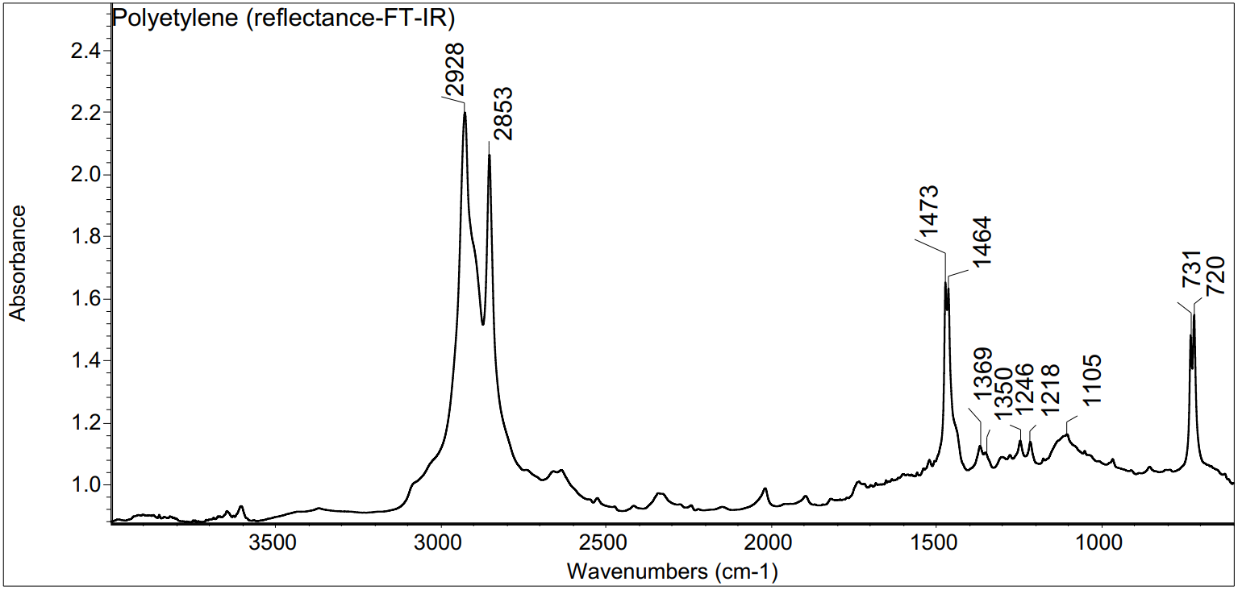
Figure S12. r-FT-IR spectrum of polyethylene fiber

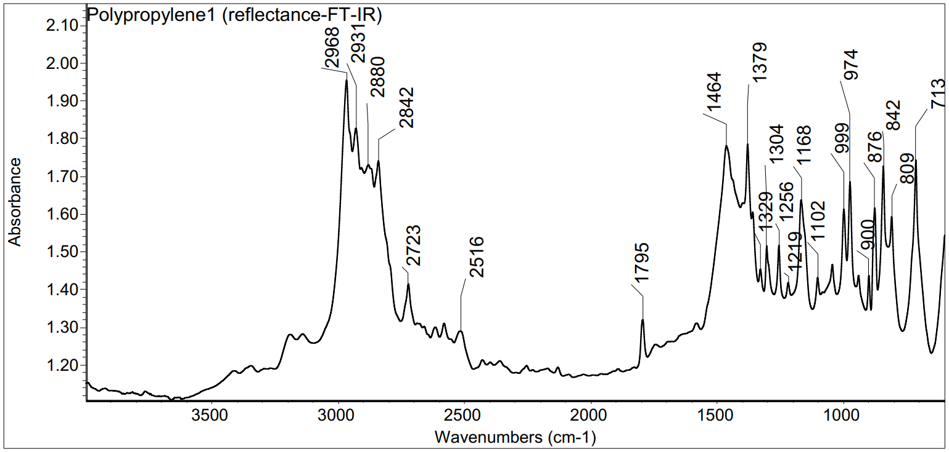
Figure S13. r-FT-IR spectrum of polypropylene fiber

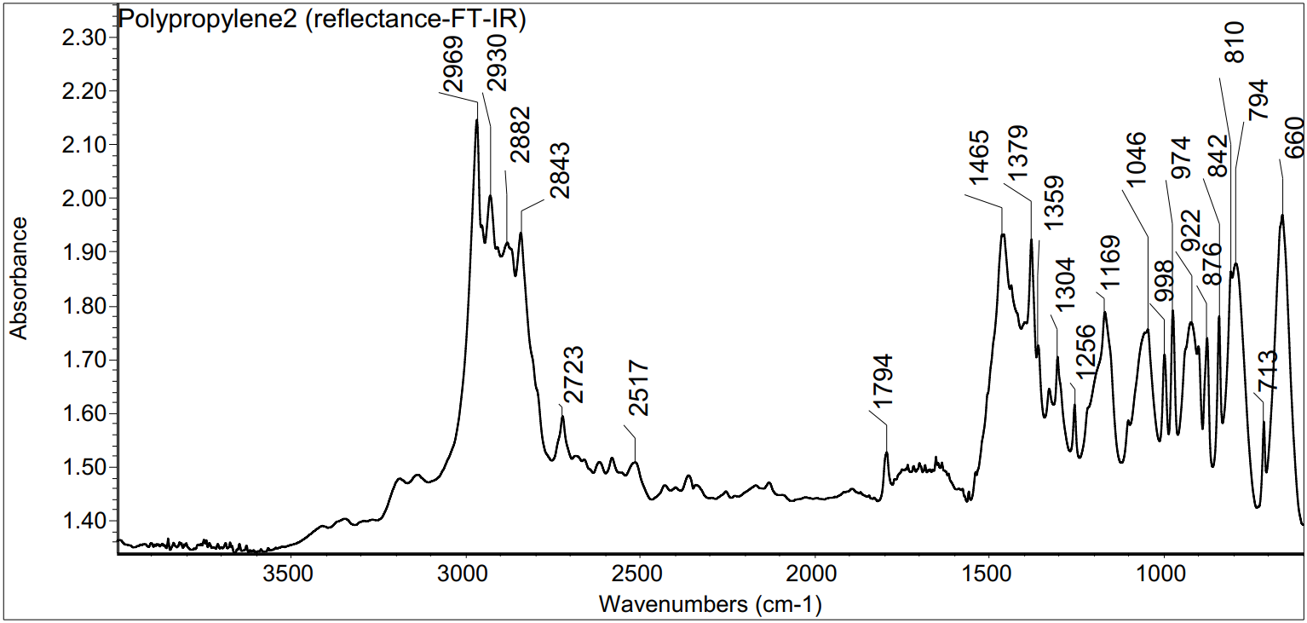
Figure S14. r-FT-IR spectrum of polypropylene fiber

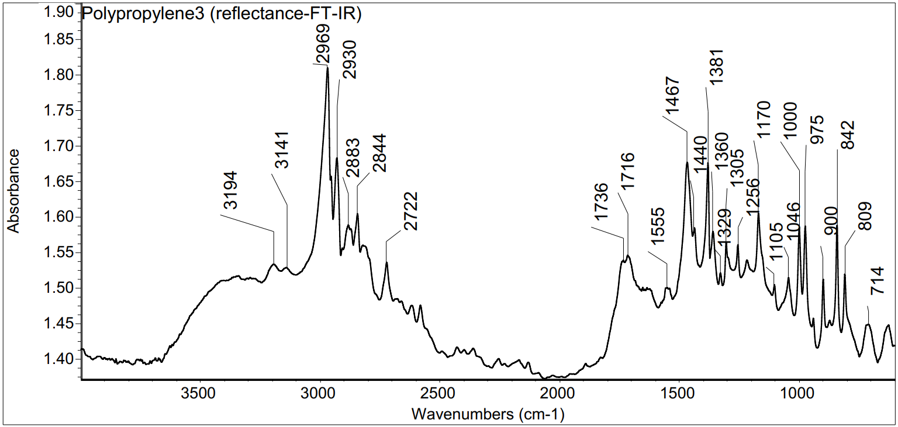
Figure S15. r-FT-IR spectrum of polypropylene fiber

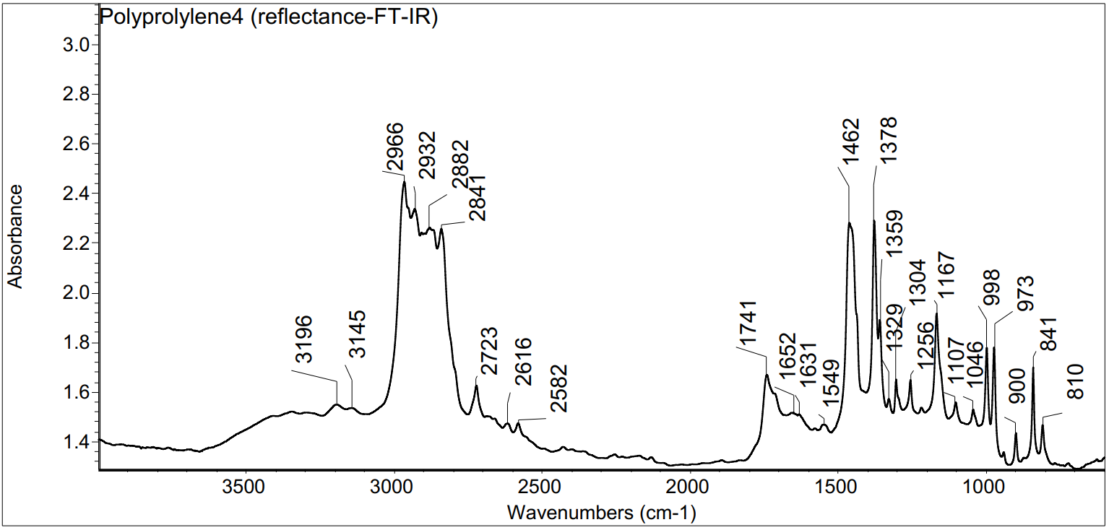
Figure S16. r-FT-IR spectrum of polypropylene fiber

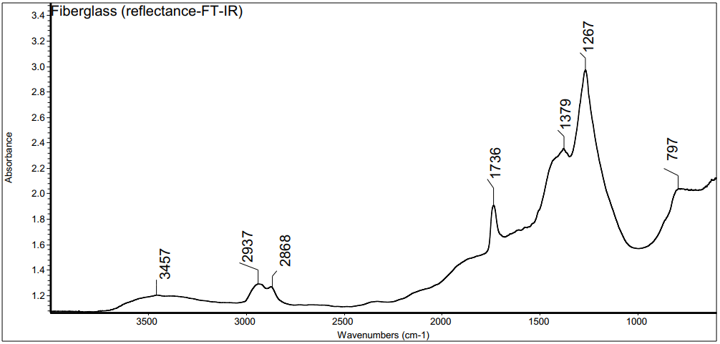
Figure S17. r-FT-IR spectrum of fiberglass

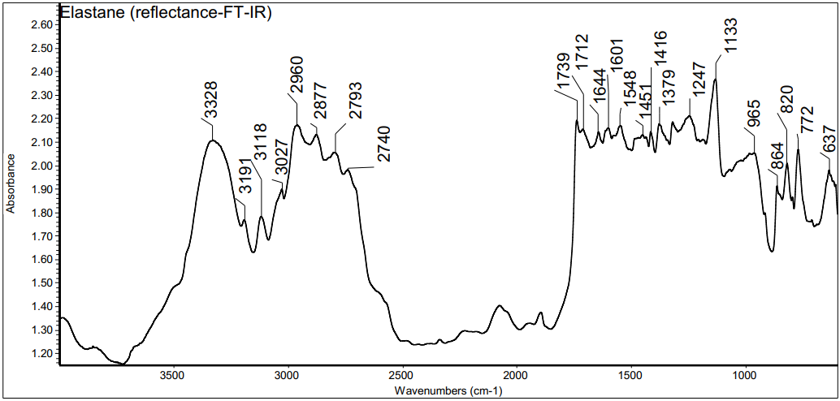
Figure S18. r-FT-IR spectrum of elastane fiber (deformed due to small fiber diameter)
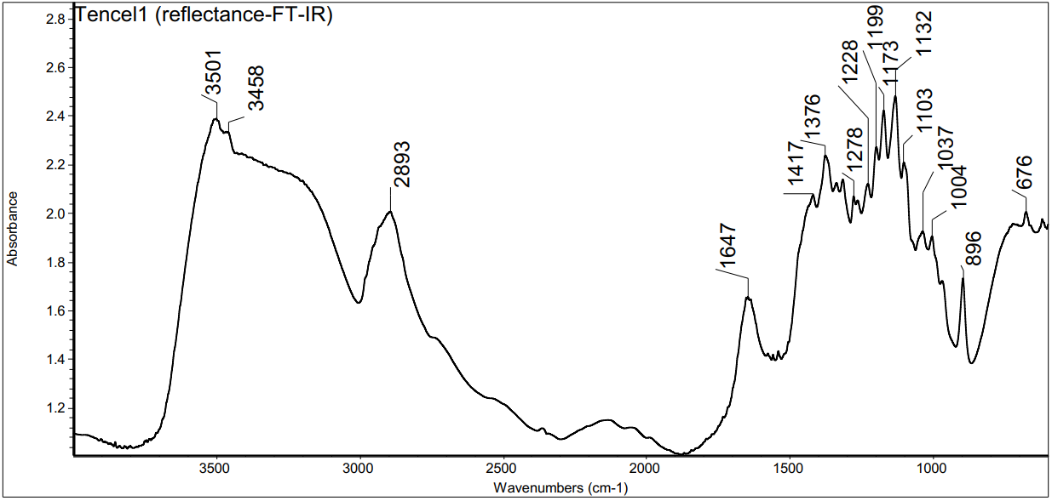
Figure S19. r-FT-IR spectrum of Tencel

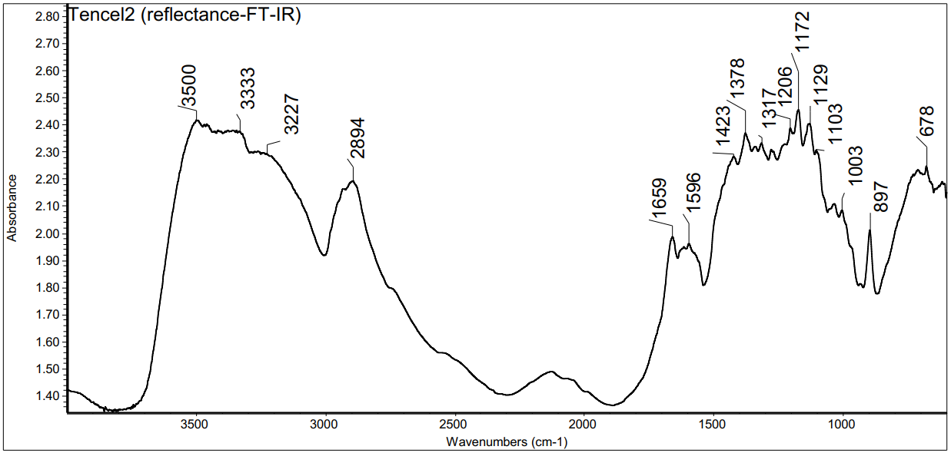
Figure S20. r-FT-IR spectrum of Tencel

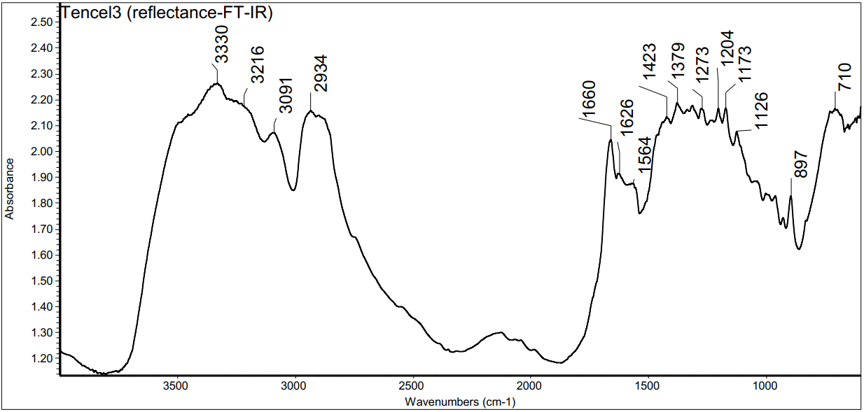
Figure S21. r-FT-IR spectrum of Tencel

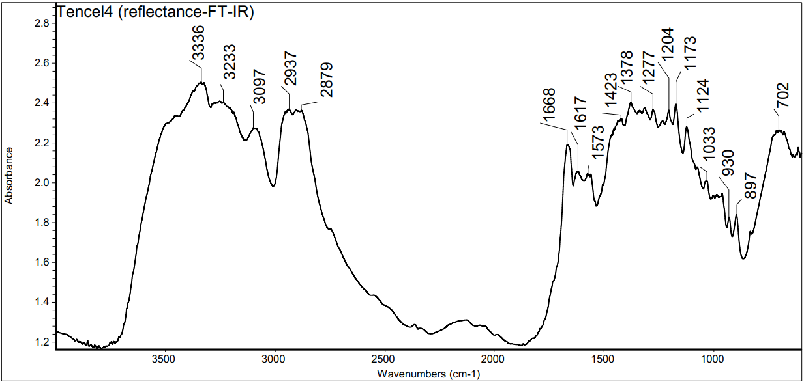
Figure S22. r-FT-IR spectrum of Tencel

Case-study: Scarf from 20th century
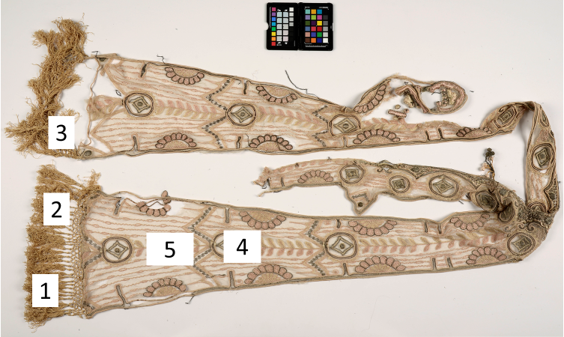
Figure S23. Photo of the analyzed scarf with the locations of the samples (Photo from the Conservation and Digitization Centre Kanut).

Sample nr | Microscope picture of the sample | Microscope picture of fibers
1 | 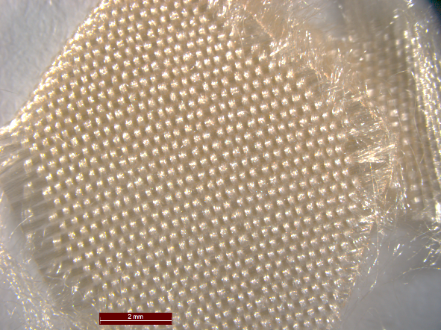 | 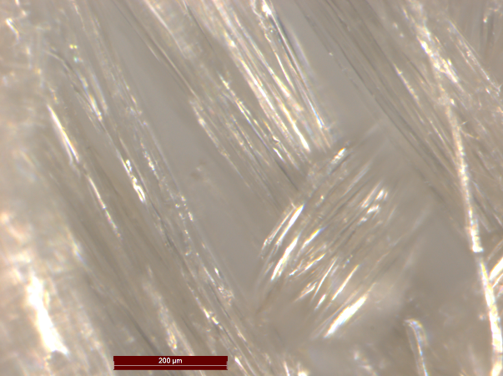
 | Figure S24. Sample 1 | Figure S25. Sample 1
2 | 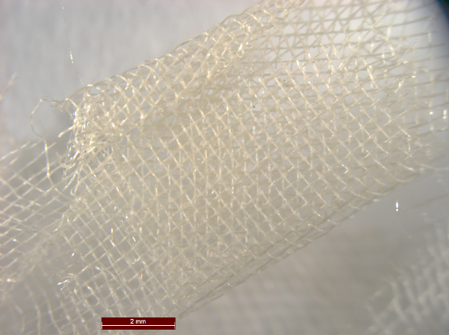
 | Figure S26. Sample 2 | Figure S27. Sample 2
3.1
 | Figure S28. Sample 3.1 | Figure S29. Sample 3.1
3.2
 | Figure S30. Sample 3.2 | Figure S31. Sample 3.2
4
 | Figure S32. Sample 4 | Figure S33. Sample 4
5.1
 | Figure S34. Sample 5.1 | Figure S35. Sample 5.1
5.2
 | Figure S36. Sample 5.2 | Figure S37. Sample 5.2

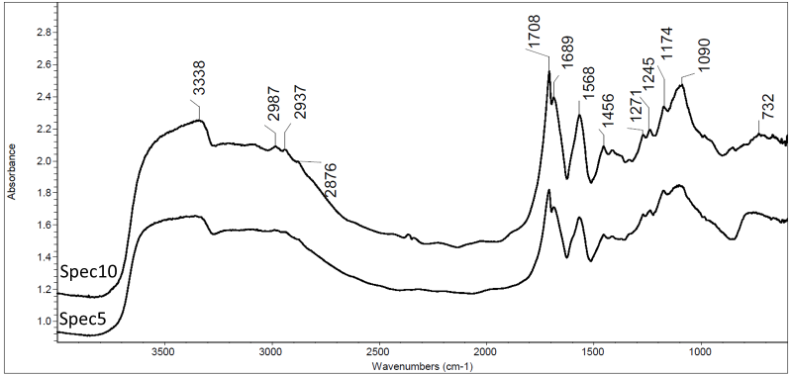
Figure S38. Examples of r-FT-IR spectra of sample 1. Two spectra are presented to show the spectral differences within the sample.

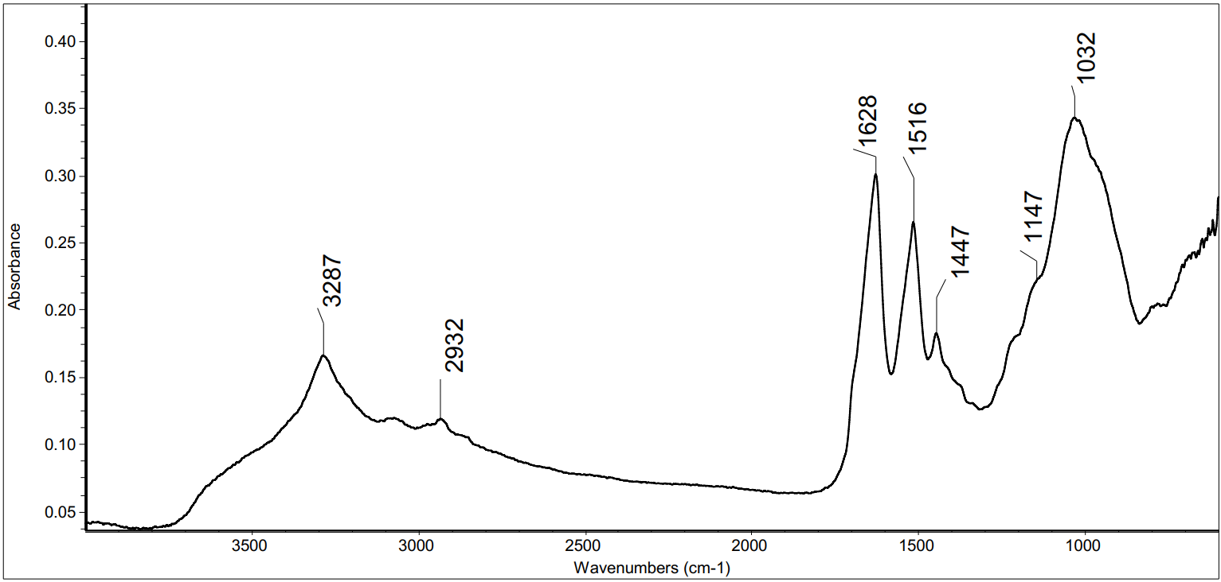
Figure S39. Example of mATR-FT-IR spectrum of sample 1

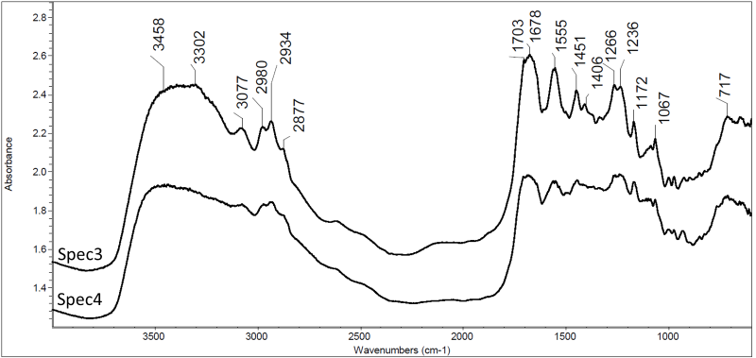
Figure S40. Examples of r-FT-IR spectra of sample 2. Two spectra are presented to show the spectral differences within the sample.

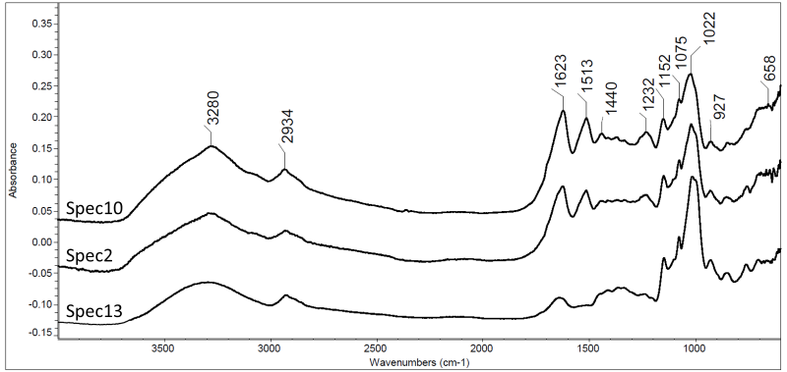
Figure S41. Examples of mATR-FT-IR spectra of sample 2. Three spectra are presented to show the spectral differences within the sample

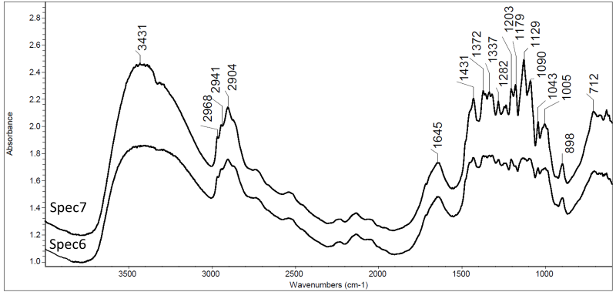
Figure S42. Examples of r-FT-IR spectra of sample 3.1. Two spectra are presented to show the spectral differences within the sample

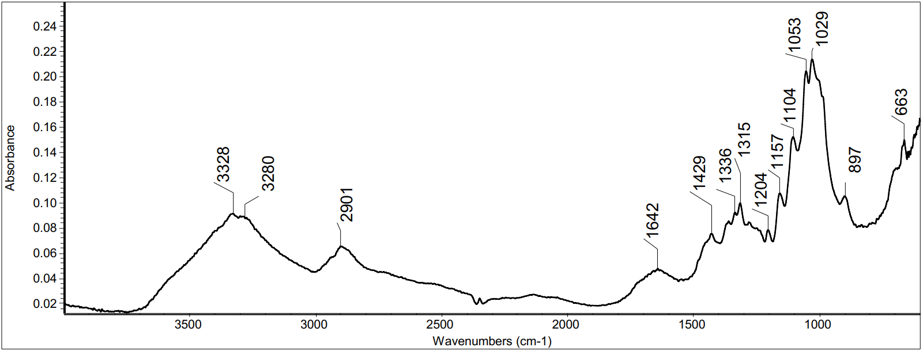
Figure S43. Examples of mATR-FT-IR spectra of sample 3.1.

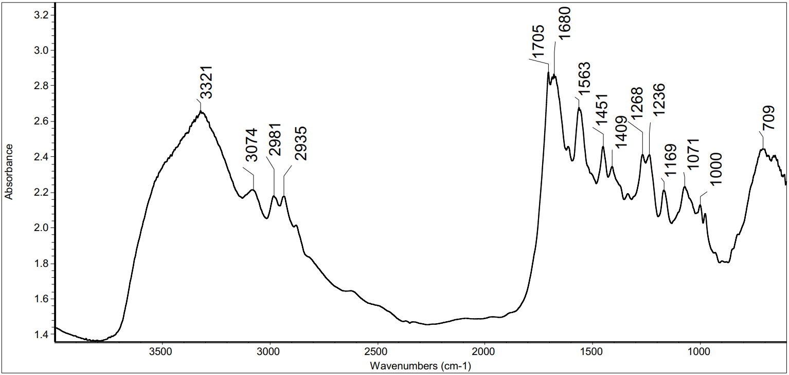
Figure S44. Example of r-FT-IR spectrum of sample 3.2

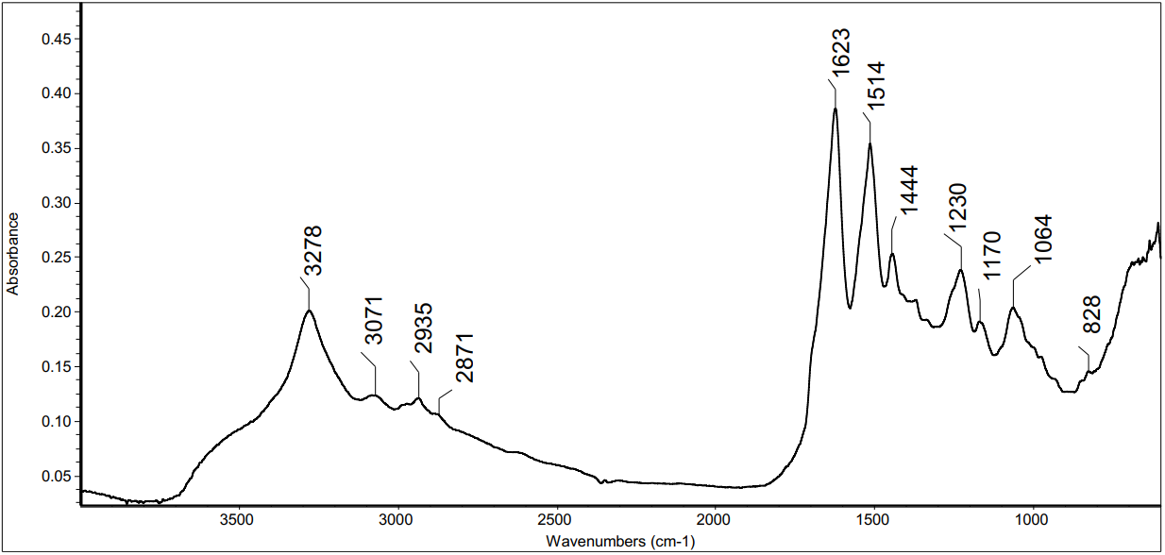
Figure S45. Examples of mATR-FT-IR spectra of sample 3.2
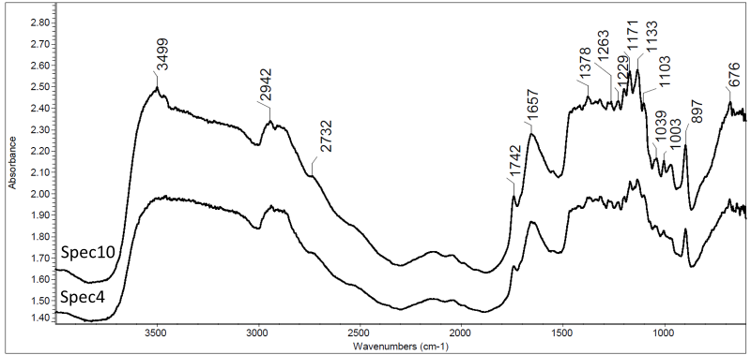
Figure S46. Examples of r-FT-IR spectra of sample 4. Two spectra are presented to show the spectral differences within the sample.

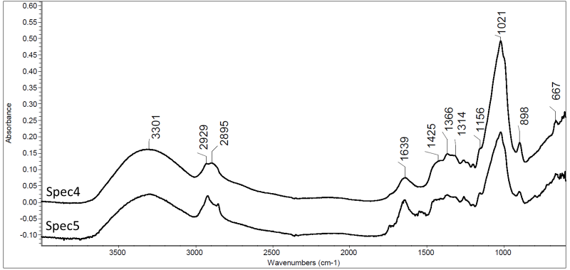
Figure S47. Examples of mATR-FT-IR spectra of sample 4. Two spectra are presented to show the spectral differences within the sample.

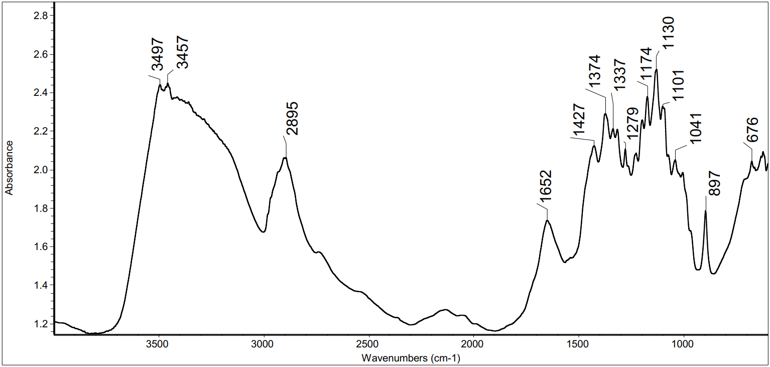
Figure S48. Example of r-FT-IR spectrum of sample 5.1

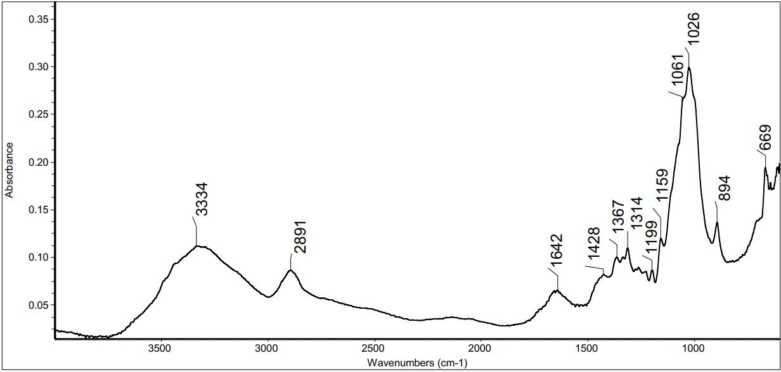
Figure S49. Examples of mATR-FT-IR spectra of sample 5.1

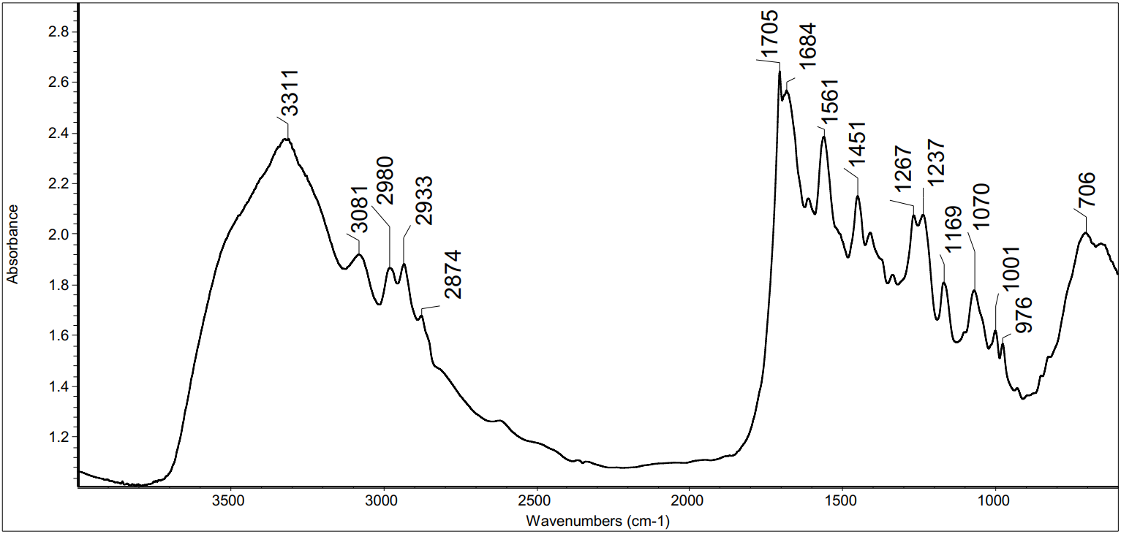
Figure S50. Example of r-FT-IR spectrum of sample 5.2

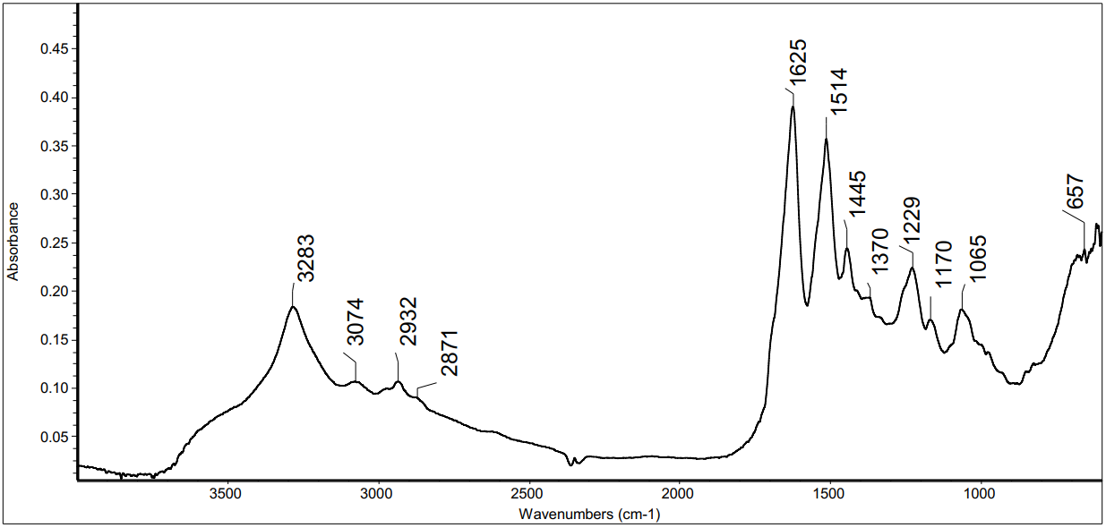
Figure S51. Examples of mATR-FT-IR spectra of sample 5.2

Table 1. Classification results with r-FT-IR. The smaller the PCA score is for DA the more accurate the result. The bigger the accuracy score (max 1.00) is for random forest the more accurate the result
Sample nr | Measured spectra | Class (Discriminant analysis) | PCA scores | Class (Random forest) | Accuracy scores
1 | Spec 1 | jute | 3.27 | wool | 0.24
 | Spec 2 | jute | 3.62 | jute | 0.27
 | Spec 3 | jute | 3.53 | jute | 0.30
 | Spec 4 | jute | 3.63 | jute | 0.29
 | Spec 5 | jute | 3.36 | jute | 0.35
 | Spec 6 | jute | 3.37 | jute | 0.29
 | Spec 7 | jute | 3.34 | jute | 0.30
 | Spec 8 | jute | 3.19 | jute | 0.29
 | Spec 9 | jute | 3.58 | jute | 0.30
 | Spec 10 | jute | 3.55 | jute | 0.28
 | Spec 11 | jute | 3.69 | jute | 0.28
 | Spec 12 | jute | 3.34 | jute | 0.33
 | Spec 13 | jute | 3.37 | jute | 0.33
 | Spec 14 | jute | 4.05 | jute | 0.24
 | Spec 15 | jute | 3.29 | jute | 0.28
 | Spec 16 | jute | 2.13 | jute | 0.31
2 | Spec 1 | silk | 2.51 | jute | 0.59
 | Spec 2 | silk | 1.61 | jute | 0.31
 | Spec 3 | jute | 2.64 | silk | 0.89
 | Spec 4 | wool | 2.54 | jute | 0.43
 | Spec 5 | jute | 2.17 | jute | 0.35
 | Spec 6 | silk | 2.57 | jute | 0.6
 | Spec 7 | silk | 1.77 | jute | 0.29
 | Spec 8 | jute | 2.65 | silk | 0.68
 | Spec 9 | wool | 2.61 | jute | 0.4
 | Spec 10 | cotton | 0.83 | jute | 0.34
3.1 | Spec 1 | jute | 1.16 | linen | 0.49
 | Spec 2 | cotton | 1.1 | linen | 0.57
 | Spec 3 | jute | 1.37 | cotton | 0.68
 | Spec 4 | jute | 1.99 | linen | 0.67
 | Spec 5 | jute | 1.77 | jute | 0.46
 | Spec 6 | cotton | 0.77 | linen | 0.42
 | Spec 7 | jute | 1.36 | cotton | 0.65
 | Spec 8 | silk | 2.87 | linen | 0.66
3.2 | Spec 1 | silk | 1.55 | silk | 0.7
 | Spec 2 | silk | 1.15 | silk | 0.95
 | Spec 3 | silk | 1.58 | silk | 0.99
 | Spec 4 | silk | 1.47 | silk | 0.99
 | Spec 5 | silk | 1.37 | silk | 0.99
 | Spec 6 | silk | 1.33 | silk | 0.93
 | Spec 7 | silk | 0.92 | silk | 0.92
 | Spec 8 | silk | 0.98 | silk | 0.99
 | Spec 9 | silk | 1.67 | silk | 0.99
4 | Spec 1 | jute | 1.38 | jute | 0.37
 | Spec 2 | jute | 1.42 | jute | 0.41
 | Spec 3 | jute | 1.59 | wool | 0.37
 | Spec 4 | jute | 1.35 | wool | 0.28
 | Spec 5 | jute | 1.62 | wool | 0.41
 | Spec 6 | jute | 1.92 | wool | 0.37
 | Spec 7 | jute | 1.46 | wool | 0.29
 | Spec 8 | jute | 1.78 | viscose | 0.31
 | Spec 9 | jute | 1.92 | viscose | 0.26
 | Spec 10 | jute | 1.35 | jute | 0.44
 | Spec 11 | jute | 1.46 | viscose | 0.27
 | Spec 12 | jute | 1.49 | wool | 0.27
5.1 | Spec 1 | cotton | 1.13 | cotton | 0.49
 | Spec 2 | viscose | 1.08 | cotton | 0.42
 | Spec 3 | viscose | 0.82 | viscose | 0.49
 | Spec 4 | viscose | 1.29 | viscose | 0.61
 | Spec 5 | viscose | 1.07 | linen | 0.34
 | Spec 6 | viscose | 1.12 | cotton | 0.37
 | Spec 7 | cotton | 0.83 | cotton | 0.55
 | Spec 8 | cotton | 1.29 | cotton | 0.49
 | Spec 9 | jute | 1.1 | cotton | 0.4
 | Spec 10 | jute | 1.24 | cotton | 0.47
 | Spec 11 | jute | 1.01 | cotton | 0.47
 | Spec 12 | cotton | 1.06 | cotton | 0.54
 | Spec 13 | cotton | 1.11 | cotton | 0.44
 | Spec 14 | jute | 0.93 | cotton | 0.49
5.2 | Spec 1 | silk | 1.03 | silk | 0.97
 | Spec 2 | silk | 1.69 | silk | 0.93
 | Spec 3 | silk | 1.19 | silk | 0.96
 | Spec 4 | silk | 1.03 | silk | 0.98
 | Spec 5 | silk | 1.56 | silk | 0.97
 | Spec 6 | silk | 1.42 | silk | 0.96
 | Spec 7 | silk | 1.44 | silk | 0.96
 | Spec 8 | silk | 1.45 | silk | 0.98
 | Spec 9 | silk | 1.2 | silk | 0.95
 | Spec 10 | silk | 1.29 | silk | 0.94

Table 2. Classification results with mATR-FT-IR. The smaller the PCA score is for DA the more accurate the result. The bigger the accuracy score (max 1.00) is for random forest the more accurate the result
Sample nr | Measured spectra | Class (Discriminant analysis) | PCA scores | Class (Random forest) | Accuracy scores
1 | Spec 1 | polyacrylic | 2.14 | silk | 0.29
 | Spec 2 | polyacrylic | 1.88 | silk | 0.33
 | Spec 3 | polyacrylic | 1.59 | silk | 0.49
 | Spec 4 | polyacrylic | 1.87 | sisal | 0.27
 | Spec 5 | polyacrylic | 2.21 | sisal | 0.25
 | Spec 6 | polyacrylic | 2.17 | sisal | 0.28
 | Spec 7 | polyacrylic | 2.17 | sisal | 0.27
 | Spec 8 | polyacrylic | 1.68 | silk | 0.48
 | Spec 9 | polyacrylic | 1.67 | silk | 0.52
 | Spec 10 | polyacrylic | 2.05 | silk | 0.35
 | Spec 12 | polyacrylic | 2.22 | sisal | 0.27
 | Spec 13 | polyacrylic | 1.79 | silk | 0.54
 | Spec 14 | polyacrylic | 1.82 | silk | 0.32
2 | Spec 1 | jute | 1.81 | sisal | 0.34
 | Spec 2 | polyacrylic | 2.04 | sisal | 0.38
 | Spec 3 | polyacrylic | 1.86 | sisal | 0.35
 | Spec 4 | jute | 2.16 | sisal | 0.34
 | Spec 5 | polyacrylic | 2.34 | viscose | 0.54
 | Spec 6 | jute | 1.69 | sisal | 0.28
 | Spec 7 | polyacrylic | 2.34 | sisal | 0.26
 | Spec 8 | polyacrylic | 2.26 | sisal | 0.29
 | Spec 9 | polyacrylic | 2.25 | sisal | 0.4
 | Spec 10 | polyacrylic | 2.11 | sisal | 0.27
 | Spec 11 | polyacrylic | 1.8 | sisal | 0.38
 | Spec 12 | polyacrylic | 1.95 | sisal | 0.36
 | Spec 13 | jute | 2.16 | viscose | 0.61
 | Spec 14 | jute | 2.14 | viscose | 0.66
 | Spec 15 | polyacrylic | 2.22 | silk | 0.42
 | Spec 16 | polyacrylic | 2.29 | sisal | 0.24
 | Spec 17 | polyacrylic | 2.27 | sisal | 0.33
 | Spec 18 | jute | 1.86 | viscose | 0.54
 | Spec 19 | jute | 1.69 | sisal | 0.36
 | Spec 20 | jute | 1.61 | sisal | 0.39
3.1 | Spec 1 | jute | 0.99 | linen | 0.365
 | Spec 2 | cotton | 1.01 | cotton | 0.34
 | Spec 3 | jute | 1.45 | jute | 0.45
 | Spec 4 | jute | 0.78 | jute | 0.49
 | Spec 6 | jute | 1.05 | linen | 0.285
 | Spec 7 | jute | 1.7 | jute | 0.29
3.2 | Spec 1 | silk | 1.14 | silk | 1
 | Spec 2 | silk | 1.5 | silk | 1
 | Spec 3 | silk | 1.66 | silk | 0.86
 | Spec 4 | silk | 1.49 | silk | 0.99
 | Spec 5 | silk | 1.82 | silk | 0.74
 | Spec 6 | silk | 1.42 | silk | 0.99
4 | Spec 1 | jute | 1.35 | viscose | 0.63
 | Spec 2 | jute | 1.54 | viscose | 0.55
 | Spec 3 | jute | 1.49 | viscose | 0.57
 | Spec 4 | jute | 1.72 | viscose | 0.6
 | Spec 5 | jute | 1.96 | jute | 0.31
5.1 | Spec 1 | jute | 1.26 | viscose | 0.49
 | Spec 2 | viscose | 1.25 | viscose | 0.92
 | Spec 3 | jute | 1.12 | viscose | 0.78
 | Spec 4 | jute | 1.1 | viscose | 0.63
 | Spec 5 | jute | 0.9 | viscose | 0.64
 | Spec 6 | jute | 1.55 | viscose | 0.51
5.2 | Spec 1 | silk | 1.08 | silk | 0.99
 | Spec 2 | silk | 1.29 | silk | 0.97
 | Spec 3 | silk | 1.41 | silk | 0.97

Case-study: Very small fiber thread from painting on the textile from the end of the 20th century
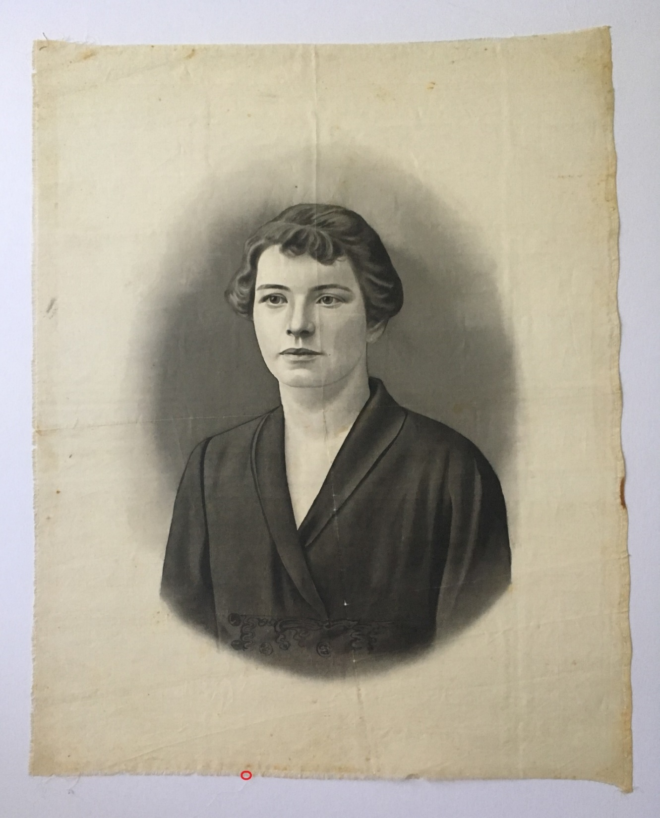
Figure S52. Photo of analyzed object. The red circle at the bottom of the painting shows where analyzed sample was taken (Photo made by Nele Ambos).

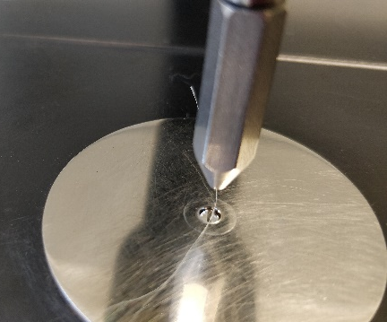
Figure S53. Picture of the analyzed fiber on ATR diamond crystal. | Figure S54. Microscope picture of the fibers | Figure S55. Microscope picture of the fibers

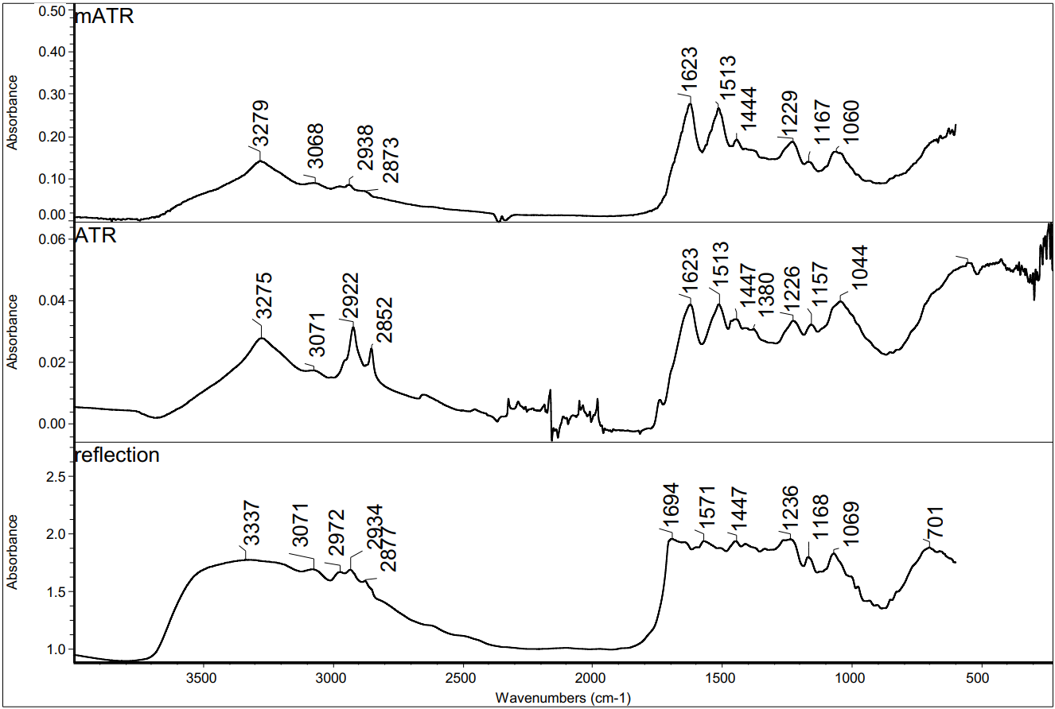
Figure S56. FT-IR spectra of analyzed paint fiber. Spectra are recorded using FT-IR microspectrometer in ATR mode, ATR-FT-IR spectrometer and FT-IR microspectrometer in reflectance mode.

Table 3. Classification results with mATR-FT-IR. The smaller the PCA score is for DA the more accurate the result. The bigger the accuracy score (max 1.00) is for random forest the more accurate the result
Measured spectra | Class (Discriminant analysis) | PCA scores | Class (Random forest) | Accuracy scores
Spec 1 | silk | 2.34 | silk | 0.99
Spec 2 | silk | 2.07 | silk | 0.95

