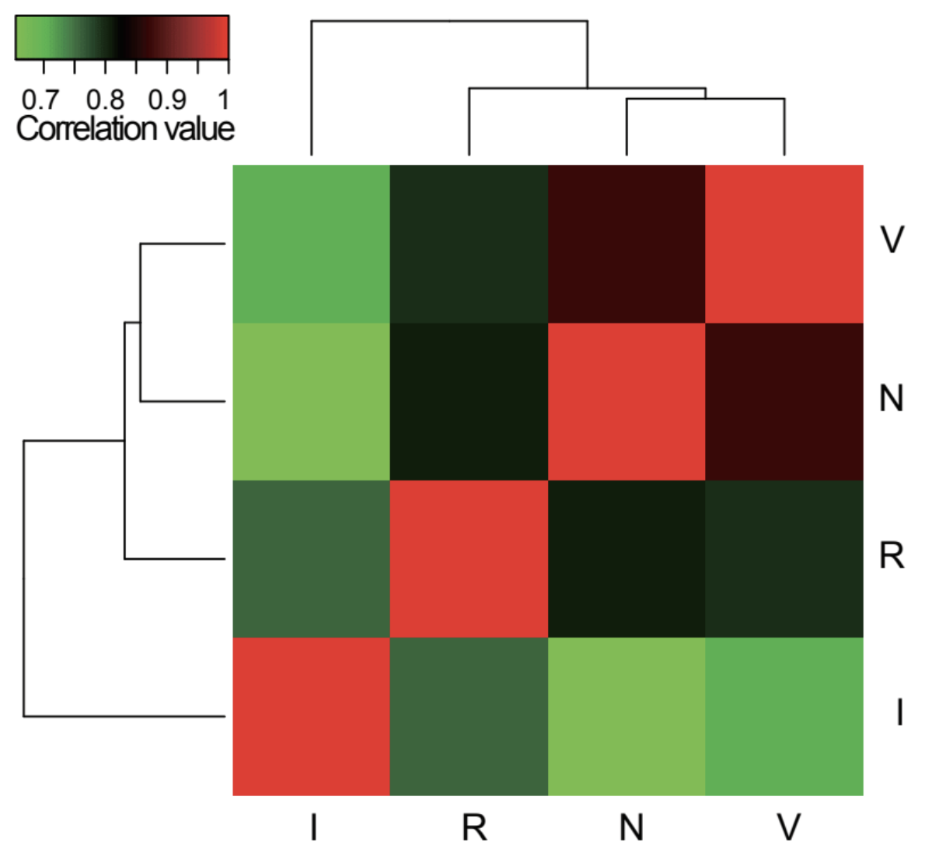
Additional file 1: Figure S1. Differentially expressed genes show correlations with life-cycle stages

