Additional File to

Hypo- or hyperactivity of zebrafish embryos provoked by neuroactive substances: A review on how experimental parameters impact the predictability of behavior changes

*Afolarin Ogungbemi, David Leuthold, Stefan Scholz, Eberhard Küster
Department of Bioanalytical Ecotoxicology, Helmholtz Centre for Environmental Research−UFZ, Permoserstr. 15, 04318 Leipzig, Germany

*Corresponding author: afolarin.ogungbemi@ufz.de

Table S1: Sources of fish embryo test lethality data used in Figure 3 of main text.
Substance | Data Source | LC50(µM) |  |  |  | Exposure duration (hpf)
Valproate | Selderslaghs et al 2012 | 1570 |  |  |  | 72
Carbamazepine | Van den brandhofs and montforts 2010 | 1037 |  |  |  | 72
Endosulfan | *Biotox database | 1.2 |  |  |  | 96
Chlorpyrifos | *Biotox database | 5.4 |  |  |  | 96
Diazinon | Steele et al 2018 | 37.5 |  |  |  | 96
Aconitine | Ali et al 2012 | 200 |  |  |  | 72
Pentylenetetrazole | Steele et al 2018 | 19153 |  |  |  | 96
Nicotine | Ali et al 2012 | 220 |  |  |  | 96
Abamectin | Weichert et al 2017 | 0.7 |  |  |  | 48
Emamectin | Weichert et al 2017 | 12.6 |  |  |  | 48
Methimazole | Selderslaghs et al 2012 | 19120 |  |  |  | 72
Acetaminophen | Selderslaghs et al 2012 | 3539 |  |  |  | 96
Retinoic acid | Selderslaghs et al 2012 | 1.47 |  |  |  | 72
*Data retrieved from internal database maintained at Department of bioanalytical ecotoxicology, Helmholtz center for environmental research, Leipzig

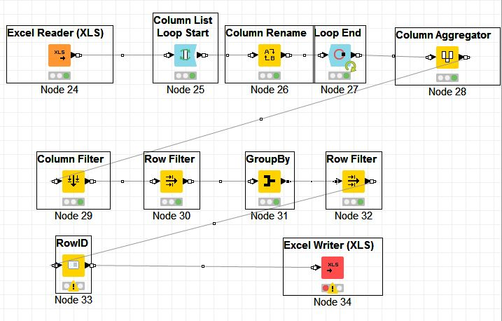
Figure S1: Summary of the literature selection process in KNIME

Comparison of individual substances with known neuroactive mode of action

Comparison of effect concentrations for all chemicals considered in this review are described in the text and the corresponding figures for each chemical depicted below. Bars show the magnitude of the effect concentrations which represents lowest effect concentrations as deduced from each study. When there is no bar, it indicates no effect observed within the tested concentration range. When two different bars are depicted for one study, it indicates effect concentrations for both hypo- and hyperactivity. The text written on top of each bar represents the behavioral test method while the numbers represents the exposure duration (hpf)

Substances with an expected hyperactivity effect on zebrafish embryos
Aconitine
Aconitine is expected to stimulate nerve cells by activating the voltage gated sodium channel, hereby causing hyperactivity (Gutser et al. 1998). Three studies were compared. Hyperactivity was observed in the LMR-L/D study by Ellis et al. (2012) and PMR study by Kokel et al. (2010). The LMR-L/D study by Ali et al. (2012) showed hypoactivity and this could be due to the long exposure duration leading to over-excitation of the nerve cells and hence paralysis.
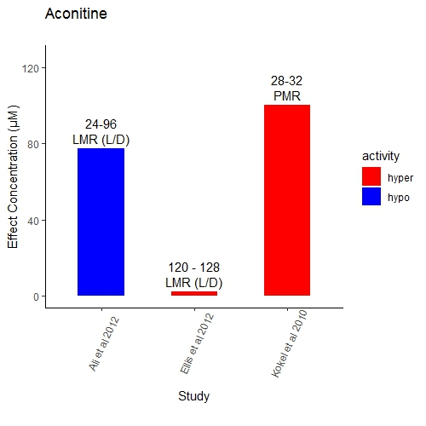

Chlorpyrifos
Chlorpyrifos is an organophosphate expected to cause hyperactivity at lower doses by inhibiting acetylcholinesterase enzyme after it is bioactivated i.e. transformed into the corresponding oxon metabolite (Casida and Durkin 2013). Twenty-two studies were compared. Five studies that reported hyperactivity were short exposure duration tests (2-20 h) except the LMR-L/D study by Oliveri et al. (2015) in which a lower concentration (0.03µM) was exposed for 115 h. This suggests that chlorpyrifos might be taken up fast in the embryo and therefore its neurotoxic effect may be visible at low concentration and short exposure. Consequently, the hypoactivity which is mostly observed at higher exposure concentrations and long duration may be due to over-excitation of the neuron cells leading to axonal defects or seizures and subsequent paralysis. In addition, endpoint parameter varies across the tests and this could also contribute to the risk of bias.
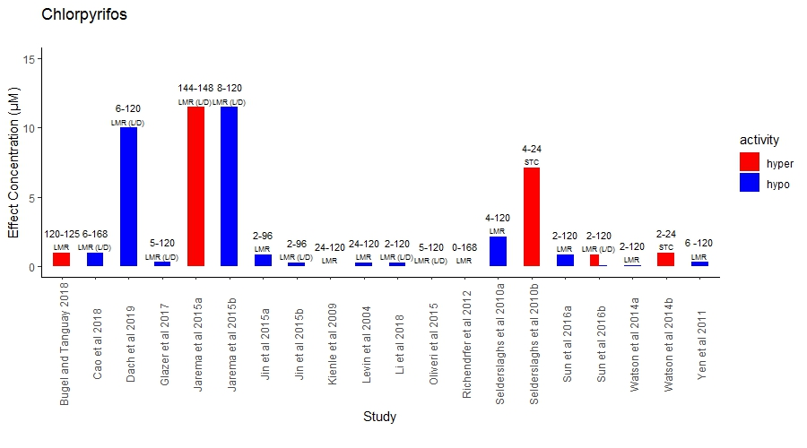

- Diazinon (see Figure 3 and S2)
Diazinon is an organophosphate expected to cause hyperactivity by inhibiting acetylcholinesterase after it is bioactivated i.e. transformed into its –oxon metabolite (Casida and Durkin 2013). Twelve studies were compared. Hyperactivity was observed only in a single LMR-L/D study (Leuthold et al. 2019). The other 10 studies either showed hypoactivity or no effect. Interestingly, the LMR-L/D study by Leuthold et al. (2019) was the only one that employed a combination of an older developmental stage (96 hpf) and a short exposure duration (24 h) and the anticipated hyperactivity of diazinon was observed at low exposure concentrations while hypoactivity was observed at high concentrations. The lack of effect observed in only short duration studies (STC and PMR) with younger stages could be due to slow uptake or a possible bioactivation limitation of the early life-stage of the developing embryo. Therefore, the hypoactivity effect could be due to the narcotic effect of diazinon at relatively high concentrations. Different endpoint parameters were also used and this made it difficult to compare effects in some cases.
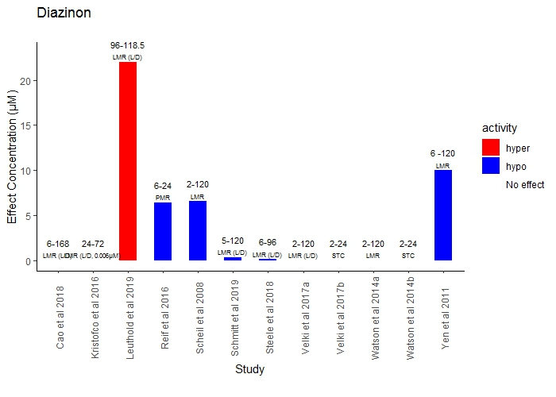

Endosulfan
Endosulfan is an organochlorine insecticide which is expected to cause hyperactivity by blocking GABA-gated chloride channel (Casida and Durkin 2013). Four studies were compared. Zebrafish embryos reacted with hyperactivity to endosulfan exposure in an LMR-L/D study by Dale et al. (2017) [long exposure duration] and Leuthold et al. (2019) [short exposure duration], but hypoactivity was observed in the STC study by Raftery and Volz (2015) [short exposure duration]. This could be due to limited uptake and perhaps limited biotransformation in the early development stage. Moreover, the STC endpoint (see selected behavioral endpoints) used in Raftery and Volz (2015) might be biased towards hypoactivity since endosulfan blocked abamectin induced hypoactivity in the same study (see section endpoint parameters above). The fourth studies, a PMR study by Reif et al. (2016) did not show any effect and this is also attributed to differences in endpoint parameter between STC and PMR.
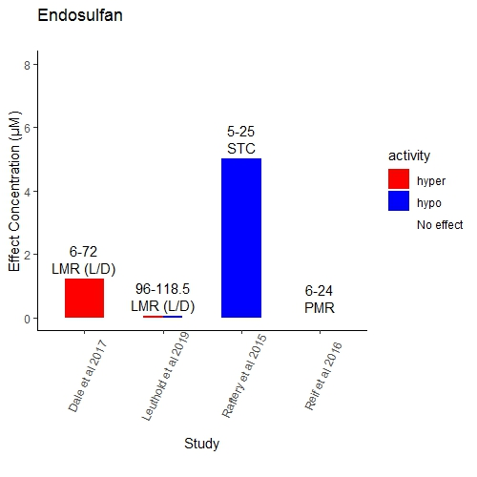

Isoproterenol
Isoproterenol is a pharmaceutical expected to cause hyperactivity by agonizing beta-adrenergic receptors (www.drugbank.ca). Four studies were compared. Isoproterenol showed consistency in its hyperactivity effects observed in 3 PMR studies. The only exception is the hypoactivity reported in the LMR study by Gauthier and Vijayan (2018). This hypoactivity could be related to side effects of isoproterenol in older developmental stages which probably could possess more molecular receptors, thus increasing susceptibility. Additionally, exposure concentration seems to be a limiting factor for adequate comparison. The LMR study exposed at a single concentration of 20µM which is 5 times lower than the effect concentration (100µM) reported in the other PMR studies
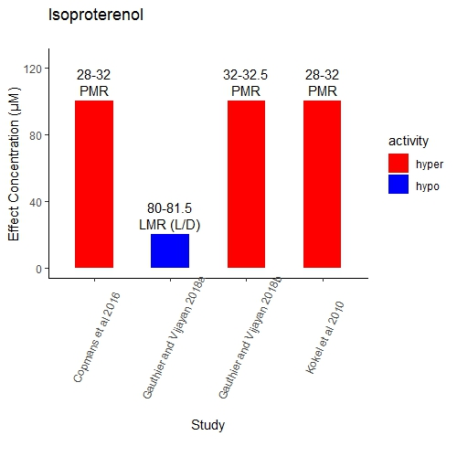

Nicotine
Nicotine is an insecticide that acts by agonizing the nicotinic acetylcholine receptors, thereby causing hyperactivity (Casida and Durkin 2013). Seven studies were found and compared. A trend can be observed in which the short exposure duration tests showed hyperactivity. Nicotine is taken up fast in zebrafish embryos and equilibrium is reached after 10 mins (Thomas et al. 2009). This suggests that the hypoactivity reported in the long duration test by Ali et al. (2012) could be due to over-excitation and paralysis. Furthermore, the STC test by Raftery et al. (2014) did not report any effect. This might probably due to short analysis duration of 6 seconds and the different endpoint parameter which might be inherently biased against detecting hyperactivity. Similarly, the PMR study by Reif et al. (2016) did not show any effect and this is also attributed to differences in endpoint parameter.
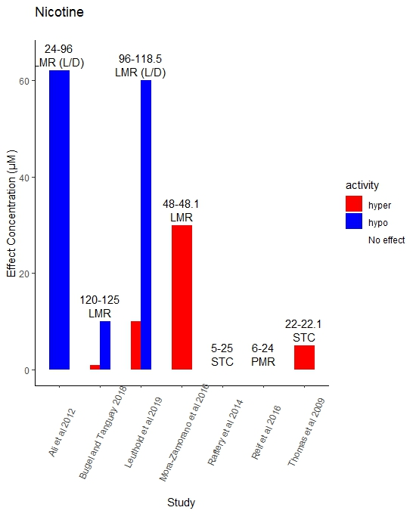

Pentylenetetrazole
PTZ is a convulsant drug and it is expected to cause hyperactivity by binding to GABA receptors (Squires et al. 1984). Sixteen studies were compared. PTZ showed hyperactivity effect in all the studies except the LMR study by Bugel and Tanguay (2018) which reported no effect. This is possibly due to the use of low exposure concentrations which are probably below the effective range of PTZ. Even though the effect concentrations for hyperactivity were within a factor of 10 in all studies, hypoactivity was also reported, at different concentrations or light period, as an additional effect to hyperactivity in some LMR-L/D studies. The effect of PTZ may be enhanced under alternating light-dark periods and PTZ has been reported to cause a reversal of the observed activity in control treatment i.e. higher activity in dark and lower activity in light phase (Ellis et al 2012; Torres-Hernandez et al 2016). Consequently, it is likely that PTZ is biphasic and this effect is only observed under alternating light conditions. Hence, the use of different light conditions during measurement could be a limiting factor for comparing different behavior methods.
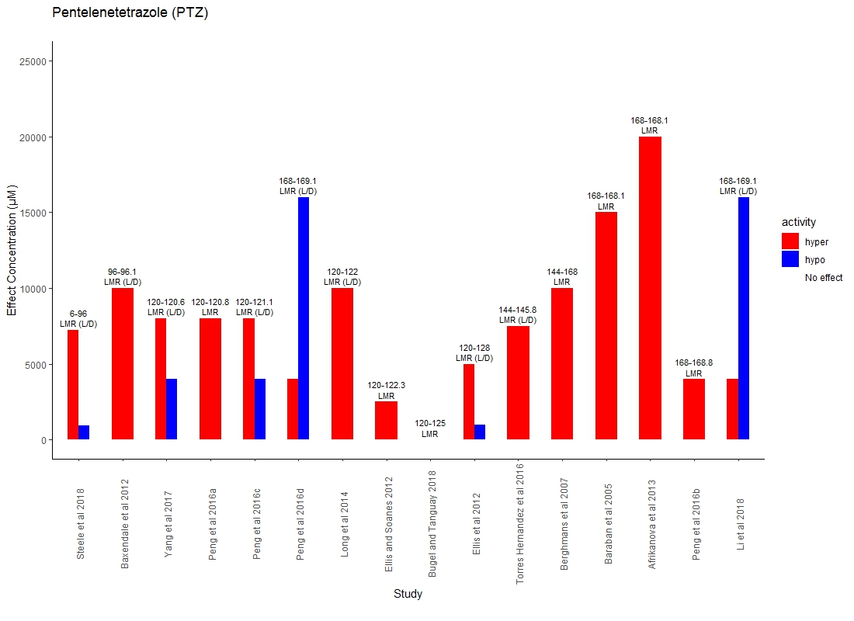

Substances with an expected hypoactivity effect on zebrafish embryos
Abamectin
Abamectin is an avermectin insecticide expected to cause hypoactivity by activating GABA gated chloride channel (Casida and Durkin 2013). Five studies were compared. All studies reported hypoactivity. Effect concentration for hypoactivity reported in all studies are within a factor of 10 (0.36 – 3.13µm) except the STC study by Raftery and Volz (2015) which reported an effect at 0.25µm. This lower effect concentration could be due to conducting exposure in glass beakers instead of plastic titer-plates as exposure vessel. Abamectin is highly lipophilic (logD_{pH7.4(ACD/Labs)} of 5.85) and hence has more affinity to bind to plastic than glass; therefore, abamectin may be highly bioavailable to the embryos in a glass container leading to effects occurring at lower concentration (see above results section on “nature of test container”).
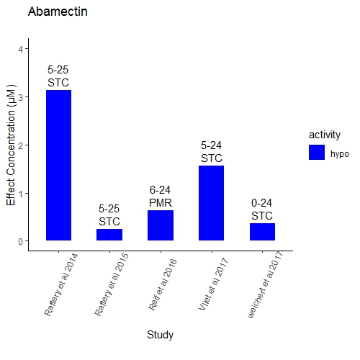
Carbamazepine
Carbamazepine is an anticonvulsant drug which is assumed to act by blocking sodium channels (www.drugbank.ca), therefore causing hypoactivity. Six studies were compared. Four out of six studies reported hypoactivity at similar effect concentrations (100 - 180µM) except the PMR study by Reif et al. (2016) and the LMR study by Martinez et al. (2018) which reported no effect. This could be due to exposure concentrations lower than observed effective range in the PMR study. The LMR study utilized an exposure duration of 1 hour and this could lead to low uptake of carbamazepine and therefore negligible effects or effects not yet developed to an extent that could be observed in the LMR test.
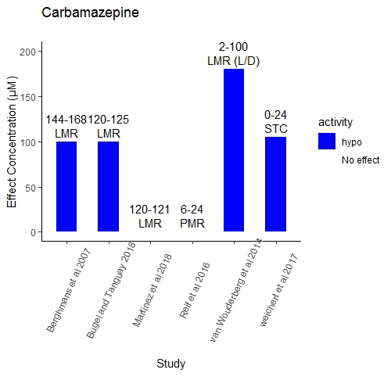

Diazepam
Diazepam is an anticonvulsant and anxiolytic drug which acts by stimulating the GABA receptor (www.drugbank.ca) and it is expected to cause hypoactivity. Five studies were compared. Hypoactivity was reported in all studies considered except the LMR-L/D study by Steenbergen et al. (2011) which reported no effect. This could be attributed to the use of a different endpoint parameter and single exposure concentration (2.5µM). The effect concentration for hypoactivity reported by Dach et al. 2019 was lower than the others and this could be due to longer exposure duration (114 h) employed.
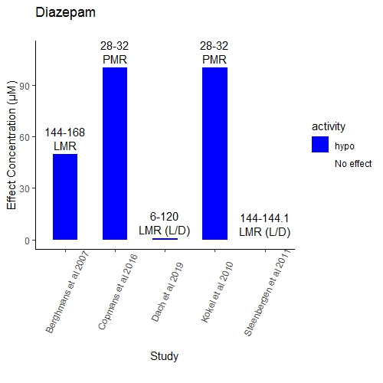

Emamectin benzoate
Emamectin is an avermectin insecticide and it is expected to cause hypoactivity by activating GABA gated chloride channels (Casida and Durkin 2013). Three studies were compared. Although all three studies reported hypoactivity for emamectin, the effect concentrations (0.0064, 1.03 and 25 µM) were not within a factor of 10. A possible explanation is the use of different exposure well sizes. The 384 well-plates used in Raftery et al. (2014) with effect concentration of 25 µM could cause a higher adsorption of emamectin (logD_{pH7} of 5) compared to the 24 well-plates used in Weichert et al. (2017) [effect concentration =1.03 µM]. This could lead to an overall decrease in bioavailability and hence toxicity in the former (see section exposure well size above). Additionally, different endpoint parameter between the STC and PMR could be responsible for the divergent effect concentrations.
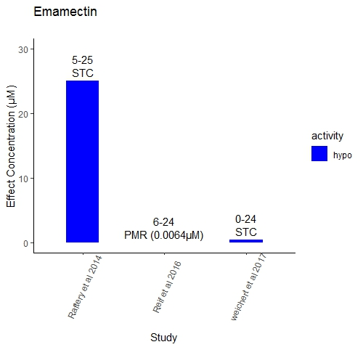

Levetiracetam
Levetiracetam is an anticonvulsant drug which is assumed to selectively prevent hypersynchronization of epileptiform burst firing by inhibiting voltage dependent calcium channel (www.drugbank.ca). It is expected to cause hypoactivity in zebrafish embryos based on its ability to reduce the release of neurotransmitters into the synaptic cleft. This is supported by effectively inhibiting the movement in PTZ (GABA receptor blocker) induced hyperactivity (Berghmans et al. 2007). Three studies were compared. It was probably impossible to detect an effect in the LMR study by Martinez et al. (2018) because the exposure concentration used was a factor of 1000 below that used in the other studies and this suggests that these concentrations might not be in the effective range of levetiracetam. Even though the LMR study by Berghmans et al. (2007) and the LMR(L/D) study by Beker van Woudenberg et al. (2014) shows hypoactivity at a similar concentration, the latter study also shows hyperactivity at higher concentrations. This might be attributed to the differences in exposure duration, developmental stage and light conditions between the studies.
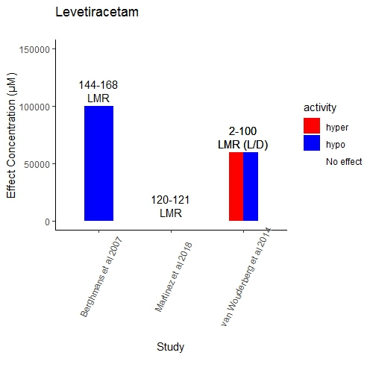

Valproate
Valproate is an anticonvulsant drug and it is expected to cause hypoactivity by inhibiting GABA transaminase (www.drugbank.ca). This assumption is supported by Baraban et al. (2005) who reported that valproate reduced PTZ invoked seizures and epileptic activity. Twelve studies were compared. In six studies, valproate showed a trend in which hyperactivity was reported mostly at low concentrations (Zellner et al. 2011; Cowden et al. 2012; Beker van Woudenberg et al. 2014; Zimmermann et al. 2015; Bailey et al. 2016; Bugel and Tanguay 2018). It is important to note that the LMR studies by Zellner et al. (2011) and Zimmermann et al. (2015) only exposed from 0 – 48 hpf and measured behavior at 144 hpf. This kind of exposure regime might influence the internal concentration of valproate. Brox et al. (2016) showed that equilibrium concentration is reached after 72hrs of exposing valproate to zebrafish embryos (0-120 hpf exposure) and that it is possible that the elimination is complete at 6 days when behavior was measured in Zellner et al. (2011) - this might partly explain the results. Therefore, exposure duration, which might influence the toxicokinetics, is a possible limiting factor for an adequate comparison. On the other hand, hypoactivity was mostly observed at high concentrations in seven studies. This suggests that valproate might act biphasic on behavior. Nonetheless, single exposure concentrations used in some studies (eg. Zellner et al. 2011; Zimmermann et al. 2015) could cause a comparison bias.
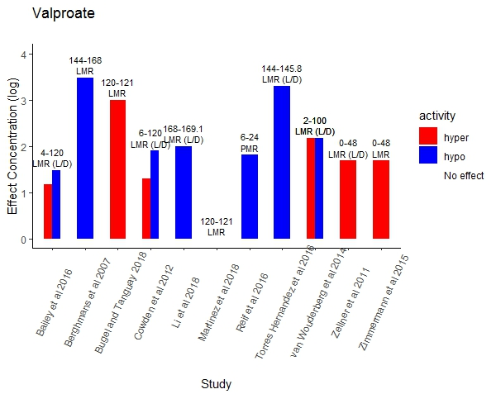

Substances with a mode of action that does not allow anticipating hyper- or hypoactivity.

Acetaminophen
Acetaminophen is a cyclooxygenase inhibitor and an analgesic drug (www.drugbank.ca). Its expected activity in zebrafish embryo based on this mode of action is not clear. Nine studies were compared. All studies considered did not report an effect except the hypoactivity effect [66.2 - 6620µM] reported in the LMR study by Reuter et al. (2016). This study is the only one that utilized a combination of higher developmental stages (144hpf) and short exposure duration (2 h). This could indicate the lack of target receptors at lower developmental stages. Additionally, LC₅₀s of 10120, 9920, 7870 and 3710 µm at 24, 48, 72 and 144 hpf respectively were reported for acetaminophen (Selderslaghs et al 2012). Hence, it is possible that the exposure concentration and hence, the internal concentration in the other studies may be excessively below the effective range of acetaminophen.
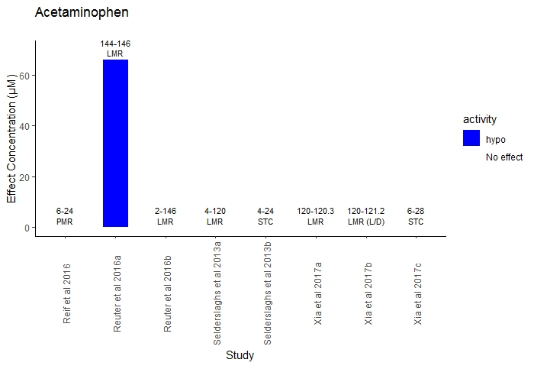

Haloperidol
Haloperidol is -beside other uses- an antipsychotic drug acting as a dopamine receptor antagonist and its expected activity in zebrafish embryo based on this mode of action is not clear. Based on known side effects in humans (www.drugbank.ca) both hypo- and hyper-activity could be expected. Five studies were compared. The LMR study by Giacomini et al. (2006) reported hypoactivity while the LMR-L/D study by Irons et al. (2013) reported a biphasic activity. The former study used only one exposure concentration and swimming speed was the endpoint parameter. This does not allow appropriate comparison with the latter study which assessed distance moved. Oliveri and Levin (2019) compared 2 different zebrafish strains (AB and 5D) and found hyperactivity effect for the 5D strain only. Furthermore, the PMR study by Reif et al. (2016) did not report any effect and this is probably due to basic differences in exposure design, especially developmental stage at exposure initiation.
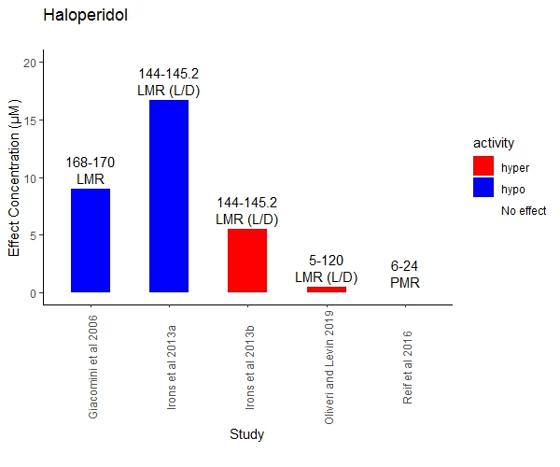

Methimazole
Methimazole is an antithyroid drug that inhibits the conversion of iodide to iodine (www.drugbank.ca). Its expected activity in zebrafish embryo based on this mode of action is not clear. Four studies were compared. Methimazole shows hypoactivity effect in only the long duration studies; LMR study by Selderslaghs et al. (2013) (4-144hpf) and LMR-L/D study by Fetter et al. (2015) (48-120hpf). The short duration studies (0-24hpf), comprising of STC and PMR, show no effect. This suggests that exposure duration, and hence kinetics could be a limiting factor in the propagation of the effect of methimazole.
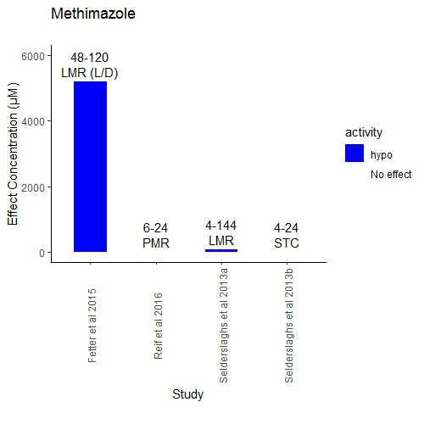

Retinoic acid
Retinoic acid is a retinoic acid receptor agonist (www.drugbank.ca) and its expected activity in zebrafish embryo is not clear. Four studies were compared. All studies except the PMR study by Reif et al. (2016) showed hyperactivity and the effect concentrations were within a variation factor of 10. The reason for the inactivity reported in Reif et al. (2016) is probably related to the different endpoint parameter used in the PMR method.
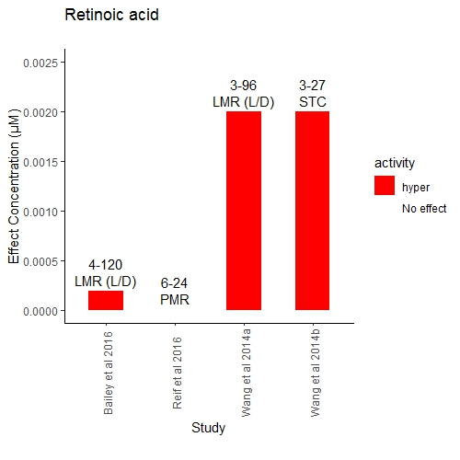
Apomorphine
Apomorphine acts by stimulating post-synaptic dopamine D2-type receptors within the brain (www.drugbank.ca). Its expected activity is not clear. All four studies showed hyperactivity. However, the effect concentration for the LMR-L/D study by Irons et al. 2013 was below a factor of 10 variation of the other studies. This could be due to the higher sensitivity of zebrafish at the developmental stage of 6dpf. The LMR-L/D method could also be more sensitive than the LMR due to the induced alternating light conditions.
