**Benzimidazole Schiff base derivatives: synthesis, characterization and antimicrobial activity**

Thierry Youmbi Fonkui1, Monisola Itohan Ikhile2, Patrick Berka Njobeh1, Derek Tantoh Ndinteh2

*1Department of Biotechnology and Food Technology, University of Johannesburg* P.O. Box 17011*,* Doornfontein Campus 2028, South Africa*.*

*2Department of Applied Chemistry, University of Johannesburg* P.O. Box 17011*,* Doornfontein Campus 2028, South Africa.

**ADDITIONAL DATA**



**Fig. S1 FTIR spectrum of Schiff base Compound 3.a**



**Fig. S2 FTIR spectrum of Schiff base Compound 3.b**



**Fig. S3 FTIR spectrum of Schiff base Compound 3.c**



**Fig. S4 FTIR spectrum of Schiff base Compound 3.d**



**Fig. S5 FTIR spectrum of Schiff base compound 3.e**



**Fig. S6 FTIR spectrum of Schiff base Compound 3.f**



**Fig. S7 Normalized UV-vis absorption spectrum of Schiff base 3.a**



**Fig. S8 Normalized UV-vis absorption spectrum of Schiff base 3.b**



**Fig. S9 Normalized UV-vis absorption spectrum of Schiff base 3.c**



**Fig. S10 Normalized UV-vis absorption spectrum of Schiff base 3.d**



**Fig. S11 Normalized UV-vis absorption spectrum of Schiff base 3.e**



**Fig. S12 Normalized UV-vis absorption spectrum of Schiff base 3.f**

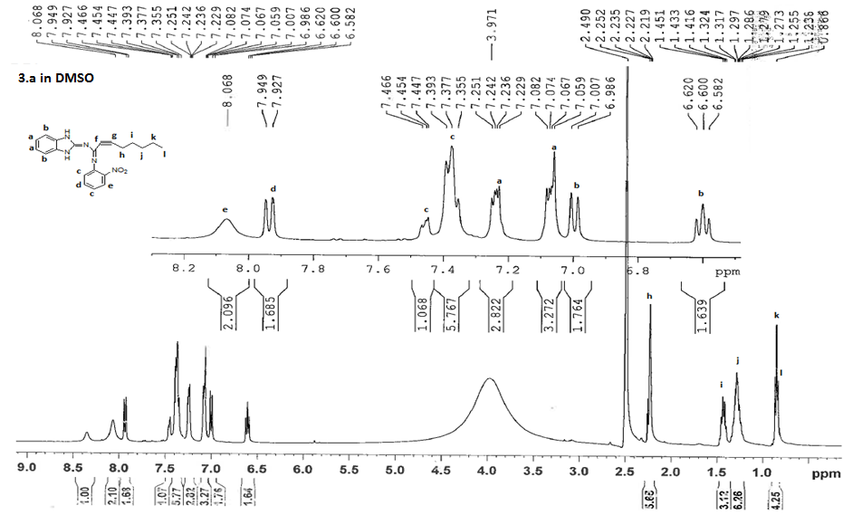

**Fig. S13 1H NMR spectrum of Schiff base Compound 3.a**

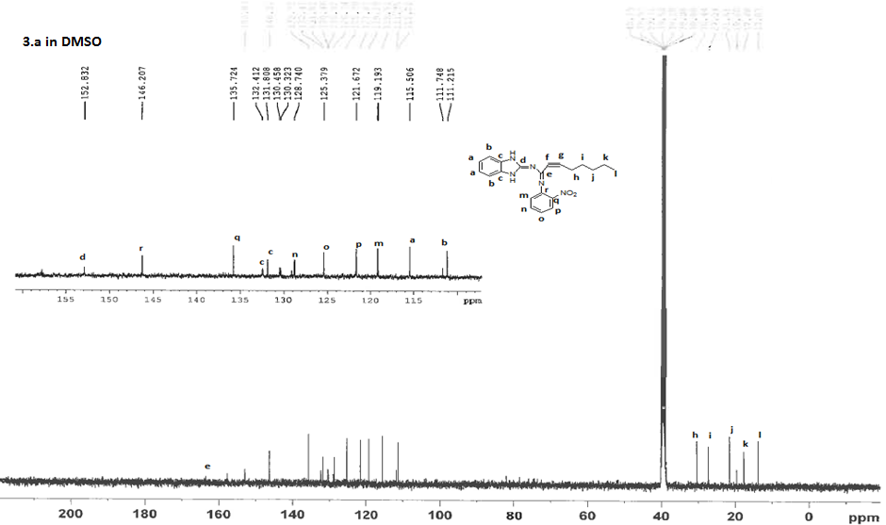**Fig. S14 13C NMR spectrum of Schiff base Compound 3.a**

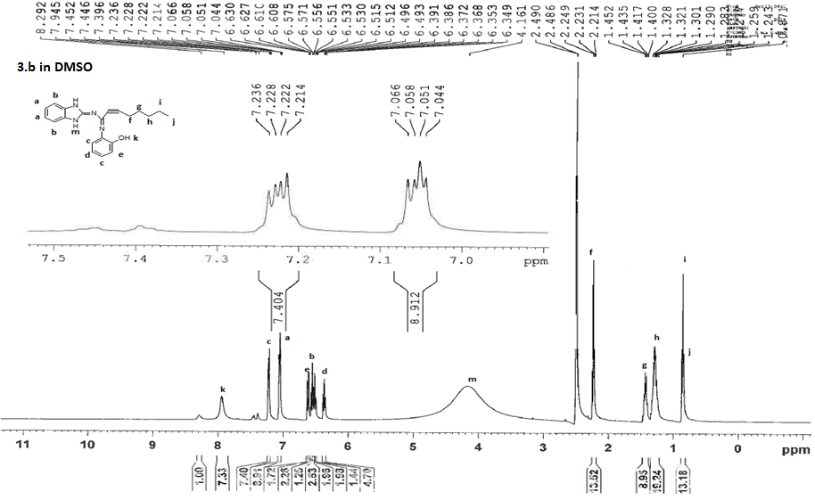

**Fig. S15 1H NMR spectrum of Schiff base Compound 3.b**

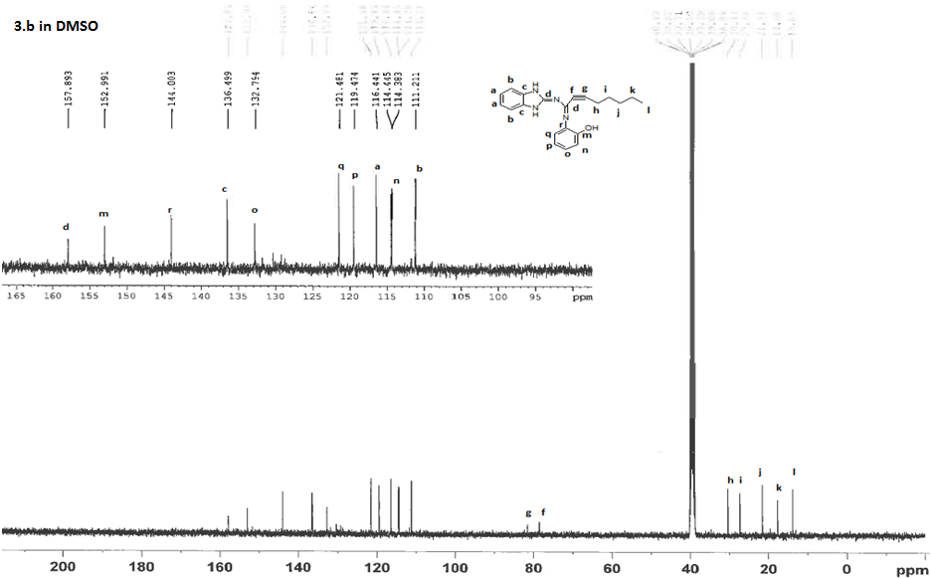**Fig. S16 13C NMR spectrum of Schiff base Compound 3.b**

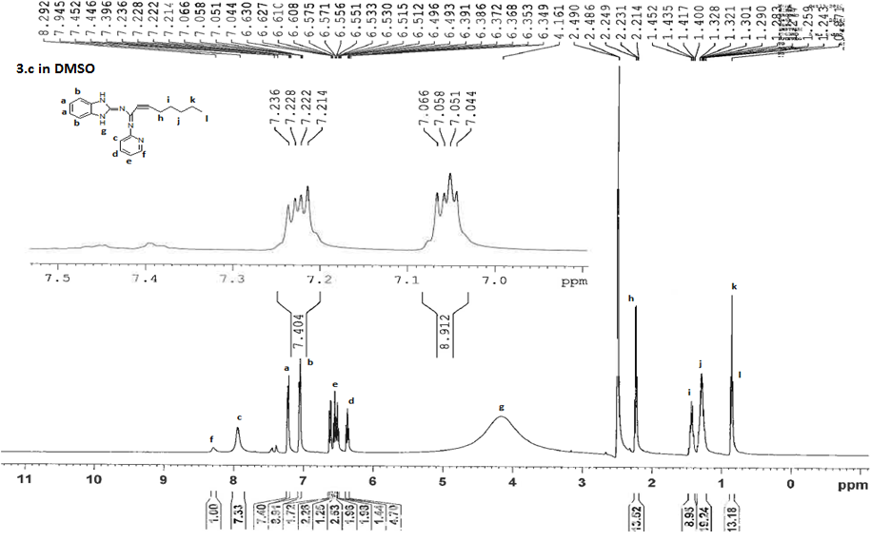**Fig. S17 1H NMR spectrum of Schiff base Compound 3.c**

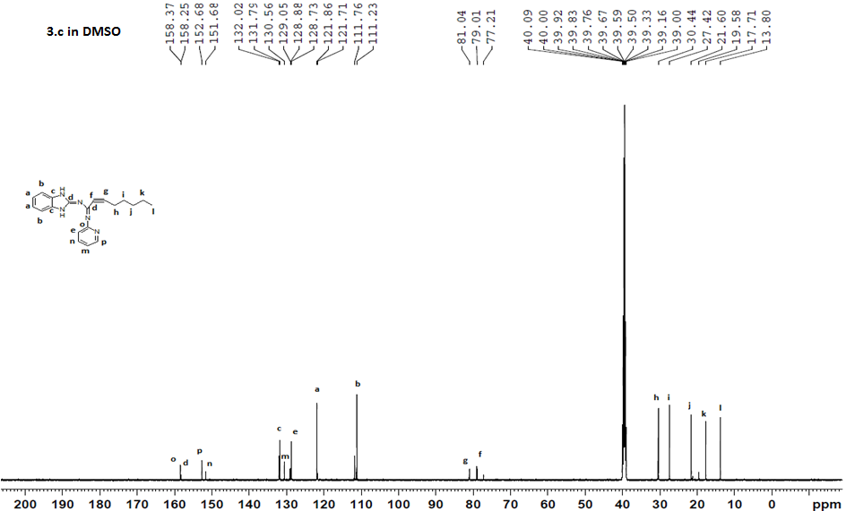**Fig. S18 13C NMR spectrum of Schiff base Compound 3.c**

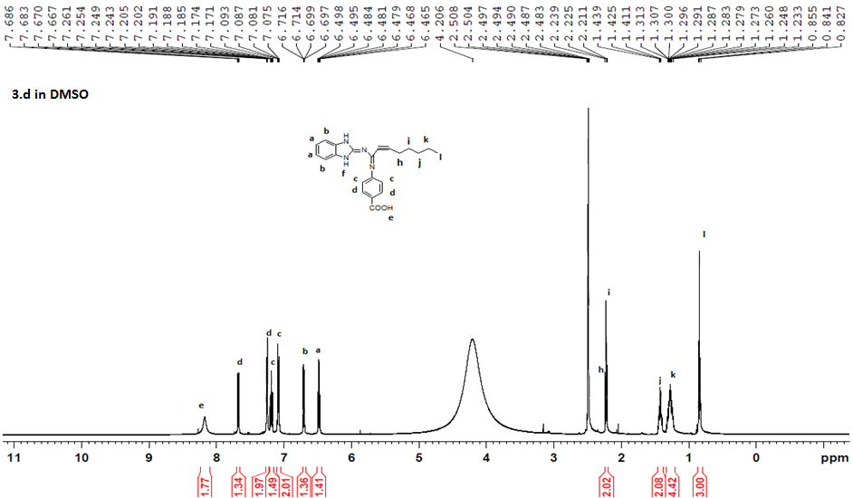**Fig. S19 1H NMR spectrum of Schiff base Compound 3.d**

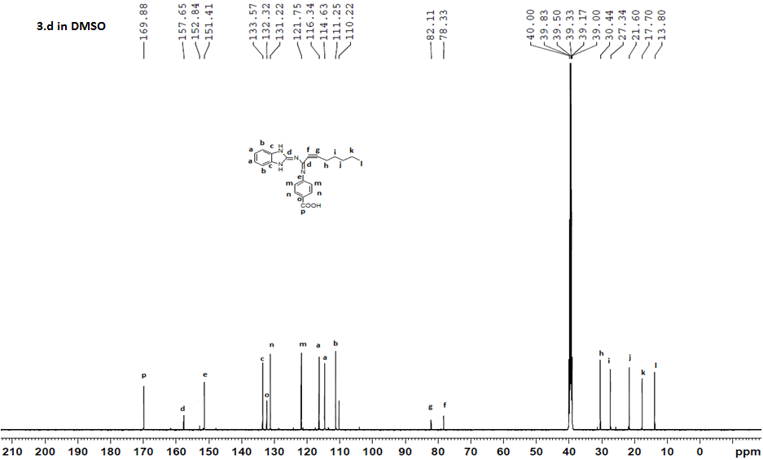**Fig. S20 13C NMR spectrum of Schiff base Compound 3.d**

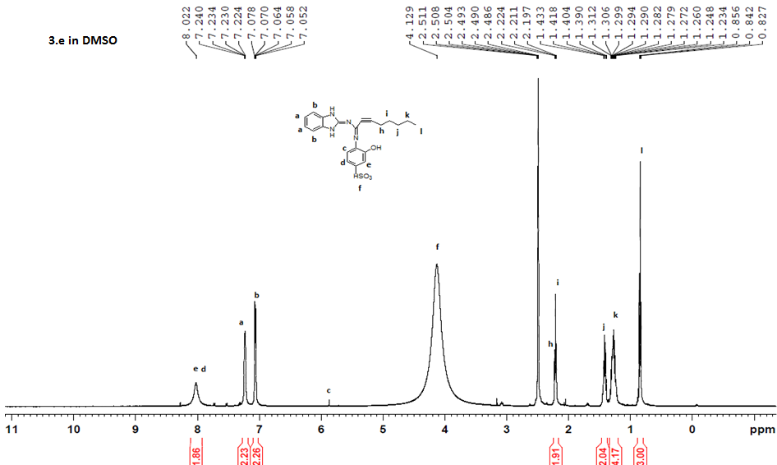**Fig. S21 1H NMR spectrum of Schiff base Compound 3.e**

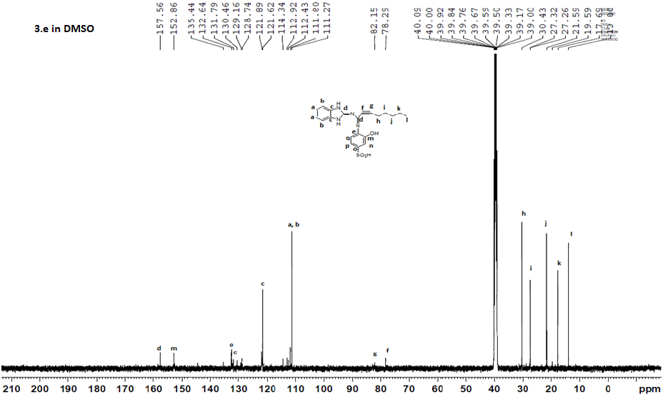**Fig. S22 13C NMR spectrum of Schiff base compound 3.e**

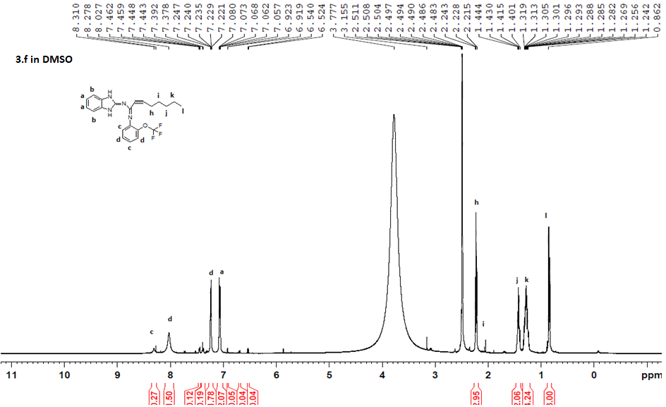**Fig. S23 1H NMR spectrum of Schiff base Compound 3.f**

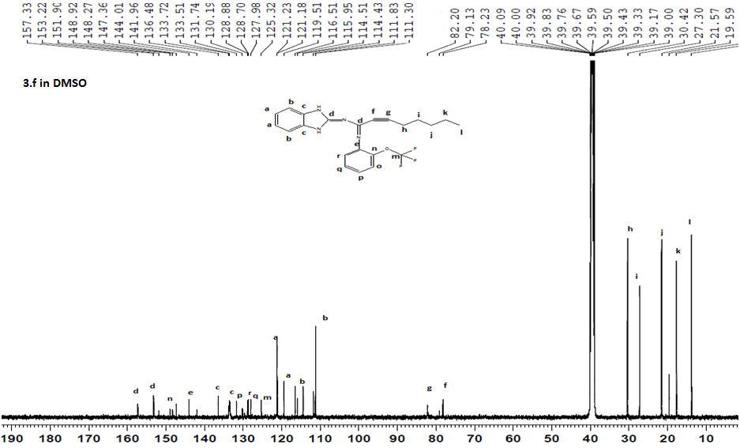**Fig. S24 13C NMR spectrum of Schiff base Compound 3.f**