SUPPORTING INFORMATION
Movement behavior of the monito del monte (Dromiciops gliroides): new insights into the ecology of a unique marsupial
Lida M. Franco, Francisco E. Fontúrbel, Giovany Guevara and Mauricio Soto-Gamboa

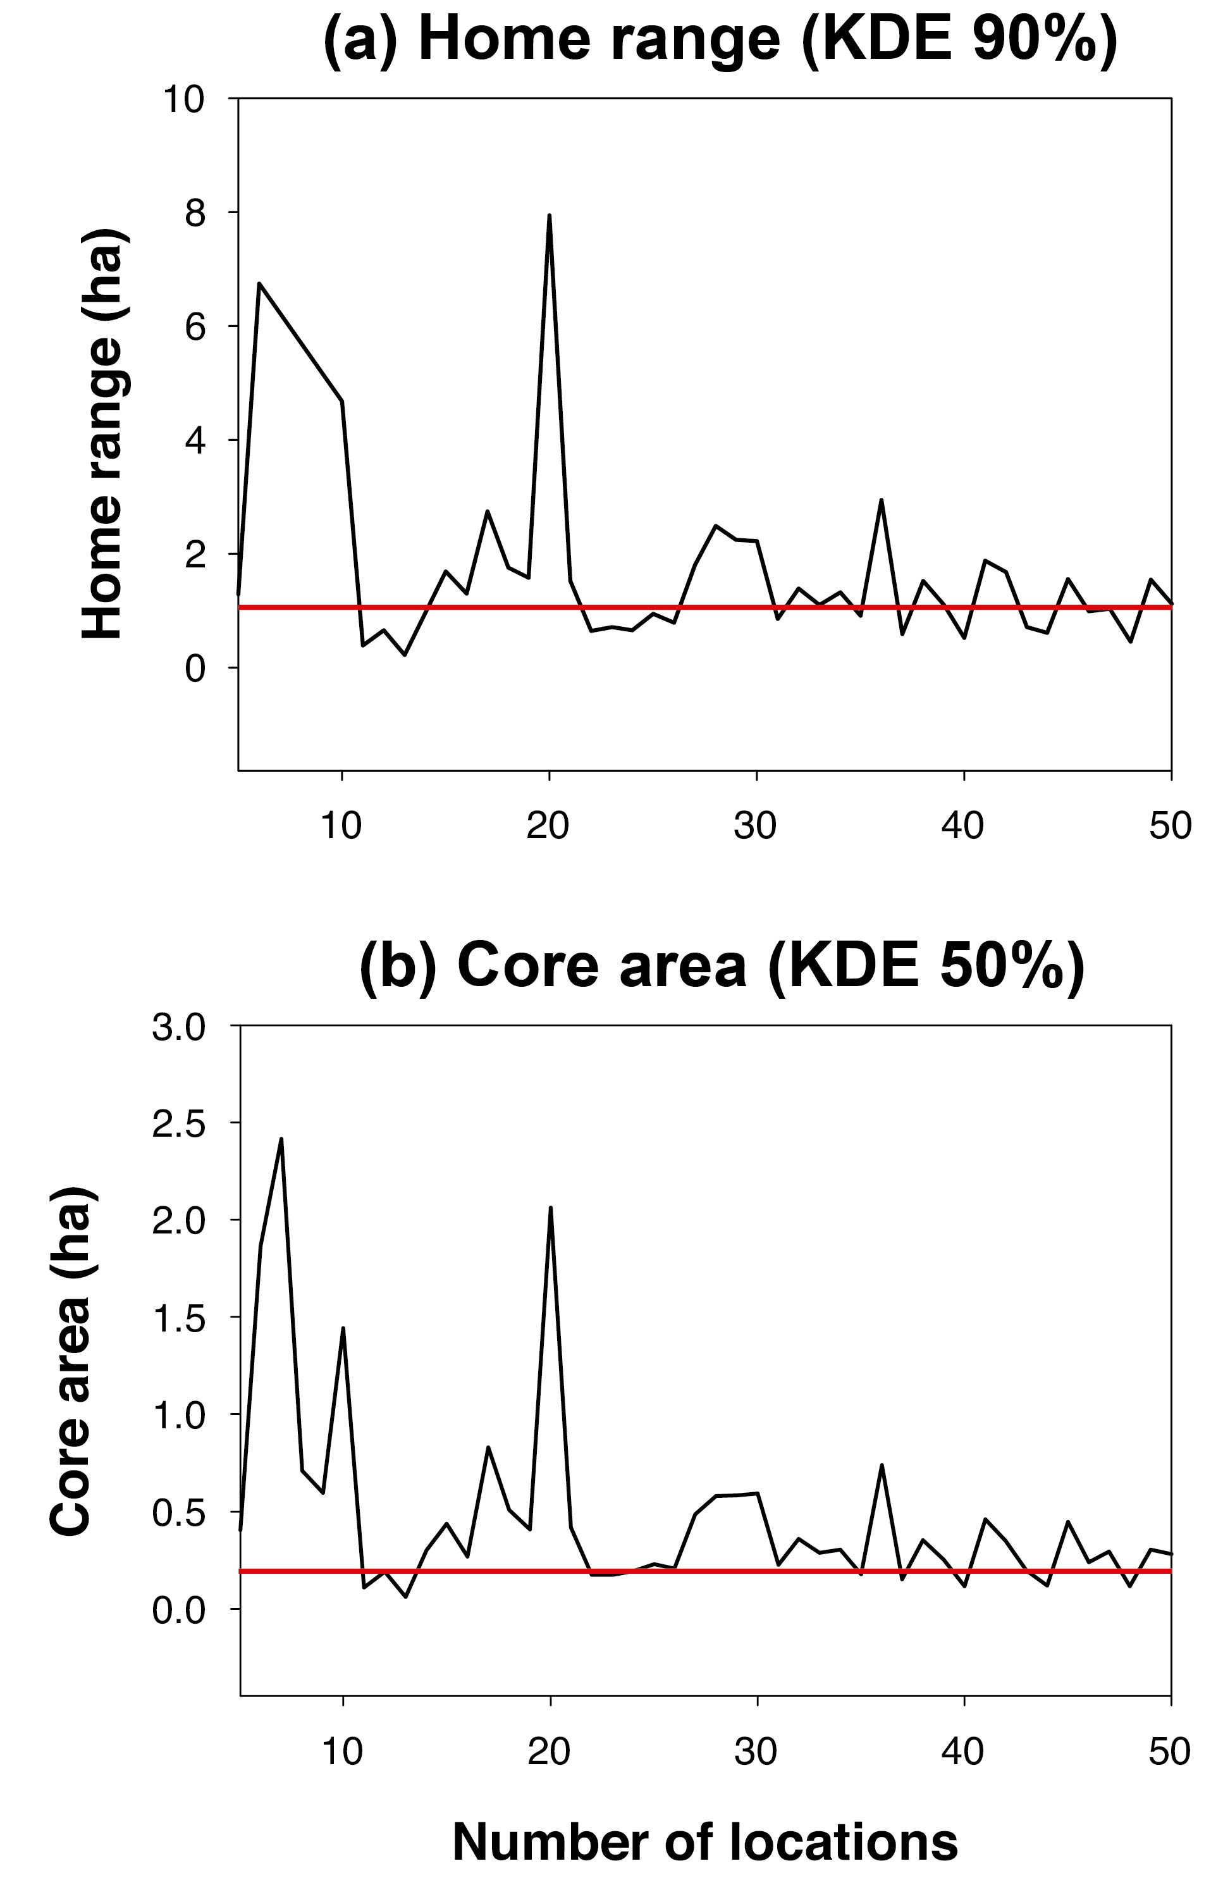
Figure S1. Accumulation curves of the number of locations (random subsets ranging from 5 to 50) and areas estimated for (a) home range, and (b) core area. Red lines represent the actual value estimated with all locations.
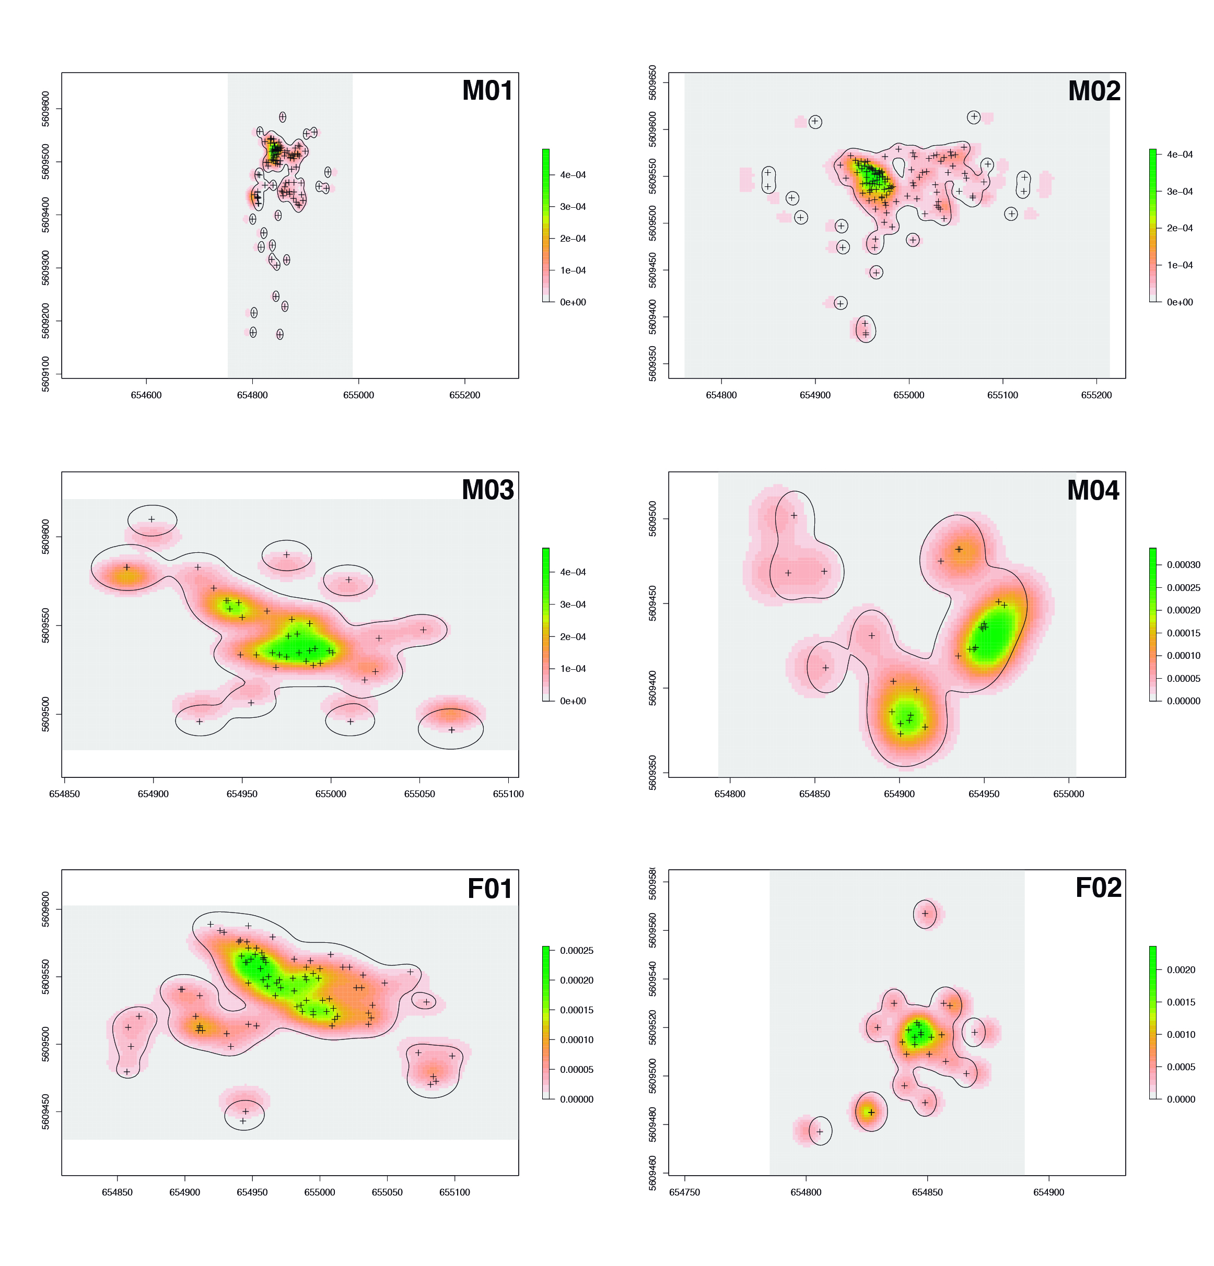
Figure S2. Home range (KDE 90%) areas of tracked Dromiciops gliroides individuals (black contours).
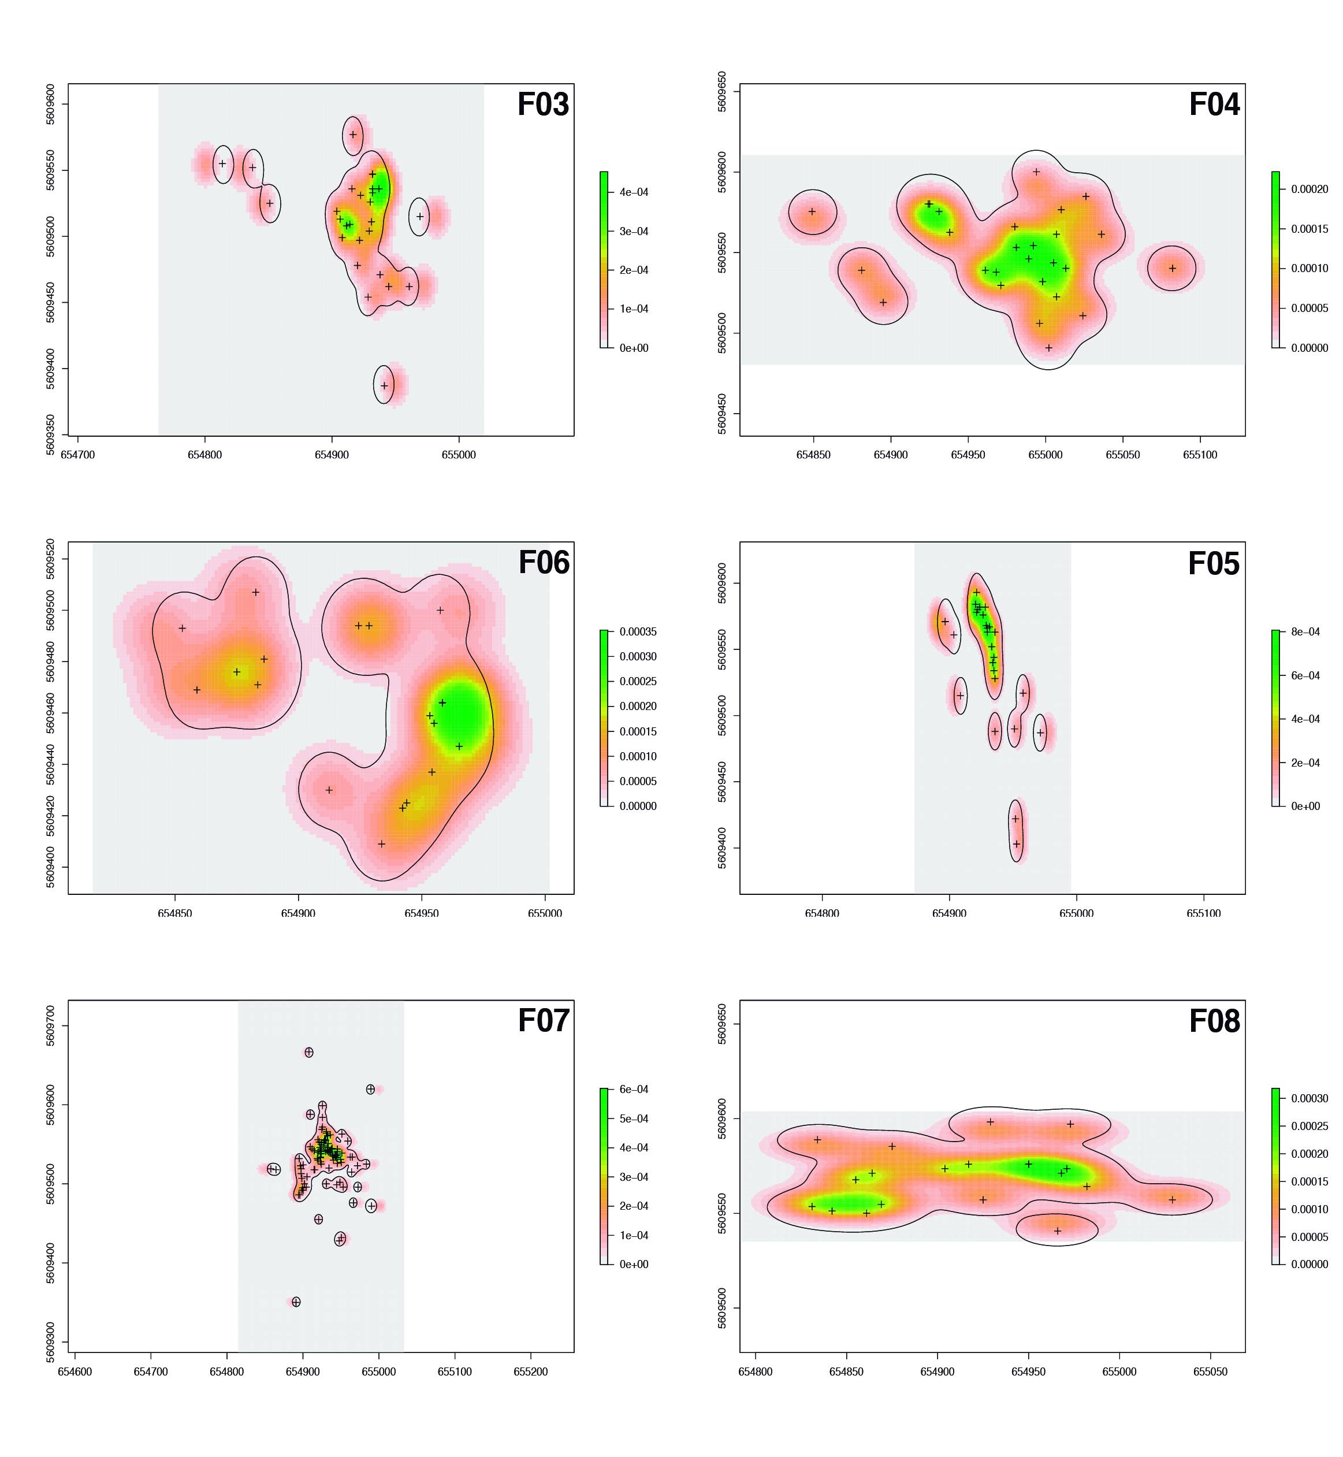
(Figure S2 continued)
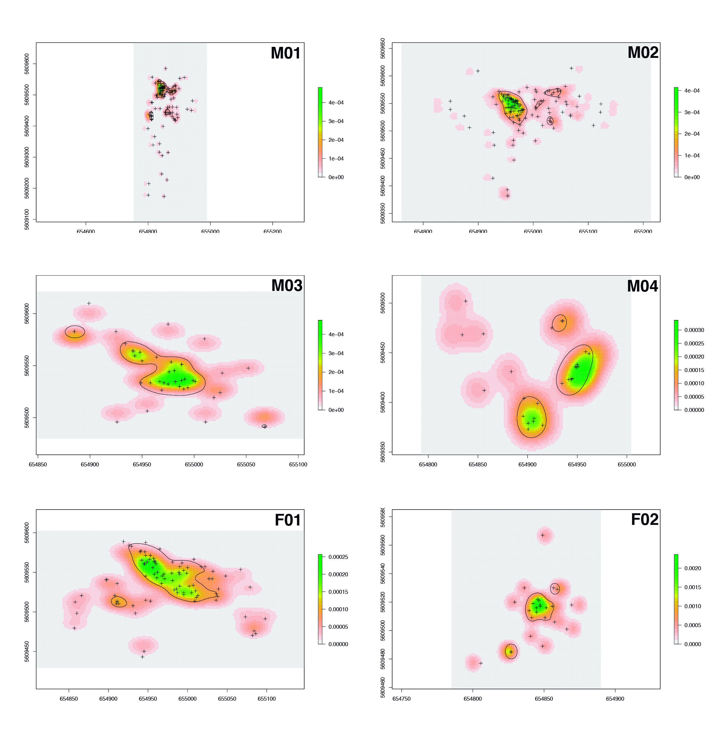
Figure S3. Core areas (KDE 50%) of tracked Dromiciops gliroides individuals (black contours).
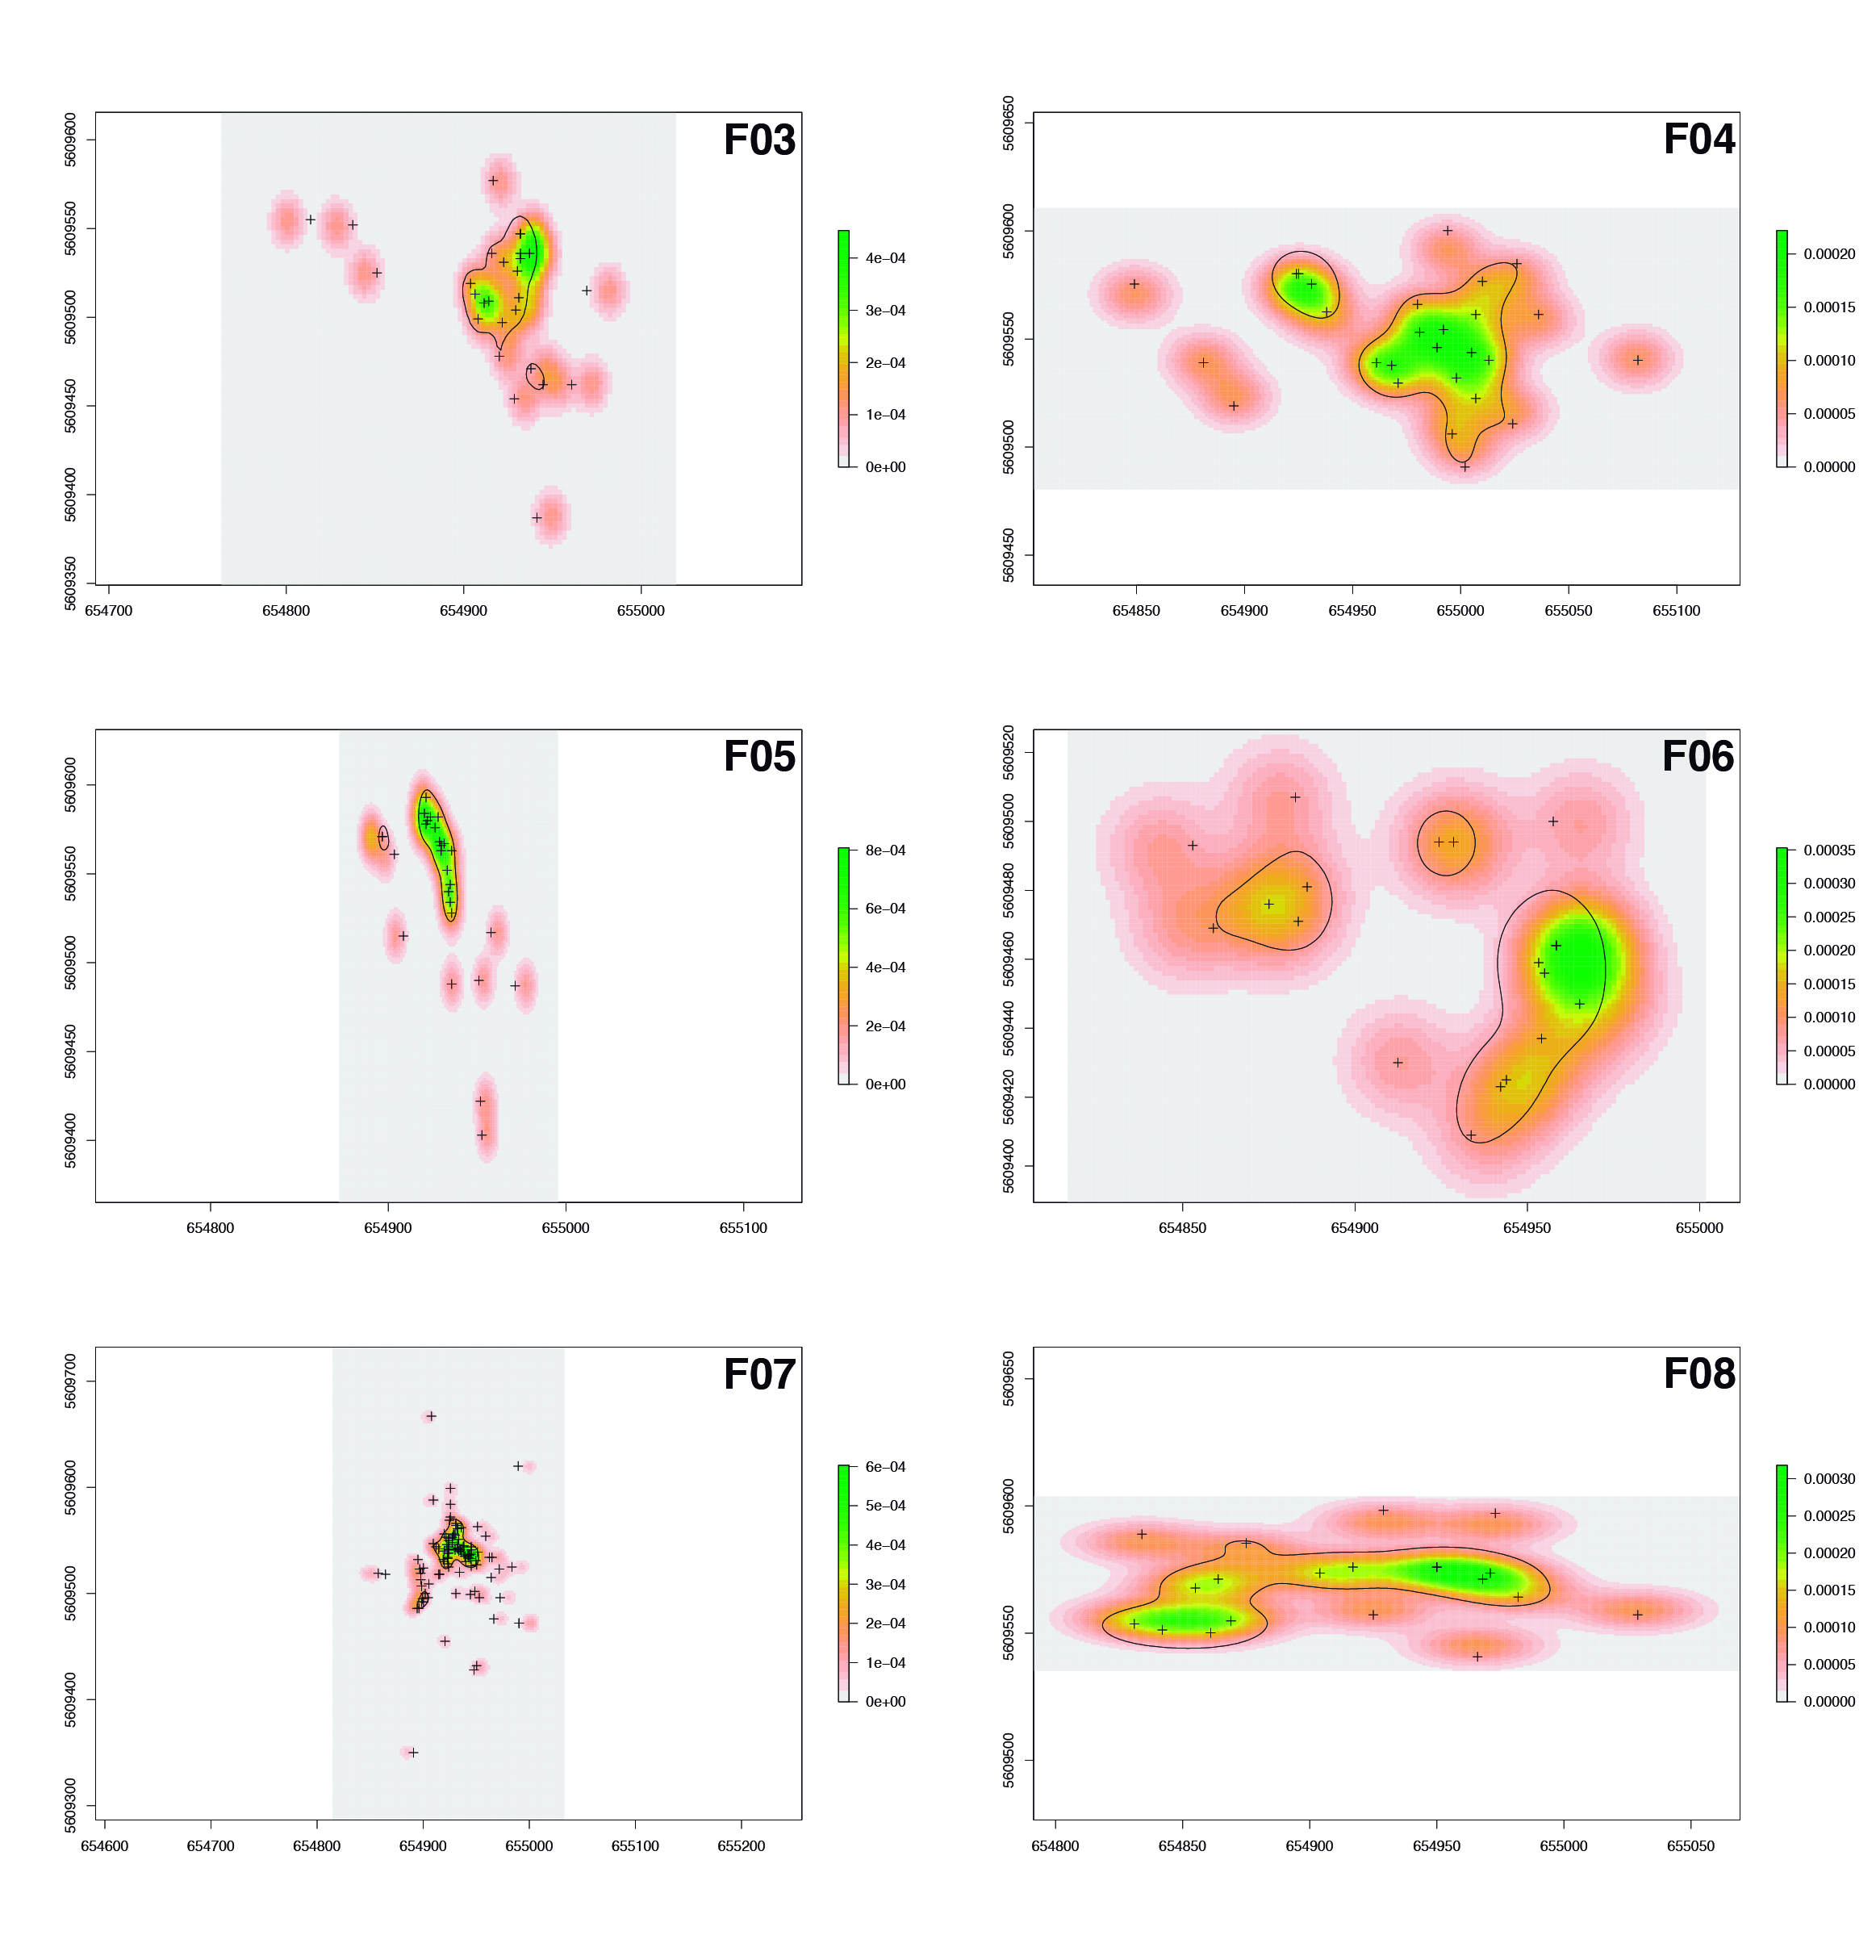
(Figure S3 continued)

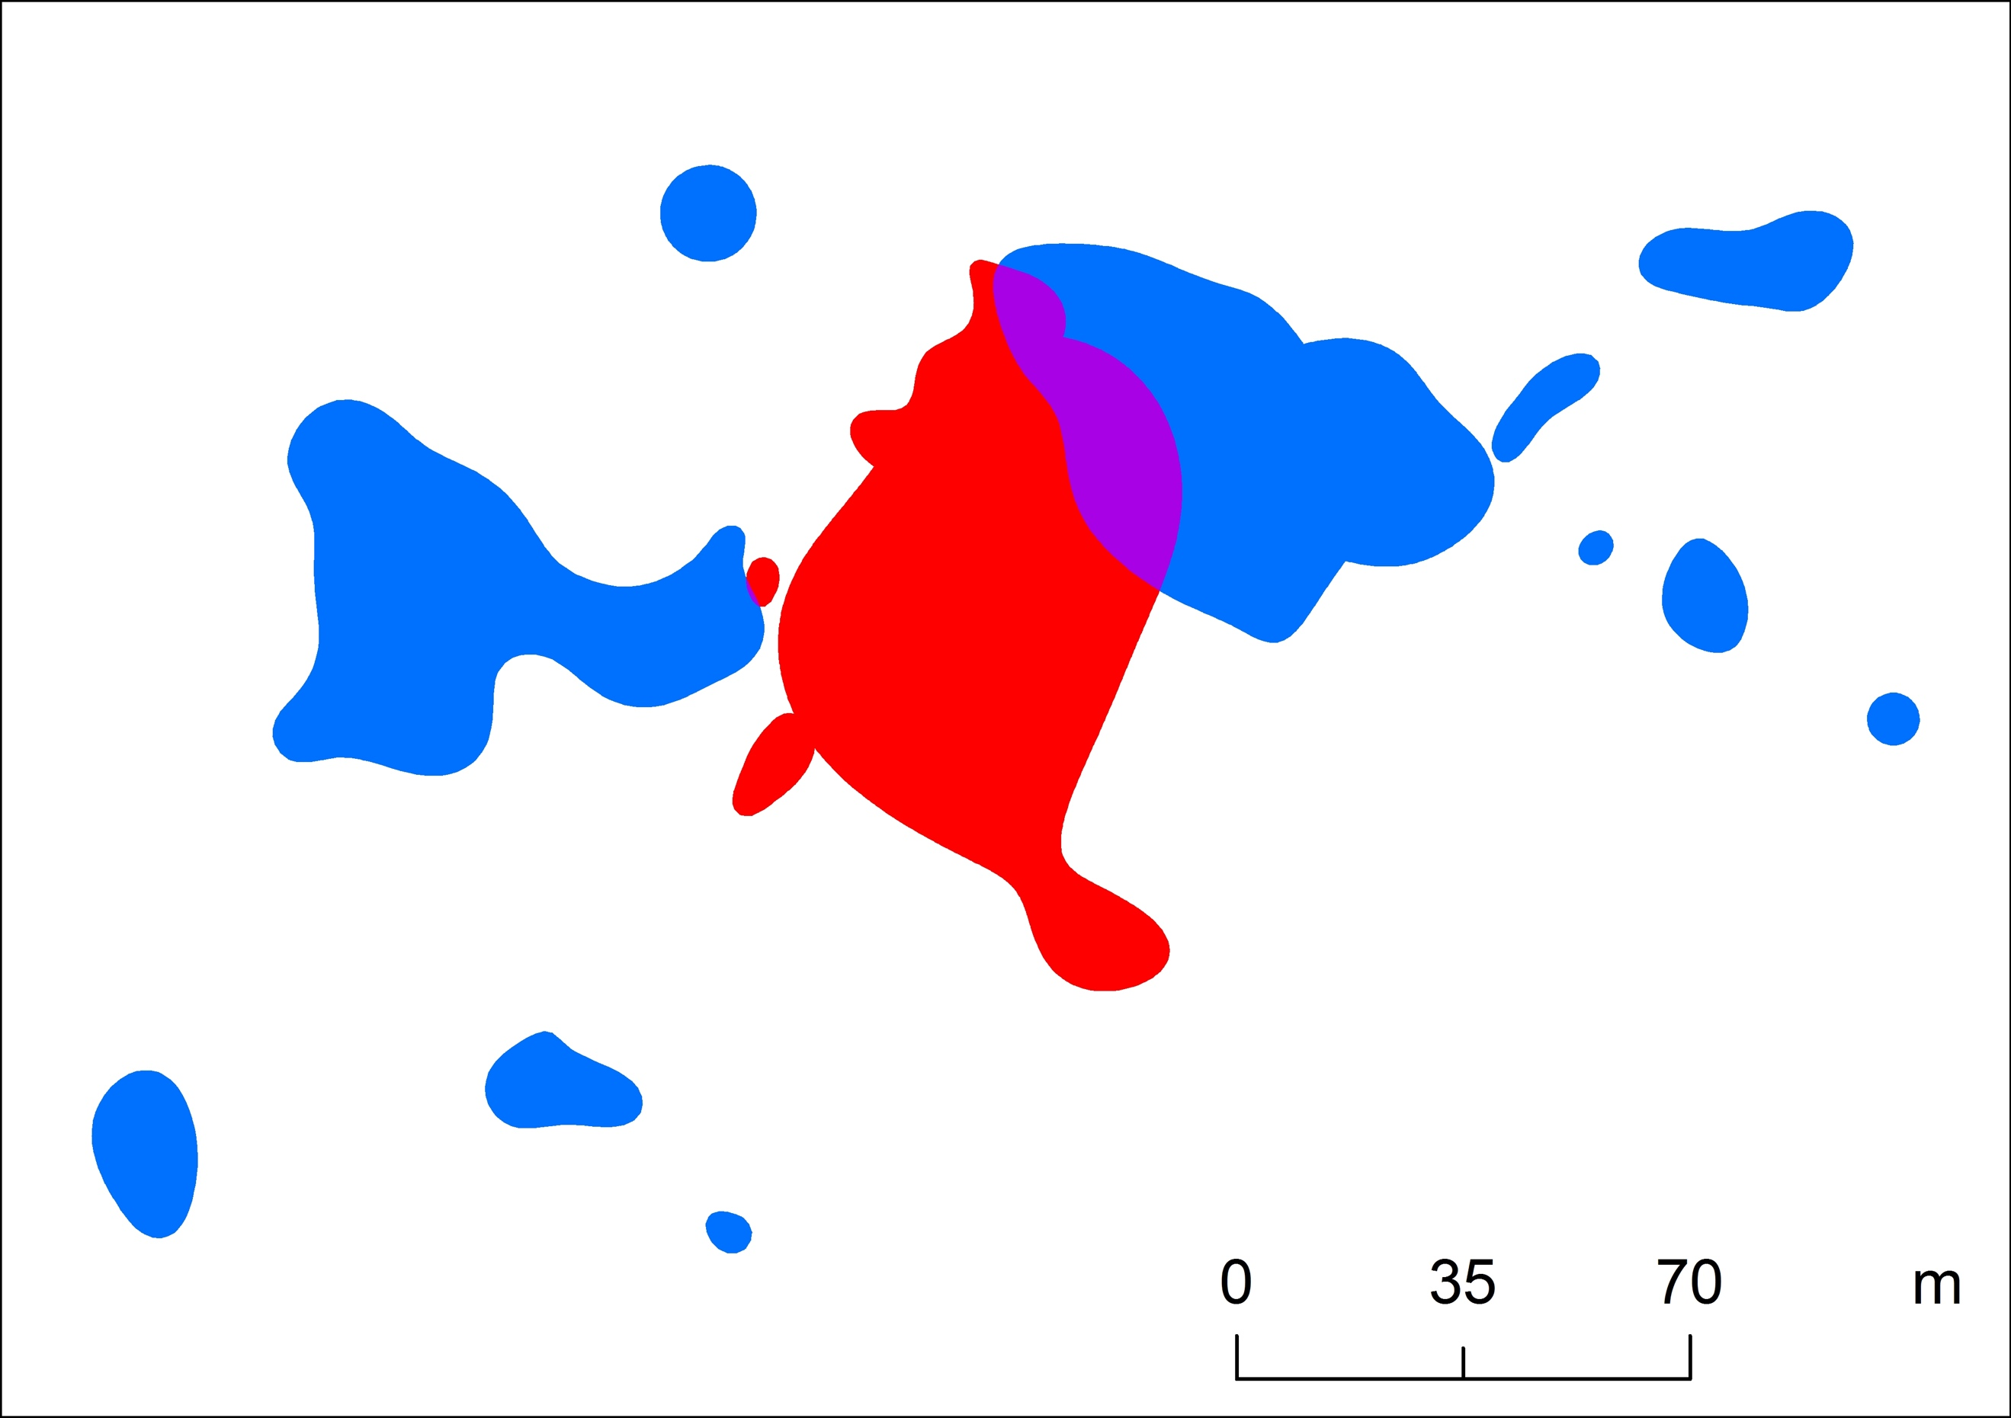

Figure S4. Core area overlap between adult males (red) and females (blue).

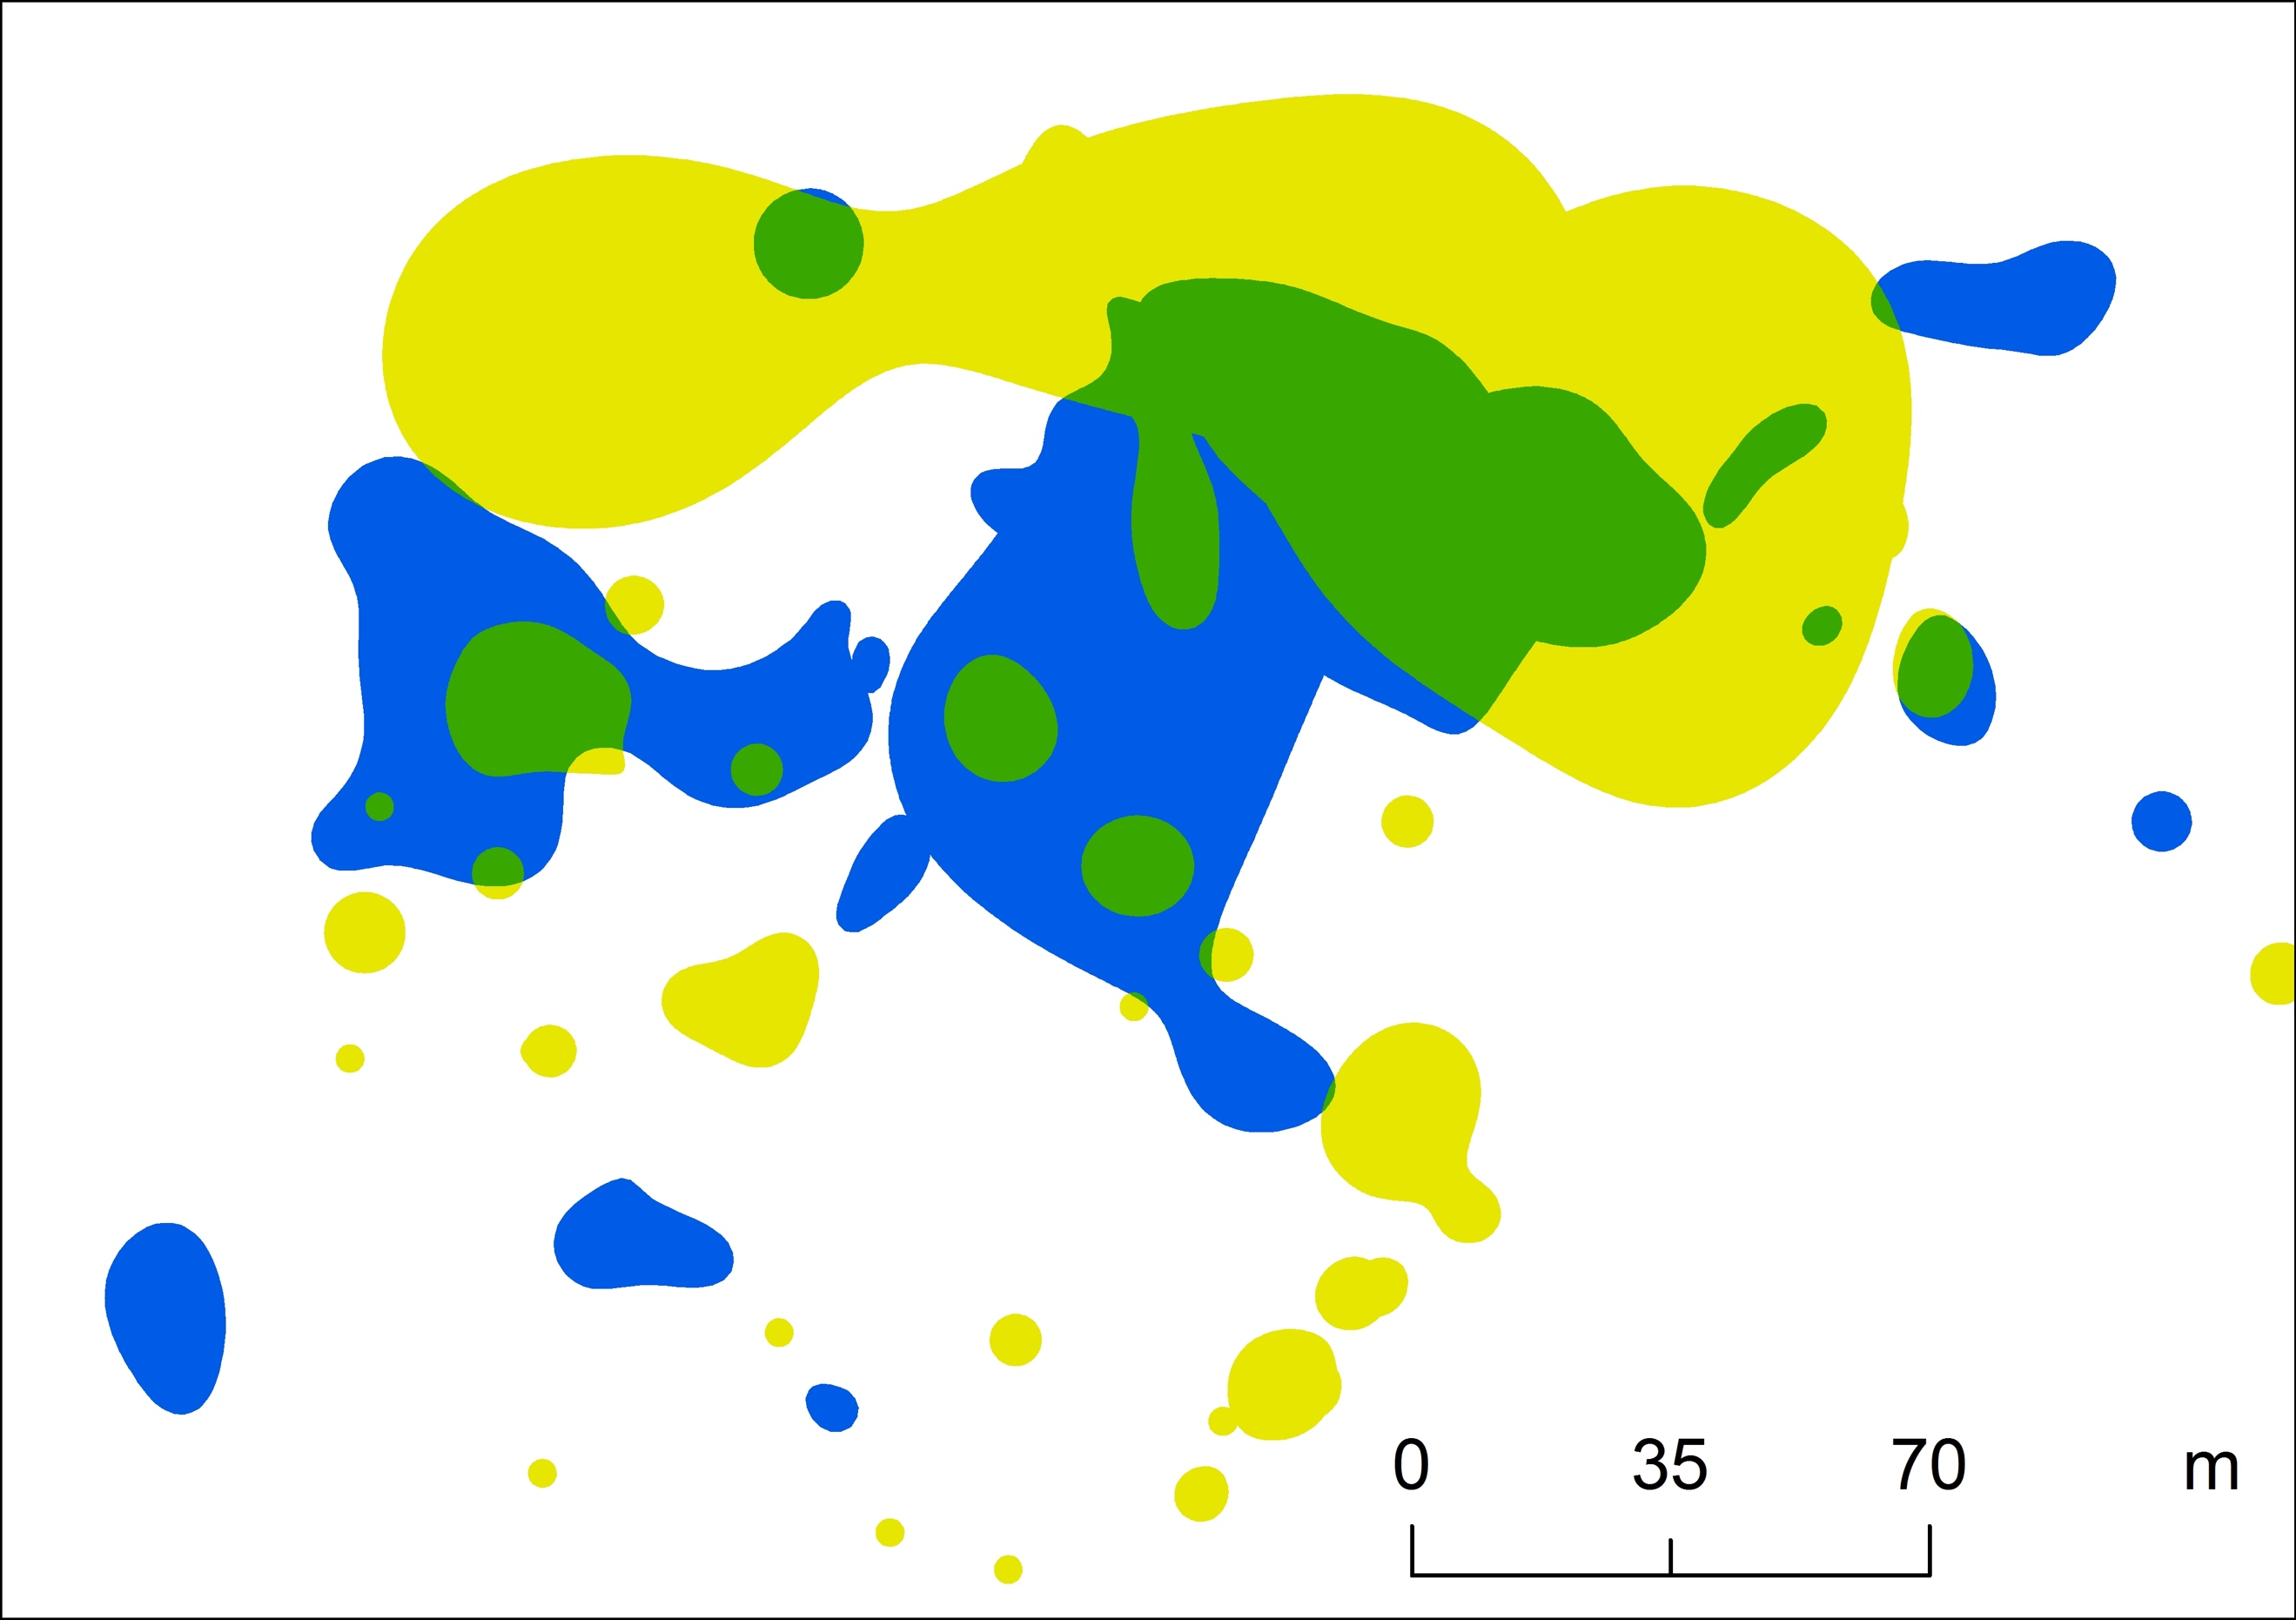

Figure S5. Core area overlap between adult (blue) and sub-adult (yellow) individuals (males and females combined).
Table S1. Detailed GLM results of body mass comparison between males and females, and between adults and sub-adults.

Variable | Estimate | Std error | t-value | P-value
Intercept | 35.933 | 1.474 | 24.374 | <0.001
gender (male) | -5.956 | 1.679 | -3.548 | 0.006
age (sub-adult) | -15.111 | 1.605 | -9.415 | <0.001

Table S2. Detailed GLM results of (a) home range and (b) core area comparisons between males and females, and between adults and sub-adults.

Variable | Estimate | Std error | t-value | P-value
(a) Home range comparisons
Intercept | 1.374 | 0.444 | 3.096 | 0.013
gender (male) | -0.278 | 0.505 | -0.550 | 0.596
age (sub-adult) | -0.419 | 0.483 | -0.868 | 0.408
(b) Core area comparisons
Intercept | 0.327 | 0.130 | 2.521 | 0.033
gender (male) | -0.106 | 0.148 | -0.715 | 0.493
age (sub-adult) | -0.042 | 0.141 | -0.297 | 0.774

Table S3. Detailed GLM results of home range and core area vs. body mass relationships (all individuals, males and females separately, adults and sub-adults separately).

Variable | Estimate | Std error | t-value | P-value
(a) Home range vs. body mass (all individuals)
Intercept | 0.534 | 0.763 | 0.700 | 0.500
bmass | 0.020 | 0.029 | 0.683 | 0.510
(b) Core area vs. body mass (all individuals)
Intercept | 0.252 | 0.225 | 1.122 | 0.288
bmass | 0.001 | 0.009 | 0.069 | 0.946
(c) Home range vs. body mass (females)
Intercept | 0.973 | 0.974 | 0.999 | 0.356
bmass | 0.004 | 0.038 | 0.092 | 0.929
(d) Home range vs. body mass (males)
Intercept | -1.382 | 0.965 | -1.432 | 0.288
bmass | 0.091 | 0.036 | 2.509 | 0.129
(e) Core area vs. body mass (females)
Intercept | 0.364 | 0.297 | 1.225 | 0.267
bmass | -0.003 | 0.012 | -0.240 | 0.819
(f) Core area vs. body mass (males)
Intercept | -0.246 | 0.154 | -1.600 | 0.251
bmass | 0.017 | 0.006 | 3.031 | 0.094
(g) Home range vs. body mass (adults)
Intercept | 0.928 | 1.538 | 0.604 | 0.589
bmass | 0.009 | 0.047 | 0.183 | 0.866
(h) Home range vs. body mass (sub-adults)
Intercept | 1.114 | 5.699 | 0.195 | 0.853
bmass | -0.010 | 0.285 | -0.035 | 0.973
(i) Core area vs. body mass (adults)
Intercept | 0.928 | 1.538 | 0.604 | 0.589
bmass | 0.009 | 0.047 | 0.183 | 0.866
(j) Core area vs. body mass (sub-adults)
Intercept | 1.114 | 5.699 | 0.195 | 0.853
bmass | -0.010 | 0.285 | -0.035 | 0.973

Table S4. Detailed GLM results of home range and core area vs. number of locations relationships (all individuals, females and males separately).

Variable | Estimate | Std error | t-value | P-value
(a) Home range vs. number of locations (all individuals)
Intercept | 0.887 | 0.347 | 2.556 | 0.029
locations | 0.003 | 0.005 | 0.534 | 0.605
(b) Core area vs. number of locations (all individuals)
Intercept | 0.282 | 0.101 | 2.784 | 0.019
locations | 0.000 | 0.002 | -0.178 | 0.862
(c) Home range vs. number of locations (females)
Intercept | 1.246 | 0.476 | 2.621 | 0.040
locations | -0.004 | 0.009 | -0.487 | 0.644
(d) Home range vs. number of locations (males)
Intercept | 0.060 | 0.246 | 0.245 | 0.829
locations | 0.012 | 0.003 | 4.340 | 0.049
(e) Core area vs. number of locations (females)
Intercept | 0.368 | 0.144 | 2.558 | 0.043
locations | -0.002 | 0.003 | -0.622 | 0.557
(f) Core area vs. number of locations (males)
Intercept | 0.049 | 0.066 | 0.741 | 0.536
locations | 0.002 | 0.001 | 2.837 | 0.105

Table S5. Detailed GLMM results of movement speed comparison among activity periods (G1 = early activity period, G2 = peal activity period, G3 = late activity period). Random factor (tracked individual) variance = 0.045.

Variable | Estimate | Std error | df | t-value | P-value
Intercept | 0.840 | 0.092 | 19.576 | 9.141 | 0.000
group (G2) | -0.245 | 0.074 | 446.840 | -3.319 | 0.001
group (G3) | -0.212 | 0.070 | 448.176 | -3.034 | 0.003

