Mechanistic formation of hazardous molecular heterocyclic amines from high temperature pyrolysis of model biomass materials: cellulose and tyrosine
Samuel K. Kirkok¹, Joshua K. Kibet¹*, Francis Okanga¹, Thomas Kinyanjui¹, Vincent Nyamori²
¹Department of Chemistry, Egerton University, P.O Box 536 -20115, Egerton
²School of Chemistry and Physics, University of KwaZulu-Natal, Westville Campus, Private Bag X54001, Durban 4000, South Africa
Author for correspondence: jkibet@egerton.ac.ke

Additional Supporting Information
S1. Tar and Char Data
Temp.  ($°C)$ | % Yield
 | Tar | Error Tar | Temp. 2 | Char | Error Char
200 | 1.34 | 0.6 | 200 | 95.2 | 2.9
250 | 1.79 | 0.8 | 300 | 78.8 | 3.3
300 | 5.68 | 0.95 | 350 | 53.5 | 3.1
350 | 10.75 | 1.1 | 400 | 30.1 | 2.4
400 | 21.29 | 1.4 | 450 | 26.6 | 3.2
450 | 33.04 | 1.5 | 500 | 26.3 | 2.9
500 | 22.32 | 1.6 | 600 | 24 | 2.8
550 | 14.29 | 1.15 | 700 | 19.2 | 2.2
600 | 6.82 | 1.12
650 | 4.36 | 1.1
700 | 2.68 | 0.8
750 | 1.79 | 0.2

S2: % Yields of Tar and Char
Temp.  ($°C)$ | Conc. (ug) |  |  |  |  |  | % Yield
 | isoindazole | Error | 1-methyl indazole | Error | 1-naphthyl isocyanate | Error | Char Yield | Error
200 | 10.55 | 1.5 | 0.64 | 0.2 | 5.05 | 1.3 | 95.2 | 2.9
300 | 127 | 4.1 | 252 | 8.8 | 19.7 | 3.2 | 78.8 | 3.3
350 | 163 | 8.2 | 29.15 | 3.1 | 119.5 | 8.5 | 53.5 | 3.1
400 | 183 | 10.8 | 9.8 | 1.8 | 110 | 7.8 | 30.1 | 2.4
450 | 130 | 6.3 | 4.87 | 1.2 | 51.5 | 5.92 | 26.6 | 3.2
500 | 56 | 3.1 | 1.74 | 0.92 | 18.8 | 2.91 | 26.3 | 2.9
600 | 34 | 2.6 | 0.63 | 0.15 | 6.1 | 1.45 | 24 | 2.8
700 | 27.65 | 1.25 | 0.161 | 0.4 | 4.885 | 0.8 | 19.2 | 2.2
S3: Input and Optimized molecular structures of compounds of interest
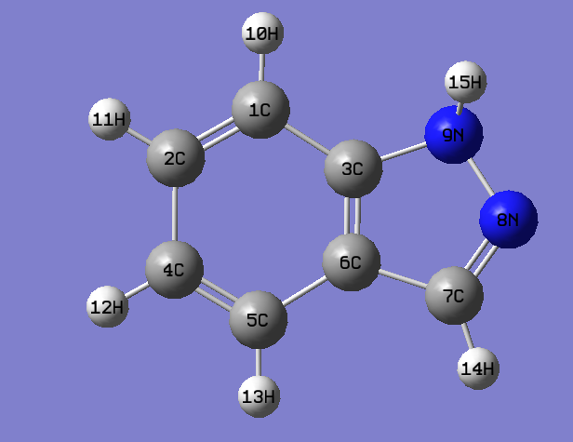
Input structure for Isoindazole

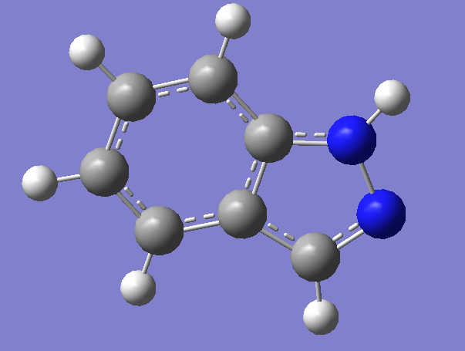
Optimized structure for isoindazole

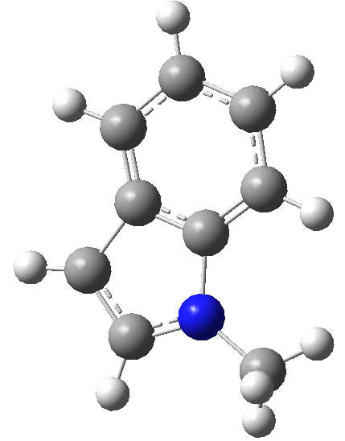
Input structure for 1-methyl indole

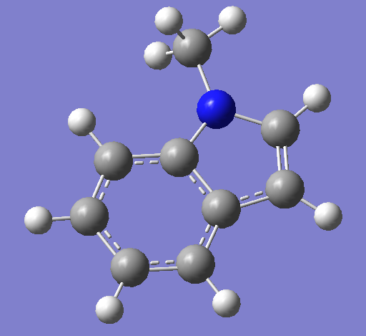
Optimized structure for 1-methyl indole

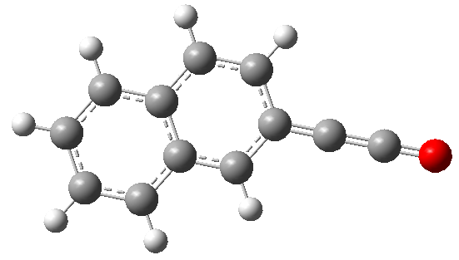
Input structure of 1-naphthylisocyanate

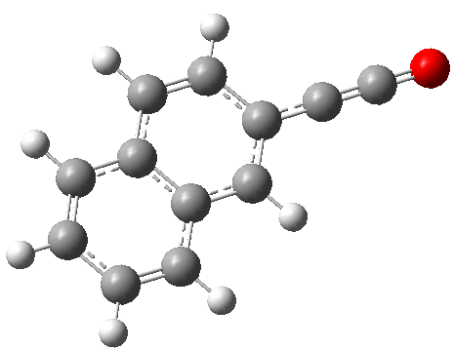
Optimized structure of 1-naphthylisocyanate
S4: Molecular orbital diagrams for compounds of interest

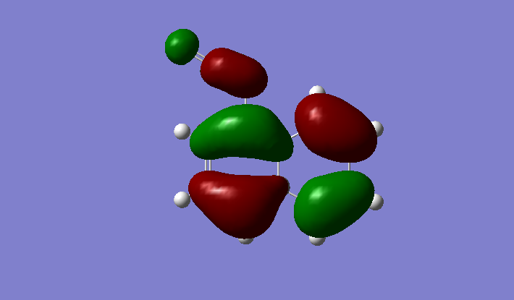
1-naphthylisocyanate

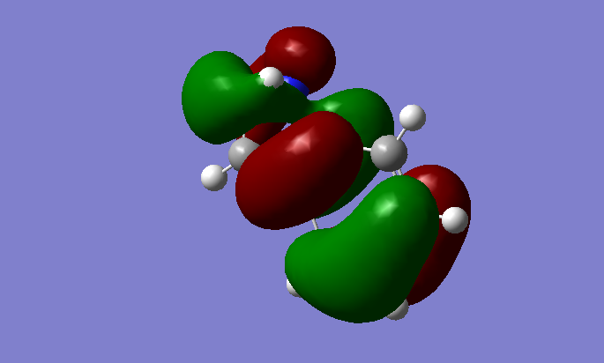
Isoindazole

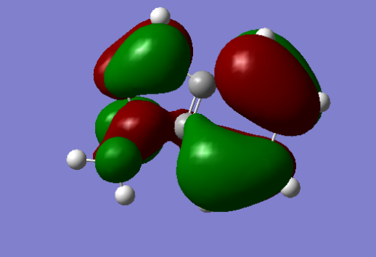
1-methylindazole

S5: Example of optimization Energies
- Isoindole
-------------------
- Thermochemistry -
-------------------
Temperature 298.150 Kelvin. Pressure 1.00000 Atm.
Atom 1 has atomic number 6 and mass 12.00000
Atom 2 has atomic number 6 and mass 12.00000
Atom 3 has atomic number 6 and mass 12.00000
Atom 4 has atomic number 6 and mass 12.00000
Atom 5 has atomic number 6 and mass 12.00000
Atom 6 has atomic number 6 and mass 12.00000
Atom 7 has atomic number 6 and mass 12.00000
Atom 8 has atomic number 1 and mass 1.00783
Atom 9 has atomic number 1 and mass 1.00783
Atom 10 has atomic number 1 and mass 1.00783
Atom 11 has atomic number 1 and mass 1.00783
Atom 12 has atomic number 1 and mass 1.00783
Atom 13 has atomic number 1 and mass 1.00783
Atom 14 has atomic number 7 and mass 14.00307
Atom 15 has atomic number 7 and mass 14.00307
Molecular mass: 118.05310 amu.
Principal axes and moments of inertia in atomic units:
1 2 3
EIGENVALUES -- 457.164021116.971451574.13544
X 1.00000 0.00161 0.00000
Y -0.00161 1.00000 -0.00001
Z 0.00000 0.00001 1.00000
This molecule is an asymmetric top.
Rotational symmetry number 1.
Warning -- assumption of classical behavior for rotation
may cause significant error
Rotational temperatures (Kelvin) 0.18946 0.07754 0.05502
Rotational constants (GHZ): 3.94769 1.61575 1.14650
Zero-point vibrational energy 312160.9 (Joules/Mol)
74.60825 (Kcal/Mol)
Warning -- explicit consideration of 7 degrees of freedom as
vibrations may cause significant error
Vibrational temperatures: 319.19 377.35 584.79 649.03 771.32
(Kelvin) 803.65 865.32 929.17 951.91 1115.15
1120.61 1173.73 1263.03 1321.61 1331.39
1343.84 1415.24 1452.64 1476.61 1498.61
1679.11 1740.06 1782.01 1840.13 1857.39
1885.13 1981.70 2034.73 2048.67 2183.23
2215.54 2305.24 2373.00 4596.21 4607.50
4623.56 4637.89 4718.16 5215.13

Zero-point correction= 0.118896 (Hartree/Particle)
Thermal correction to Energy= 0.124809
Thermal correction to Enthalpy= 0.125753
Thermal correction to Gibbs Free Energy= 0.088779
Sum of electronic and zero-point Energies= -377.623299
Sum of electronic and thermal Energies= -377.617386
Sum of electronic and thermal Enthalpies= -377.616441
Sum of electronic and thermal Free Energies= -377.653415

E (Thermal) CV S
KCal/Mol Cal/Mol-Kelvin Cal/Mol-Kelvin
Total 78.319 24.470 77.818
Electronic 0.000 0.000 0.000
Translational 0.889 2.981 40.213
Rotational 0.889 2.981 28.177
Vibrational 76.541 18.509 9.429
Vibration 1 0.648 1.808 1.944
Vibration 2 0.670 1.742 1.647
Vibration 3 0.771 1.456 0.939
Vibration 4 0.810 1.358 0.792
Vibration 5 0.891 1.170 0.574
Vibration 6 0.914 1.121 0.527
Vibration 7 0.960 1.029 0.447
Q Log10(Q) Ln(Q)
Total Bot 0.146023D-40 -40.835579 -94.027396
Total V=0 0.712173D+14 13.852585 31.896757
Vib (Bot) 0.902454D-54 -54.044575 -124.442233
Vib (Bot) 1 0.890927D+00 -0.050158 -0.115492
Vib (Bot) 2 0.739750D+00 -0.130915 -0.301443
Vib (Bot) 3 0.436438D+00 -0.360078 -0.829110
Vib (Bot) 4 0.379817D+00 -0.420425 -0.968065
Vib (Bot) 5 0.296628D+00 -0.527788 -1.215276
Vib (Bot) 6 0.278644D+00 -0.554951 -1.277822
Vib (Bot) 7 0.247910D+00 -0.605706 -1.394690
Vib (V=0) 0.440139D+01 0.643590 1.481920
Vib (V=0) 1 0.152164D+01 0.182312 0.419790
Vib (V=0) 2 0.139288D+01 0.143913 0.331372
Vib (V=0) 3 0.116368D+01 0.065835 0.151592
Vib (V=0) 4 0.112790D+01 0.052271 0.120359
Vib (V=0) 5 0.108137D+01 0.033973 0.078227
Vib (V=0) 6 0.107240D+01 0.030357 0.069900
Vib (V=0) 7 0.105809D+01 0.024521 0.056461
Electronic 0.100000D+01 0.000000 0.000000
Translational 0.504163D+08 7.702571 17.735826
Rotational 0.320940D+06 5.506424 12.679011
***** Axes restored to original set *****
-------------------------------------------------------------------
Center Atomic Forces (Hartrees/Bohr)
Number Number X Y Z
-------------------------------------------------------------------
1 6 -0.000092853 -0.000025933 0.000085968
2 6 -0.000037442 -0.000147501 -0.000086134
3 6 -0.000000889 0.000027959 -0.000045994
4 6 -0.000030606 -0.000006079 0.000016402
5 6 0.000022403 0.000002201 0.000014662
6 6 -0.000005426 -0.000006847 -0.000013920
7 6 -0.000038162 -0.000054237 0.000140762
8 1 0.000010668 0.000000195 0.000010953
9 1 0.000004940 0.000009089 0.000000525
10 1 -0.000005361 0.000007416 -0.000005159
11 1 -0.000010566 0.000009105 -0.000000866
12 1 0.000044378 0.000047200 -0.000010898
13 1 0.000000693 -0.000011559 -0.000019510
14 7 0.000102761 0.000120959 -0.000078188
15 7 0.000035463 0.000028034 -0.000008603
-------------------------------------------------------------------
Cartesian Forces: Max 0.000147501 RMS 0.000050664

GradGradGradGradGradGradGradGradGradGradGradGradGradGradGradGradGradGrad
Berny optimization.
Internal Forces: Max 0.000137168 RMS 0.000029317
Search for a local minimum.
Step number 1 out of a maximum of 2
All quantities printed in internal units (Hartrees-Bohrs-Radians)
Second derivative matrix not updated -- analytic derivatives used.
Eigenvalues --- 0.00707 0.01188 0.01734 0.01759 0.01985
Eigenvalues --- 0.02178 0.02410 0.02567 0.03163 0.03234
Eigenvalues --- 0.04132 0.05556 0.10799 0.11286 0.11577
Eigenvalues --- 0.11868 0.12991 0.13234 0.16730 0.19700
Eigenvalues --- 0.20292 0.20814 0.23710 0.25790 0.30039
Eigenvalues --- 0.34632 0.35931 0.36266 0.36502 0.36624
Eigenvalues --- 0.37781 0.38677 0.39997 0.40238 0.45619
Eigenvalues --- 0.46906 0.47430 0.50225 0.512801000.00000
Eigenvalues --- 1000.000001000.000001000.000001000.000001000.00000
Eigenvalues --- 1000.000001000.000001000.000001000.000001000.00000
Eigenvalues --- 1000.000001000.000001000.000001000.000001000.00000
Eigenvalues --- 1000.000001000.000001000.000001000.000001000.00000
Eigenvalues --- 1000.000001000.000001000.000001000.000001000.00000
Eigenvalues --- 1000.000001000.000001000.000001000.000001000.00000
Eigenvalues --- 1000.000001000.000001000.000001000.000001000.00000
Eigenvalues --- 1000.000001000.00000
Angle between quadratic step and forces= 56.07 degrees.
Linear search not attempted -- first point.
Iteration 1 RMS(Cart)= 0.00018610 RMS(Int)= 0.00000006
Iteration 2 RMS(Cart)= 0.00000005 RMS(Int)= 0.00000005
Variable Old X -DE/DX Delta X Delta X Delta X New X
(Linear) (Quad) (Total)
R1 2.69437 0.00003 0.00000 0.00013 0.00013 2.69450
R2 2.65071 0.00001 0.00000 0.00000 0.00000 2.65071
R3 2.59237 -0.00012 0.00000 -0.00023 -0.00023 2.59214
R4 2.65234 0.00003 0.00000 0.00008 0.00008 2.65242
R5 2.70823 -0.00003 0.00000 -0.00009 -0.00009 2.70814
R6 2.62056 0.00001 0.00000 0.00002 0.00002 2.62058
R7 2.04801 0.00001 0.00000 0.00003 0.00003 2.04804
R8 2.67335 -0.00002 0.00000 -0.00006 -0.00006 2.67329
R9 2.04717 0.00001 0.00000 0.00003 0.00003 2.04721
R10 2.62177 0.00000 0.00000 0.00001 0.00001 2.62178
R11 2.04819 0.00001 0.00000 0.00002 0.00002 2.04821
R12 2.04654 0.00001 0.00000 0.00003 0.00003 2.04657
R13 2.03578 0.00001 0.00000 0.00002 0.00002 2.03579
R14 2.52124 -0.00014 0.00000 -0.00025 -0.00025 2.52098
R15 1.90755 -0.00006 0.00000 -0.00012 -0.00012 1.90743
R16 2.66669 0.00000 0.00000 -0.00009 -0.00009 2.66660
A1 2.11548 0.00003 0.00000 0.00009 0.00009 2.11557
A2 1.85204 -0.00006 0.00000 -0.00016 -0.00016 1.85188
A3 2.31566 0.00002 0.00000 0.00008 0.00008 2.31574
A4 2.09462 -0.00004 0.00000 -0.00015 -0.00015 2.09448
A5 1.83019 0.00004 0.00000 0.00011 0.00011 1.83030
A6 2.35837 0.00000 0.00000 0.00004 0.00004 2.35841
A7 2.06974 0.00001 0.00000 0.00004 0.00004 2.06978
A8 2.10369 0.00000 0.00000 0.00000 0.00000 2.10369
A9 2.10975 0.00000 0.00000 -0.00003 -0.00003 2.10972
A10 2.11043 0.00002 0.00000 0.00005 0.00005 2.11048
A11 2.09366 -0.00001 0.00000 -0.00004 -0.00004 2.09362
A12 2.07909 -0.00001 0.00000 -0.00002 -0.00002 2.07908
A13 2.12275 0.00000 0.00000 -0.00002 -0.00002 2.12273
A14 2.07882 0.00000 0.00000 0.00002 0.00002 2.07884
A15 2.08161 0.00000 0.00000 0.00000 0.00000 2.08161
A16 2.05335 -0.00001 0.00000 -0.00002 -0.00002 2.05334
A17 2.11952 0.00001 0.00000 0.00006 0.00006 2.11958
A18 2.11031 0.00000 0.00000 -0.00005 -0.00005 2.11026
A19 2.23012 0.00003 0.00000 0.00012 0.00012 2.23024
A20 1.95857 -0.00005 0.00000 -0.00013 -0.00013 1.95844
A21 2.09450 0.00002 0.00000 0.00001 0.00001 2.09451
A22 1.82861 0.00005 0.00000 0.00011 0.00011 1.82872
A23 2.26004 -0.00004 0.00000 -0.00027 -0.00027 2.25976
A24 1.95537 0.00002 0.00000 0.00007 0.00007 1.95544
A25 2.06778 0.00002 0.00000 0.00020 0.00020 2.06798
D1 -0.00010 0.00000 0.00000 0.00010 0.00010 0.00000
D2 -3.14134 -0.00001 0.00000 -0.00025 -0.00025 3.14159
D3 -3.14132 -0.00002 0.00000 -0.00027 -0.00027 -3.14159
D4 0.00062 -0.00003 0.00000 -0.00062 -0.00062 0.00000
D5 0.00026 -0.00001 0.00000 -0.00026 -0.00026 0.00000
D6 -3.14137 -0.00001 0.00000 -0.00022 -0.00022 3.14159
D7 3.14137 0.00001 0.00000 0.00022 0.00022 3.14159
D8 -0.00026 0.00001 0.00000 0.00026 0.00026 0.00000
D9 3.14104 0.00002 0.00000 0.00056 0.00056 -3.14159
D10 -0.00024 0.00001 0.00000 0.00024 0.00024 0.00000
D11 -0.00012 0.00000 0.00000 0.00012 0.00012 0.00000
D12 -3.14140 -0.00001 0.00000 -0.00020 -0.00020 3.14159
D13 -0.00013 0.00001 0.00000 0.00013 0.00013 0.00000
D14 -3.14126 -0.00001 0.00000 -0.00033 -0.00033 3.14159
D15 3.14098 0.00002 0.00000 0.00061 0.00061 -3.14159
D16 -0.00015 0.00001 0.00000 0.00015 0.00015 0.00000
D17 -3.14122 0.00000 0.00000 -0.00037 -0.00037 3.14159
D18 -0.00085 0.00004 0.00000 0.00085 0.00085 0.00000
D19 0.00080 -0.00002 0.00000 -0.00080 -0.00080 0.00000
D20 3.14117 0.00003 0.00000 0.00042 0.00042 3.14159
D21 0.00019 -0.00001 0.00000 -0.00019 -0.00019 0.00000
D22 -3.14146 -0.00001 0.00000 -0.00013 -0.00013 -3.14159
D23 3.14132 0.00001 0.00000 0.00027 0.00027 -3.14159
D24 -0.00033 0.00001 0.00000 0.00033 0.00033 0.00000
D25 -0.00002 0.00000 0.00000 0.00002 0.00002 0.00000
D26 3.14136 0.00001 0.00000 0.00023 0.00023 -3.14159
D27 -3.14156 0.00000 0.00000 -0.00003 -0.00003 3.14159
D28 -0.00018 0.00001 0.00000 0.00018 0.00018 0.00000
D29 -0.00020 0.00001 0.00000 0.00020 0.00020 0.00000
D30 3.14143 0.00001 0.00000 0.00016 0.00016 -3.14159
D31 -3.14158 0.00000 0.00000 -0.00001 -0.00001 3.14159
D32 0.00005 0.00000 0.00000 -0.00005 -0.00005 0.00000
D33 0.00070 -0.00004 0.00000 -0.00070 -0.00070 0.00000
D34 3.14118 0.00001 0.00000 0.00042 0.00042 -3.14159
D35 -0.00028 0.00002 0.00000 0.00028 0.00028 0.00000
D36 3.14159 0.00001 0.00000 0.00000 0.00000 3.14159
Item Value Threshold Converged?
Maximum Force 0.000137 0.000450 YES
RMS Force 0.000029 0.000300 YES
Maximum Displacement 0.000813 0.001800 YES
RMS Displacement 0.000186 0.001200 YES
Predicted change in Energy=-1.602428D-07
Optimization completed.
-- Stationary point found.

b) 1-methyl indazole
-------------------
- Thermochemistry -
-------------------
Temperature 298.150 Kelvin. Pressure 1.00000 Atm.
Atom 1 has atomic number 6 and mass 12.00000
Atom 2 has atomic number 6 and mass 12.00000
Atom 3 has atomic number 6 and mass 12.00000
Atom 4 has atomic number 6 and mass 12.00000
Atom 5 has atomic number 6 and mass 12.00000
Atom 6 has atomic number 6 and mass 12.00000
Atom 7 has atomic number 6 and mass 12.00000
Atom 8 has atomic number 1 and mass 1.00783
Atom 9 has atomic number 1 and mass 1.00783
Atom 10 has atomic number 1 and mass 1.00783
Atom 11 has atomic number 1 and mass 1.00783
Atom 12 has atomic number 1 and mass 1.00783
Atom 13 has atomic number 7 and mass 14.00307
Atom 14 has atomic number 7 and mass 14.00307
Atom 15 has atomic number 6 and mass 12.00000
Atom 16 has atomic number 1 and mass 1.00783
Atom 17 has atomic number 1 and mass 1.00783
Atom 18 has atomic number 1 and mass 1.00783
Molecular mass: 132.06875 amu.
Principal axes and moments of inertia in atomic units:
1 2 3
EIGENVALUES -- 647.583651394.177462030.52179
X 0.99922 -0.03950 0.00000
Y 0.03950 0.99922 0.00000
Z 0.00000 0.00000 1.00000
This molecule is an asymmetric top.
Rotational symmetry number 1.
Warning -- assumption of classical behavior for rotation
may cause significant error
Rotational temperatures (Kelvin) 0.13375 0.06213 0.04266
Rotational constants (GHZ): 2.78689 1.29448 0.88881
Zero-point vibrational energy 414007.9 (Joules/Mol)
98.95026 (Kcal/Mol)
Warning -- explicit consideration of 8 degrees of freedom as
vibrations may cause significant error
Vibrational temperatures: 120.02 218.15 365.83 376.84 458.09
(Kelvin) 728.70 739.70 840.18 928.81 947.40
1027.71 1140.63 1197.23 1261.05 1323.56
1449.05 1457.09 1483.58 1524.72 1580.26
1635.76 1700.41 1757.27 1796.95 1823.23
1841.57 1918.54 1941.76 1989.86 2063.17
2114.65 2173.82 2263.32 2325.28 2357.98
2396.10 2400.27 2424.84 2495.38 2571.87
4605.98 4677.49 4783.38 4826.20 4838.57
4861.87 4875.42 4957.77

Zero-point correction= 0.157687 (Hartree/Particle)
Thermal correction to Energy= 0.164826
Thermal correction to Enthalpy= 0.165770
Thermal correction to Gibbs Free Energy= 0.125430
Sum of electronic and zero-point Energies= -413.988195
Sum of electronic and thermal Energies= -413.981056
Sum of electronic and thermal Enthalpies= -413.980112
Sum of electronic and thermal Free Energies= -414.020452

E (Thermal) CV S
KCal/Mol Cal/Mol-Kelvin Cal/Mol-Kelvin
Total 103.430 27.183 84.902
Electronic 0.000 0.000 0.000
Translational 0.889 2.981 40.547
Rotational 0.889 2.981 28.996
Vibrational 101.652 21.221 15.359
Vibration 1 0.600 1.961 3.809
Vibration 2 0.619 1.901 2.652
Vibration 3 0.665 1.756 1.701
Vibration 4 0.669 1.743 1.649
Vibration 5 0.705 1.638 1.318
Vibration 6 0.862 1.236 0.642
Vibration 7 0.869 1.219 0.624
Vibration 8 0.941 1.066 0.478
Q Log10(Q) Ln(Q)
Total Bot 0.202388D-57 -57.693816 -132.844920
Total V=0 0.687298D+15 14.837145 34.163789
Vib (Bot) 0.699958D-71 -71.154928 -163.840277
Vib (Bot) 1 0.246752D+01 0.392261 0.903215
Vib (Bot) 2 0.133673D+01 0.126044 0.290227
Vib (Bot) 3 0.766034D+00 -0.115752 -0.266529
Vib (Bot) 4 0.740867D+00 -0.130260 -0.299935
Vib (Bot) 5 0.590982D+00 -0.228426 -0.525970
Vib (Bot) 6 0.322638D+00 -0.491285 -1.131225
Vib (Bot) 7 0.315654D+00 -0.500788 -1.153107
Vib (Bot) 8 0.259912D+00 -0.585174 -1.347414
Vib (V=0) 0.237702D+02 1.376033 3.168432
Vib (V=0) 1 0.301767D+01 0.479672 1.104485
Vib (V=0) 2 0.192718D+01 0.284923 0.656059
Vib (V=0) 3 0.141477D+01 0.150686 0.346968
Vib (V=0) 4 0.139380D+01 0.144201 0.332036
Vib (V=0) 5 0.127412D+01 0.105210 0.242255
Vib (V=0) 6 0.109506D+01 0.039438 0.090808
Vib (V=0) 7 0.109130D+01 0.037945 0.087371
Vib (V=0) 8 0.106352D+01 0.026745 0.061584
Electronic 0.100000D+01 0.000000 0.000000
Translational 0.596562D+08 7.775655 17.904108
Rotational 0.484682D+06 5.685457 13.091249
***** Axes restored to original set *****
-------------------------------------------------------------------
Center Atomic Forces (Hartrees/Bohr)
Number Number X Y Z
-------------------------------------------------------------------
1 6 -0.000038148 -0.000062210 -0.000006627
2 6 0.000017516 -0.000034242 -0.000010342
3 6 0.000022241 0.000009021 0.000026979
4 6 -0.000006401 0.000003300 0.000002165
5 6 0.000015731 -0.000018517 -0.000031063
6 6 0.000005627 0.000037546 0.000046580
7 6 -0.000000789 -0.000001688 -0.000022978
8 1 -0.000002441 0.000000966 -0.000006960
9 1 -0.000000048 0.000002668 -0.000002833
10 1 -0.000000841 0.000002337 0.000001724
11 1 0.000003355 0.000000631 -0.000005712
12 1 -0.000004251 -0.000002813 0.000002820
13 7 -0.000031722 0.000005818 -0.000019778
14 7 0.000009870 0.000027224 0.000013123
15 6 0.000012204 0.000030798 0.000013081
16 1 -0.000006362 0.000004252 -0.000004669
17 1 -0.000003595 -0.000000685 -0.000001412
18 1 0.000008055 -0.000004404 0.000005903
-------------------------------------------------------------------
Cartesian Forces: Max 0.000062210 RMS 0.000018307

GradGradGradGradGradGradGradGradGradGradGradGradGradGradGradGradGradGrad
Berny optimization.
Internal Forces: Max 0.000047495 RMS 0.000011287
Search for a local minimum.
Step number 1 out of a maximum of 2
All quantities printed in internal units (Hartrees-Bohrs-Radians)
Second derivative matrix not updated -- analytic derivatives used.
Eigenvalues --- 0.00052 0.00720 0.01452 0.02120 0.02193
Eigenvalues --- 0.02442 0.02785 0.03051 0.03244 0.03912
Eigenvalues --- 0.04051 0.04768 0.06250 0.07479 0.07573
Eigenvalues --- 0.12602 0.13093 0.13572 0.14714 0.14988
Eigenvalues --- 0.15302 0.16489 0.19651 0.21445 0.21888
Eigenvalues --- 0.23165 0.23648 0.24943 0.26690 0.27492
Eigenvalues --- 0.32274 0.36661 0.37271 0.39010 0.39424
Eigenvalues --- 0.39866 0.40102 0.40278 0.40461 0.41288
Eigenvalues --- 0.42427 0.43443 0.44857 0.45376 0.53392
Eigenvalues --- 0.54742 0.57564 0.630851000.000001000.00000
Eigenvalues --- 1000.000001000.000001000.000001000.000001000.00000
Eigenvalues --- 1000.000001000.000001000.000001000.000001000.00000
Eigenvalues --- 1000.000001000.000001000.000001000.000001000.00000
Eigenvalues --- 1000.000001000.000001000.000001000.000001000.00000
Eigenvalues --- 1000.000001000.000001000.000001000.000001000.00000
Eigenvalues --- 1000.000001000.000001000.000001000.000001000.00000
Eigenvalues --- 1000.000001000.000001000.000001000.000001000.00000
Eigenvalues --- 1000.000001000.000001000.000001000.000001000.00000
Eigenvalues --- 1000.000001000.00000
Angle between quadratic step and forces= 51.33 degrees.
Linear search not attempted -- first point.
Iteration 1 RMS(Cart)= 0.00017869 RMS(Int)= 0.00000002
Iteration 2 RMS(Cart)= 0.00000003 RMS(Int)= 0.00000001
Variable Old X -DE/DX Delta X Delta X Delta X New X
(Linear) (Quad) (Total)
R1 2.64297 0.00001 0.00000 0.00005 0.00005 2.64302
R2 2.63409 0.00003 0.00000 0.00009 0.00009 2.63418
R3 2.71020 -0.00001 0.00000 -0.00003 -0.00003 2.71016
R4 2.63930 0.00002 0.00000 0.00005 0.00005 2.63934
R5 2.56816 -0.00005 0.00000 -0.00010 -0.00010 2.56806
R6 2.58935 -0.00001 0.00000 -0.00002 -0.00002 2.58932
R7 2.02347 0.00000 0.00000 -0.00001 -0.00001 2.02346
R8 2.65964 -0.00001 0.00000 -0.00002 -0.00002 2.65962
R9 2.02608 0.00000 0.00000 0.00000 0.00000 2.02608
R10 2.59002 0.00000 0.00000 -0.00002 -0.00002 2.59001
R11 2.02446 0.00000 0.00000 0.00001 0.00001 2.02447
R12 2.02610 0.00000 0.00000 -0.00001 -0.00001 2.02610
R13 2.01281 0.00000 0.00000 0.00001 0.00001 2.01282
R14 2.45575 -0.00001 0.00000 0.00001 0.00001 2.45576
R15 2.62656 -0.00001 0.00000 -0.00008 -0.00008 2.62648
R16 2.74163 -0.00001 0.00000 -0.00003 -0.00003 2.74160
R17 2.04704 0.00000 0.00000 0.00000 0.00000 2.04704
R18 2.03693 0.00000 0.00000 0.00001 0.00001 2.03695
R19 2.04702 0.00001 0.00000 0.00002 0.00002 2.04704
A1 2.10157 -0.00003 0.00000 -0.00012 -0.00012 2.10144
A2 1.82348 0.00001 0.00000 0.00001 0.00001 1.82348
A3 2.35814 0.00002 0.00000 0.00012 0.00012 2.35826
A4 2.11485 0.00002 0.00000 0.00009 0.00009 2.11494
A5 1.86911 -0.00001 0.00000 -0.00003 -0.00003 1.86908
A6 2.29923 -0.00001 0.00000 -0.00006 -0.00006 2.29916
A7 2.05094 0.00000 0.00000 -0.00002 -0.00002 2.05091
A8 2.11797 0.00000 0.00000 -0.00001 -0.00001 2.11797
A9 2.11428 0.00000 0.00000 0.00003 0.00003 2.11430
A10 2.12479 0.00000 0.00000 -0.00003 -0.00003 2.12476
A11 2.08266 0.00000 0.00000 0.00003 0.00003 2.08269
A12 2.07574 0.00000 0.00000 -0.00001 -0.00001 2.07573
A13 2.10583 0.00001 0.00000 0.00006 0.00006 2.10589
A14 2.07965 -0.00001 0.00000 -0.00002 -0.00002 2.07963
A15 2.09771 -0.00001 0.00000 -0.00004 -0.00004 2.09767
A16 2.06840 0.00000 0.00000 0.00002 0.00002 2.06843
A17 2.10473 0.00000 0.00000 0.00001 0.00001 2.10473
A18 2.11005 0.00000 0.00000 -0.00003 -0.00003 2.11002
A19 2.23120 0.00001 0.00000 0.00005 0.00005 2.23125
A20 1.94122 -0.00002 0.00000 -0.00004 -0.00004 1.94118
A21 2.11077 0.00001 0.00000 -0.00001 -0.00001 2.11075
A22 1.92868 0.00001 0.00000 0.00004 0.00004 1.92872
A23 2.25824 -0.00004 0.00000 -0.00022 -0.00022 2.25803
A24 2.09626 0.00003 0.00000 0.00017 0.00017 2.09644
A25 1.86230 0.00001 0.00000 0.00001 0.00001 1.86231
A26 1.93411 -0.00001 0.00000 -0.00008 -0.00008 1.93402
A27 1.86847 0.00000 0.00000 0.00001 0.00001 1.86848
A28 1.93396 0.00001 0.00000 0.00006 0.00006 1.93402
A29 1.90949 0.00000 0.00000 -0.00002 -0.00002 1.90947
A30 1.90783 0.00000 0.00000 0.00003 0.00003 1.90786
A31 1.90946 0.00000 0.00000 0.00000 0.00000 1.90947
D1 0.00004 0.00000 0.00000 -0.00004 -0.00004 0.00000
D2 -3.14152 0.00000 0.00000 -0.00008 -0.00008 3.14159
D3 -3.14159 0.00000 0.00000 -0.00001 -0.00001 -3.14159
D4 0.00005 0.00000 0.00000 -0.00005 -0.00005 0.00000
D5 -0.00030 0.00001 0.00000 0.00030 0.00030 0.00000
D6 -3.14158 0.00000 0.00000 -0.00001 -0.00001 3.14159
D7 3.14133 0.00001 0.00000 0.00026 0.00026 3.14159
D8 0.00005 0.00000 0.00000 -0.00005 -0.00005 0.00000
D9 -3.14155 0.00000 0.00000 -0.00005 -0.00005 3.14159
D10 -0.00010 0.00001 0.00000 0.00010 0.00010 0.00000
D11 0.00001 0.00000 0.00000 -0.00001 -0.00001 0.00000
D12 3.14146 0.00001 0.00000 0.00013 0.00013 -3.14159
D13 0.00020 -0.00001 0.00000 -0.00020 -0.00020 0.00000
D14 3.14154 0.00000 0.00000 0.00005 0.00005 3.14159
D15 -3.14145 0.00000 0.00000 -0.00014 -0.00014 -3.14159
D16 -0.00011 0.00001 0.00000 0.00011 0.00011 0.00000
D17 0.00002 0.00000 0.00000 -0.00002 -0.00002 0.00000
D18 3.14138 0.00000 0.00000 0.00021 0.00021 -3.14159
D19 -3.14153 0.00000 0.00000 -0.00006 -0.00006 3.14159
D20 -0.00016 0.00000 0.00000 0.00016 0.00016 0.00000
D21 -0.00016 0.00001 0.00000 0.00016 0.00016 0.00000
D22 3.14140 0.00001 0.00000 0.00019 0.00019 3.14159
D23 -3.14150 0.00000 0.00000 -0.00009 -0.00009 3.14159
D24 0.00006 0.00000 0.00000 -0.00006 -0.00006 0.00000
D25 -0.00011 0.00000 0.00000 0.00011 0.00011 0.00000
D26 -3.14152 0.00000 0.00000 -0.00007 -0.00007 3.14159
D27 3.14151 0.00000 0.00000 0.00008 0.00008 3.14159
D28 0.00010 0.00000 0.00000 -0.00010 -0.00010 0.00000
D29 0.00034 -0.00001 0.00000 -0.00034 -0.00034 0.00000
D30 -3.14157 0.00000 0.00000 -0.00002 -0.00002 3.14159
D31 -3.14144 -0.00001 0.00000 -0.00015 -0.00015 -3.14159
D32 -0.00016 0.00001 0.00000 0.00016 0.00016 0.00000
D33 0.00011 -0.00001 0.00000 -0.00011 -0.00011 0.00000
D34 3.14157 0.00000 0.00000 0.00003 0.00003 3.14159
D35 -0.00008 0.00000 0.00000 0.00008 0.00008 0.00000
D36 -3.14147 0.00000 0.00000 -0.00012 -0.00012 3.14159
D37 -1.06039 0.00000 0.00000 -0.00017 -0.00017 -1.06056
D38 -3.14148 0.00000 0.00000 -0.00011 -0.00011 3.14159
D39 1.06071 0.00000 0.00000 -0.00015 -0.00015 1.06056
D40 2.08096 0.00000 0.00000 0.00007 0.00007 2.08103
D41 -0.00013 0.00000 0.00000 0.00013 0.00013 0.00000
D42 -2.08112 0.00000 0.00000 0.00009 0.00009 -2.08103
Item Value Threshold Converged?
Maximum Force 0.000047 0.000450 YES
RMS Force 0.000011 0.000300 YES
Maximum Displacement 0.000644 0.001800 YES
RMS Displacement 0.000179 0.001200 YES
Predicted change in Energy=-3.257444D-08
Optimization completed.
-- Stationary point found.

c) 1-naphthyl isocyanate
-------------------
- Thermochemistry -
-------------------
Temperature 298.150 Kelvin. Pressure 1.00000 Atm.
Atom 1 has atomic number 6 and mass 12.00000
Atom 2 has atomic number 6 and mass 12.00000
Atom 3 has atomic number 6 and mass 12.00000
Atom 4 has atomic number 6 and mass 12.00000
Atom 5 has atomic number 6 and mass 12.00000
Atom 6 has atomic number 6 and mass 12.00000
Atom 7 has atomic number 6 and mass 12.00000
Atom 8 has atomic number 6 and mass 12.00000
Atom 9 has atomic number 6 and mass 12.00000
Atom 10 has atomic number 6 and mass 12.00000
Atom 11 has atomic number 6 and mass 12.00000
Atom 12 has atomic number 7 and mass 14.00307
Atom 13 has atomic number 8 and mass 15.99491
Atom 14 has atomic number 1 and mass 1.00783
Atom 15 has atomic number 1 and mass 1.00783
Atom 16 has atomic number 1 and mass 1.00783
Atom 17 has atomic number 1 and mass 1.00783
Atom 18 has atomic number 1 and mass 1.00783
Atom 19 has atomic number 1 and mass 1.00783
Atom 20 has atomic number 1 and mass 1.00783
Molecular mass: 169.05276 amu.
Principal axes and moments of inertia in atomic units:
1 2 3
EIGENVALUES -- 1234.229333050.919114285.14844
X -0.50195 0.86490 0.00000
Y 0.86490 0.50195 0.00000
Z 0.00000 0.00000 1.00000
This molecule is an asymmetric top.
Rotational symmetry number 1.
Warning -- assumption of classical behavior for rotation
may cause significant error
Rotational temperatures (Kelvin) 0.07018 0.02839 0.02021
Rotational constants (GHZ): 1.46224 0.59154 0.42116
Zero-point vibrational energy 399331.8 (Joules/Mol)
95.44260 (Kcal/Mol)
Warning -- explicit consideration of 15 degrees of freedom as
vibrations may cause significant error
Vibrational temperatures: 93.75 105.33 229.51 261.74 384.55
(Kelvin) 406.08 625.00 629.77 684.50 704.27
770.91 791.22 805.94 857.96 886.35
976.95 1027.59 1094.49 1167.05 1187.94
1212.90 1253.73 1311.44 1359.21 1436.61
1469.33 1486.05 1489.76 1507.16 1587.45
1716.19 1739.73 1754.61 1801.20 1819.28
1887.99 1969.59 1989.63 2065.63 2145.67
2164.05 2200.70 2229.01 2301.46 2345.26
2378.93 3429.25 4588.11 4596.60 4605.60
4615.57 4625.96 4636.05 4646.44

Zero-point correction= 0.152097 (Hartree/Particle)
Thermal correction to Energy= 0.161571
Thermal correction to Enthalpy= 0.162515
Thermal correction to Gibbs Free Energy= 0.116405
Sum of electronic and zero-point Energies= -550.171205
Sum of electronic and thermal Energies= -550.161731
Sum of electronic and thermal Enthalpies= -550.160787
Sum of electronic and thermal Free Energies= -550.206898

E (Thermal) CV S
KCal/Mol Cal/Mol-Kelvin Cal/Mol-Kelvin
Total 101.387 37.458 97.047
Electronic 0.000 0.000 0.000
Translational 0.889 2.981 41.283
Rotational 0.889 2.981 31.157
Vibrational 99.610 31.496 24.607
Vibration 1 0.597 1.971 4.294
Vibration 2 0.599 1.967 4.065
Vibration 3 0.621 1.892 2.556
Vibration 4 0.630 1.864 2.309
Vibration 5 0.672 1.733 1.614
Vibration 6 0.681 1.707 1.520
Vibration 7 0.795 1.395 0.844
Vibration 8 0.798 1.388 0.834
Vibration 9 0.832 1.304 0.722
Vibration 10 0.845 1.273 0.685
Vibration 11 0.891 1.171 0.574
Vibration 12 0.905 1.140 0.544
Vibration 13 0.916 1.118 0.524
Vibration 14 0.954 1.040 0.456
Vibration 15 0.976 0.998 0.423
Q Log10(Q) Ln(Q)
Total Bot 0.286783D-53 -53.542447 -123.286040
Total V=0 0.261448D+17 16.417385 37.802426
Vib (Bot) 0.230846D-67 -67.636678 -155.739206
Vib (Bot) 1 0.316711D+01 0.500663 1.152820
Vib (Bot) 2 0.281604D+01 0.449638 1.035331
Vib (Bot) 3 0.126757D+01 0.102972 0.237101
Vib (Bot) 4 0.110332D+01 0.042703 0.098327
Vib (Bot) 5 0.724083D+00 -0.140211 -0.322849
Vib (Bot) 6 0.680401D+00 -0.167235 -0.385073
Vib (Bot) 7 0.399725D+00 -0.398239 -0.916979
Vib (Bot) 8 0.395660D+00 -0.402678 -0.927201
Vib (Bot) 9 0.352823D+00 -0.452443 -1.041789
Vib (Bot) 10 0.338882D+00 -0.469952 -1.082104
Vib (Bot) 11 0.296862D+00 -0.527445 -1.214487
Vib (Bot) 12 0.285392D+00 -0.544558 -1.253891
Vib (Bot) 13 0.277422D+00 -0.556859 -1.282216
Vib (Bot) 14 0.251352D+00 -0.599717 -1.380900
Vib (Bot) 15 0.238378D+00 -0.622734 -1.433898
Vib (V=0) 0.210452D+03 2.323154 5.349259
Vib (V=0) 1 0.370634D+01 0.568945 1.310044
Vib (V=0) 2 0.336008D+01 0.526350 1.211965
Vib (V=0) 3 0.186262D+01 0.270124 0.621984
Vib (V=0) 4 0.171133D+01 0.233334 0.537271
Vib (V=0) 5 0.137994D+01 0.139861 0.322041
Vib (V=0) 6 0.134436D+01 0.128516 0.295919
Vib (V=0) 7 0.114014D+01 0.056958 0.131152
Vib (V=0) 8 0.113761D+01 0.055993 0.128930
Vib (V=0) 9 0.111195D+01 0.046086 0.106116
Vib (V=0) 10 0.110402D+01 0.042977 0.098959
Vib (V=0) 11 0.108149D+01 0.034021 0.078337
Vib (V=0) 12 0.107572D+01 0.031698 0.072986
Vib (V=0) 13 0.107181D+01 0.030116 0.069346
Vib (V=0) 14 0.105962D+01 0.025151 0.057913
Vib (V=0) 15 0.105392D+01 0.022806 0.052514
Electronic 0.100000D+01 0.000000 0.000000
Translational 0.863950D+08 7.936489 18.274440
Rotational 0.143795D+07 6.157743 14.178726
***** Axes restored to original set *****
-------------------------------------------------------------------
Center Atomic Forces (Hartrees/Bohr)
Number Number X Y Z
-------------------------------------------------------------------
1 6 0.000002375 0.000002561 0.000000000
2 6 0.000004637 0.000004063 0.000000000
3 6 -0.000000528 0.000006133 0.000000000
4 6 0.000000896 0.000003942 0.000000000
5 6 -0.000004578 0.000007002 0.000000000
6 6 0.000003273 -0.000000991 0.000000000
7 6 -0.000010791 0.000010251 0.000000000
8 6 -0.000001108 -0.000022727 0.000000000
9 6 -0.000020487 -0.000001129 0.000000000
10 6 0.000014235 -0.000004041 0.000000000
11 6 -0.000002986 0.000000447 0.000000000
12 7 0.000020383 -0.000001738 0.000000000
13 8 0.000000379 -0.000011635 0.000000000
14 1 0.000006227 -0.000001448 0.000000000
15 1 0.000004702 0.000004584 0.000000000
16 1 0.000001350 0.000008408 0.000000000
17 1 -0.000002688 0.000005291 0.000000000
18 1 -0.000003853 0.000000663 0.000000000
19 1 -0.000009130 -0.000003559 0.000000000
20 1 -0.000002309 -0.000006077 0.000000000
-------------------------------------------------------------------
Cartesian Forces: Max 0.000022727 RMS 0.000006421

GradGradGradGradGradGradGradGradGradGradGradGradGradGradGradGradGradGrad
Berny optimization.
Internal Forces: Max 0.000022412 RMS 0.000003816
Search for a local minimum.
Step number 1 out of a maximum of 2
All quantities printed in internal units (Hartrees-Bohrs-Radians)
Second derivative matrix not updated -- analytic derivatives used.
Eigenvalues --- 0.00357 0.00567 0.01468 0.01540 0.01747
Eigenvalues --- 0.01791 0.02004 0.02169 0.02273 0.02414
Eigenvalues --- 0.02445 0.02568 0.02579 0.02866 0.02995
Eigenvalues --- 0.03083 0.03306 0.03566 0.11515 0.11817
Eigenvalues --- 0.12244 0.12743 0.13114 0.13225 0.13266
Eigenvalues --- 0.15747 0.18991 0.19799 0.20186 0.20199
Eigenvalues --- 0.21016 0.21210 0.22311 0.27098 0.28527
Eigenvalues --- 0.34062 0.36045 0.36219 0.36330 0.36405
Eigenvalues --- 0.36548 0.36649 0.37058 0.38716 0.39319
Eigenvalues --- 0.40077 0.43304 0.43834 0.48643 0.48862
Eigenvalues --- 0.50263 0.51203 0.89069 1.036291000.00000
Eigenvalues --- 1000.000001000.000001000.000001000.000001000.00000
Eigenvalues --- 1000.000001000.000001000.000001000.000001000.00000
Eigenvalues --- 1000.000001000.000001000.000001000.000001000.00000
Eigenvalues --- 1000.000001000.000001000.000001000.000001000.00000
Eigenvalues --- 1000.000001000.000001000.000001000.000001000.00000
Eigenvalues --- 1000.000001000.000001000.000001000.000001000.00000
Eigenvalues --- 1000.000001000.000001000.000001000.000001000.00000
Eigenvalues --- 1000.000001000.000001000.000001000.000001000.00000
Eigenvalues --- 1000.000001000.000001000.000001000.000001000.00000
Angle between quadratic step and forces= 59.01 degrees.
Linear search not attempted -- first point.
Iteration 1 RMS(Cart)= 0.00010778 RMS(Int)= 0.00000001
Iteration 2 RMS(Cart)= 0.00000001 RMS(Int)= 0.00000000
Variable Old X -DE/DX Delta X Delta X Delta X New X
(Linear) (Quad) (Total)
R1 2.60089 0.00000 0.00000 0.00000 0.00000 2.60089
R2 2.68191 0.00000 0.00000 0.00000 0.00000 2.68191
R3 2.04544 0.00000 0.00000 0.00000 0.00000 2.04544
R4 2.67894 0.00000 0.00000 0.00001 0.00001 2.67894
R5 2.04775 0.00000 0.00000 0.00000 0.00000 2.04775
R6 2.70873 0.00000 0.00000 0.00001 0.00001 2.70873
R7 2.70398 0.00000 0.00000 0.00001 0.00001 2.70399
R8 2.60003 0.00000 0.00000 0.00000 0.00000 2.60003
R9 2.04789 0.00000 0.00000 0.00000 0.00000 2.04790
R10 2.68902 0.00001 0.00000 0.00002 0.00002 2.68904
R11 2.04962 0.00000 0.00000 0.00000 0.00000 2.04962
R12 2.68622 0.00001 0.00000 0.00001 0.00001 2.68623
R13 2.61521 0.00002 0.00000 0.00005 0.00005 2.61526
R14 2.62923 0.00001 0.00000 -0.00001 -0.00001 2.62922
R15 2.66836 0.00000 0.00000 0.00000 0.00000 2.66837
R16 2.04658 0.00000 0.00000 0.00000 0.00000 2.04658
R17 2.60038 -0.00002 0.00000 -0.00004 -0.00004 2.60034
R18 2.04731 0.00000 0.00000 0.00000 0.00000 2.04731
R19 2.04876 0.00000 0.00000 0.00000 0.00000 2.04876
R20 2.27280 -0.00001 0.00000 -0.00004 -0.00004 2.27277
R21 2.25760 0.00000 0.00000 0.00000 0.00000 2.25761
A1 2.10542 0.00000 0.00000 0.00000 0.00000 2.10542
A2 2.11260 0.00000 0.00000 0.00001 0.00001 2.11261
A3 2.06516 0.00000 0.00000 -0.00001 -0.00001 2.06515
A4 2.10129 0.00000 0.00000 0.00000 0.00000 2.10129
A5 2.09578 0.00000 0.00000 0.00001 0.00001 2.09579
A6 2.08612 0.00000 0.00000 -0.00001 -0.00001 2.08611
A7 2.08054 0.00000 0.00000 0.00000 0.00000 2.08055
A8 2.12826 0.00000 0.00000 0.00001 0.00001 2.12827
A9 2.07438 0.00000 0.00000 -0.00001 -0.00001 2.07436
A10 2.09911 0.00000 0.00000 0.00000 0.00000 2.09911
A11 2.08663 0.00000 0.00000 -0.00001 -0.00001 2.08662
A12 2.09744 0.00000 0.00000 0.00001 0.00001 2.09745
A13 2.10967 0.00000 0.00000 0.00000 0.00000 2.10968
A14 2.10556 0.00000 0.00000 0.00000 0.00000 2.10556
A15 2.06795 0.00000 0.00000 0.00000 0.00000 2.06795
A16 2.07033 0.00000 0.00000 -0.00001 -0.00001 2.07032
A17 2.08264 0.00000 0.00000 0.00001 0.00001 2.08265
A18 2.13021 0.00000 0.00000 0.00000 0.00000 2.13021
A19 2.09531 0.00000 0.00000 -0.00001 -0.00001 2.09530
A20 2.06038 0.00000 0.00000 0.00001 0.00001 2.06039
A21 2.12750 0.00000 0.00000 0.00000 0.00000 2.12750
A22 2.10612 0.00000 0.00000 0.00000 0.00000 2.10612
A23 2.08676 0.00000 0.00000 -0.00001 -0.00001 2.08675
A24 2.09030 0.00000 0.00000 0.00001 0.00001 2.09031
A25 2.10628 0.00000 0.00000 0.00000 0.00000 2.10627
A26 2.07623 0.00000 0.00000 0.00002 0.00002 2.07624
A27 2.10068 0.00000 0.00000 -0.00002 -0.00002 2.10067
A28 2.10164 0.00000 0.00000 0.00001 0.00001 2.10166
A29 2.07510 0.00000 0.00000 0.00001 0.00001 2.07510
A30 2.10644 0.00000 0.00000 -0.00002 -0.00002 2.10642
A31 2.56651 0.00001 0.00000 0.00030 0.00030 2.56680
A32 3.24931 0.00000 0.00000 -0.00006 -0.00006 3.24925
A33 3.14159 0.00000 0.00000 0.00000 0.00000 3.14159
D1 0.00000 0.00000 0.00000 0.00000 0.00000 0.00000
D2 3.14159 0.00000 0.00000 0.00000 0.00000 3.14159
D3 3.14159 0.00000 0.00000 0.00000 0.00000 3.14159
D4 0.00000 0.00000 0.00000 0.00000 0.00000 0.00000
D5 0.00000 0.00000 0.00000 0.00000 0.00000 0.00000
D6 3.14159 0.00000 0.00000 0.00000 0.00000 3.14159
D7 3.14159 0.00000 0.00000 0.00000 0.00000 3.14159
D8 0.00000 0.00000 0.00000 0.00000 0.00000 0.00000
D9 0.00000 0.00000 0.00000 0.00000 0.00000 0.00000
D10 3.14159 0.00000 0.00000 0.00000 0.00000 3.14159
D11 3.14159 0.00000 0.00000 0.00000 0.00000 3.14159
D12 0.00000 0.00000 0.00000 0.00000 0.00000 0.00000
D13 0.00000 0.00000 0.00000 0.00000 0.00000 0.00000
D14 3.14159 0.00000 0.00000 0.00000 0.00000 3.14159
D15 3.14159 0.00000 0.00000 0.00000 0.00000 3.14159
D16 0.00000 0.00000 0.00000 0.00000 0.00000 0.00000
D17 3.14159 0.00000 0.00000 0.00000 0.00000 3.14159
D18 0.00000 0.00000 0.00000 0.00000 0.00000 0.00000
D19 0.00000 0.00000 0.00000 0.00000 0.00000 0.00000
D20 3.14159 0.00000 0.00000 0.00000 0.00000 3.14159
D21 0.00000 0.00000 0.00000 0.00000 0.00000 0.00000
D22 3.14159 0.00000 0.00000 0.00000 0.00000 3.14159
D23 3.14159 0.00000 0.00000 0.00000 0.00000 3.14159
D24 0.00000 0.00000 0.00000 0.00000 0.00000 0.00000
D25 0.00000 0.00000 0.00000 0.00000 0.00000 0.00000
D26 3.14159 0.00000 0.00000 0.00000 0.00000 3.14159
D27 3.14159 0.00000 0.00000 0.00000 0.00000 3.14159
D28 0.00000 0.00000 0.00000 0.00000 0.00000 0.00000
D29 0.00000 0.00000 0.00000 0.00000 0.00000 0.00000
D30 3.14159 0.00000 0.00000 0.00000 0.00000 3.14159
D31 3.14159 0.00000 0.00000 0.00000 0.00000 3.14159
D32 0.00000 0.00000 0.00000 0.00000 0.00000 0.00000
D33 0.00000 0.00000 0.00000 0.00000 0.00000 0.00000
D34 3.14159 0.00000 0.00000 0.00000 0.00000 3.14159
D35 3.14159 0.00000 0.00000 0.00000 0.00000 3.14159
D36 0.00000 0.00000 0.00000 0.00000 0.00000 0.00000
D37 3.14159 0.00000 0.00000 0.00000 0.00000 3.14159
D38 0.00000 0.00000 0.00000 0.00000 0.00000 0.00000
D39 0.00000 0.00000 0.00000 0.00000 0.00000 0.00000
D40 3.14159 0.00000 0.00000 0.00000 0.00000 3.14159
D41 3.14159 0.00000 0.00000 0.00000 0.00000 3.14159
D42 0.00000 0.00000 0.00000 0.00000 0.00000 0.00000
D43 0.00000 0.00000 0.00000 0.00000 0.00000 0.00000
D44 3.14159 0.00000 0.00000 0.00000 0.00000 3.14159
D45 3.14159 0.00000 0.00000 0.00000 0.00000 3.14159
D46 0.00000 0.00000 0.00000 0.00000 0.00000 0.00000
Item Value Threshold Converged?
Maximum Force 0.000022 0.000450 YES
RMS Force 0.000004 0.000300 YES
Maximum Displacement 0.000778 0.001800 YES
RMS Displacement 0.000108 0.001200 YES
Predicted change in Energy=-3.110932D-09
Optimization completed.
-- Stationary point found.

