Additional Materials

Table S1 Quantiles of adjusted urinary arsenic concentrations (U-As) (µg/g creatinine)
Visit 1
Quantiles | 0% | 25% | 50% | 75% | 100%
U-As (µg/g creatinine) | 0.4 | 41.5 | 77.2 | 178 | 2604
Visit 2
Quantiles | 0% | 25% | 50% | 75% | 100%
U-As (µg/g creatinine) | 6.9 | 51.4 | 89.8 | 190 | 1964

Table S2 Determinants of the proportion of arsenic metabolites in urine in mid-to-late gestation (visit 2)
 | All mothers (N = 1595) |  |  |  |  |  | Restricted sample (adjusted U-As >50 µg/g-creatinine; N = 1097)ª
 | iAs% |  | MMA% |  | DMA% |  | iAs% |  | MMA% |  | DMA%
 | β | p-value | β | p-value | β | p-value | β | p-value | β | p-value | β | p-value
Intercept | 13.08 | 0.01 | 2.04 | 0.30 | 84.88 | <0.01 | 17.54 | <0.01 | 3.65 | 0.05 | 78.81 | <0.01
Gestational age at measurement (week) | -0.20 | 0.19 | 0.07 | 0.29 | 0.13 | 0.41 | -0.30 | 0.10 | 0.02 | 0.71 | 0.28 | 0.13
Maternal age (year) | -0.07 | 0.34 | 0.02 | 0.59 | 0.05 | 0.49 | -0.05 | 0.55 | 0.02 | 0.43 | 0.03 | 0.74
BMI at enrollment (kg/m²) | 0.07 | 0.45 | -0.01 | 0.86 | -0.07 | 0.51 | 0.03 | 0.80 | -0.06 | 0.12 | 0.03 | 0.82
Education level (≥secondary education) | -0.31 | 0.60 | 0.11 | 0.64 | 0.20 | 0.75 | -0.23 | 0.76 | 0.06 | 0.80 | 0.17 | 0.82
Income of financial provider (≥3,000 taka) | -1.42 | 0.02 | 0.26 | 0.29 | 1.16 | 0.07 | -1.51 | 0.04 | 0.78 | <0.01 | 0.73 | 0.33
Adjusted U-As (μg/g-creatinine) | 0.01 | <0.01 | 0 | <0.01 | -0.01 | <0.01 | 0.01 | <0.01 | 0 | <0.01 | -0.01 | <0.01
Daily protein intake (g) | -0.01 | 0.35 | 0 | 0.45 | 0.01 | 0.55 | -0.01 | 0.16 | 0 | 0.28 | 0.01 | 0.29
Daily energy intake (kcal), medium tertile | 0.46 | 0.54 | -0.26 | 0.40 | -0.21 | 0.79 | 1.05 | 0.26 | -0.03 | 0.92 | -1.02 | 0.28
Daily energy intake (kcal), high tertile | 0.03 | 0.97 | -0.41 | 0.26 | 0.38 | 0.69 | 0.89 | 0.42 | -0.57 | 0.11 | -0.33 | 0.77
Daily folate intake (µg) | 0 | 0.36 | 0 | 0.75 | 0 | 0.32 | 0 | 0.40 | 0 | 0.23 | -0.01 | 0.23
ª Linear model applied to all mothers, as well as to a restricted sample of participants with adjusted U-As >50 µg/g creatinine.

Fig. S1 Scatter plots of DMA% and gestational weeks for all mothers
DMA% (%) plotted over gestational age (weeks), showing arsenic methylation efficiency of each participant at two repeated measurements. We applied linear regression to fit a solid line with the shade of standard error. Weeks of gestation were determined by ultrasound examination performed by trained healthcare workers. Dark blue dots indicate observations in Sirajdikhan; light blue dots indicate observations in Pabna.
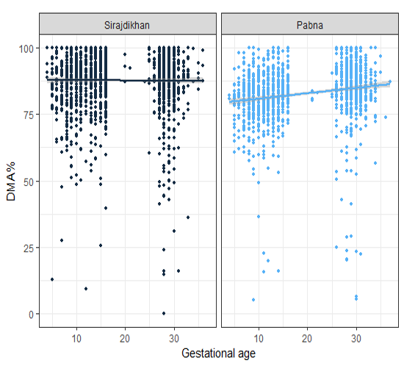

Fig. S2 Correlation between adjusted U-As at visit 1 and visit 2
Log-transformed adjusted U-As (unit of adjusted U-As: μg/g-creatinine) at visit 2 plotted over it at visit 1, showing the correlation of urinary arsenic excretion level between two visits. We applied linear regression to fit a solid line with the shade of standard error.

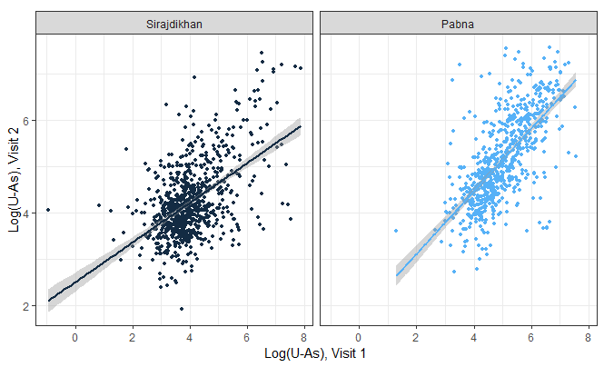

Fig. S3 Association between unadjusted U-As and urinary creatinine at visit 1 (top) and visit 2 (bottom)
Log-transformed adjusted U-As (unit of adjusted U-As: μg/g-creatinine) plotted over log-transformed U-creatinine (unit of U-creatinine: mg/dL), showing the relationship between total urinary arsenic excretion and creatinine level. We applied linear regression to fit a solid line with the shade of standard error. It showed the necessity of creatinine adjustment of urinary arsenic metabolites.

