SUPPLEMENTARY DATA

Appendix 1.Assessment of risk of bias in the included studies using Cochrane criteria for RCTs

Study (trial) year | Sequence | Allocation | Blinding of | Blinding of | Incomplete | Selective | Other
 | generation | concealment | participants | outcome | outcome | outcome | bias
 |  |  | and personnel | assessment | data | reporting
Kjekshus (CORONA) 2007 | L | L | L | U | L | L | L
Tevazzi (the GISSI-HF trial) 2008 | L | L | L | L | L | L | L
Legend: L: low risk of bias; H: high risk of bias; U: unclear risk of bias.

Appendix 2. Assessment of risk of bias in the included studies using Newcastle-Ottawa Quality Assessment Scale (NOS) for cohort studies
Study, year | Selection | Selection | Selection | Selection | Comparability | Exposure | Exposure | Exposure | Quality
 | 1 | 2 | 3 | 4 | 1 | 1 | 2 | 3
Horwich et al. 2004 | a) | a) | a) | a) | a) | b) | a) | b) | Good
Sola et al. 2005 | b) | a) | a) | a) | b) | a), b) | a) | a) | Good
Fukuta et al 2005 | a) | a) | b) | a) | b) | b) | a) | b) | Good
Hong et al. 2005 | b) | a) | b) | a) | b) | b) |  | a) | Good
Go et al. 2006 | b) | a) | a) | b) | a) | b) | a) | b) | Good
Huan et al. 2007 | c) | a) | b) | a) | b) | d) | a) | b) | Good
Coleman et al. 2008 | b) | a) | d) | b) | b) | d) | a) | b) | Fair
Roik et al. 2008 | a) | a) | b) | b) | b) | b) | a) | a) | Good
Gomez-Soto et al. 2010 | a) | a) | c) | b) | b) | b) | a) | a) | Good
Kaneko et al. 2013 | c) | b) | c) | a) | b) | a) | a) | b) | Fair
Yap et al. 2015 | c) | a) | b) | a) | a) | b | d) | b) | Fair
Nochioka et al. 2015 | a) | a) | b) | a) | a) | b) | a) | b) | Good
Alehagen U et al.2015 | a) | a) | b) | a) | b) | a) | a) | b) | Good
Alehagen et al. 2015 | b) | a) | b) | a) | b) | a) | a) | b) | Good
Tsujimoto et al. 2018 | a) | b) | a) | a) | a) | a) | a) | b) | Good

Legend: NOS: Selection- 1: a),b) one star, c), d) no star; Selection- 2: a) one star, b, c) no star; Selection- 3: a), b) one star, c), d), e) no star, Selection- 4: a) one star, b) no star; Comparability: a), b) one star, c) no star; Exposure-1: a),b) one star, c), d), e) no star; Exposure-2: a) one star, b) no star; Exposure-2: a),b) one star, c), d), no star.
Good quality: 3 or 4 stars in selection domain AND 1 or 2 stars in comparability domain AND 2 or 3 stars in outcome/exposure domain
Fair quality: 2 stars in selection domain AND 1 or 2 stars in comparability domain AND 2 or 3 stars in outcome/exposure domain
Poor quality: 0 or 1 star in selection domain OR 0 stars in comparability domain OR 0 or 1 stars in outcome/exposure domain
Figure S1. Association of statin versus non-statin use with all-cause mortality in heart failure only in cohort studies.
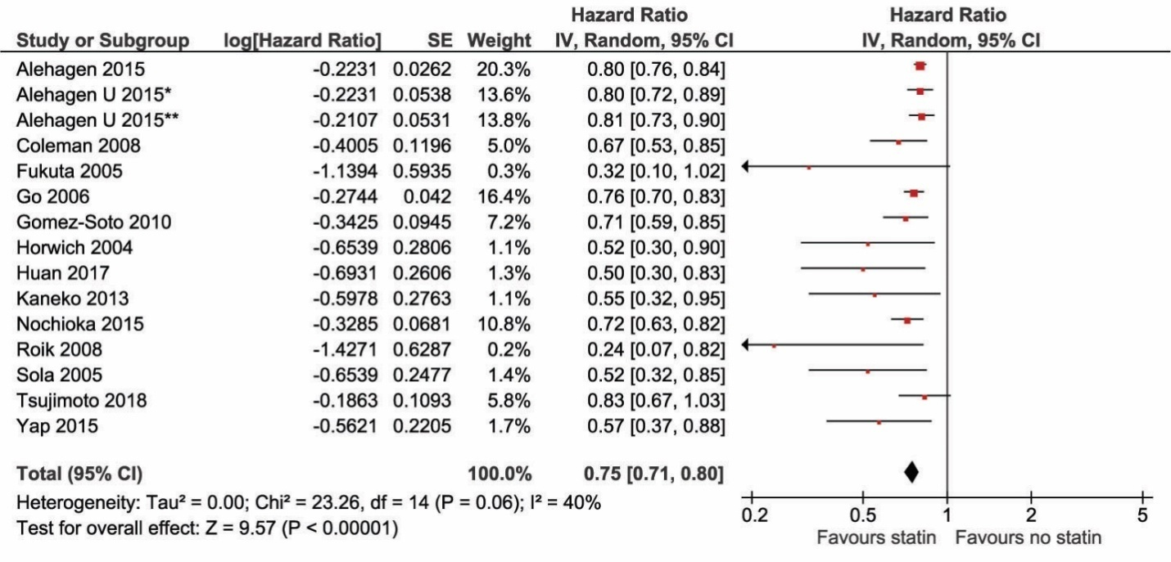

Figure S2. Association of statin versus non-statin use with CV mortality in heart failure only in cohort studies.

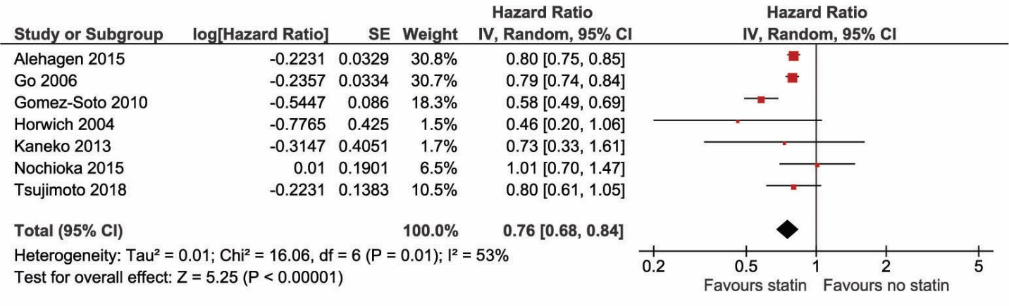

Figure S3. Association of statin versus non-statin use hospitalization in heart failure only in cohort studies.

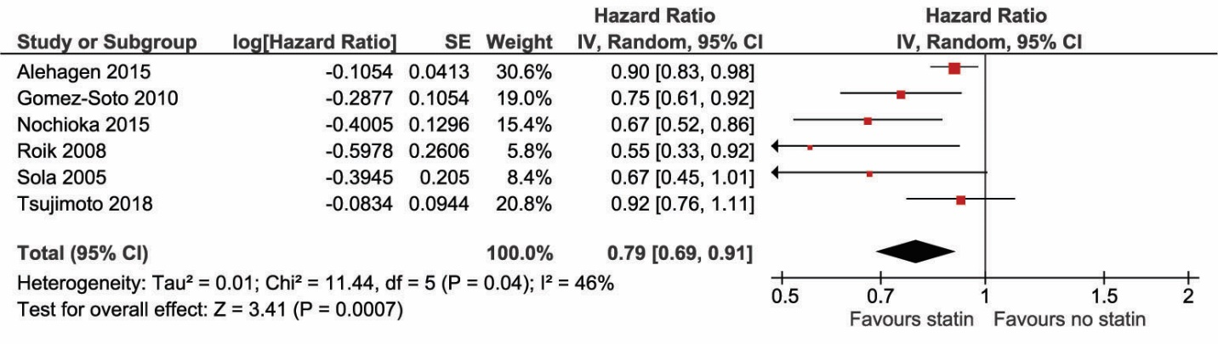

Figure S4. Association of statin versus non-statin use with all-cause mortality by type of heart failure only in cohort studies.

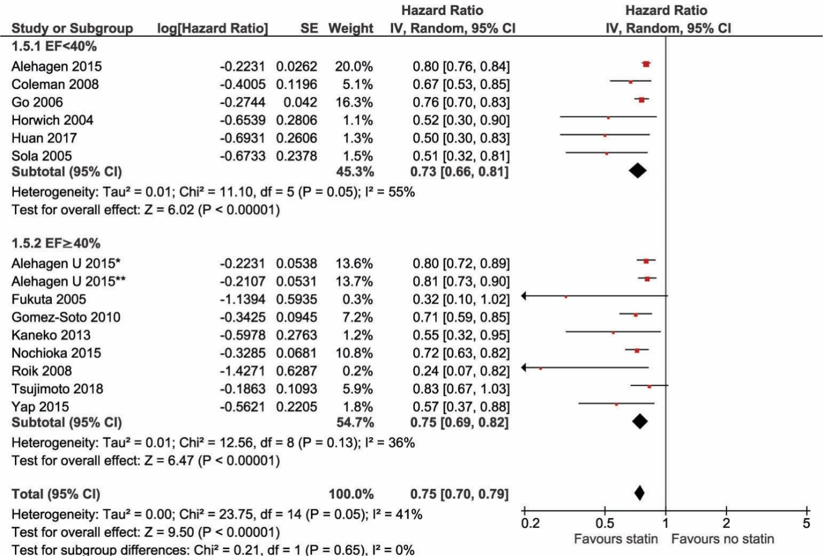

Figure S5. Association of statin versus non-statin use with CV mortality by type of heart failure only in cohort studies.
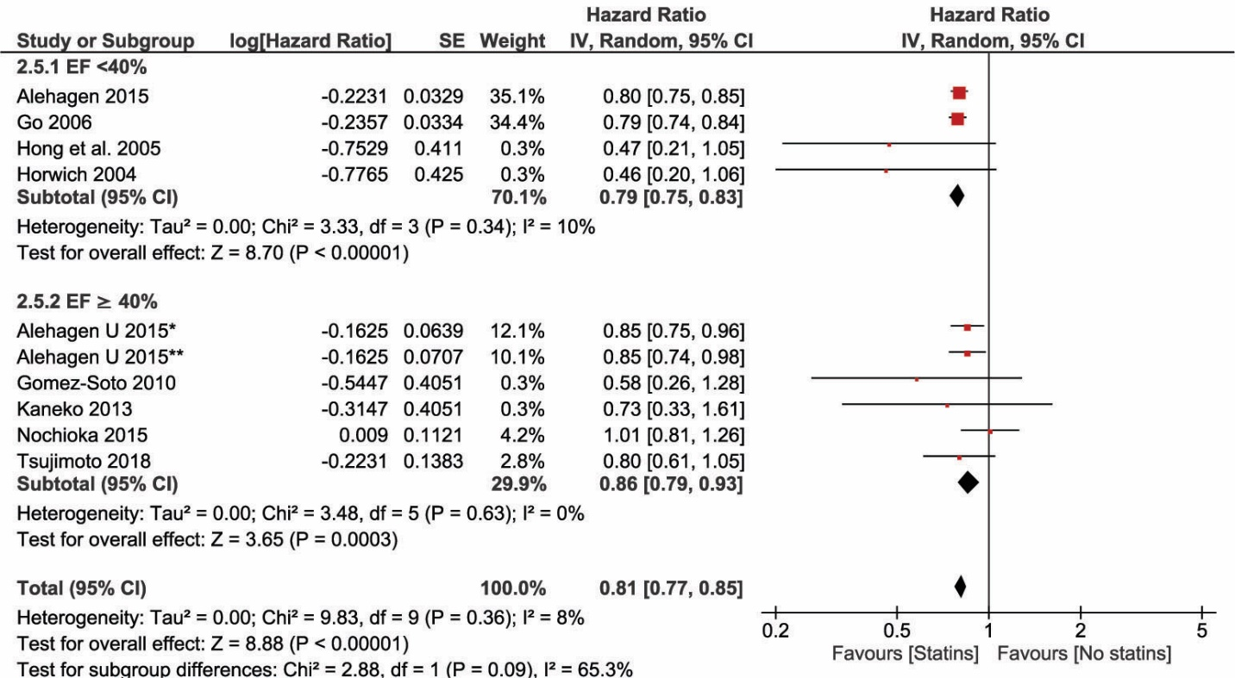

Figure S6. Association of statin versus non-statin use with hospitalization by type of heart failure only in cohort studies.

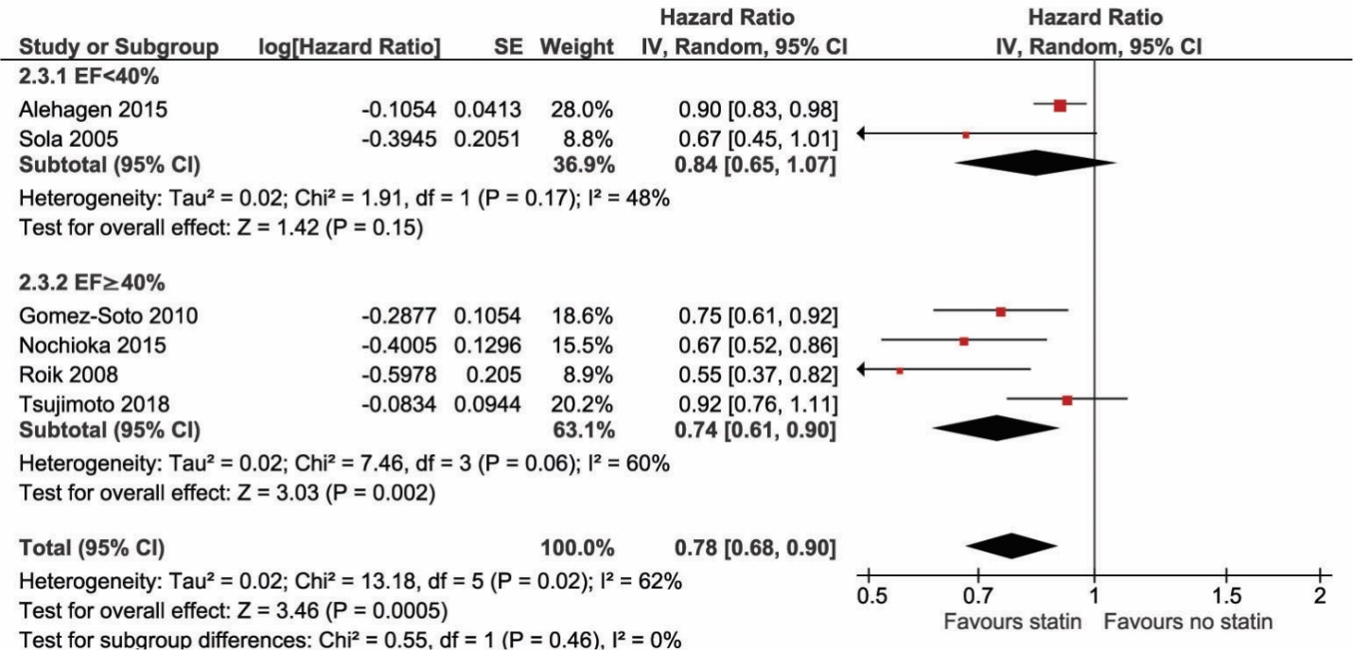

Table S1.Assessment of risk of bias in the included studies using Cochrane criteria for RCTs

Study (trial) year | Sequence | Allocation | Blinding of | Blinding of | Incomplete | Selective | Other
 | generation | concealment | participants | outcome | outcome | outcome | bias
 |  |  | and personnel | assessment | data | reporting
Kjekshus (CORONA) 2007 | L | L | L | U | L | L | L
Tevazzi (the GISSI-HF trial) 2008 | L | L | L | L | L | L | L
Legend: L: low risk of bias; H: high risk of bias; U: unclear risk of bias.

Table S2. Assessment of risk of bias in the included studies using Newcastle-Ottawa Quality Assessment Scale (NOS) for cohort studies.
Study, year | Selection | Selection | Selection | Selection | Comparability | Exposure | Exposure | Exposure | Quality
 | 1 | 2 | 3 | 4 | 1 | 1 | 2 | 3
Horwich et al. 2004 | a) | a) | a) | a) | a) | b) | a) | b) | Good
Sola et al. 2005 | b) | a) | a) | a) | b) | a), b) | a) | a) | Good
Fukuta et al 2005 | a) | a) | b) | a) | b) | b) | a) | b) | Good
Hong et al. 2005 | b) | a) | b) | a) | b) | b) |  | a) | Good
Go et al. 2006 | b) | a) | a) | b) | a) | b) | a) | b) | Good
Huan et al. 2007 | c) | a) | b) | a) | b) | d) | a) | b) | Good
Coleman et al. 2008 | b) | a) | d) | b) | b) | d) | a) | b) | Fair
Roik et al. 2008 | a) | a) | b) | b) | b) | b) | a) | a) | Good
Gomez-Soto et al. 2010 | a) | a) | c) | b) | b) | b) | a) | a) | Good
Kaneko et al. 2013 | c) | b) | c) | a) | b) | a) | a) | b) | Fair
Yap et al. 2015 | c) | a) | b) | a) | a) | b | d) | b) | Fair
Nochioka et al. 2015 | a) | a) | b) | a) | a) | b) | a) | b) | Good
Alehagen U et al.2015 | a) | a) | b) | a) | b) | a) | a) | b) | Good
Alehagen et al. 2015 | b) | a) | b) | a) | b) | a) | a) | b) | Good
Tsujimoto et al. 2018 | a) | b) | a) | a) | a) | a) | a) | b) | Good

Legend: NOS: Selection- 1: a),b) one star, c), d) no star; Selection- 2: a) one star, b, c) no star; Selection- 3: a), b) one star, c), d), e) no star, Selection- 4: a) one star, b) no star; Comparability: a), b) one star, c) no star; Exposure-1: a),b) one star, c), d), e) no star; Exposure-2: a) one star, b) no star; Exposure-2: a),b) one star, c), d), no star.
Good quality: 3 or 4 stars in selection domain AND 1 or 2 stars in comparability domain AND 2 or 3 stars in outcome/exposure domain
Fair quality: 2 stars in selection domain AND 1 or 2 stars in comparability domain AND 2 or 3 stars in outcome/exposure domain
Poor quality: 0 or 1 star in selection domain OR 0 stars in comparability domain OR 0 or 1 stars in outcome/exposure domain

