ADDITIONAL INFORMATION
Cerium oxide nanoparticles improve liver regeneration after acetaminophen-induced liver injury and partial hepatectomy in rats
Bernat Córdoba-Jover^{1,&}, Altamira Arce-Cerezo^{1,&}, Jordi Ribera¹, Montse Pauta¹, Denise Oró¹, Gregori Casals^{1,2}, Guillermo Fernández-Varo¹, Eudald Casals^{3,4,6}, Victor Puntes^{3,4,5}, Wladimiro Jiménez^{1,7} and Manuel Morales-Ruiz^{1,2,7*}.
&Both authors contributed equally to this study
*Corresponding authors:
-Manuel Morales-Ruiz, Ph.D., Biochemistry and Molecular Genetics Department, Hospital Clinic, 170 Villarroel St. Barcelona, 08036, Spain. Tel: +34-932275466, Fax: +34-932275697, e-mail: morales@clinic.cat

Table of content:
1. Additional Materials and methods
2. Additional Figure and Legend
3. References

Additional Materials and methods
Experimental model of partial hepatectomy.
All the surgical procedures performed in rats were made under isoflurane anesthesia (Sigma-Aldrich, St. Louis, MO). Partial hepatectomy (PHx) was performed according to the technique described by Higgins and Anderson[1]. The abdomen was opened via a midline incision and the median and left lobes were removed. After PHx, control and treated rats were euthanized at different time points. The regenerating bottom right lobe was snap-frozen into liquid nitrogen and the upper right lobe was fixed in 4% paraformaldehyde (PFA) at 4°C, cryoprotected overnight in 30% sucrose solution, and embedded in OCT medium (Tissue-Tek® O.C.T™ Compound, SAKURA) and frozen for future processing. The percentage of liver regeneration was calculated following the formula: weight of non-removed lobes/total body weight of rats, as previously described [1].
Acetaminophen (APAP) toxicity and N-acetyl-cysteine treatment.
After vehicle administration or CeO₂NPs treatment, rats were administered 1g/kg APAP (Acetaminophen BioXtra, ≥99.0%, Sigma Aldrich, St. Louis, MO) intraperitoneally and euthanized at 0h, 48h and 96h to obtain liver and serum samples for further analysis. As a therapeutic control group, thirteen rats were treated with 300mg/kg N-acetyl-cysteine (NAC) (N-Acetyl-L-cysteine, Sigma Grade, ≥99% [TLC], Sigma Aldrich, St. Louis, MO) intraperitoneally 1h after APAP administration. Liver left lobes were removed from these rats and dissected into pieces for: 1/ fixation in 4% PFA at 4ºC, cryoprotection in 30% sucrose solution overnight and inclusion in OCT medium (Tissue-Tek® O.C.T™ Compound, SAKURA); 2/ fixation in 10% formaldehyde and paraffin inclusion and 3/ storage in liquid nitrogen for protein extraction. APAP-induced liver injury was microscopically evaluated by performing hematoxylin-eosin staining (Hematoxylin Solution, Gill No. 3, Sigma Aldrich, St. Louis, MO) on liver sections included in paraffin. All the histology images were taken using a light microscope coupled with a digital image acquisition system (Nikon Eclipse E600, Kawasaki, Kanagawa, Japan). In addition, the presence of oxidative stress in the livers of the APAP-treated animals was determined by measuring the end product of lipid peroxidation 4-hydroxynonenal (HNE), a well known marker for oxidative damage, using OxiSelect™ HNE Adduct Competitive ELISA kit (Cell Biolabs Inc., San Diego, CA), following manufacturer’s instructions.
Immunofluorescence.
For both models, PHx and APAP, frozen sections of 8-μm were rehydrated, blocked with 5% normal goat serum and incubated with mouse anti-ki67 (1:100, Abcam, ab16667). Controls without primary antibodies were revealed with Alexa-488 goat-anti-rabbit IgG (1:500, Thermo Fisher Scientific, Waltham, MA, USA). Next, slides were mounted with mounting medium containing DAPI (VECTASHIELD®, Vector Laboratories Inc., Burlingame, CA, USA). Tissue slides were visualized with a fluorescence microscope (Nikon Eclipse E600, Kawasaki, Kanagawa, Japan). Ki67 positive cells were counted using Image J (version 1.37, National Institutes of Health, Bethesda, MD).

Western blot analysis.
Tissue lysates were prepared in a lysis buffer (Tris–HCl 20 mM pH 7.4 containing 1% Triton X-100, 0.1% SDS, 50 mM NaCl, 2.5 mM EDTA, 1 mM Na₄P₂O₇ 10H₂O, 20 mM NaF, 1 mM Na₃VO₄, 2 mM Pefabloc and Complete® from Roche, Basel, Switzerland). Proteins were separated on a 10% SDS-polyacrylamide gel (Mini Protean III, BioRad, Richmond, CA, USA) and transferred for 1 hour at 4ºC to 0,2 µm nitrocellulose transfer membranes (BioRad, Richmond, CA, USA). Membranes were incubated at 4ºC overnight with the following antibodies; rabbit anti-IKB alpha (1:1000, ab32518, abcam, Cambridge, UK), rabbit anti-Cyclin D1 (1:1000, #2922, Cell Signaling, Danvers MA, USA), rabbit anti-active Caspase-3 antibody (1:1000, ab32042, abcam, Cambridge, UK) and rabbit anti β-actin (13E5 HRP conjugate, 1:1000, #4970, Cell Signaling, Danvers MA, USA). Membranes were incubated with a donkey ECL™-anti-rabbit IgG horseradish peroxidase-conjugated secondary antibody at 1:5000 dilution (GE Healthcare, Chicago, IL, USA) for 1 hour at room temperature. Bands were visualized using LuminataTM Forte Western HRP Substrate (Merck Millipore, Burlington, MA, USA) and ImageQuantTM LAS 4000 (GE Healthcare, Chicago, IL, USA). Densitometry analysis of membranes was performed using Image J (version 1.37, National Institutes of Health, Bethesda, MD).
Cell cycle analysis.
HepG2 cells were washed twice with ice-cold PBS, fixed in 70% cold ethanol, treated with 100 μg/mL ribonuclease A (Roche, Basel, Switzerland) and labeled with 50 μg/mL propidium iodide (PI) for at least 4h at 4°C. Next, cells were analyzed by flow cytometry (FACScalibur, Becton-Dickinson) using selective gating to exclude the doublets of cells and quantified using the MODFIT software (Verity Software House, Inc.).
Biochemical assays.
At the end of the treatment, rats were euthanized, serum was obtained by blood centrifugation and biochemical parameters were assayed using an automatic chemistry analyzer (BS-200E, Mindray Medical International LTD, Shenzhen, China). In these samples, aspartate aminotransferase (AST), alanine transaminase (ALT), glucose, albumin, and lactate dehydrogenase (LDH) were determined.

Additional Figures and Legends
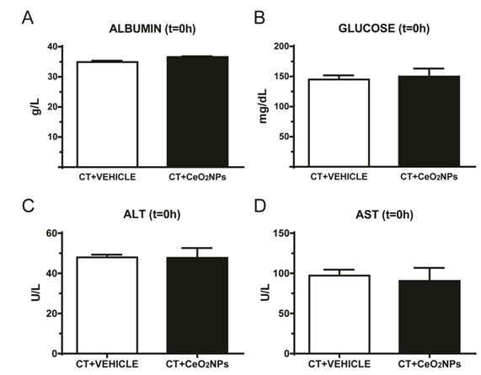
Figure S1. Measurement of serum laboratory parameters in rats treated with vehicle and CeO₂NPs before PHx or APAP i.p. injection. Serum concentration of albumin, glucose, ALT and AST in rats treated with vehicle (white bars, n=8) and CeO₂NPs (black bars, n=8) at t=0 hours before PHx or APAP treatment. No significant differences were found between groups in any of the biochemical parameters evaluated.

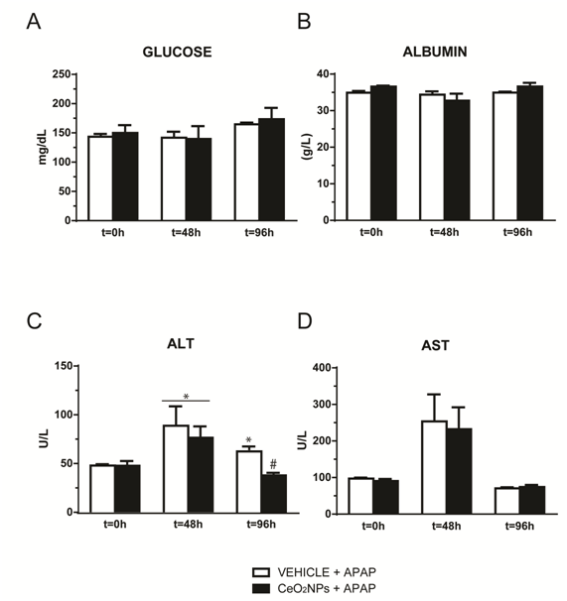
Figure S2. Measurement of serum laboratory parameters in rats treated with vehicle and CeO₂NPs after APAP i.p. injection. Serum concentration of glucose, albumin, ALT and AST in rats treated with vehicle (white bars, n=8) and CeO₂NPs (black bars, n=8) at t=0h, t=48h and t=96h after APAP i.p. injection (*p<0.01 compared with t=0 and CeO₂NPs treatment at t=96h; #p<0.05 compared with vehicle at the same time points).
References
1. Higgins GM. Anderson. RM. Experimental pathology of the liver: Restoration of the liver of the white rat following partial surgical removal. Arch Pathol. 1931;12:186–202.

