Additional file 2
Figures Details of the variables from the frailty index, reported at admission (remaining non-frail and becoming frail at 6 months) and at 6 months (patients remaining non-frail and becoming frail)
Figure S1: basic and instrumental daily living activities.
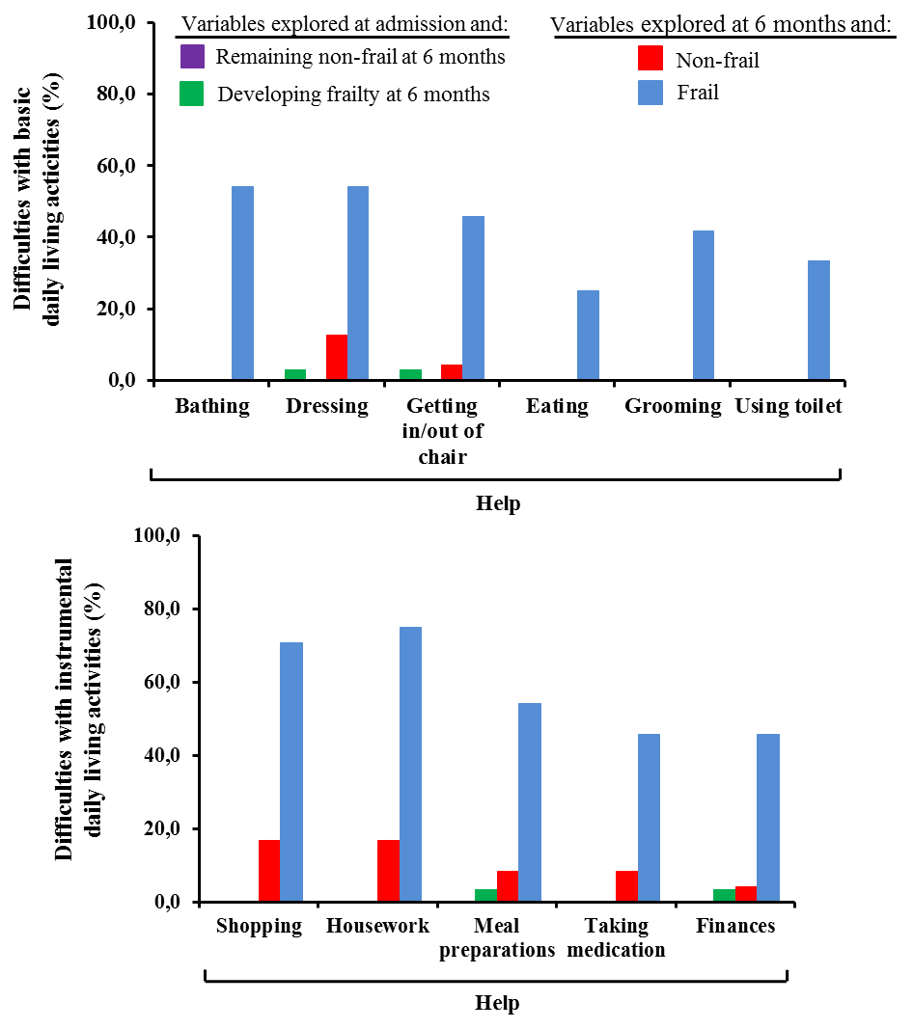

Figure S2: Problems related to mobility and strength.
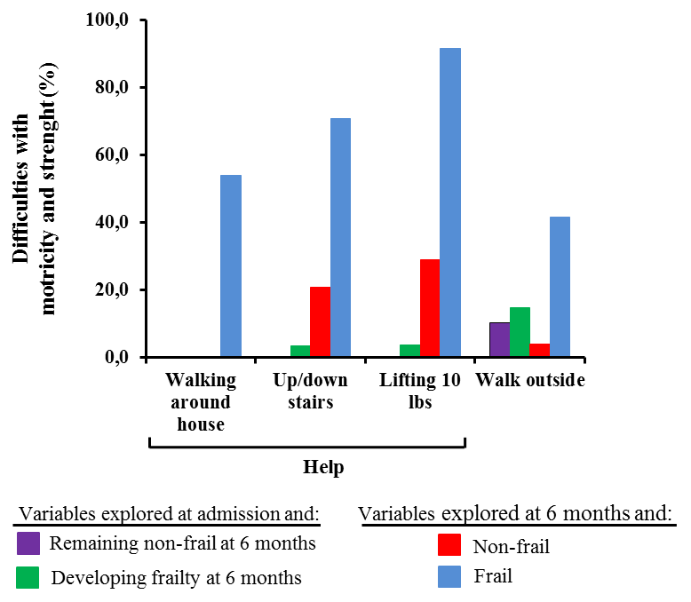

Figure S3: Various feeling declared by the patients and trouble getting going.
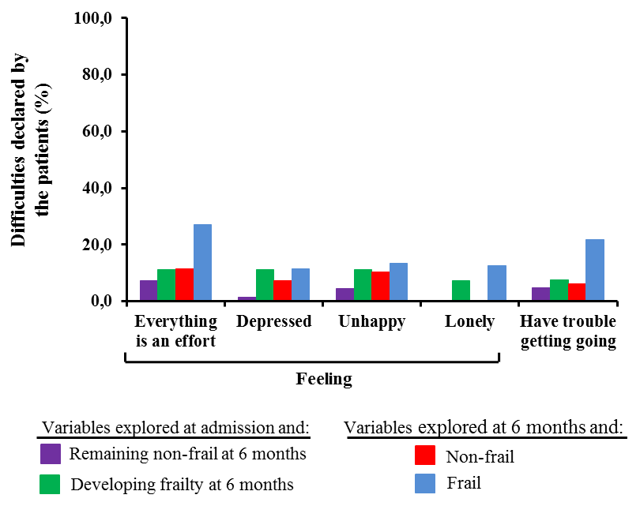

Figure S4: Weight loss, altered health status and problems with usual activities health.
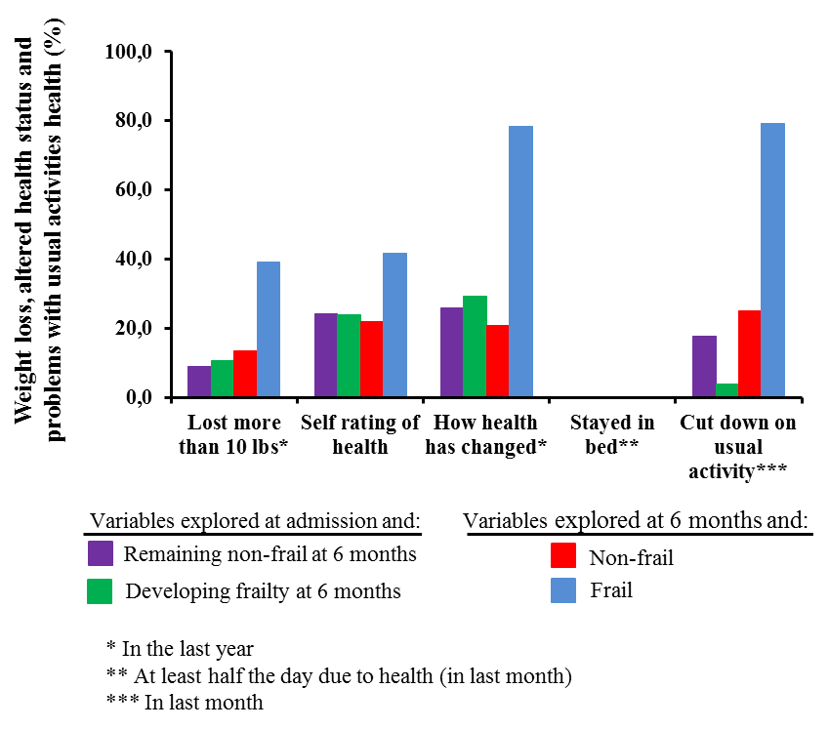

Figure S5: Comorbidities.

