RD-LPS reduces apoptosis of Lin- stem cells
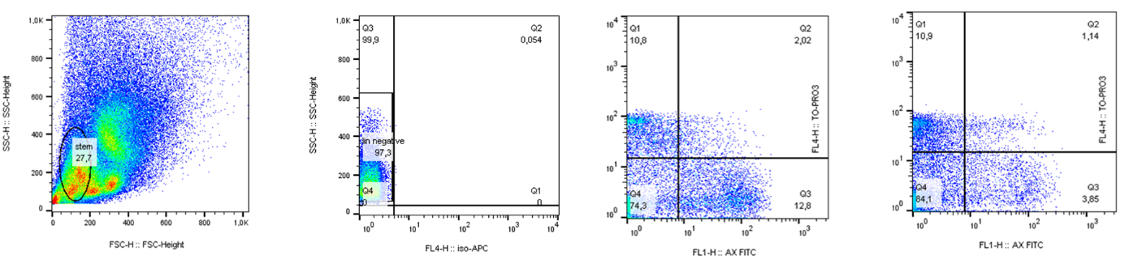
Analysis of apoptosis prevented by RD-LPS. Isolated BM cells were labeled with Annexin V –FITC (Sony) and 1 mg/μl Το-Pro3 (Life Technologies) and measured by FACSCalibur. The representative figures show the gating strategies.

