Safer-by-design flame-sprayed silicon dioxide nanoparticles: The role of silanol content on ROS generation, surface activity and cytotoxicity

Laura Rubio^{a+}, Pyrgiotakis G^{a+} , Juan Beltran-Huaracª, Yipei Zhang^{b}, Gaurav N. Joshi^{c}, Glen DeLoidª, Anastasia Spyrogianni^{d}, Kristopher A. Sarosiek^{c}, Dhimiter Bello^{a,b}, and Philip Demokritou^{a,}*

ª Center for Nanotechnology and Nanotoxicology, HSPH-NIEHS Nanosafety Center, Department of Environmental Health, Harvard T. H. Chan School of Public School, Harvard University, 665 Huntington Boston, MA 02115, USA.

^{b} Department of Biomedical and Nutritional Sciences, Zuckerberg College of Health Sciences, University of Massachusetts Lowell, MA 01854, USA.

^{c} John B. Little Center for Radiation Sciences, Department of Environmental Health, Harvard T.H. Chan School of Public Health, Boston, MA 02115, USA

^{d} Particle Technology Laboratory, Institute of Process Engineering, Department of Mechanical and Process Engineering, ETH Zurich, Sonneggstrasse 3, CH-8092, Zurich, Switzerland

*Corresponding author. E-mail: pdemokri@hsph.harvard.edu
⁺Equally contributing authors

Keywords: Silanol groups, amorphous silica, chemistry surface, flame spray pyrolysis, toxicity

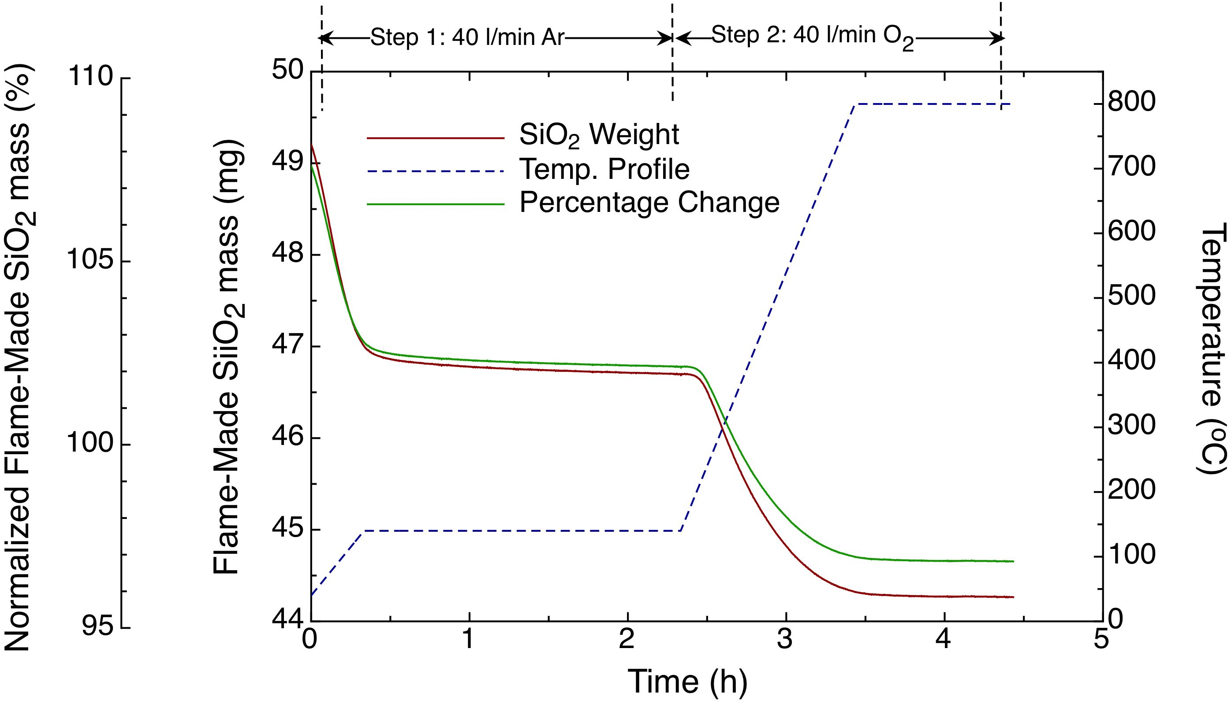
Figure S1: TGA temperature-time profile (right ordinate, dashed line), corresponding sample mass (left ordinate) of as-produced (solid lines) and the mass loss normalized to the mass at the end of Step 1.

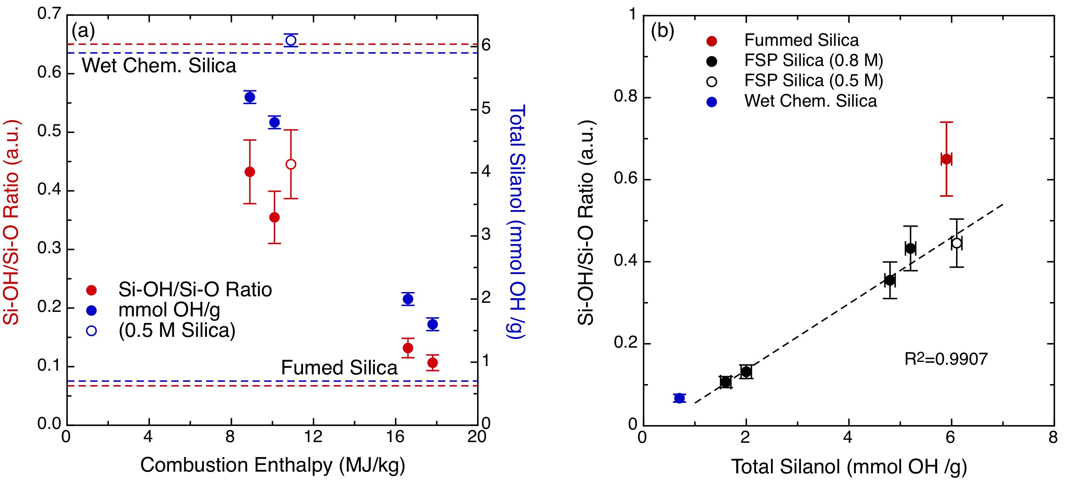
Figure S2: XPS analysis. (a) Si-OH/O-Si-O ratio and total silanol content varying as a function of the combustion enthalpy. (b) Si-OH/O-Si-O ratio as a function of the total silanol.

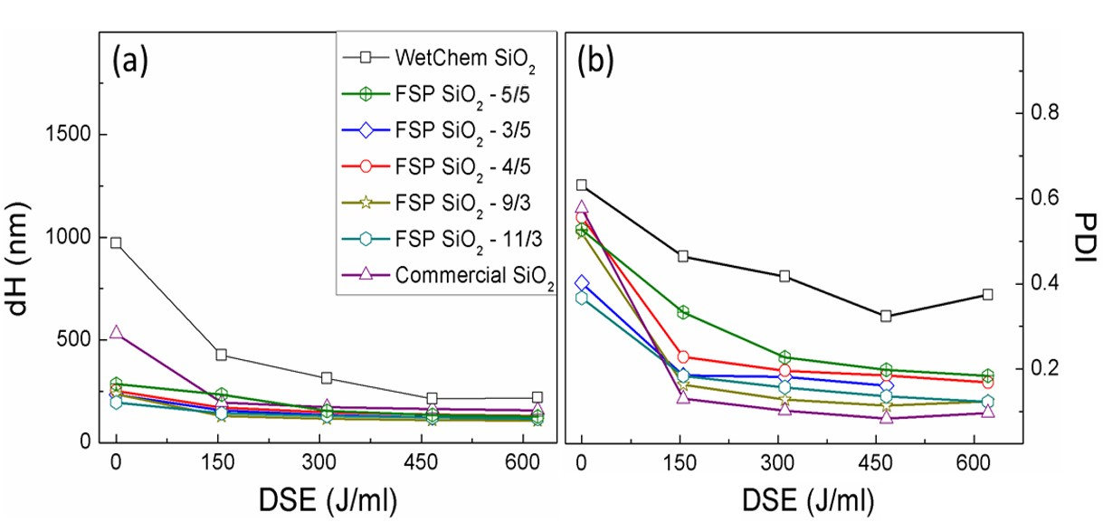
Figure S3: Determining the critical delivered sonication energy of SiO₂ NPs. (a) Mean hydrodynamic diameter and (b) polydispersity index as a function of dispersion sonication energy of Wetchem SiO₂ NPs, FSP made SiO₂ NPs and commercial fumed SiO₂ NPs in DI H₂O.

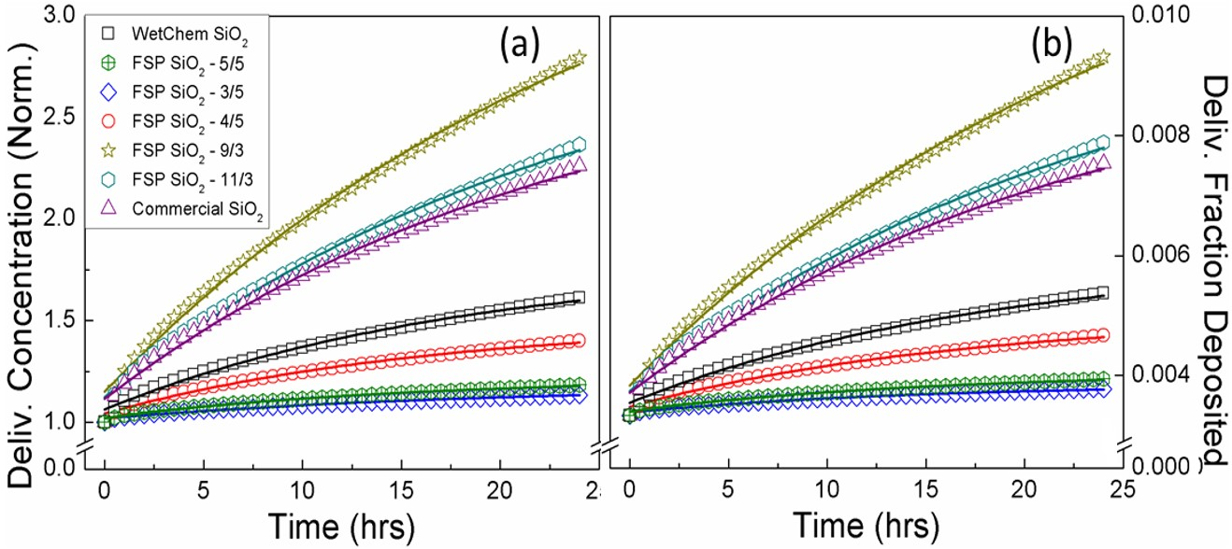
Figure S4: Fate and transport modeling results for SiO₂ NPs. (a) Delivered-to-cell concentration normalized to the administered dose and (b) delivered-to-cell fraction deposited of wet chemistry made silica, FSP made SiO₂ NPs and commercial fumed SiO₂ NPs in RPMI + 10% (vol/vol) FBS. Solid lines are the fitting curves obtained using eq. 1 and 2.

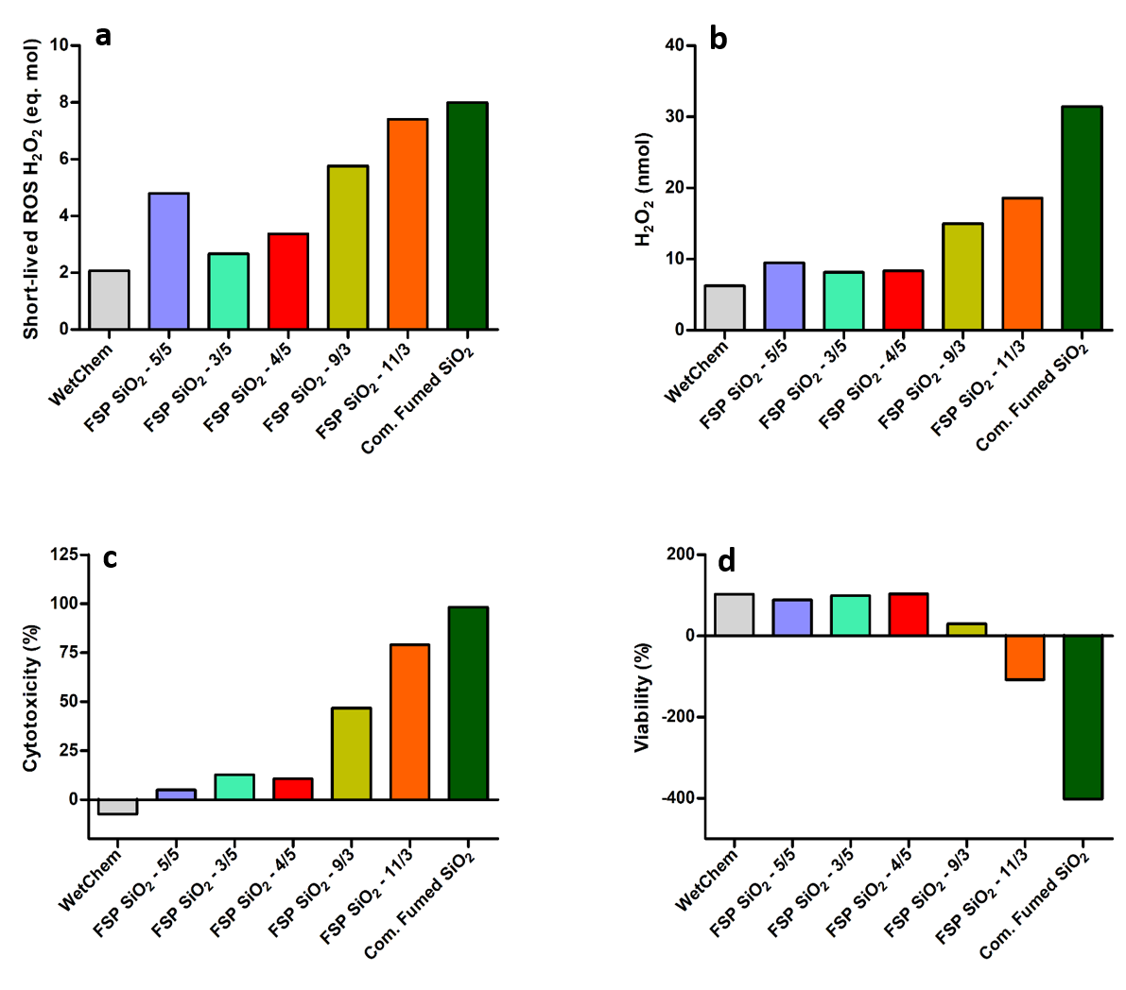
Figure S5: Importance of other modulators in silica NPs effect analyzing RAW264.7 cells. (a, b) short-lived ROS and H₂O₂ produced by the different SiO₂ NPs at a fixed value of silanol content of 150 nmol. (c) Cytotoxicity of different SiO₂ NPs at a fixed value of delivered silanol per cell area of 1 x 10¹⁴ #/cm². (d) Viability of different SiO₂ NPs at a fixed value of delivered silanol per cell area of 1.5 x 10¹⁴ #/cm².

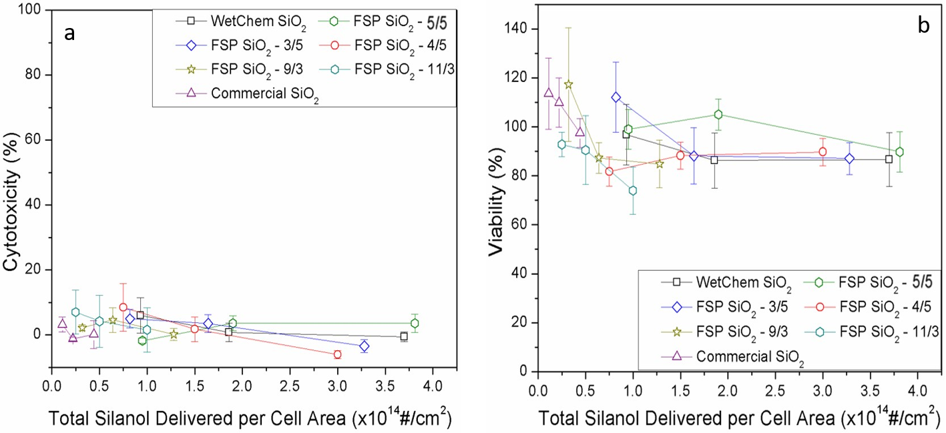
Fig. S6. Cytotoxicity (a) and Viability (PrestoBlue assay) (b) measured in SAEC cells. The data represented as function of total silanol delivered per cell area for the three delivered doses used. Data represent an average of three independent experiments performed in triplicate.

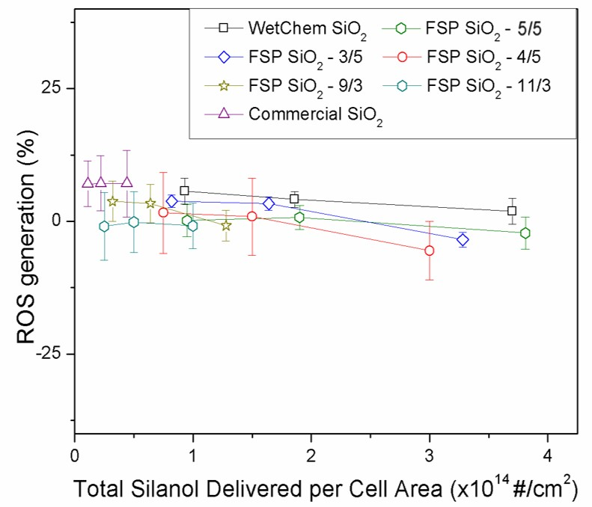

Fig. S7. ROS generation as a measure of oxidative damage (CellROX Green assay) in SAEC cells. After 24-hour treatment, ROS generation was measured and data represented as function of total silanol delivered per cell area for the three delivered doses used. Data represent an average of three independent experiments performed in triplicate.

Fig. S8. Cytotoxicity measured in RAW264.7 cells. The data is represented as function of short life ROS-H₂O₂ eq. nmol. Data represent an average of three independent experiments performed in triplicate.

Table S1. Mean values of the parameters obtained for suspension preparation and colloidal characterization of wet chemistry made silica, FSP made silicas and commercial fumed silica in H₂O and RPMI + 10% (vol/vol) FBS.
Silica type | DSE_{cr}  (J/ml) | Media | Colloidal Properties
 |  |  | d_{H} (nm) |  | PDI | ζ (mV) | σ (mS/cm) | ρ_{eff} (g/cc)
WetChem SiO₂ | 380 | DI Water | 207.7±26.4 |  | 0.57±0.05 | -23.6±4.1 | 0.02±0.00
 |  | RPMI/10%/FBS | t=0h  t=24h | 326.8±18.2  228.6±19.5 | 0.52±0.05 | -11.7±0.3 | 10.50±0.10 | 1.31±0.07
 |  |  |  |  | 0.55±0.12 | -12.2±0.9 | 10.40±0.17
FSP SiO₂ -5/5 | 161 | DI Water | 135.0±1.4 |  | 0.20±0.01 | -16.2±1.9 | 0.03±0.00
 |  | RPMI/10%/FBS | t=0h | 236.2±60.2 | 0.32±0.01 | -11.3±2.0 | 10.30±2.12 | 1.13±0.01
 |  |  | t=24h | 269.0±19.5 | 0.33±0.04 | -12.0±0.1 | 13.61±0.15
FSP SiO₂-3/5 | 200 | DI Water | 137.6±0.7 |  | 0.18±0.010.21±0.05  0.22±0.05 | -25.1±3.7  -12.6±3.1  -14.4±0.5 | 0.01±0.00  9.51±0.77  10.60±0.23
 |  | RPMI/10%/FBS | t=0h | 228.6±9.2 |  |  |  | 1.12±0.01
 |  |  | t=24h | 196.9±1.8
FSP SiO₂-4/5 | 220 | DI Water | 131.0±0.8 |  | 0.16±0.01  0.17±0.01  0.28±0.13 | -15.3±1.2  -12.9±1.2  -12.5±0.1 | 0.01±0.00  8.91±0.54  8.83±0.13
 |  | RPMI/10%/FBS | t=0h | 205.8±3.2 |  |  |  | 1.20±0.02
 |  |  | t=24h | 369.5±42.8
FSP SiO₂-9/3 | 205 | DI Water | 158.4±7.2 |  | 0.20±0.02  0.14±0.07  0.23±0.07 | -25.9±2.9  -13.1±0.7  -14.6±0.8 | 0.01±0.01  10.80±0.40  10.20±0.11
 |  | RPMI/10%/FBS | t=0h | 221.0±3.6 |  |  |  | 1.18±0.02
 |  |  | t=24h | 291.9±19.7
FSP SiO₂-11/3 | 190 | DI Water | 130.8±3.8 |  | 0.15±0.02  0.21±0.04  0.34±0.25 | -18.2±1.9  -12.5±0.4  -11.5±0.3 | 0.01±0.00  10.70±0.38  10.20±0.10
 |  | RPMI/10%/FBS | t=0h | 218.3±8.3 |  |  |  | 1.25±0.01
 |  |  | t=24h | 227.2±75.1
Commercial fumed SiO₂ | 195 | DI Water | 183.5±1.5 |  | 0.12±0.01  0.17±0.03  0.19±0.03 | -23.1±4.6  -11.2±0.7  -5.2±0.9 | 0.01±0.00  10.50±0.32  10.50±0.60
 |  | RPMI/10%/FBS | t=0h | 249.3±1.4 |  |  |  | 1.19±0.01
 |  |  | t=24h | 252.5±2.9

FSP, flame spray pyrolysis; DSEcr, critical delivered sonication energy; d_{H}, in water is determined from the DLS intensity-weighted size distribution, whereas in medium the DLS volume-weighted size distribution; PDI, polydispersity index; ζ, zeta potential; σ, specific conductance; ρ_{eff}, effective density.

Table S2: The short-lived ROS and H₂O₂ generated from seven types of silica over the 10-100 µg/mL range. Values have been corrected for sonication and background oxidation of Trolox.

Dose (µg/mL) | Silica type – All ROS and H2O2 values are in nmol/mL
 | WetChem |  | FSP 5/5 |  | FSP 3/5 |  | FSP 4/5 |  | FSP 9/3 |  | FSP 11/3 |  | Commercial
 | ROS | H₂O₂ | ROS | H₂O₂ | ROS | H₂O₂ | ROS | H₂O₂ | ROS | H₂O₂ | ROS | H₂O₂ | ROS | H₂O₂
10 | 2.01 | 5.78 | 4.08 | 8.52 | 2.49 | 7.03 | 2.95 | 7.23 | 4.63 | 11.53 | 5.70 | 15.38 | 5.37 | 15.07
25 | 2.06 | 6.22 | 4.78 | 9.35 | 2.58 | 8.05 | 3.27 | 7.61 | 4.98 | 12.26 | 5.96 | 16.08 | 6.34 | 15.87
50 | 2.20 | 7.03 | 5.33 | 10.67 | 2.88 | 8.52 | 3.61 | 8.86 | 5.30 | 14.36 | 6.40 | 15.91 | 6.69 | 16.01
100 | 2.43 | 8.65 | 6.03 | 10.69 | 3.52 | 9.62 | 3.75 | 9.46 | 6.20 | 15.98 | 7.58 | 19.24 | 7.36 | 19.06

Cellular statistical analysis

Tukey's multiple comparisons test | Mean Diff, | 95,00% CI of diff, | Significant? | Summary | Adjusted P Value
0.026 µg/cm2
Wet chem. vs. FSP 5/5 | -12,29 | -22,89 to -1,678 | Yes | * | 0,0141
Wet chem. vs. FSP 3/5 | -17,13 | -27,73 to -6,519 | Yes | *** | 0,0002
Wet chem. vs. FSP 4/5 | -10,03 | -20,64 to 0,5768 | No | ns | 0,0745
Wet chem. vs. FSP 9/3 | -18,92 | -29,52 to -8,308 | Yes | **** | <0,0001
Wet chem. vs. FSP 11/3 | -23,98 | -34,59 to -13,37 | Yes | **** | <0,0001
Wet chem. vs. Com. Fumed | -28,02 | -38,63 to -17,41 | Yes | **** | <0,0001
FSP 5/5 vs. FSP 3/5 | -4,841 | -15,45 to 5,767 | No | ns | 0,7920
FSP 5/5 vs. FSP 4/5 | 2,255 | -8,353 to 12,86 | No | ns | 0,9942
FSP 5/5 vs. FSP 9/3 | -6,63 | -17,24 to 3,978 | No | ns | 0,4698
FSP 5/5 vs. FSP 11/3 | -11,69 | -22,3 to -1,086 | Yes | * | 0,0224
FSP 5/5 vs. Com. Fumed | -15,73 | -26,34 to -5,126 | Yes | *** | 0,0007
FSP 3/5 vs. FSP 4/5 | 7,096 | -3,512 to 17,7 | No | ns | 0,3882
FSP 3/5 vs. FSP 9/3 | -1,789 | -12,4 to 8,818 | No | ns | 0,9984
FSP 3/5 vs. FSP 11/3 | -6,853 | -17,46 to 3,755 | No | ns | 0,4300
FSP 3/5 vs. Com. Fumed | -10,89 | -21,5 to -0,2848 | Yes | * | 0,0407
FSP 4/5 vs. FSP 9/3 | -8,885 | -19,49 to 1,723 | No | ns | 0,1542
FSP 4/5 vs. FSP 11/3 | -13,95 | -24,56 to -3,341 | Yes | ** | 0,0036
FSP 4/5 vs. Com. Fumed | -17,99 | -28,6 to -7,38 | Yes | **** | <0,0001
FSP 9/3 vs. FSP 11/3 | -5,063 | -15,67 to 5,544 | No | ns | 0,7561
FSP 9/3 vs. Com. Fumed | -9,103 | -19,71 to 1,505 | No | ns | 0,1353
FSP 11/3 vs. Com. Fumed | -4,04 | -14,65 to 6,568 | No | ns | 0,8981
0.052 µg/cm2
Wet chem. vs. FSP 5/5 | -16,23 | -26,84 to -5,62 | Yes | *** | 0,0005
Wet chem. vs. FSP 3/5 | -30,02 | -40,63 to -19,42 | Yes | **** | <0,0001
Wet chem. vs. FSP 4/5 | -32,38 | -42,99 to -21,77 | Yes | **** | <0,0001
Wet chem. vs. FSP 9/3 | -33,18 | -43,78 to -22,57 | Yes | **** | <0,0001
Wet chem. vs. FSP 11/3 | -58,23 | -68,84 to -47,62 | Yes | **** | <0,0001
Wet chem. vs. Com. Fumed | -52,14 | -62,75 to -41,53 | Yes | **** | <0,0001
FSP 5/5 vs. FSP 3/5 | -13,8 | -24,4 to -3,188 | Yes | ** | 0,0040
FSP 5/5 vs. FSP 4/5 | -16,15 | -26,76 to -5,545 | Yes | *** | 0,0005
FSP 5/5 vs. FSP 9/3 | -16,95 | -27,56 to -6,341 | Yes | *** | 0,0002
FSP 5/5 vs. FSP 11/3 | -42 | -52,61 to -31,4 | Yes | **** | <0,0001
FSP 5/5 vs. Com. Fumed | -35,91 | -46,52 to -25,3 | Yes | **** | <0,0001
FSP 3/5 vs. FSP 4/5 | -2,357 | -12,96 to 8,251 | No | ns | 0,9926
FSP 3/5 vs. FSP 9/3 | -3,153 | -13,76 to 7,455 | No | ns | 0,9672
FSP 3/5 vs. FSP 11/3 | -28,21 | -38,82 to -17,6 | Yes | **** | <0,0001
FSP 3/5 vs. Com. Fumed | -22,12 | -32,72 to -11,51 | Yes | **** | <0,0001
FSP 4/5 vs. FSP 9/3 | -0,7958 | -11,4 to 9,812 | No | ns | >0,9999
FSP 4/5 vs. FSP 11/3 | -25,85 | -36,46 to -15,24 | Yes | **** | <0,0001
FSP 4/5 vs. Com. Fumed | -19,76 | -30,37 to -9,152 | Yes | **** | <0,0001
FSP 9/3 vs. FSP 11/3 | -25,05 | -35,66 to -14,45 | Yes | **** | <0,0001
FSP 9/3 vs. Com. Fumed | -18,96 | -29,57 to -8,356 | Yes | **** | <0,0001
FSP 11/3 vs. Com. Fumed | 6,091 | -4,517 to 16,7 | No | ns | 0,5701
0.104 µg/cm2
Wet chem. vs. FSP 5/5 | -30,27 | -40,87 to -19,66 | Yes | **** | <0,0001
Wet chem. vs. FSP 3/5 | -56,32 | -66,92 to -45,71 | Yes | **** | <0,0001
Wet chem. vs. FSP 4/5 | -64,39 | -75 to -53,78 | Yes | **** | <0,0001
Wet chem. vs. FSP 9/3 | -67,89 | -78,5 to -57,28 | Yes | **** | <0,0001
Wet chem. vs. FSP 11/3 | -83,41 | -94,02 to -72,8 | Yes | **** | <0,0001
Wet chem. vs. Com. Fumed | -75,07 | -85,68 to -64,46 | Yes | **** | <0,0001
FSP 5/5 vs. FSP 3/5 | -26,05 | -36,66 to -15,44 | Yes | **** | <0,0001
FSP 5/5 vs. FSP 4/5 | -34,13 | -44,73 to -23,52 | Yes | **** | <0,0001
FSP 5/5 vs. FSP 9/3 | -37,62 | -48,23 to -27,01 | Yes | **** | <0,0001
FSP 5/5 vs. FSP 11/3 | -53,15 | -63,75 to -42,54 | Yes | **** | <0,0001
FSP 5/5 vs. Com. Fumed | -44,81 | -55,42 to -34,2 | Yes | **** | <0,0001
FSP 3/5 vs. FSP 4/5 | -8,075 | -18,68 to 2,533 | No | ns | 0,2426
FSP 3/5 vs. FSP 9/3 | -11,57 | -22,18 to -0,9642 | Yes | * | 0,0246
FSP 3/5 vs. FSP 11/3 | -27,1 | -37,7 to -16,49 | Yes | **** | <0,0001
FSP 3/5 vs. Com. Fumed | -18,76 | -29,36 to -8,149 | Yes | **** | <0,0001
FSP 4/5 vs. FSP 9/3 | -3,498 | -14,11 to 7,11 | No | ns | 0,9463
FSP 4/5 vs. FSP 11/3 | -19,02 | -29,63 to -8,414 | Yes | **** | <0,0001
FSP 4/5 vs. Com. Fumed | -10,68 | -21,29 to -0,0746 | Yes | * | 0,0474
FSP 9/3 vs. FSP 11/3 | -15,52 | -26,13 to -4,916 | Yes | *** | 0,0009
FSP 9/3 vs. Com. Fumed | -7,185 | -17,79 to 3,423 | No | ns | 0,3733
FSP 11/3 vs. Com. Fumed | 8,339 | -2,269 to 18,95 | No | ns | 0,2105

