**Table S1. Markers Associated with C3 and C4**

\**p*< 0.05

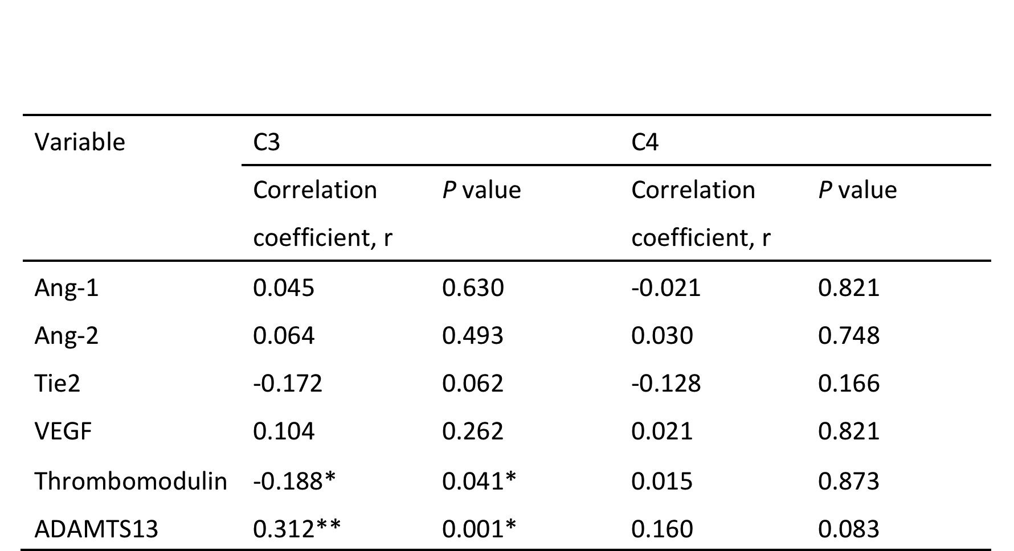

**Table S2. Markers associated with NIH Activity Index**

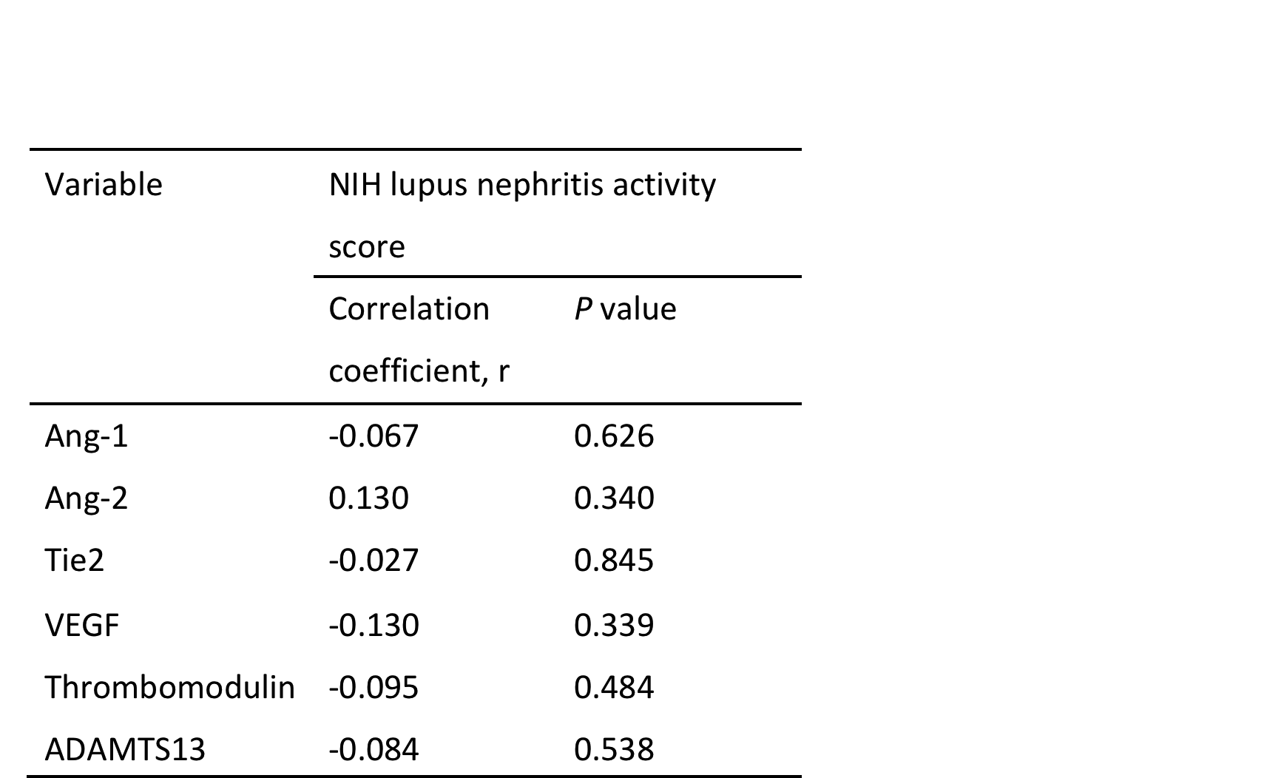

**Table S3. Markers in Four SLEDAI Subgroups**

**Group 1: 0≤ SLEDAI≤4**

**Group 2: 4< SLEDAI≤7**

**Group 3: 7< SLEDAI≤12**

**Group 4: 12<SLEDAI** 