ADDITIONAL FILES
Additional File 1. Kaplan-Meier estimates of a progression-free survival (PFS) and b overall survival (OS) in the first-line subgroup according to programmed death-ligand 1 (PD-L1) status (based on expression in ≥ 1% of tumor cells). CI confidence interval, NE not evaluable
A
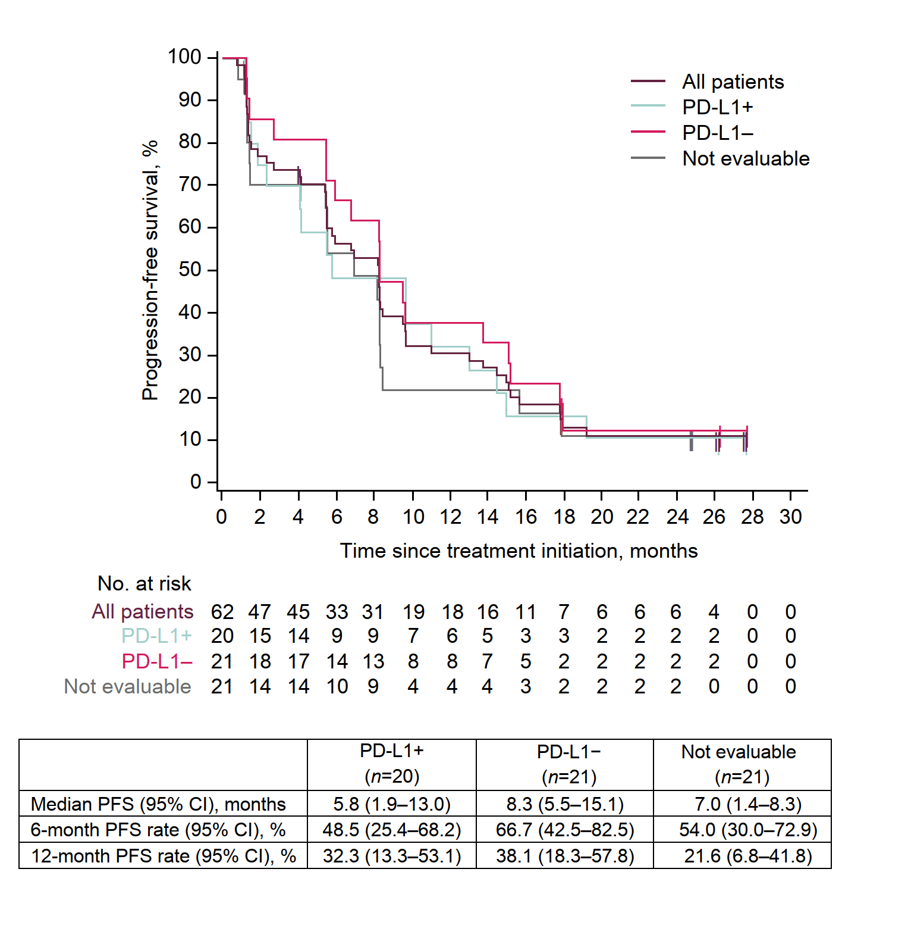

B
