Okuyama et al. Application of a computer vision technique to animal-borne video data: Extraction of head movement to understand sea turtles’ visual assessment of surroundings

ADDITIONAL FILES

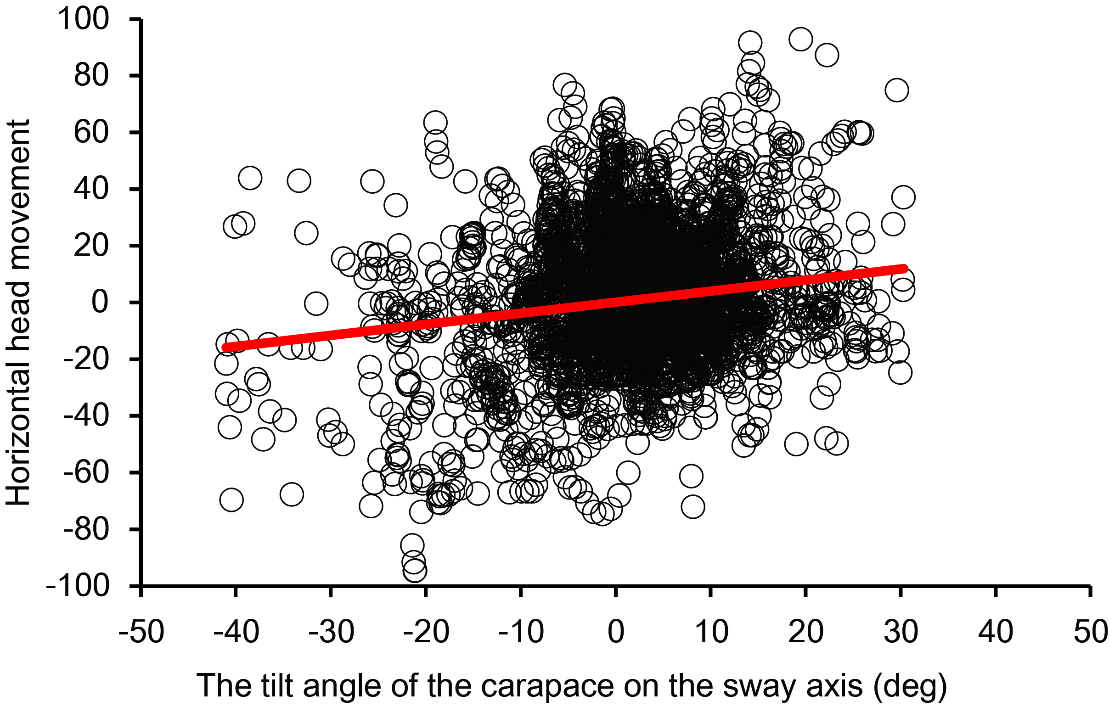
Additional file 2. The relationship between the carapace tilt angle on the sway (lateral) axis and horizontal head position. A significant relationship (y = 0.39x + 0.91, R² = 0.13, N = 16915, F = 292, P < 0.01) indicates that turtles tended to move their heads to the side in which they were tilted.

