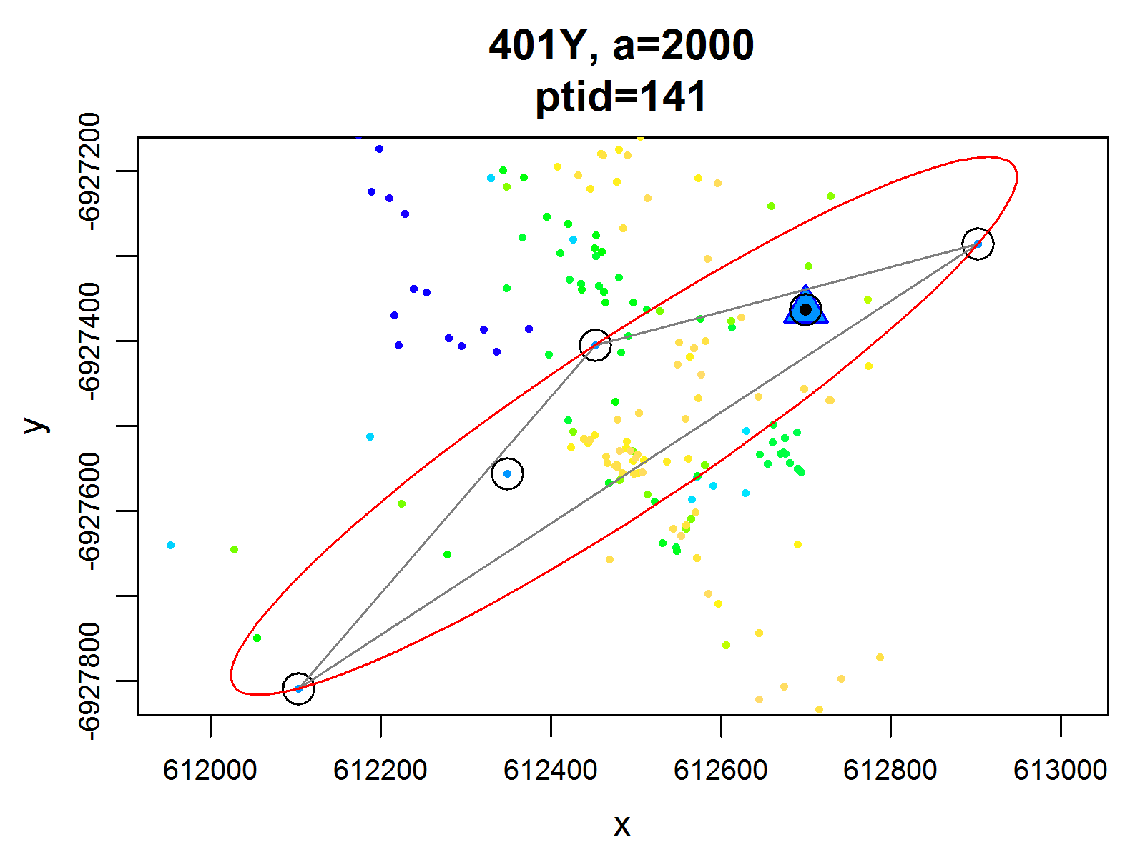
Additional file 3 Sample Time Local Convex Hull (401Y). A randomly selected example hull from the GPS data set of leopard seal 401Y. The parent point (ptid = 141) is shown by a triangle and highlighted in blue. Nearest neighbors are circled. Non-selected points within the hull were close in space, but excluded due to temporal distance. The red ellipse has a characteristic eccentricity or elongation that is used to estimate relative direction of travel.

