The ITO wafer was first thoroughly cleaned with non-halogenated hydrocarbons: acetone, methanol, and isopropanol and then rinsed with DI water. The wafer was then dehydrated at 150° C for 2 minutes. A vapor priming process was performed (YES-310 HMDS Vapor Prime Oven) using hexamethyldisilazane (HMDS) to provide good adhesion capabilities to the photo resist (PR) to ensure the integrity of pattern/electrical characteristic transfer. A positive PR (Microchem S1813) was spin coated on the wafer with the following recipe: spin speed was ramped up to 500 rpm at 100 rpm/s for 5s then ramped up to 3000 rpm at 900 rpm/s for 30s. This resulted in 1.2 μm thick uniform PR layer. The glass substrate with the coated PR layer was baked to harden the PR at 115°C for 1 min.
The photomask was designed in L-Edit and patterned on a glass sheet ($5^{''}×5^{''})$using a laser printer (Heidelberb DWL66). Photolithography was done on the glass substrate with a light dose of 140 mJ/cm² on a contact aligner (Karl Suss). The wafer was then baked at 110°C for 1 min. After developing in a developer (Microchem, MF-319) for 45 seconds and dehydrating at 115°C for 2 min, the projected electrode pattern onto the PR layer was observed under a microscope for accuracy. The wafer was then agitated in mixture of Hydrogen Chloride (HCL) acid, Nitric (HNO₃) acid and DI water (H₂O) (wt %- 20% HCl, 5% HNO₃, 75% H₂O or vol %- 8:1:15, HCl: HNO₃: H₂O) for 2.5 min at 55°C to etch the ITO layer. After PR stripping (AZ 400 T stripper) at 80° C for 40 minutes, the wafer was dehydrated at 150°C for 2 min.
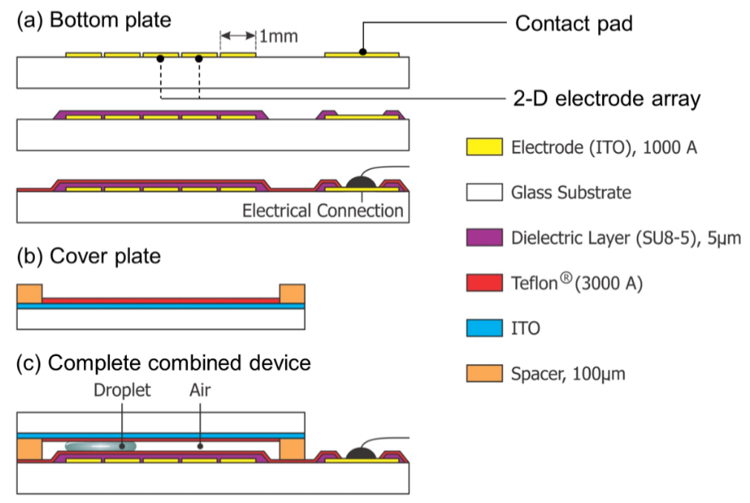
Figure S2. Schematic side view of the parallel plate EWOD system (a) bottom plate is a glass substrate which consists of two-dimensional electrode array and contact pads patterned by standard photolithography process. Dielectric and hydrophobic layers are spin coated over the electrode array (b) cover plate is a glass substrate which consists of a single grounded electrode covered by a hydrophobic coating (c) complete combined device is assembled by positioning the cover plate above the bottom plate with a suitable spacer gap.
After electrode creation, a layer of dielectric (SU-8-5, Microchem) was spin coated on the wafer. The spin speed was ramped up to 500 rpm at 100 rpm/s for 5s and then ramped up to 2000 rpm at 900 rpm/s for 30s. This resulted in 7 μm thick uniform dielectric layer. The glass substrate with the coated dielectric layer was then baked to harden the layer at 65°C for 1 min and then 95°C for 3 min. Photo Lithography was done for this dielectric layer coated glass substrate with a light dose of 90 mJ/cm² on the contact aligner (Karl Suss). The glass substrate was then soft baked at 65°C for 1 min, 95°C for 1 min and hard baked at 150°C for 5 min. A layer of Teflon was spin coated on the dielectric coated glass surface to provide hydrophobicity with following recipe; spin speed was ramped up to 1000 rpm with 300 rpm/s for 30s. This resulted in 300 nm thick uniform hydrophobic layer. After that, dielectric and hydrophobic layer coated glass substrate was annealed at 150°C for few hours (~5hrs) to increase surface uniformity (Figure B1 (a)). Electrical wiring was connected to the contact pads of the bottom plate to create interconnects between the individual electrodes and external control board circuitry.
Finally, the ITO coated cover plate was first cleaned thoroughly with non-halogenated hydrocarbons: acetone, methanol, isopropanol and then rinsed with DI water. The cover plate was then dehydrated at 150°C for 2 minutes. A layer of Teflon with 300 nm thick was spin coated on the cover plate to provide hydrophobicity, and annealed at 150°C for few hours to increase the surface uniformity (Figure B1 (b)). The parallel plate EWOD system with a sandwich drop of water between the bottom plate and the cover plate with a smaller spacer gap (~100 µm) can be seen in Figure B1 (c). In the above EWOD system, fluid droplets can be formed and manipulated in the gap while in contact with the bottom plate and the cover plate.

