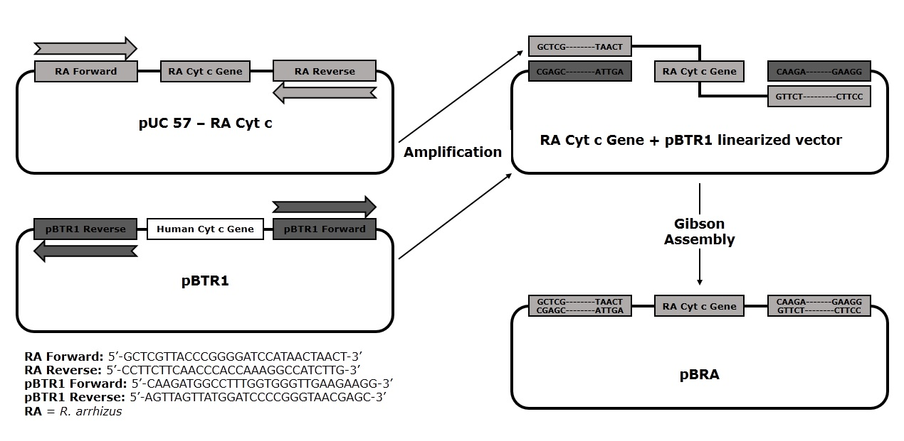

Supplementary Figure 7. The commercially synthesized R. arrhizus cyt c gene (in cloning vector pUC57) was amplified using the primers RA forward and RA reverse. The plasmid pBTR1 (containing human cyt c gene) was amplified using the primers pBTR1 forward and pBTR1 reverse, to produce the linearized pBTR1 vector (without human cyt c gene). Then, both fragments (with overlapping sequences) were incubated in a Gibson Assembly reaction to generate the pBRA plasmid with the R. arrhizus cyt c gene. R. arrhizus cyt c gene insertion was confirmed by commercial DNA sequencing (MCLAB).

