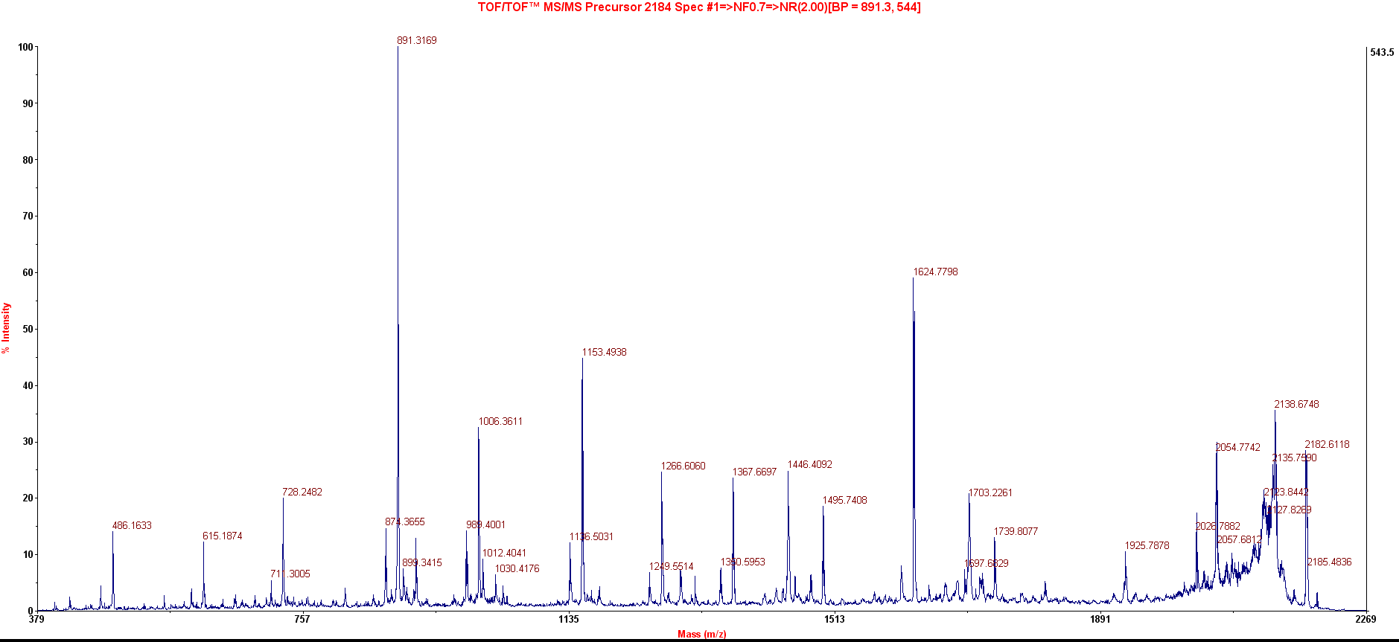
Observed Mr(expt) Mr(calc) Delta Miss Score Expect Rank Unique Peptide
2184.0000 2182.9927 2182.0582 0.9345 1 86 2e-05 1 U K.GVTWDEQTLFDYLENPKK.Y
Supplementary Figure 6. MS/MS spectra of a specific peptide to check possible tri-methylation at lysine corresponding to K-72 of budding yeast. Observed and theoretical mass of the peptide from recombinant R. arrhizus protein having the lysine corresponding to K-72 of yeast indicates the absence of tri-methylation of lysine in R. arrhizus. A tri-methylation would have increased the observed peptide mass by 42 Da (14*3).

