File 2 Consultation questionnaire for AHP indexes

Consultation Form of TCM Clinical Guidelines Application Evaluation System

Name ：
Organization：
Education：□Bachelor below □Bachelor
□Master Degree □Doctor Degree
Gender： Age：
Medical Title：□Chief Physician □Associate Chief Physician
□Doctor-in-charge □Resident Physician
Professional：
Engaged in the clinical field of Chinese medicine： years

Dear Expert：
We have been performing the study which aims to evaluate the consistency between Clinical Practice Guidelines (CPGs) of TCM and clinical practice. According to Analytic Hierarchy Process (AHP), main contents of TCM CPGs have been broken and a 3-level AHP construction was built.
Now asking for your opinion as below：
1.Suggestion for 3-level AHP construction
2.Score of the pairwise comparisons in the indexes
Sincerely thank you for your help.
Guangdong provincial hospital of Chinese Medicine 2014-5-12

Part I Suggestion for 3-level AHP construction
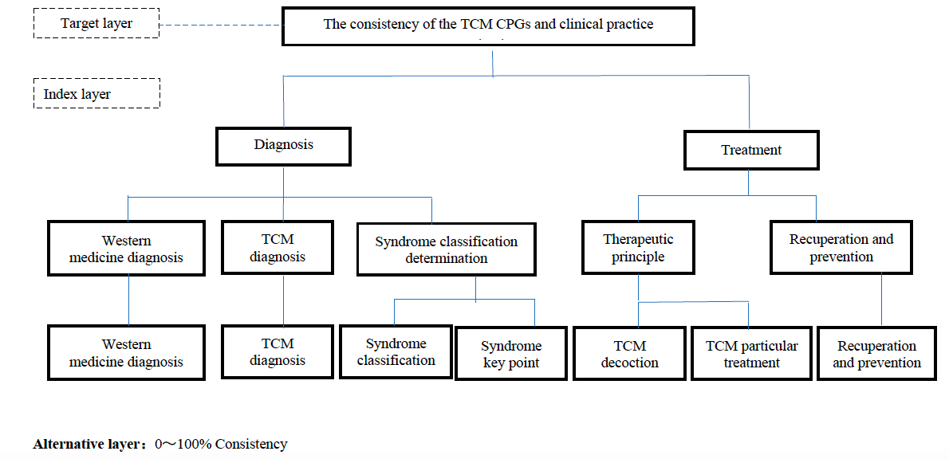
According AHP theory，TCM CPGs have been broken into 3 levels and the construction of evaluation system has been built.
Is it reasonable or needed revisions？

Part II Comparison of the importance of each evaluation indicator

This is Example for pairwise comparisons of the importance of each indexes.
Please compare the importance between the indexes of Diagnosis and Treatment

Score | 9 | 8 | 7 | 6 | 5 | 4 | 3 | 2 | 1 | 2 | 3 | 4 | 5 | 6 | 7 | 8 | 9 | Score
Diagnosis | extremely important |  | much more important |  | more important |  | slightly more important |  | same important |  | slightly more important |  | more important |  | much more important |  | extremely important | Treatment
■ ★
If you recognize Diagnosis is slightly more important than Treatment，you should choose Score 3（place marked ■）.
if you recognize Treatment is slightly more important than Diagnosis，you should choose Score 3（the place marked ★）,which would be changed to 1/3 according to AHP Saaty method.
(2, 4, 6, 8) was the intermediate value of the two adjacent degrees and was used when necessary.

1.The pairwise comparison for the primary indexes
Please compare the relative importance in the CPGs between the indexes of Diagnosis and Treatment（Score using √）
Score | 9 | 8 | 7 | 6 | 5 | 4 | 3 | 2 | 1 | 2 | 3 | 4 | 5 | 6 | 7 | 8 | 9 | Score
Diagnosis | extremely important |  | much more important |  | more important |  | slightly more important |  | same important |  | slightly more important |  | more important |  | much more important |  | extremely important | Treatment

2.The pairwise comparison for the secondary indexes

2.1 Please compare the relative importance in the CPGs between the indexes of TCM diagnosis and Western medicine diagnosis（Score using √）.
Score | 9 | 8 | 7 | 6 | 5 | 4 | 3 | 2 | 1 | 2 | 3 | 4 | 5 | 6 | 7 | 8 | 9 | Score
TCM diagnosis | extremely important |  | much more important |  | more important |  | slightly more important |  | same important |  | slightly more important |  | more important |  | much more important |  | extremely important | Western medicine diagnosis

2.2 Please compare the relative importance in the CPGs between the indexes of TCM diagnosis and Syndrome differentiation determination（Score using √）.
 | Score | 9 | 8 | 7 | 6 | 5 | 4 | 3 | 2 | 1 | 2 | 3 | 4 | 5 | 6 | 7 | 8 | 9 | Score
TCM diagnosis |  | extremely important |  | much more important |  | more important |  | slightly more important |  | same important |  | slightly more important |  | more important |  | much more important |  | extremely important | Syndrome differentiation  determination

2.3 Please compare the relative importance in the CPGs between the indexes of Western medicine diagnosis and Syndrome differentiation determination（Score using √）.
 | Score | 9 | 8 | 7 | 6 | 5 | 4 | 3 | 2 | 1 | 2 | 3 | 4 | 5 | 6 | 7 | 8 | 9 | Score
Western medicine diagnosis |  | extremely important |  | much more important |  | more important |  | slightly more important |  | same important |  | slightly more important |  | more important |  | much more important |  | extremely important | Syndrome differentiation  determination

2.4 Please compare the relative importance in the CPGs between the indexes of therapeutic principle and Recuperation and prevention（Score using √）.
 | Score | 9 | 8 | 7 | 6 | 5 | 4 | 3 | 2 | 1 | 2 | 3 | 4 | 5 | 6 | 7 | 8 | 9 | Score
Therapeutic principle |  | extremely important |  | much more important |  | more important |  | slightly more important |  | same important |  | slightly more important |  | more important |  | much more important |  | extremely important | Recuperation and prevention

3.The pairwise comparison for the tertiary indexes

3.1 Please compare the relative importance in the CPGs between the indexes of Syndrome classification and Syndrome key point（Score using √）.
 | Score | 9 | 8 | 7 | 6 | 5 | 4 | 3 | 2 | 1 | 2 | 3 | 4 | 5 | 6 | 7 | 8 | 9 | Score
Syndrome classification |  | extremely important |  | much more important |  | more important |  | slightly more important |  | same important |  | slightly more important |  | more important |  | much more important |  | extremely important | Syndrome  key point

3.2 Please compare the relative importance in the CPGs between the indexes of TCM decoction and TCM particular treatment（Score using √）
 | Score | 9 | 8 | 7 | 6 | 5 | 4 | 3 | 2 | 1 | 2 | 3 | 4 | 5 | 6 | 7 | 8 | 9 | Score
TCM decoction |  | extremely important |  | much more important |  | more important |  | slightly more important |  | same important |  | slightly more important |  | more important |  | much more important |  | extremely important | TCM particular  treatment

