Table S1. Regression results for the association between epigenetic age acceleration and blood pressure in GENOA African Americans (n=1390)

Blood pressure | Epigenetic age acceleration | Model 1 |  | Model 2 |  | Model 3
 |  | β | P | β | P | β | P
SBP | IEAA | 0.119 | 0.321 | 0.116 | 0.176 | 0.073 | 0.401
 | EEAA | 0.149 | 0.127 | 0.188 | 0.015 | 0.147 | 0.051
DBP | IEAA | -6.0E-3 | 0.924 | -0.040 | 0.374 | -0.011 | 0.797
 | EEAA | -0.021 | 0.678 | -0.072 | 0.073 | -0.049 | 0.203

Abbreviations: SBP, systolic blood pressure; DBP, diastolic blood pressure; EAA, epigenetic age acceleration; IEAA, intrinsic epigenetic age acceleration; EEAA, extrinsic epigenetic age acceleration

Model 1: Blood pressure = epigenetic age acceleration + chronological age + sex + time between methylation and blood pressure
Model 2: Blood pressure = Model 1 covariates + (SBP or DBP) + antihypertensive medication
Model 3: Blood pressure = Model 2 covariates + smoking + diabetes + BMI

P-values <0.05 are in bold.

Table S2. Beta coefficient for IEAA association with target organ damage measures in Model 2 and with Model 3 covariates added separately

Target organ damage | Model 2 |  | Model 2  + smoking |  |  | Model 2  + diabetes |  |  | Model 2  + BMI |  |  | Model 2  + albuminuria
 | β | P | β | P | Δβ (%) | β | P | Δβ (%) | β | P | Δβ (%) | β | P | Δβ (%)
UACR | 0.017 | 0.036 | 0.016 | 0.041 | 2.4 | 9.1E-3 | 0.233 | 45.5 | 0.016 | 0.044 | 4.3 | . | .
RWT | 5.4E-4 | 0.041 | 5.3E-4 | 0.045 | 1.4 | 4.7E-4 | 0.074 | 12.4 | 5.3E-4 | 0.044 | 2.2 | 5.2E-4 | 0.050 | 4.1
ABI | -1.9E-3 | 0.028 | -1.6E-3 | 0.057 | 15.9 | -1.8E-3 | 0.035 | 4.5 | -2.0E-3 | 0.019 | -6.2 | . | .

Abbreviations: IEAA, intrinsic epigenetic age acceleration; UACR, urinary albumin to creatinine ratio; RWT, relative wall thickness; ABI, ankle-brachial index

Only associations in which the beta coefficient for epigenetic age acceleration was significant (p<0.05) in Model 2 and non-significant (p>0.05) in Model 3 are shown. β and P represent the beta coefficient for IEAA from the specified regression model, P represents the corresponding p-value for the beta coefficient, and Δβ represents the percentage change in β from Model 2 to the specified model.

Model 2: Target organ damage = epigenetic age acceleration + chronological age + sex + time between methylation and target organ damage + SBP + DBP + antihypertensive medication

P-values <0.05 are in bold.

Table S3. Regression results for the association between epigenetic age acceleration and target organ damage measures among GENOA African Americans, adjusting for array type or limiting analyses to those with EPIC data
Target organ damage | Epigenetic age acceleration | Original Model 1 (N=1,416) |  | Model 1, Adjusting for Array Type (N=1,416) |  | Original Model 1 in EPIC only (N=1,074)
 |  | β | P | β | P | β | P
eGFR (n=1389) | IEAA | -0.082 | 0.444 | -0.083 | 0.440 | 1.1E-3 | 0.993
 | EEAA | 0.119 | 0.180 | 0.119 | 0.180 | 0.080 | 0.430
UACR* (n=1390) | IEAA | 0.023 | 0.004 | 0.023 | 0.004 | 0.017 | 0.059
 | EEAA | 0.010 | 0.187 | 0.010 | 0.187 | 0.013 | 0.095
RWT (n=1352) | IEAA | 6.2E-4 | 0.022 | 6.2E-4 | 0.022 | 7.1E-4 | 0.016
 | EEAA | -3.4E-5 | 0.886 | -3.4E-5 | 0.885 | 1.9E-4 | 0.448
LVMI (n=1346) | IEAA | 0.163 | 0.007 | 0.163 | 0.007 | 0.118 | 0.062
 | EEAA | 0.131 | 0.005 | 0.131 | 0.005 | 0.171 | 0.001
ABI (n=1359) | IEAA | -2.1E-3 | 0.014 | -2.1E-3 | 0.014 | -1.6E-3 | 0.107
 | EEAA | -1.2E-3 | 0.075 | -1.2E-3 | 0.077 | -1.4E-3 | 0.080
WMH*  (n=758) | IEAA | -4.2e-3 | 0.333 | -4.1E-3 | 0.340 | -3.3E-4 | 0.942
 | EEAA | 6.8e-3 | 0.068 | 6.9E-3 | 0.068 | 8.0E-3 | 0.040

Abbreviations: IEAA, intrinsic epigenetic age acceleration; EEAA, extrinsic epigenetic age acceleration; eGFR, estimated glomerular filtration rate; UACR, urinary albumin to creatinine ratio; RWT, relative wall thickness; LVMI, left ventricular mass index; ABI, ankle-brachial index; WMH, white matter hyperintensity

Original Model 1: Target organ damage = epigenetic age acceleration + chronological age + sex + time between methylation and target organ damage measure

*Variables were natural log transformed prior to analysis.

P-values <0.05 are in bold.

Table S4. Regression results for the association between epigenetic age acceleration and target organ damage measures among GENOA African Americans, adjusting for educational attainment
Target Organ Damage | Epigenetic Age Acceleration | Model 1a |  | Model 2a |  | Model 3a
 |  | β | P | β | P | β | P
eGFR (n=1389) | IEAA | -0.073 | 0.501 | -0.032 | 0.767 | -0.026 | 0.805
 | EEAA | 0.139 | 0.122 | 0.114 | 0.204 | 0.106 | 0.241
UACR* (n=1390) | IEAA | 0.022 | 0.006 | 0.016 | 0.048 | 8.1E-3 | 0.288
 | EEAA | 7.8E-3 | 0.299 | 5.4E-3 | 0.427 | 6.0E-5 | 0.993
RWT (n=1352) | IEAA | 6.4E-4 | 0.020 | 5.6E-4 | 0.036 | 4.7E-4 | 0.078
 | EEAA | -1.7E-5 | 0.943 | -2.8E-5 | 0.904 | -9.4E-5 | 0.693
LVMI (n=1346) | IEAA | 0.155 | 0.010 | 0.103 | 0.070 | 0.062 | 0.261
 | EEAA | 0.119 | 0.011 | 0.110 | 0.017 | 0.092 | 0.032
ABI (n=1359) | IEAA | -1.9E-3 | 0.030 | -1.6E-3 | 0.056 | -1.4E-3 | 0.087
 | EEAA | -7.6E-4 | 0.271 | -6.1E-4 | 0.365 | -4.9E-4 | 0.460
WMH* (n=758) | IEAA | -4.6E-3 | 0.298 | -5.8E-3 | 0.186 | -8.0E-3 | 0.071
 | EEAA | 6.4E-3 | 0.094 | 6.6E-3 | 0.077 | 5.6E-3 | 0.128

Abbreviations: IEAA, intrinsic epigenetic age acceleration; EEAA, extrinsic epigenetic age acceleration; eGFR, estimated glomerular filtration rate; UACR, urinary albumin to creatinine ratio; RWT, relative wall thickness; LVMI, left ventricular mass index; ABI, ankle-brachial index; WMH, white matter hyperintensity

Model 1a: Target organ damage = epigenetic age acceleration + chronological age + sex + time between methylation and target organ damage measure + educational attainment
Model 2a: Target organ damage = Model 1 covariates + SBP + DBP + antihypertensive medication + educational attainment
Model 3a: Target organ damage = Model 2 covariates + smoking + diabetes + BMI + educational attainment
Model 3 for RWT and LVM also includes microalbuminuria and macroalbuminuria.
All models for WMH also include total intracranial volume (TIV).

*Variables were natural log transformed prior to analysis.

P-values <0.05 are in bold.

Table S5. Regression results for the association between epigenetic age acceleration and target organ damage measures among GENOA African Americans with hypertension

Target organ damage | Epigenetic age acceleration | Model 1 |  | Model 2 |  | Model 3
 |  | β | P | β | P | β | P
eGFR (n=1126) | IEAA | -0.054 | 0.647 | -0.053 | 0.647 | -0.032 | 0.785
 | EEAA | 0.118 | 0.232 | 0.093 | 0.342 | 0.097 | 0.323
UACR* (n=1127) | IEAA | 0.021 | 0.026 | 0.019 | 0.035 | 9.3E-3 | 0.290
 | EEAA | 0.012 | 0.152 | 7.9E-3 | 0.304 | 7.4E-4 | 0.924
RWT (n=1092) | IEAA | 3.7E-4 | 0.220 | 3.9E-4 | 0.176 | 3.0E-4 | 0.306
 | EEAA | -1.7E-4 | 0.505 | -2.2E-4 | 0.379 | -2.9E-4 | 0.250
LVMI (n=1086) | IEAA | 0.124 | 0.062 | 0.115 | 0.073 | 0.070 | 0.254
 | EEAA | 0.127 | 0.017 | 0.111 | 0.035 | 0.085 | 0.083
ABI (n=1097) | IEAA | -2.3E-3 | 0.020 | -2.1E-3 | 0.028 | -1.7E-3 | 0.061
 | EEAA | -1.3E-3 | 0.112 | -1.0E-3 | 0.177 | -8.8E-4 | 0.246
WMH* (n=592) | IEAA | -5.8E-3 | 0.226 | -5.7E-3 | 0.223 | -8.5E-3 | 0.075
 | EEAA | 8.5E-3 | 0.040 | 8.2E-3 | 0.041 | 7.1E-3 | 0.071

Abbreviations: IEAA, intrinsic epigenetic age acceleration; EEAA, extrinsic epigenetic age acceleration; eGFR, estimated glomerular filtration rate; UACR, urinary albumin to creatinine ratio; RWT, relative wall thickness; LVMI, left ventricular mass index; ABI, ankle-brachial index; WMH, white matter hyperintensity

Model 1: Target organ damage = epigenetic age acceleration + chronological age + sex + time between methylation and target organ damage measure
Model 2: Target organ damage = Model 1 covariates + SBP + DBP + antihypertensive medication
Model 3: Target organ damage = Model 2 covariates + smoking + diabetes + BMI
Model 3 for RWT and LVM also includes microalbuminuria and macroalbuminuria.
All models for WMH also include total intracranial volume (TIV).

*Variables were natural log transformed prior to analysis.

P-values <0.05 are in bold.

Table S6. Heritability estimates of epigenetic age acceleration and target organ damage measures among GENOA African Americans

Measure | h² in Model 1 | h² in Model 2 | h² in Model 3
IEAA | 0.480*** | 0.508*** | 0.503***
EEAA | 0.607*** | 0.601*** | 0.603***
eGFR | 0.418*** | 0.398*** | 0.439***
UACRª | 0.381*** | 0.377*** | 0.331***
RWT | 0.276*** | 0.259*** | 0.249***
LVMI | 0.577*** | 0.520*** | 0.451***
ABI | 0.354*** | 0.355*** | 0.317***
WMHª | 0.346*** | 0.323** | 0.325**

Abbreviations: IEAA, intrinsic epigenetic age acceleration; EEAA, extrinsic epigenetic age acceleration; eGFR, estimated glomerular filtration rate; UACR, urinary albumin to creatinine ratio; RWT, relative wall thickness; LVMI, left ventricular mass index; ABI, ankle-brachial index; WMH, white matter hyperintensity; h², heritability estimate

Model 1: Epigenetic age acceleration or target organ damage measure = chronological age + sex
Model 2: Epigenetic age acceleration or target organ damage measure = Model 1 covariates + SBP + DBP + antihypertensive medication
Model 3: Epigenetic age acceleration or target organ damage measure = Model 2 covariates + smoking + diabetes + BMI + albuminuria

ªVariables were natural log transformed prior to analysis.

†p<0.1, *p<0.05, **p<0.01, ***p<0.001

Figure S1. Scatterplots of DNAm age and epigenetic age acceleration from 102 duplicated samples using 450K and EPIC array data

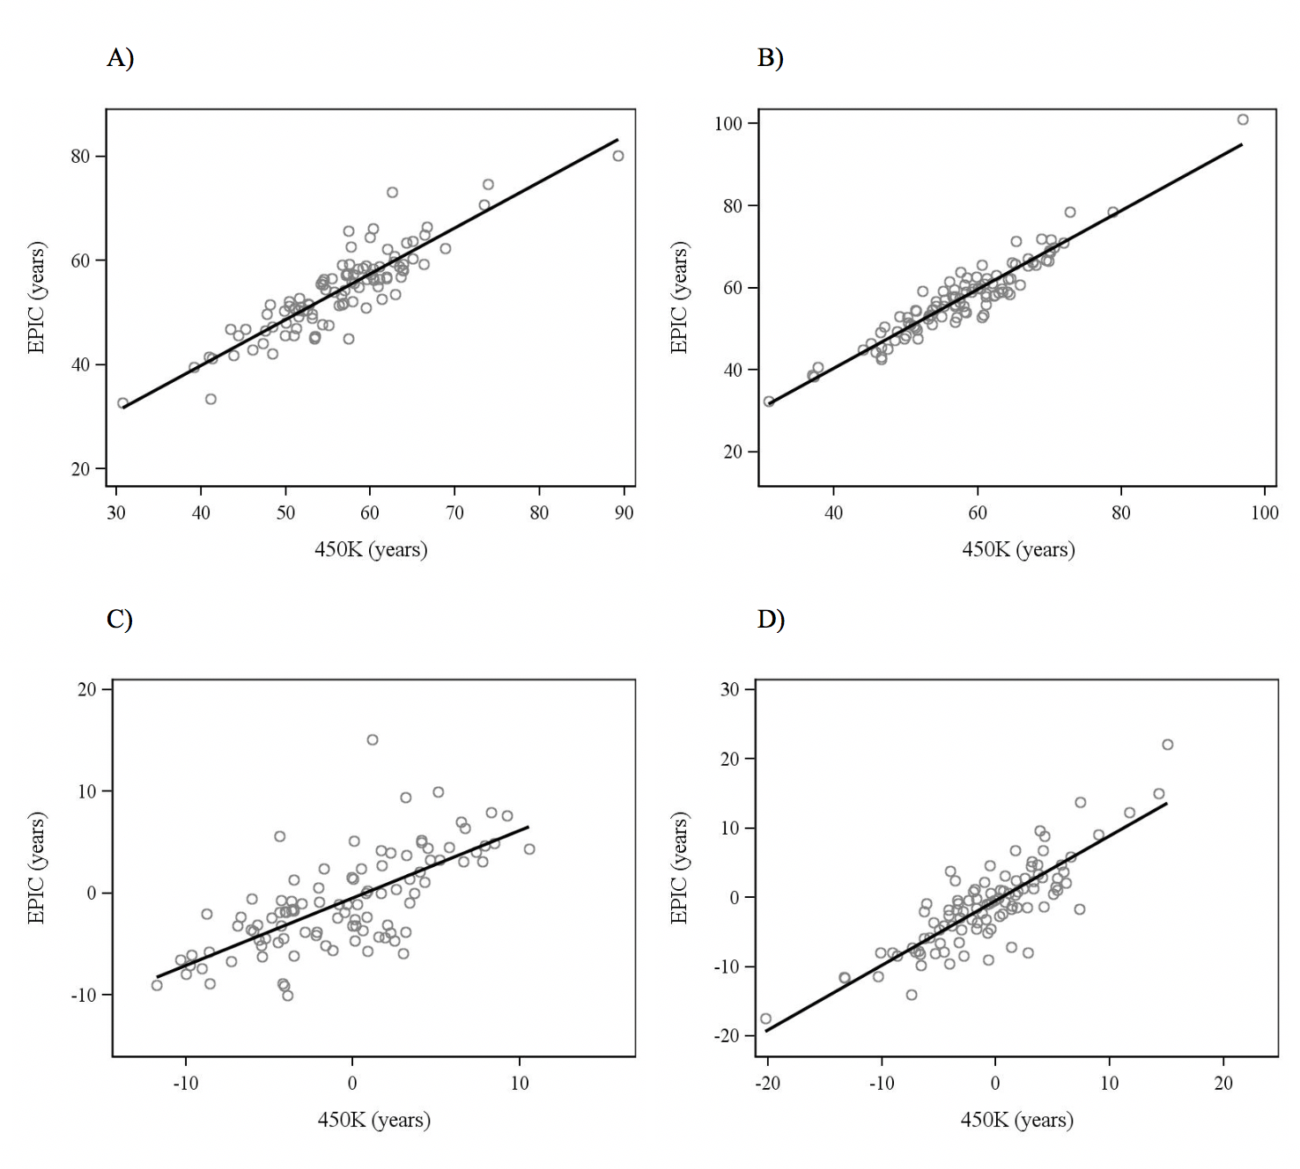
A) Horvath DNAm age (r=0.88), B) Hannum DNAm age (r=0.95), C) Intrinsic DNAm age acceleration (IEAA, r=0.70), D) Extrinsic DNAm age acceleration (EEAA, r=0.84). Linear regression lines are shown.

Figure S2. Distributions of epigenetic age acceleration measures

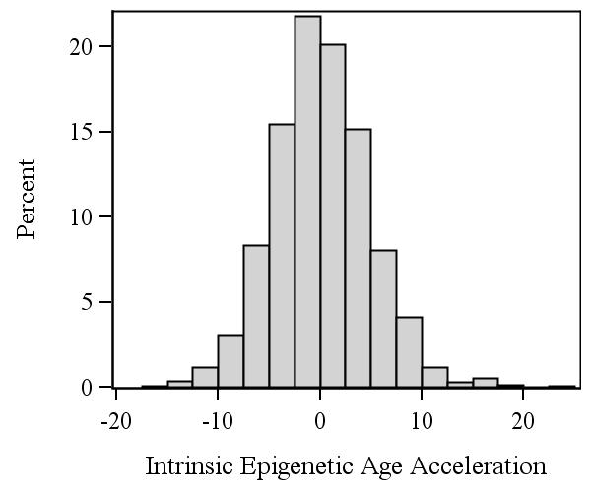
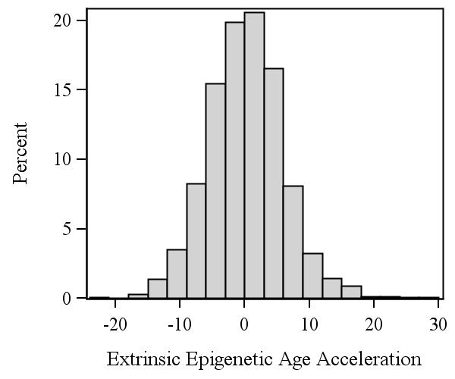
- B)

A) Intrinsic epigenetic age acceleration (IEAA); B) extrinsic epigenetic age acceleration (EEAA). Negative values indicate that the epigenetic age of the individual is younger than expected, while positive values indicate that epigenetic age is older than expected.

