Electronic Supporting Information

Nitrogen-doped porous carbon nanosheets strongly coupled with Mo₂C nanoparticles for efficient electrocatalytic hydrogen evolution
Ying Lei,^{1,2} Yong Yang,³ Yudong Liu,^{1,2} Yaxing Zhu,^{1,2} Mengmeng Jia,^{1,2} Yang Zhang,^{1,2} Ke Zhang,^{1,2} Aifang Yu^{1,2}, Juan Liu^{4*} and Junyi Zhai^{1,2*}
¹ CAS Center for Excellence in Nanoscience, Beijing Key Laboratory of Micro-nano Energy and Sensor, Beijing Institute of Nanoenergy and Nanosystems, Chinese Academy of Sciences, Beijing 100083, China.
² College of Nanoscience and Technology, University of Chinese Academy of Sciences, Beijing 100049, China
³ Department of Materials Science & Engineering, College of Engineering, Peking University, Beijing 100871, China.
^{d} College of Environmental Sciences and Engineering, Peking University, Beijing, 100871, China

Email: jyzhai@binn.cas.cn

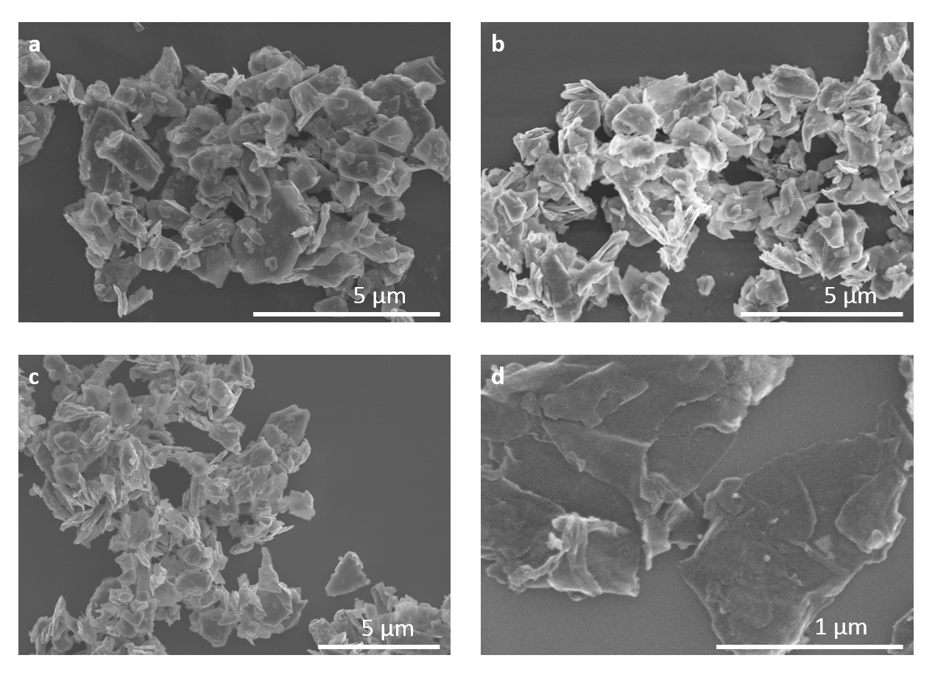

Fig. S1. SEM images of (a) c-MoS₂, (b) MoS₂@PDA, (c) MoS₂@NC and (d) Mo₂C/NPC.

Fig. S2. TGA curve of the as-prepared Mo₂C/NPC nanosheets from 100 to 700 ℃ under air gas flow with a temperature ramp of 10 ℃ min⁻¹.
For the TGA curve, the initial weight gain below 350 ℃ is due to the gradual oxidation of Mo₂C to MoO₃, followed by a significant weight loss caused by the combustion of carbon.
The remaining weight of the sample after heating to 600 ℃ is about 62 wt.%. Therefore, the Mo₂C content could be calculated from the following equation:
m (Mo₂C) = 62 wt.%*M(Mo₂C)/2M(MoO₃) = 62 wt.%*204/288 ≈ 44 wt.%

Fig. S3. The calculation of ECSA for Mo₂C/NPC.
Loading amount of the catalyst is 0.305 mg cm⁻², we assume a standard value of 60 μF/cm², C_{dl} of the catalyst is 102.4 mF cm⁻².
C=C_{dl}/m=335 F/g
ECSA=C/(60 μF cm⁻²)=558 m²/g

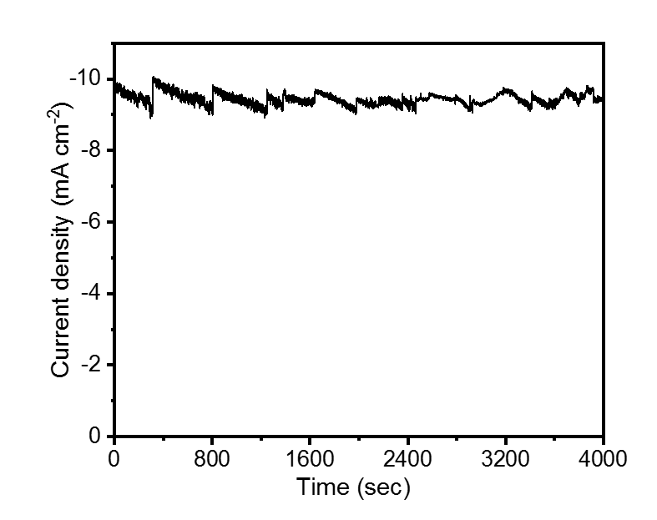
Fig. S4. Chronoamperometric response at the potential of -0.166 V vs. the RHE.

Tab. S1. Comparison of the exchange current density (j₀) in acidic media for Mo₂C/NPC with other non-noble metal electrocatalysts.
Catalysts | j₀ (μA cm⁻²) | Ref.
Mo₂C/NPC | 37.4 | This work
nw-W4MoC | 29 | [1]
Mo₂C Nanotubes | 17 | [2]
Mo₂C/CNT | 14 | [3]
Mo₂C/GCSs | 12.5 | [4]
β-Mo₂C-20 | 33 | [5]
Mo–Mo₂C-0.077 | 19 | [6]
MoC_{x} | 23 | [7]

References
1. Xiao P, Ge X, Wang H, Liu Z, Fisher A, and Wang X (2015) Novel Molybdenum Carbide-Tungsten Carbide Composite Nanowires and Their Electrochemical Activation for Efficient and Stable Hydrogen Evolution. Adv Funct Mater 25:1520-1526
2. Ma F X, Wu H B, Xia B Y, Xu C Y, and Lou X W (2015) Hierarchical β-Mo2 C Nanotubes Organized by Ultrathin Nanosheets as a Highly Efficient Electrocatalyst for Hydrogen Production. Angew Chem Int Ed 54:15395
3. Chen W F, Wang C H, Sasaki K, Marinkovic N, Xu W, Muckerman J T, Zhu Y, and Adzic R R (2013) Highly active and durable nanostructured molybdenum carbide electrocatalysts for hydrogen production. Energy Environ Sci 6:943
4. Cui W, Cheng N, Liu Q, Ge C, Asiri A M, and Sun X (2014) Mo2C Nanoparticles Decorated Graphitic Carbon Sheets: Biopolymer-Derived Solid-State Synthesis and Application as an Efficient Electrocatalyst for Hydrogen Generation. ACS Catal 4:2658-2661
5. Tang C, Sun A, Xu Y, Wu Z, and Wang D (2015) High specific surface area Mo 2 C nanoparticles as an efficient electrocatalyst for hydrogen evolution. Journal of Power Sources 296:18-22
6. Jie D, Qiang W, Huang C, Yao W, and Xu Q (2018) Cost Effective Mo Rich Mo2C Electrocatalysts for Hydrogen Evolution Reaction. J Mater Chem A 10.1039.C1038TA02550A
7. Wu H B, Xia B Y, Yu L, Yu X Y, and Lou X W (2015) Porous molybdenum carbide nano-octahedrons synthesized via confined carburization in metal-organic frameworks for efficient hydrogen production. Nat Commun 6:6512

