Additional File 6: The originate plant and voucher specimen of Pyrola decorata H. Andres (Luxiancao).

Antioxidant and Cytoprotective Effects of Pyrola decorata H. Andres and Its Five Phenolic Components
Ban Chen ^{1,2}, Xican Li ^{1, 2*}, Jie Liu ^{3, 4}, Wei Qin ^{3, 4}, Minshi Liang ^{1, 2}, Qianru Liu ^{1, 2}, Dongfeng Chen ^{3, 4, *}
¹ School of Chinese Herbal Medicine, ² Innovative Research & Development Laboratory of TCM, ³ School of Basic Medical Science, ⁴ The Research Center of Integrative Medicine, Guangzhou University of Chinese Medicine, Guangzhou, China, 510006.

* Corresponding author. E-mail: lixican@126.com; chen888@gzucm.edu.cn
E-mail Addresses
Ban Chen: imchenban@foxmail.com
Xican Li: lixican@126.com; lixc@gzucm.edu.cn
Jie Liu: 15014173165@163.com
Wei Qin: qinwei2017210@163.com
Minshi Liang: lminshi@outlook.com
Qianru Liu: liuqianru2333@163.com
Dongfeng Chen: chen888@gzucm.edu.cn

Address: School of Chinese Herbal Medicine, Guangzhou University of Chinese Medicine, Waihuan East Road No.232, Guangzhou Higher Education Mega Center, 510006, Guangzhou, China.
Homepage http://www.researchgate.net/profile/Xican_Li

Tel: +86-20-39358076 Fax: +86-20-38892690 Paper type: Research Article
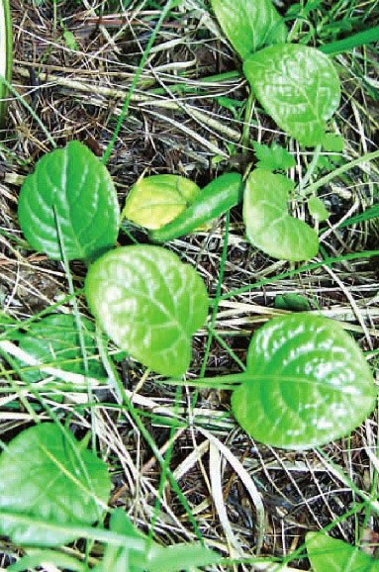
Fig. S6.1 The original plant of Pyrola decorata H. Andres

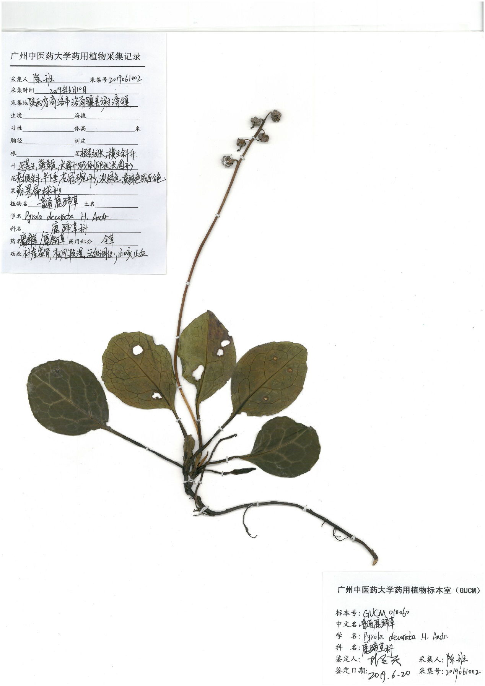

Fig. S6.2 The voucher specimen of Pyrola decorata H. Andres

