Additional file 3: Flowchart in the derivation set by sex
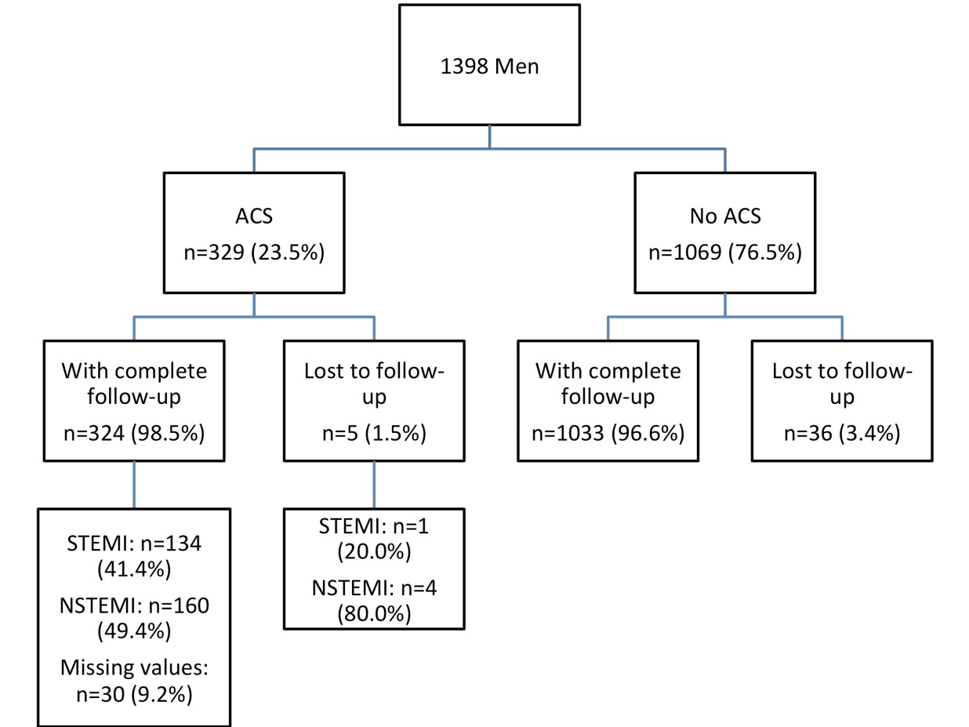
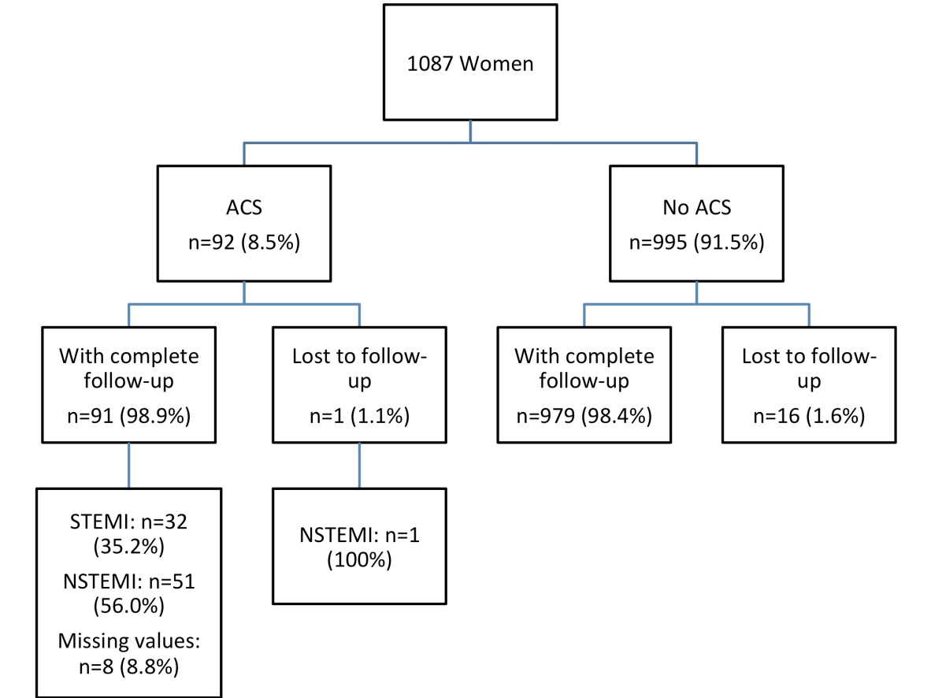

ACS, acute coronary syndrome; STEMI, ST elevation myocardial infarction; NSTEMI, non– ST elevation myocardial infarction

