Supplementary Information

Table S1. Characteristics of gold particles.

 | Characterization of gold particles
 | Au-NPs | Au-MPs
TEM image | 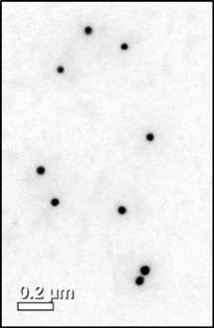 | 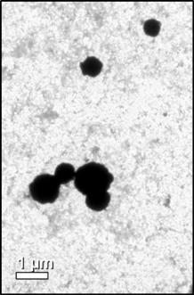
Mean primary particle size (nm) (TEM) | 40 ± 1 | 637 ± 9
Hydrodynamic diameter (nm) | 151 ± 18 | 480 ± 180
Zeta potential (mV) | −10.7 ± 1.5 | −22.2 ± 6.5
- For further information, please refer to our earlier publication.^{[7]}
- Optical property of Au-NPs was identified by the absorption spectra at the wavelength 500-550 nm.
- Data are expressed as means ± S.E.M.

Table S2. Effects of Au-NPs and Au-MPs on bEnd.3 cell viability.

Table S2-1.
Au-NPs (ng/mL) | Cell viability (%)
 | 60 min treatment |  | 24 h treatment
 | bEnd.3 | bEnd.3 Cav1-KD | bEnd.3 | bEnd.3 Cav1-KD
0 | 100.00 ± 0.00 | 100.00 ± 0.00 | 100.00 ± 0.00 | 100.00 ± 0.00
10 | 102.06 ± 2.96 | 100.84 ± 0.69 | 101.05 ± 2.60 | 99.51 ± 1.88
50 | 102.03 ± 2.83 | 100.83 ± 1.69 | 101.02 ± 3.56 | 97.85 ± 1.78
100 | 100.84 ± 1.56 | 101.96 ± 0.40 | 99.89 ± 4.13 | 98.01 ± 1.28
500 | 100.93 ± 3.77 | 100.25 ± 0.53 | 97.20 ± 13.60 | 97.96 ± 0.75
Table S2-2.
 | Cell viability (%)
Au-MPs (ng/mL) | bEnd.3
0 | 100.00±0.00
10 | 102.47±2.96
50 | 100.56±5.00
100 | 102.39±5.14
500 | 100.87±6.17
- Cell viability was evaluated using the MTT assay. Briefly, bEnd.3 cells were treated with series of concentrations of Au-NPs or Au-MPs for 24 h or 60 min. After incubation, MTT reagent was added to the cultures, and cells were incubated at 37°C for another 2 h. Finally, the medium was gently removed, and the formazan was dissolved in DMSO. Absorption was measured at 570 nm.
- Data are expressed as means ± S.D. (N = 5).
- Treatment with Au-NPs exerted no clear cytotoxicity on bEnd.3 cells.

Table S3. Primer sets for qPCR
Gene | Sense primer | Antisense primer
mAQP1 | CTGCTGGCGATTGACTACACTG | GGTTTGAGAAGTTGCGGGTGAG
mCav1 | GACCCCAAGCATCTCAACGA | GCCATTGGGATGCCGAAGA
mActin | TGTCCACCTTCCAGCAGATGT | AGCTCAGTAACAGTCCGCCTAG

Figure S1.
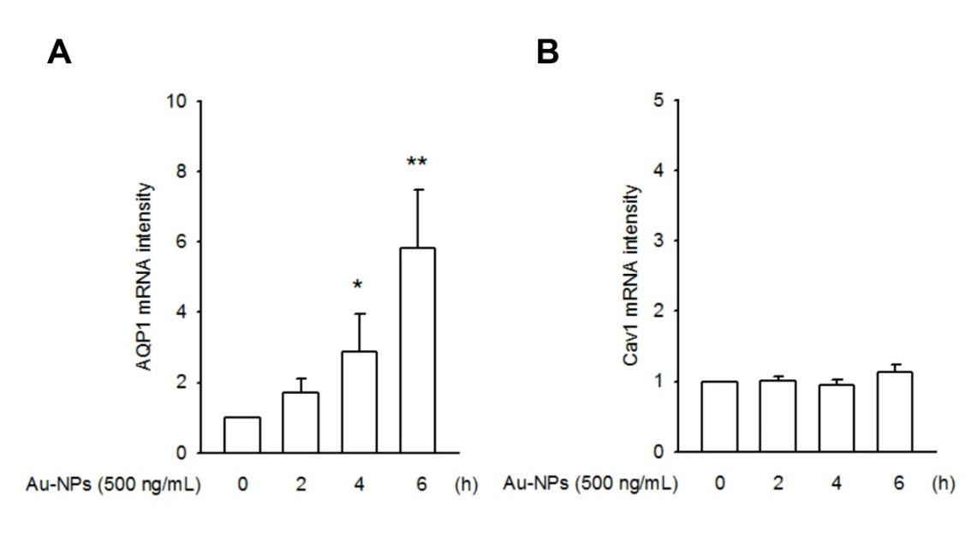
Figure S1. Changes in mRNA level of AQP1 and Cav1 in Au-NP-treated bEnd.3 cells. We found that AQP1 was up-regulated in its mRNA level after 4-6 h Au-NP (500 ng/ml) treatment (A), whereas the expressing level of Cav1 was remained unaltered (B). (* p < 0.05, ** p < 0.01, indicates statistically significant difference from the control treatment; N = 5).
Figure S2.
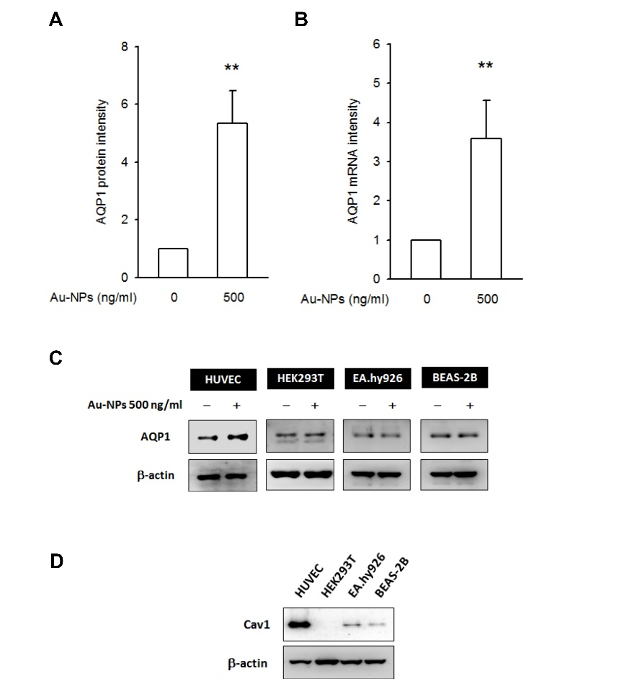

Figure S2. Au-NPs did not induce AQP1 expression in cells with hypo-expression level of Cav1. (A/B) Au-NP-induced AQP1 expression was presented in human umbilical vein endothelial cells (HUVEC), either in transcriptional level (N = 10) or in translational level (N = 5). (** p < 0.01, indicates statistically significant difference from the control group). (C/D) As compared to those cells with a hypo-expressing Cav1 (such as HEK293T, EA.hy926, and BEAS-2B), the HUVECs were abundant in its Cav1 protein level and responded to Au-NP treatment. No Au-NP-induced AQP1 expression were found in HEK293T (human embryonic kidney cell), EA.hy926 (a permanent hybrid cell line established by fusing HUVEC with A549), and BEAS-2B (an immortalized, normal human bronchial epithelial cell line).

Figure S3.
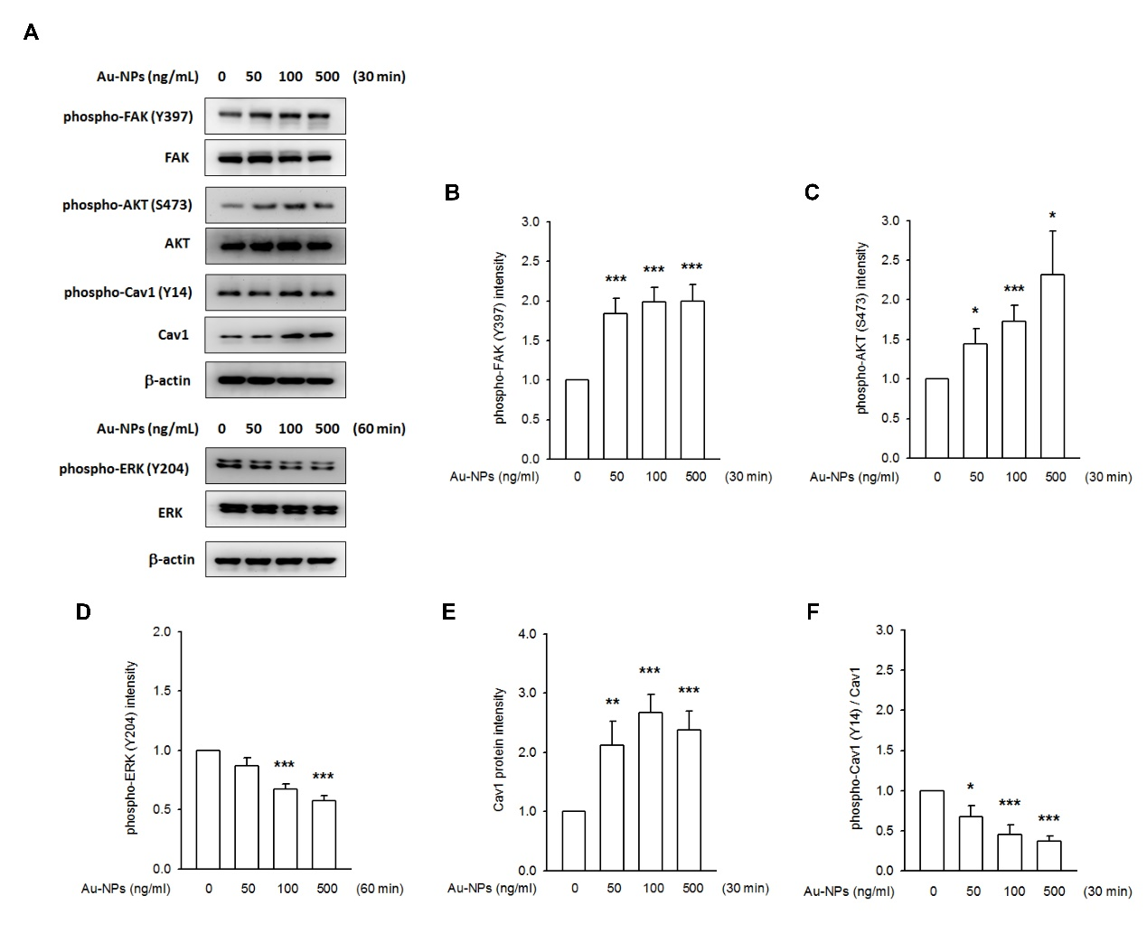
Figure S3. Au-NP treatment rapidly changed the phosphorylating status of FAK, AKT and ERK in concentration-dependent manner. bEnd.3 cells were incubated with Au-NPs (50, 100, 500 ng/mL) for 30 or 60 min. (A) Representative images showed an augmentation of FAK and AKT phosphorylation; an accumulation of Cav1 protein, but a reduced Cav1 phosphorylation level, after 30 min Au-NP treatment. A reduction of ERK activity was found after 60 min Au-NP treatment. Quantified data was gained by densitometry analysis, followed by a normalized process to their total form. (B) phospho-FAK, (C) phospho-AKT, (D) phospho-ERK, (E) Cav1 and (F) phospho-Cav1. (* p < 0.05, ** p < 0.01, and *** p < 0.001 indicates statistically significant difference from the control group; N > 7).
Figure S4.
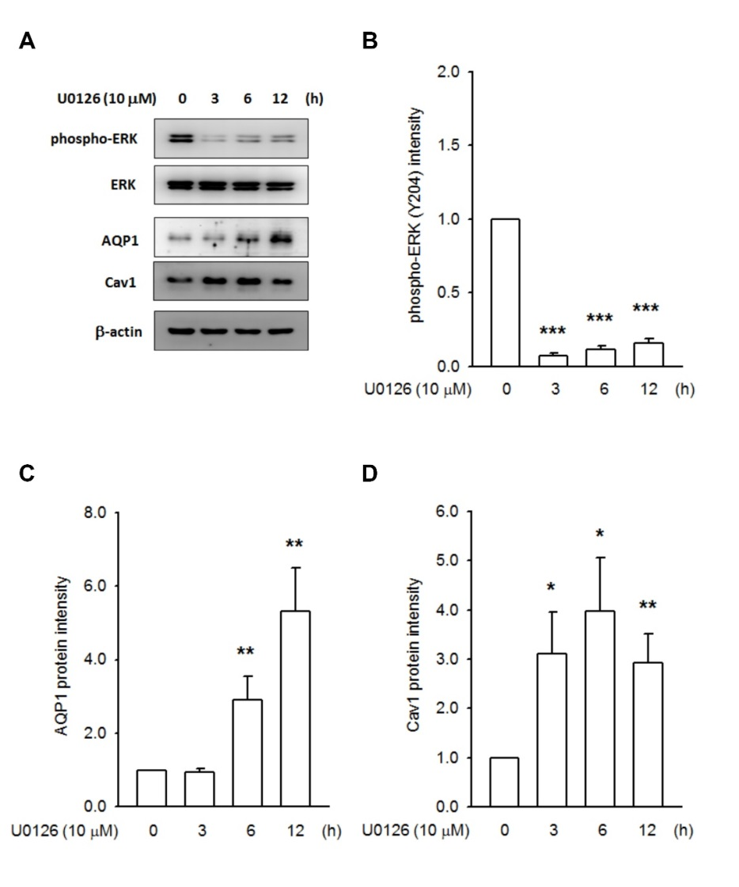
Figure S4. The ERKs functioned as the negative controller on Cav1 and AQP1 expression in bEnd.3 cells. bEnd.3 cells were incubated with ERK inhibitor, U0126 (10 μM) for 0, 3, 6 and 12 h. (A) Representative images showed the repression on ERK activity. A remarkable accumulation of Cav1 protein was observed after 3 h incubation, and sustained at least 12 h. In parallel, the AQP1 was increased after 6 h incubation. Quantified data was gained by densitometry analysis, followed by a normalized process to their total form or β-actin. (B) phospho-ERK, (C) AQP1, and (D) Cav1. (* p < 0.05, ** p < 0.01, and *** p < 0.001 indicates statistically significant difference from the control group; N = 4).
Figure S5.

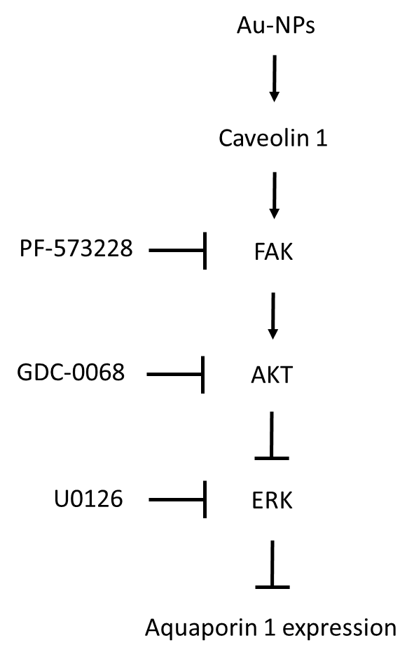
Figure S5. Proposed signaling pathway responsible for Au-NP-mediated AQP1 expression in bEnd.3 endothelial cells Au-NP exposure rapidly increased the Cav1 protein level, boosted the phosphorylation levels of FAK and AKT (after 15-30 min treatment), and reduced phospho-ERK level (after 60 min treatment). Neither these signaling molecules nor AQP1 expression responded to Au-NPs while Cav1 was silenced. The inhibition of AKT (GDC-0068) or FAK (PF-573228) has no obvious influence on Au-NP-mediated Cav1 accumulation, but rescued Au-NP-mediated ERK de-phosphorylation and prevented AQP1 induction. PF-573228 decreased the phospho-AKT level induced by Au-NPs, whereas GDC-0068 failed to prevent Au-NP-induced FAK phosphorylation, suggested FAK may be an upstream effector of AKT. Inhibition of ERK activity (U0126) remarkably enhanced AQP1 expression in bEnd.3 cells. These data demonstrate that Au-NP-mediated AQP1 induction is Cav1 dependent, but requires the repression on ERK activity.

