Table S1. Primers and probes of 18s rRNA malaria parasites according to Perandin et al.
Species | Primer and probe | Sequence | Product size
P. falciparum | FAL-F  FAL-R  FAL probe | 5’-CTTTTGAGAGGTTTTGTTACTTTGAGTAA  5’-TATTCCATGCTGTAGTATTCAAACACAA  5’ FAM-TGTTCATAACAGACGGGTAGTCATGATTGAGTTCA-TEMRA | 98
P. vivax | VIV-F  VIV-R  VIV probe | 5’-ACGCTTCTAGCTTAATCCACATAACT  5’-ATTTACTCAAAGTAACAAGGACTTCCAAGC  5’ TET-TTCGTATCGACTTTGTGCGCATTTTGC-TEMRA | 141

Table S2: Parameters of the QCs independents of the model used on this study. NOTE. SD: Standard deviation.

QC | Pre-processing | Calculation of relative concentration | Thresholds
H₂O(g) | Normalization | Abs at 3846 cm⁻¹ – Abs at 3852 cm⁻¹ | < Average - 1.5 SD  > Average + 1.5 SD
MeOH | First Derivative | Abs at 1029 cm⁻¹ – Abs at 1033 cm⁻¹ | > Average +1.5 SD
Sample | None | Absorbance at 1650 cm⁻¹ | < Average -1.5 SD

Table S3 summarizing the comparison of malaria diagnosis by light microscopy and serological RDT against the gold standard real time-PCR analysis (a). Diagnostic sensitivity and specificity of RDT (b) and light microscopy (c) were calculated.
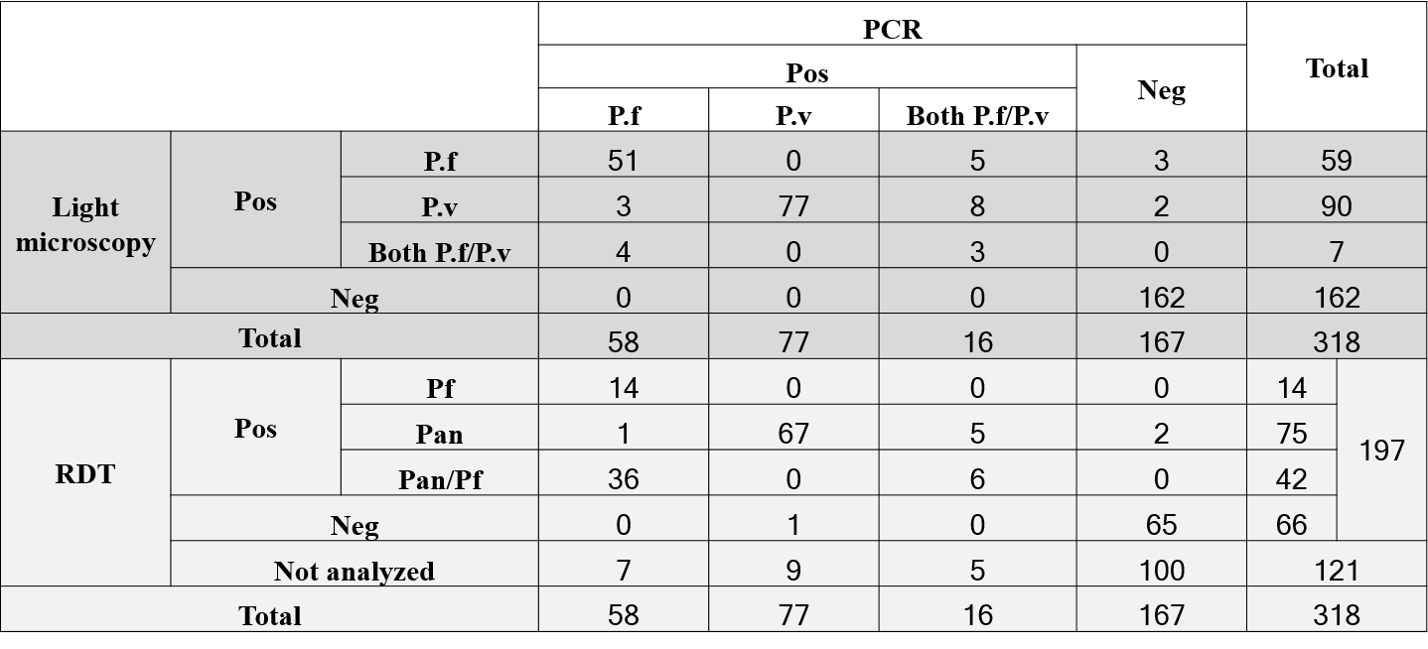
a

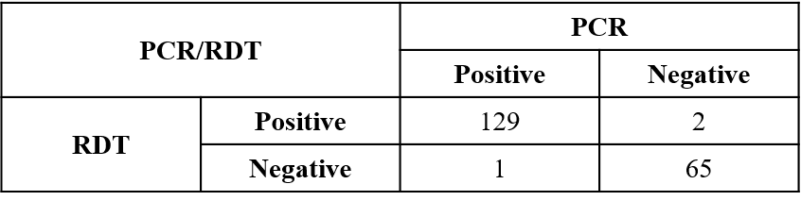
b

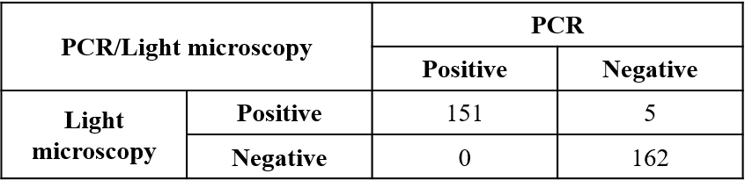
c

