Supplementary material

Rapid One-step Enzyme Immunoassay and Lateral Flow Immunochromatographic Assay for Colistin in Animal Feed and Food
Jiayi Wang ¹, Jinyu Zhou ¹, Yiqiang Chen ^{1, *}, Xinpei Zhang ¹, Yongpeng Jin ¹, Xiaoqian Cui ¹, Dongting He ¹, Wenqing Lai ¹, Lidong He ²

¹ Beijing Advanced Innovation Center for Food Nutrition and Human Health, and State Key Laboratory of Animal Nutrition, College of Animal Science and Technology, China Agricultural University, Beijing, China
² Department of Chemistry and Biochemistry, Florida State University, Tallahassee, FL, USA

* Corresponding author:
Yiqiang Chen, Ph. D, Associate Professor
Tel: (86-10)62733764; Fax: (86-10)62733588; E-mail: yqchen@cau.edu.cn

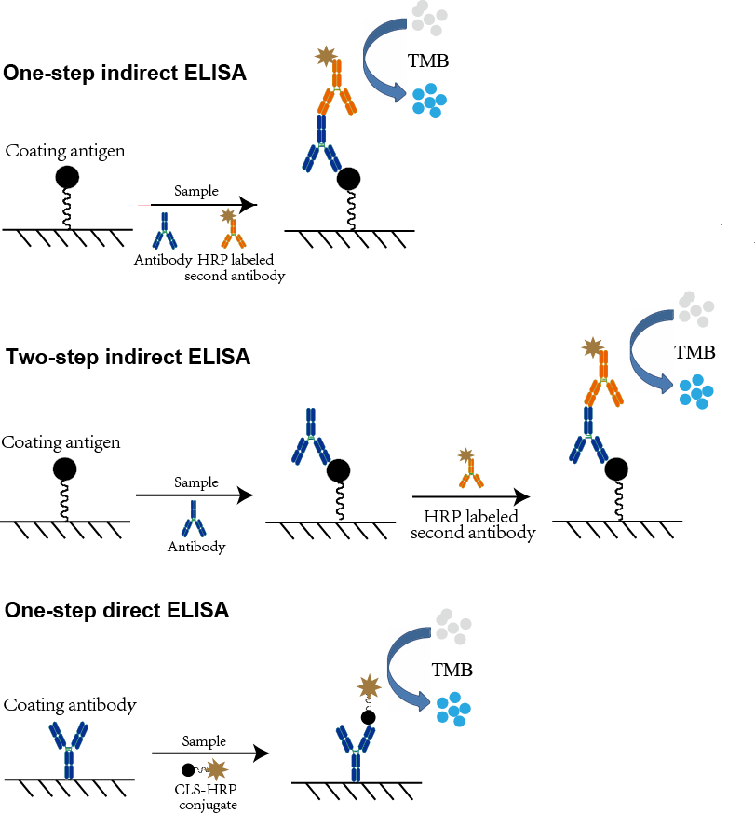
Fig. S1 Schemes of one-step indirect ELISA, two-step indirect ELISA and one-step direct ELISA for colistin.

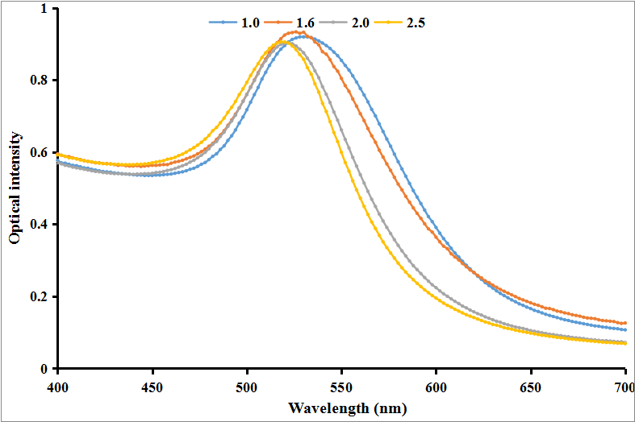
Fig. S2 Ultraviolet-visible spectrum of four GNPs solutions synthesized by reducing chlorauric acid with 1.0, 1.6, 2.0 and 2.5 mL of citrate solution.

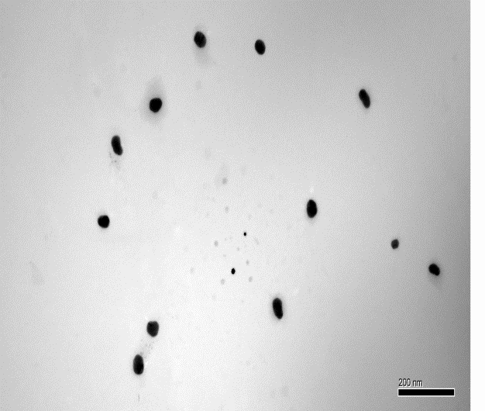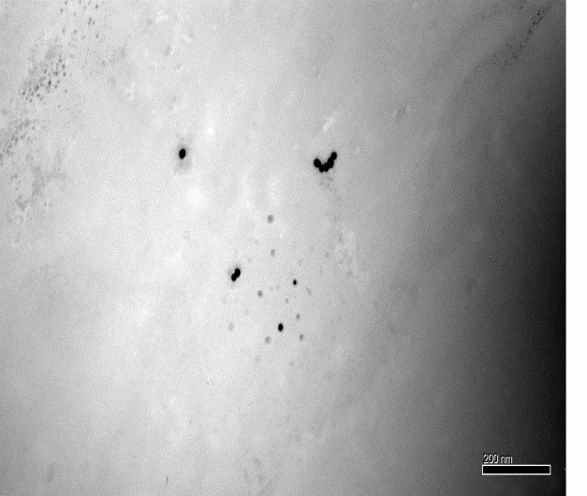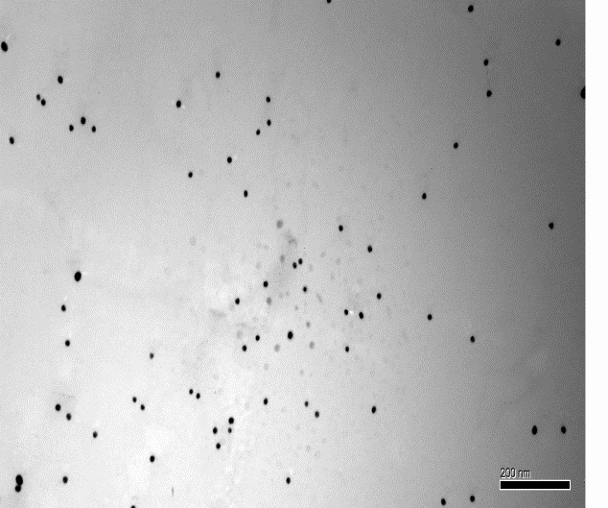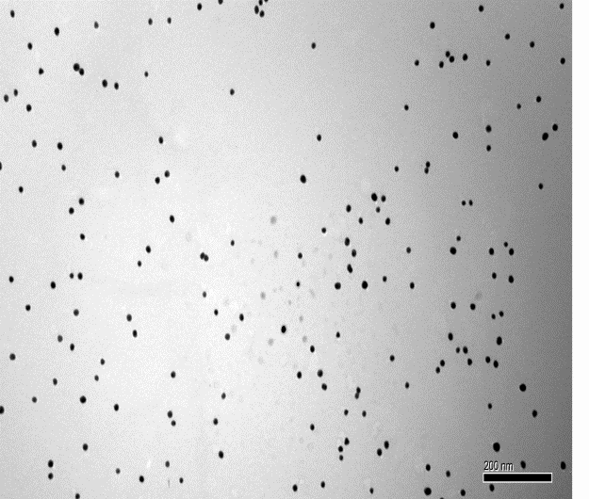
- A
- B
- C
- D

Fig. S3 TEM images of four GNPs solutions synthesized by reducing chlorauric acid with 1.0 mL (A), 1.6 mL (B), 2.0 mL (C) and 2.5 mL (D) of citrate solution.

Table S1 The IC₅₀ values of all sera from mice immunized with two different dosages.
Group 1 | 1 | 2 | 3 | 4 | 5 | 6 | 7 | 8 | 9 | 10
IC₅₀ values (ng/mL) | 82 | 111 | 93 | 77 | 68 | 85 | 116 | 133 | 121 | 89
Group 2 | 1 | 2 | 3 | 4 | 5 | 6 | 7 | 8 | 9 | 10
IC₅₀ values (ng/mL) | 124 | 149 | 88 | 95 | 101 | 79 | 76 | 112 | 86 | 92
Note: Group 1: Low dosage group, 15 μg per immunization; Group 2: High dosage group, 60 μg per immunization.

Table S2 Comparison of one step ci-ELISA, two step ci-ELISA and one step cd-ELISA regarding IC₅₀ values and assay time (n=4).
 | One step ci-ELISA | two step ci-ELISA | one step cd-ELISA
IC₅₀ value (ng/mL) | 9.7±0.2 | 9.1±0.1 | 23.7±0.4
Assay time | ~60 min | ~110 min | ~60 min

Table S3 Comparison of the developed ELISA method with that literature reported enzyme immunoassay.
Limit of detection | Assay accuracy | Assay precision | Literature
30 ng/mL in buffer | --- | --- | Kitagawa et al., 1985
10.9 μg/kg in milk | 116-146% | 10.8-56.2% | Suhren and Knappstein, 2005
5.9 μg/kg in milk | 87.44-110.13%, | 8.91-10.78% | This study

Table S4 Detection results of colistin in actual animal feed by ELISA, LFIA and HPLC method.
Sample No. | 1 | 2 | 3 | 4 | 5 | 6 | 7 | 8 | 9 | 10
Sample type | Swine feed | Swine feed | Swine feed | Swine feed | Swine feed | Swine feed | Chicken feed | Chicken feed | Chicken feed | Chicken feed
ELISA, mg/kg | 24.5 | － | 19.7 | － | 6.7 | － | － | 14.2 | － | －
LFIA, mg/kg | 23.9 | － | 18.4 | － | 7.6 | － | － | 15.4` | － | －
LC-MS, mg/kg | 26.3 | － | 20.9 | － | 7.3 | － | － | 14.7 | － | －
Sample No. | 11 | 12 | 13 | 14 | 15 | 16 | 17 | 18 | 19 | 20
Sample type | Chicken feed | Chicken feed | Milk | Milk | Milk | Milk | Meat | Meat | Meat | Meat
ELISA, mg/kg | 10.7 | － | － | － | － | － | － | 0.091 | － | －
LFIA, mg/kg | 9.9 | － | － | － | － | － | － | 0.087 | － | －
LC-MS, mg/kg | 10.2 | － | － | － | － | － | － | 0.096 | － | －

