ADDITIONAL FILE 1
Aryl Hydrocarbon Receptor Modulates Stroke-induced Astrogliosis and Neurogenesis in the Adult Mouse Brain
Wan-Ci Chen¹, MSc; Li-Hsin Chang², BS; Shiang-Suo Huang³, PhD; Yu-Jie Huang¹, BS; Chun-Lien Chih⁴, AS; Hung-Chih Kuo⁵, PhD; Yi-Hsuan Lee^{1*}, PhD; I-Hui Lee^{2, 6*}, MD, PhD
¹Department and Institute of Physiology, National Yang-Ming University, Taipei, Taiwan; ²Institute of Brain Science, Brain Research Center, National Yang-Ming University, Taipei, Taiwan; ³Department of Pharmacology, Institute of Medicine, Chung-Shan Medical University, Taichung, Taiwan; ⁴Cheng-Hsin General Hospital, Taipei, Taiwan; ⁵Stem Cell Program, Institute of Cellular and Organismic Biology, Academia Sinica, Taipei, Taiwan; ⁶Division of Cerebrovascular Diseases, Neurological Institute, Taipei Veterans General Hospital, Taipei, Taiwan
*Contributed equally
Corresponding author:
I-Hui Lee, MD, PhD
Address: No.201, Sec. 2, Shipai Rd., Beitou District, Taipei City, Taiwan 11217
Phone: +886-2-28712121 ext.8109
Fax: +886-2-28757579
E-mail address: ihlee@vghtpe.gov.tw
Yi-Hsuan Lee, PhD
Address: No.155, Sec. 2, Linong Street, Beitou District, Taipei City, Taiwan 11217
Phone: +886-2-28267067
Fax: +886-2-28264049
E-mail address: yhlee3@ym.edu.tw
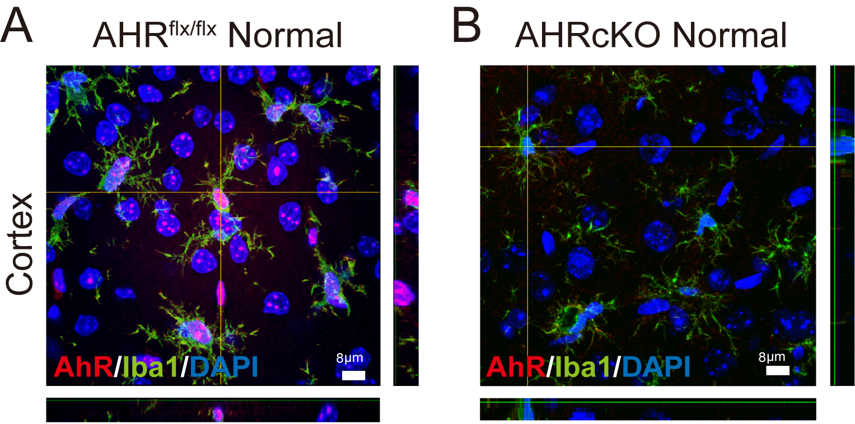
Figure S1. Representative immunohistochemical staining for AHR intracellular distribution.
Depending on the status of AHR expression and the availability of AHR ligands, which is presumably different among cells, AHR ligands would bind to cytoplasmic AHR for its activation and nuclear translocation dynamically. Compared with the normal AHRcKO which had little AHR immunoreactivity (B), the normal AHR^{flx/flx} (A) showed predominantly nuclear distribution of AHR immunoreactivity, and to a lesser extent in the cytoplasm in Iba1-positive and Iba-1 negative cells.

Figure S2. The expression levels of 84 candidate genes and 5 housekeeping genes from the ipsilesional hemisphere by neurogenesis array.
(A) The array data obtained by real-time polymerase chain reaction (RT-PCR). Changes beyond 1±0.5-fold are shown as differentially expressed genes. The WT-Vehicle group show the upregulated gene expression of S100β, Cxcl1, Bmp2, Tgfβ1, Odz1 and downregulated Mef2c, Ngn2 and Ngn1 at 48 hours after MCAO. In contrast, the WT-TMF group downregulated the gene expression of S100β, Cxcl1, Bmp2, Tgfβ1, and Odz1 and upregulated Mef2c, Ngn2 and Ngn1 compared with vehicle treatment after MCAO. (B) On the other hand, in the AhR^{flx/flx} group, upregulated S100β and Cxcl1 gene expression was observed after MCAO. In AhRcKO mice, downregulated S100β and Cxcl1 and upregulated Ngn2, Nr2e3 and Cdk5rap2 gene expression were noted compared with the AhR^{flx/flx} group after MCAO (n=3/each group). (C) In summary of the 84 gene expression regulation, the common changes by pharmacological inhibition (TMF, marked in blue) and AhRcKO mice (marked in pink) were S100β, Cxcl1, Ngn2, and Ngn1 (marked in purple). #p<0.05 compared with the respective normals. *p<0.05 WT-TMF compared with the WT-Vehicle and AhRcKO compared with the AhR^{flx/flx}.

