Additional file

Development of a simple and high-yielding fed-batch process for the production of porcine circovirus type 2 virus-like particle subunit vaccine
Wenlong Cao ª†, Hui Cao^{b}†, Xiaoping Yi ª* and Yingping Zhuang ª
ª school of biotechnology, East China University Of Science and Technology, Shanghai, 200237, China.
^{b} Zhejiang EBVAC Biotech CO., LTD., Hangzhou, Zhejiang, 310018, China.

† These authors contribute equally to this paper.
*Corresponding authors:
#Address correspondence to Xiaoping Yi, xpyi_ecust@sohu.com.

Additional tables:
Table S1 Assigned concentrations of variables at different levels in Plackett–Burman design for cap protein production in Sf9 cells
S.no | Variables with designate | Low level | High level
 |  | (-1) | (+1)
1 | X1 Amino acids mixture¹ | 0 | 3.88 g/L
2 | X2 Hydrolysate
 | Yeast extract | 0 | 4 g/L
 | Rice extract | 0 | 2 g/L
3 | X3 Lipids mixture² | 0 | 1×
4 | X4 Vitamin mixture³ | 0 | 2 g/L
5 | X5 Inorganic Salts mixture⁴ | 0
6 | X6 disacchride
 | Maltose | 0 | 1 g/L
 | Sucrose | 0 | 1.65 g/L
7 | X7 Organic acid
 | pyruvic acid | 0 | 6 mM
 | α- ketoglutaric acid | 0 | 6 mM
¹Amino acids mixture: 0.9 g/L Pro, 0.05 g/L His, 0.1 g/L Met, 0.08 g/L Lys, 0.05 g/L Ser, 0.6 g/L Thr, 1 g/L Trp, 1.2 g/L Cys, 0.9 g/L Tyr.
²Lipids mixture (Sigma-Aldrich, cat. L5146)
³Vanderzant vitamin mixture for insects (Sigma-Aldrich, cat.V1007)
⁴Inorganic Salts mixture: 0.4 mg/L (NH₄)₆MO₇O₂₄·4H₂O, 0.5 mg/L CoCl₂·6H₂O, 2 mg/L CuCl₂·2H₂O, 5.5 mg/L FeSO₄·7H₂O, 0.2 mg/L MnCl₂·4H₂O, 0.4 mg/L ZnCl₂

Table S2 Plackett–Burman design for 7 variables with coded values and observed results of the maxium cell density in SFM
S.No. | X1 | X2 | X3 | X4 | X5 | X6 | X7 | Maxium density
1 | -1 | 1 | 1 | -1 | 1 | -1 | -1 | 15.36
2 | 1 | 1 | -1 | 1 | -1 | -1 | -1 | 12.28
3 | 1 | 1 | 1 | -1 | 1 | 1 | -1 | 14.28
4 | -1 | 1 | -1 | -1 | -1 | 1 | 1 | 10.26
5 | 1 | 1 | -1 | 1 | 1 | -1 | 1 | 12.69
6 | 1 | -1 | 1 | -1 | -1 | -1 | 1 | 7.36
7 | -1 | -1 | -1 | -1 | -1 | -1 | -1 | 11.84
8 | -1 | -1 | 1 | 1 | 1 | -1 | 1 | 9.32
9 | 1 | -1 | 1 | 1 | -1 | 1 | -1 | 10.38
10 | 1 | -1 | -1 | -1 | 1 | 1 | 1 | 8.05
11 | -1 | -1 | -1 | 1 | 1 | 1 | -1 | 10.00
12 | -1 | 1 | 1 | 1 | -1 | 1 | 1 | 6.66
ªThe maxium cell density is the average value of the triplicate cultures with the unit of 106 cells/mL viable cells

Table S3 Analysis of the results for Plackett-Burman design
S.NO. | Variables | Coefficient | P value | Confidence
 |  |  |  | Level (%)
X1 | Amino acids | -30.7 | 0.613 | 38.7
X2 | Hydrolysate | 300.3 | 0.012 | 98.8
X3 | Lipid | 28.0 | 0.642 | 35.8
X4 | Vitamins | -39.7 | 0.519 | 48.1
X5 | Inorganic salts | 24.7 | 0.106 | 59.4
X6 | disaccharide | -96.3 | 0.175 | 92.5
X7 | Organic acids | -172.7 | 0.015 | 98.5

Additional Figures:
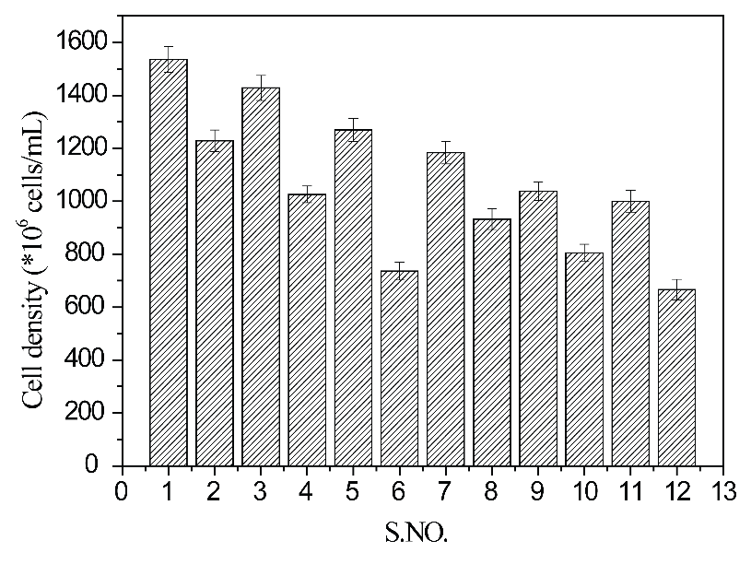
Fig. S1 The maximum cell density in Sf9 cultures following nutrient concentrate additions were made according the Plackett-Burman design in the exponential growth phase. The data shown represents the average of three parallel flask experiments. Error bars represent the standard deviation.

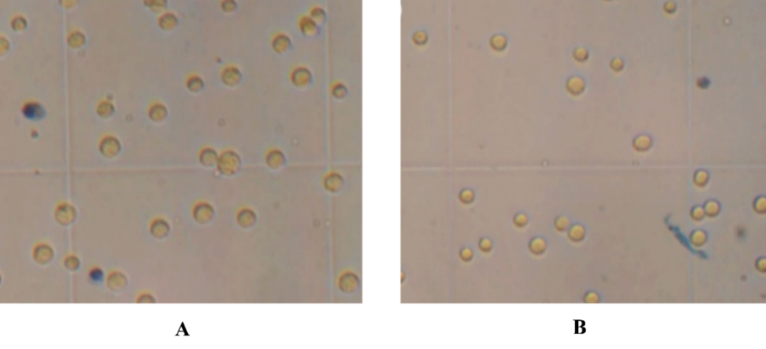
Fig. S2 Image of Sf9 cells under a microscope (400×) in group C(A) and group D(B).

