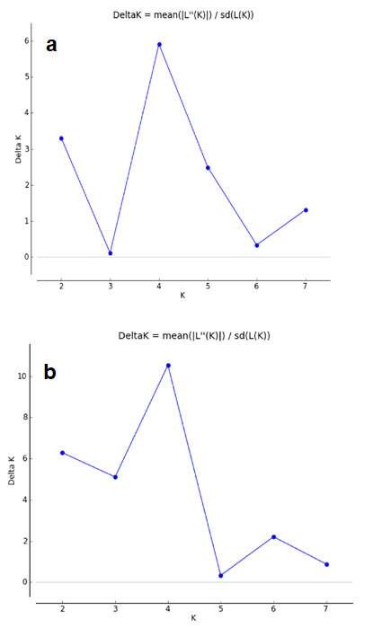
Additional file 5: Figure S2. Evanno plot derived from STRUCTURE HARVESTER depicting the most likely number of genetic clusters. a. No-admixture model. b. Admixture model.

