Additional file 5
Optimization of Saccharomyces cerevisiae α-galactosidase production and application in the degradation of raffinose family oligosaccharides
María-Efigenia Álvarez-Cao, María-Esperanza Cerdán, María-Isabel González-Siso and Manuel Becerra*
Universidade da Coruña. Grupo EXPRELA, Centro de Investigacións Científicas Avanzadas (CICA), Departamento de Bioloxía, Facultade de Ciencias, A Coruña, Spain
*Corresponding author‘s e-mail: manu@udc.es

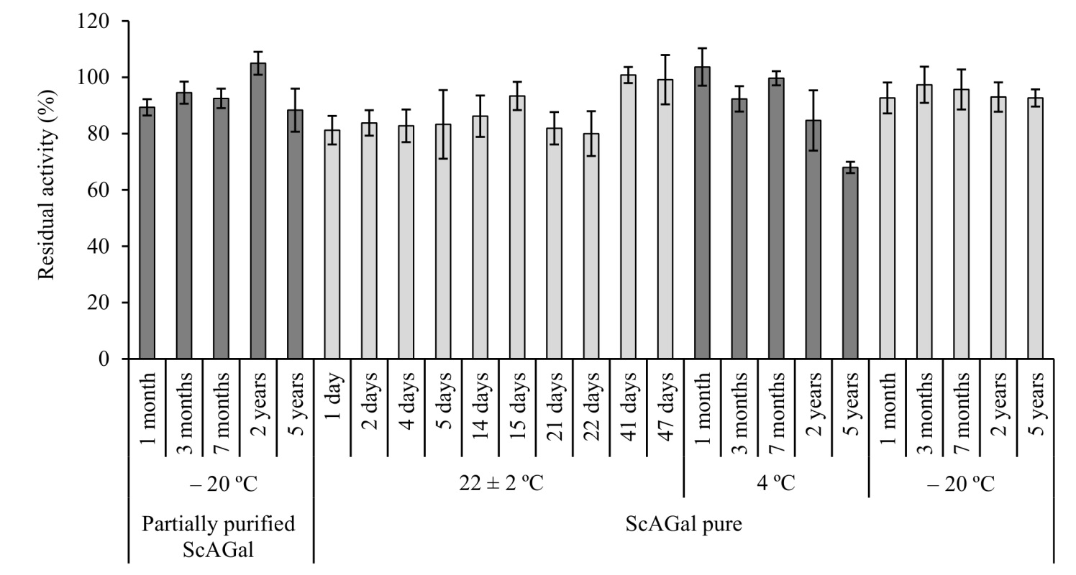
Fig. S3. Conservation conditions of ScAGal. Residual activity reached from partially purified ScAGal batches stored at -20°C and pure ScAGal batches stored at RT (22 ± 2°C), 4°C and -20°C. (Mean ± DS, N = 3).

