Additional file 4
Optimization of Saccharomyces cerevisiae α-galactosidase production and application in the degradation of raffinose family oligosaccharides
María-Efigenia Álvarez-Cao, María-Esperanza Cerdán, María-Isabel González-Siso and Manuel Becerra*
Universidade da Coruña. Grupo EXPRELA, Centro de Investigacións Científicas Avanzadas (CICA), Departamento de Bioloxía, Facultade de Ciencias, A Coruña, Spain
*Corresponding author‘s e-mail: manu@udc.es

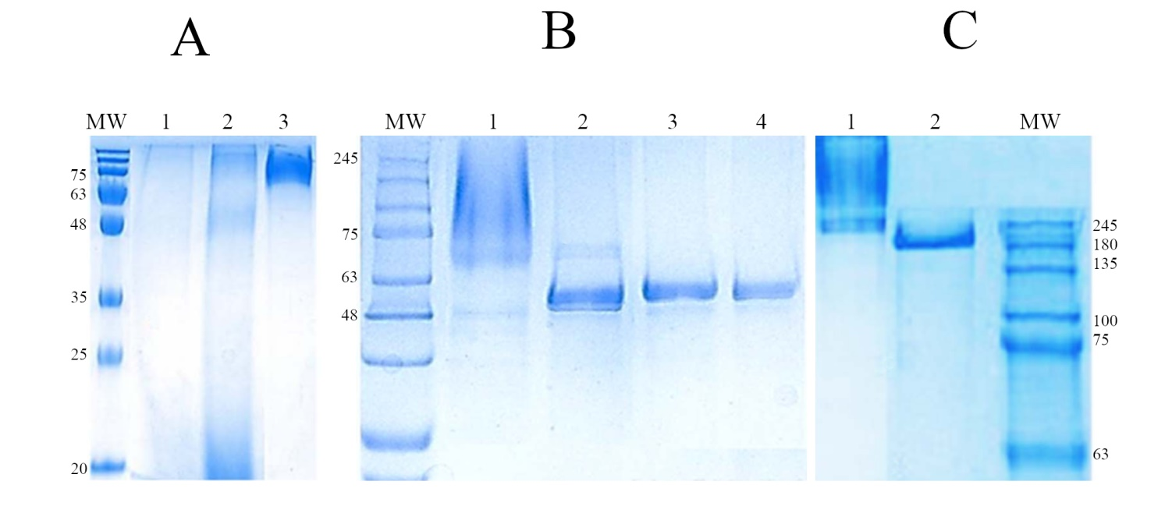
Fig. S2. PAGE analysis of ScAGal. (A) Purification steps in 10% SDS-PAGE: 28 μg of extracellular culture medium (lane 1), 16 μg of concentrated medium (lane 2), 3.5 μg of protein purified by affinity chromatography (lane 3); (B) Monomeric form in 8% SDS-PAGE: glycosylated (7 μg) and deglycosylated (2 μg) protein (lanes 1 and 2, respectively), 1.8 μg of deglycosylated protein purified by molecular exclusion (lane 3), 0.5 μg of freeze-dried deglycosylated protein (lane 4); (C) Tetrameric form in 8% Native-PAGE: 7 μg of glycosylated (lane 1) and 2 μg of deglycosylated (lane 2) protein. MW, molecular weight marker (NZYColour Protein Marker II, Nzytech).

