Additional file 3
Optimization of Saccharomyces cerevisiae α-galactosidase production and application in the degradation of raffinose family oligosaccharides
María-Efigenia Álvarez-Cao, María-Esperanza Cerdán, María-Isabel González-Siso and Manuel Becerra*
Universidade da Coruña. Grupo EXPRELA, Centro de Investigacións Científicas Avanzadas (CICA), Departamento de Bioloxía, Facultade de Ciencias, A Coruña, Spain
*Corresponding author‘s e-mail: manu@udc.es
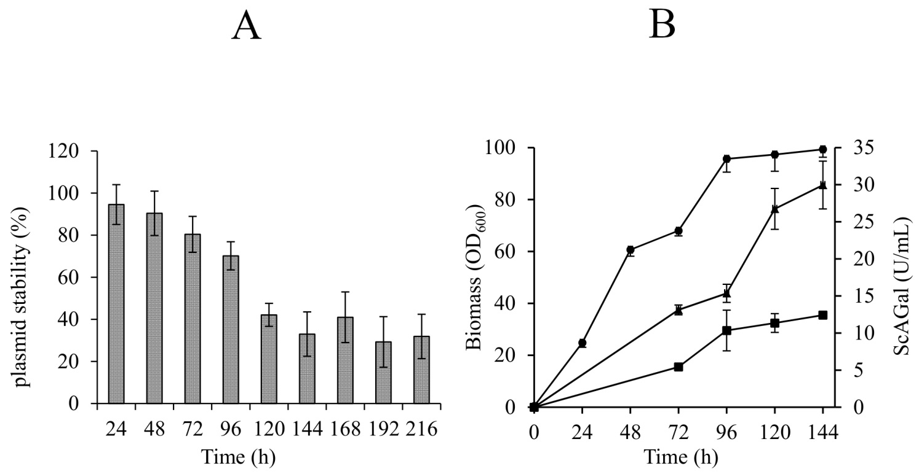
Fig. S1. Plasmid stability (A) and typical profile of cell growth (circle), extracellular (square) and intracellular (triangle) α-galactosidase (B) activity of cultures of BJ3505/YEpMEL1His. Mean ± DS, N = 3.

