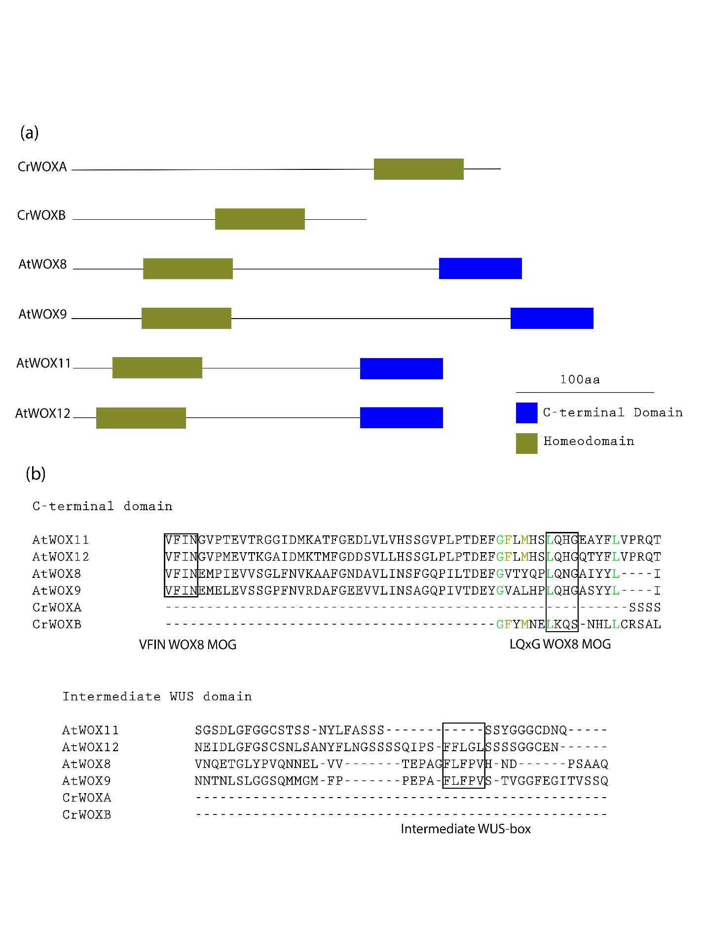

**Figure S3.** Protein domain comparison of intermediate clade WOX proteins from *A. thaliana* and *C. richardii*. (a) Model of intermediate clade WOX proteins from *C. richardii* and *A. thaliana*, green boxes represent the homeodomain and blue the C-terminal domain. (b) T-Coffee sequence alignment of *C. richardii* and *A. thaliana* intermediate WOX proteins domains. Specific motifs are outlined, and conserved residues are highlighted in green, less conserved sites are highlighted in yellow.