Supplementary informations

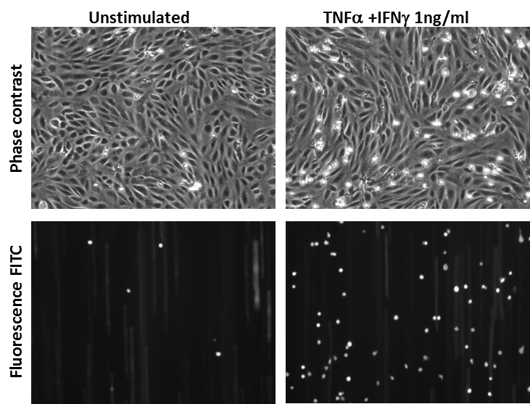
Fig. S1: Representative picture of shear-resistant firmly adhered Jurkat cells to hCMEC/D3 cells. TOP PANELS Phase contrast pictures of confluent hCMEC/D3 cells stimulated with combination of cytokine (TNFα + IFNγ) at 1 ng/ml for 24 h (RIGHT PANEL) or left unstimulated (LEFT PANEL). BOTTOM PANELS Fluorescent pictures (λ_{ex}= 495, λ_{em}= 521) of firmly adhered Jurkat T cells to hCMEC/D3 cells. Field of view (640 x 480 μm).

Parameter | Equation | Definitions | Unit
Shear rate (γ) | γ = 8v  d | γ = Shear rate  v= Linear fluid velocity  d= Inside diameter of the vessel | [1/s]
Dynamic viscosity (μ) (mu) | F = μ A u  y | The magnitude F of this force is found to be proportional to the speed u and the area A of each wall, and inversely proportional to their separation y. | cP(centipoise)  1cP= 1mPa s  =[0.01dyn.s/cm²]  = η (eta)
Flow rate (Φ) | Φ = v⋅ Α | V = Velocity of the blood flowing  A = Cross sectional vector of the vessel | Φ [ml/min]
Shear stress (τ) | τ = μ ⋅ γ | Newtonian fluids flowing upon a planar surface  τ = Shear stress  γ = Shear rate  μ = Dynamic viscosity | [dyn/cm² ]

Table S1: Parameters to determine shear stress for vessel blood flow. Assuming that the vessel is inelastic, cylindrical and straight, and, the blood is a Newtonian fluid and flow is laminar, the Haagen-Poiseuille equation indicates that the shear stress is directly proportional to blood shear rate and inversely proportional to vessel diameter. Shear stress (τ) depends on shear rate (γ) and dynamic viscosity (μ), which are related to the properties of the fluid, and the geometry of the vessel. Blood and water`s dynamic viscosities are 1.2 cP and 1 cP, respectively.

Pulled thought Ibidi channel u-slide IV ^{0.4} | Shear stress |  | Time (min)
Leukocyte in media | 0.5 dyn/cm² | 0.28 ml/min | 5
Media only | 1.5 dyn/cm² | 0.85 ml/min | 0.5

Table S2: Parameters used for flow based adhesion in Ibidi channel u-slide IV ^{0.4.} Data about the geometry of the chamber can be found at www.ibidi.com.

