SUPPLEMENTARY FIGURES
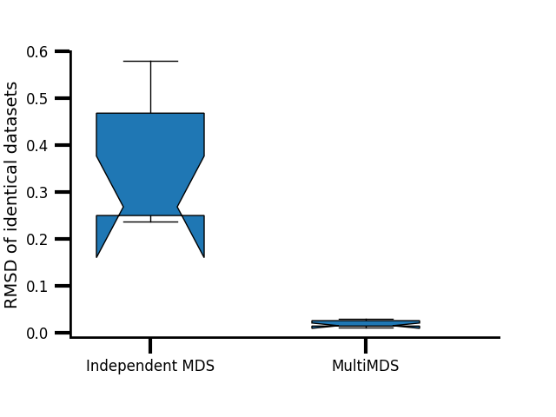
Supplementary Figure 1. Root mean square distance (RMSD) of aligned structures from identical datasets (GM12878 chr21, 100-kb resolution) independently inferred and aligned from multiple iterations of MDS (left) and jointly inferred and aligned from MultiMDS (right). Each algorithm was tested 10 times.
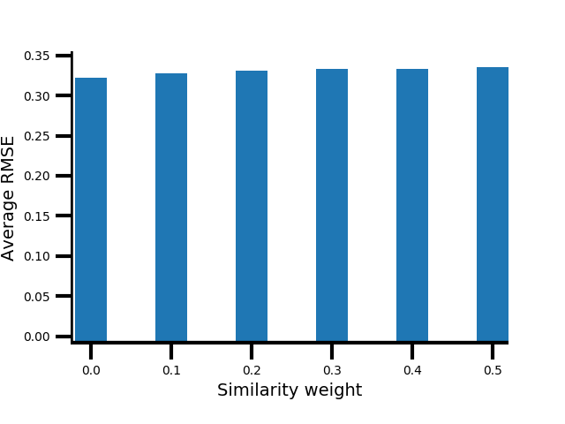
Supplementary Figure 2. Embedding error for MultiMDS run on GM12878 and K562 chr21, measured across a range of similarity weights.
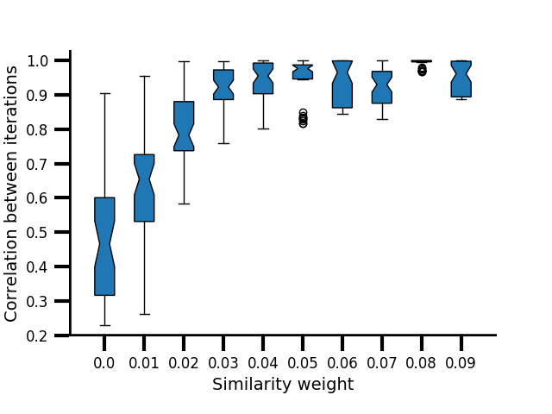
Supplementary Figure 3. Pairwise correlations between multiple runs of MultiMDS applied to mESC and mouse hepatocyte chr19, measured across a range of similarity weights. Zero weight represents independent inference and alignment.
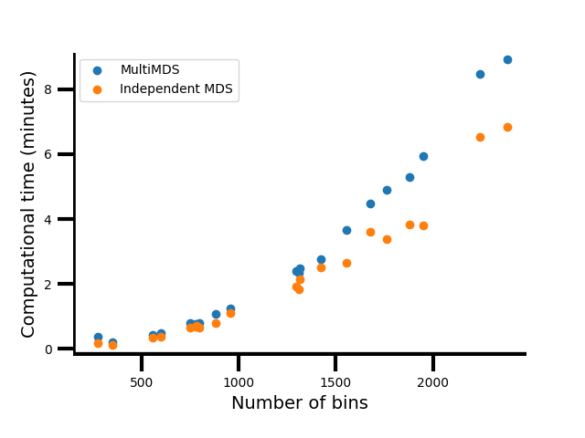

Supplementary Figure 4. Computational time for intrachromosomal datasets of various sizes, measured for MultiMDS and for independent MDS structural inference followed by alignment.

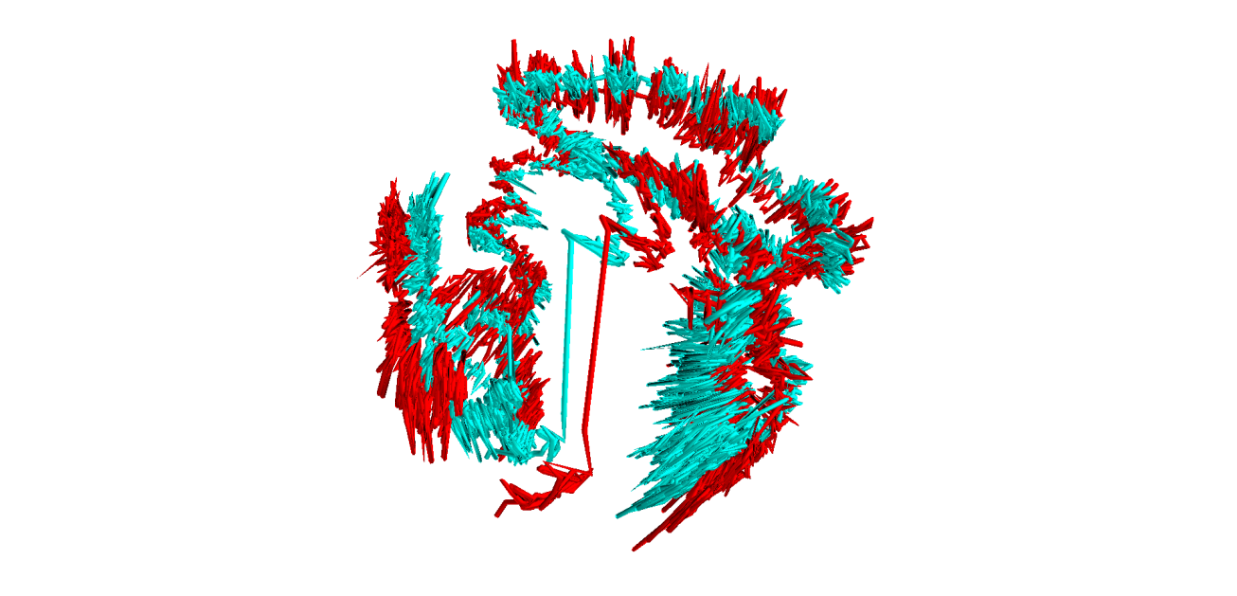
Supplementary Figure 5. MultiMDS applied to GM12878 (red) and K562 (cyan) chr21 datasets at 5-kb resolution. Only loci with average mappability > 0.75 are shown.
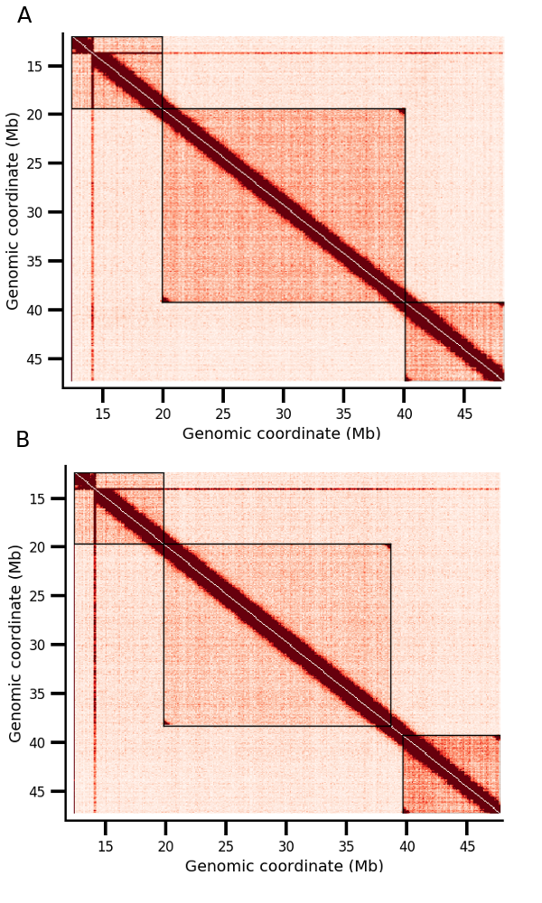
Supplementary Figure 6. Simulated chr21 Hi-C contact heatmaps. Black boxes are shown around CIDs. A simulated differential CID boundary is found at 40 Mb in A and 39 Mb at B.
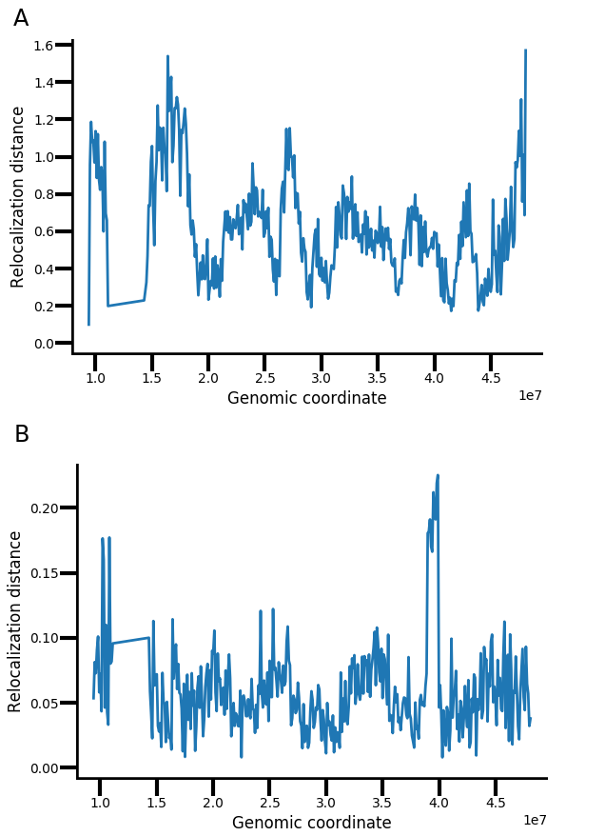
Supplementary Figure 7. Relocalization between two simulated datasets calculated with independent MDS inference and alignment (A) and MultiMDS (B).

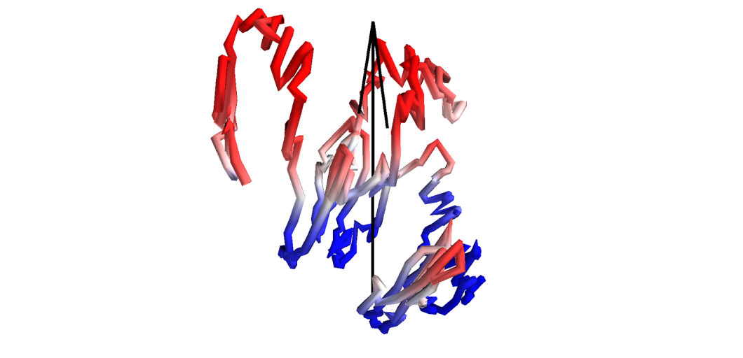
Supplementary Figure 8. Compartment score plotted on GM12878 chr21 at 100-kb resolution. Positive scores (corresponding to A compartment) are plotted in reds, and negative scores (corresponding to B compartment) are plotted in blues. The structure has been rotated so that the SVR axis (arrow) aligns with the z axis. Pericentromeric regions have been removed.
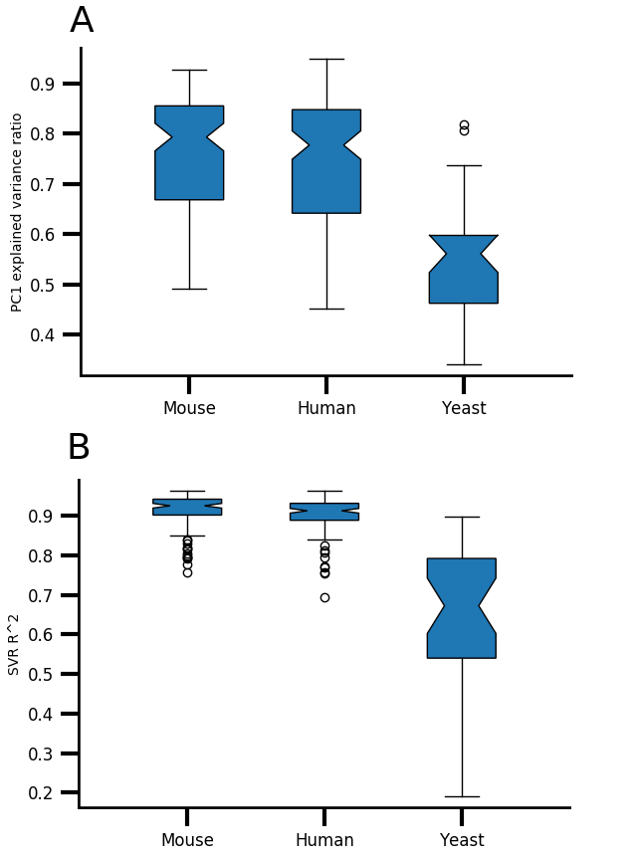
Supplementary Figure 9. A) Variance explained by PC1 of Hi-C correlation matrix by species. B) Linear SVR coefficient of determination of compartment scores predicted by 3D coordinates by species.
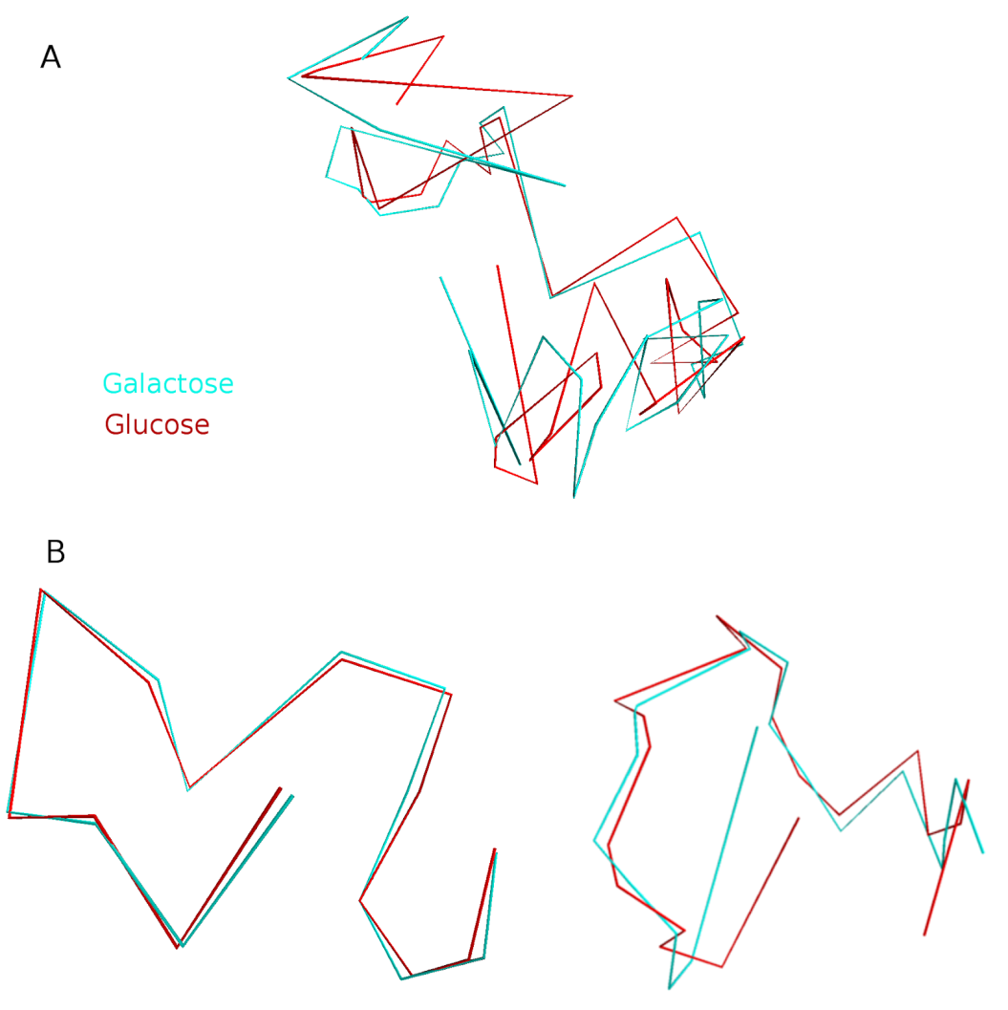

Supplementary Figure 10. chr12 S. cerevisiae glucose (red) and galactose (cyan) alignment for A) full structures and B) split structures.
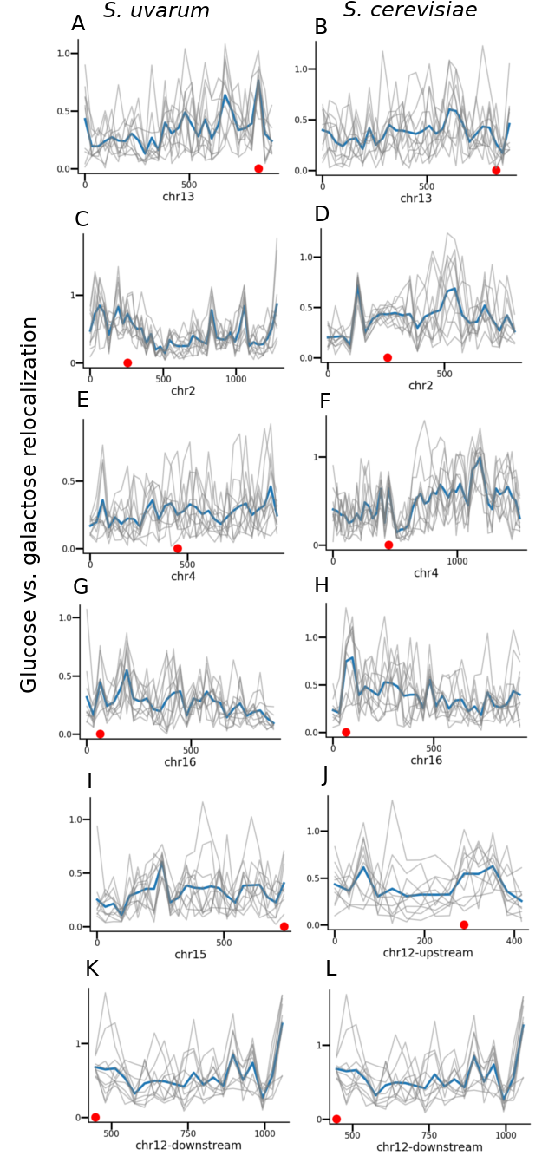
Supplementary Figure 11. Relocalization of yeast loci between glucose and galactose conditions calculated from independent MDS inference and alignment, separated by homolog, for selected chromosomes, calculated from individual inference and alignment. Gray: individual iterations. Blue: mean. Genomic coordinates (kb) are shown on x axes. A-B: Has1-Tda1. C-D: Gal1-Gal7-Gal10. E-F: Gal3. G-H: Gal4. I-J: Gal2. K-L: rDNA.
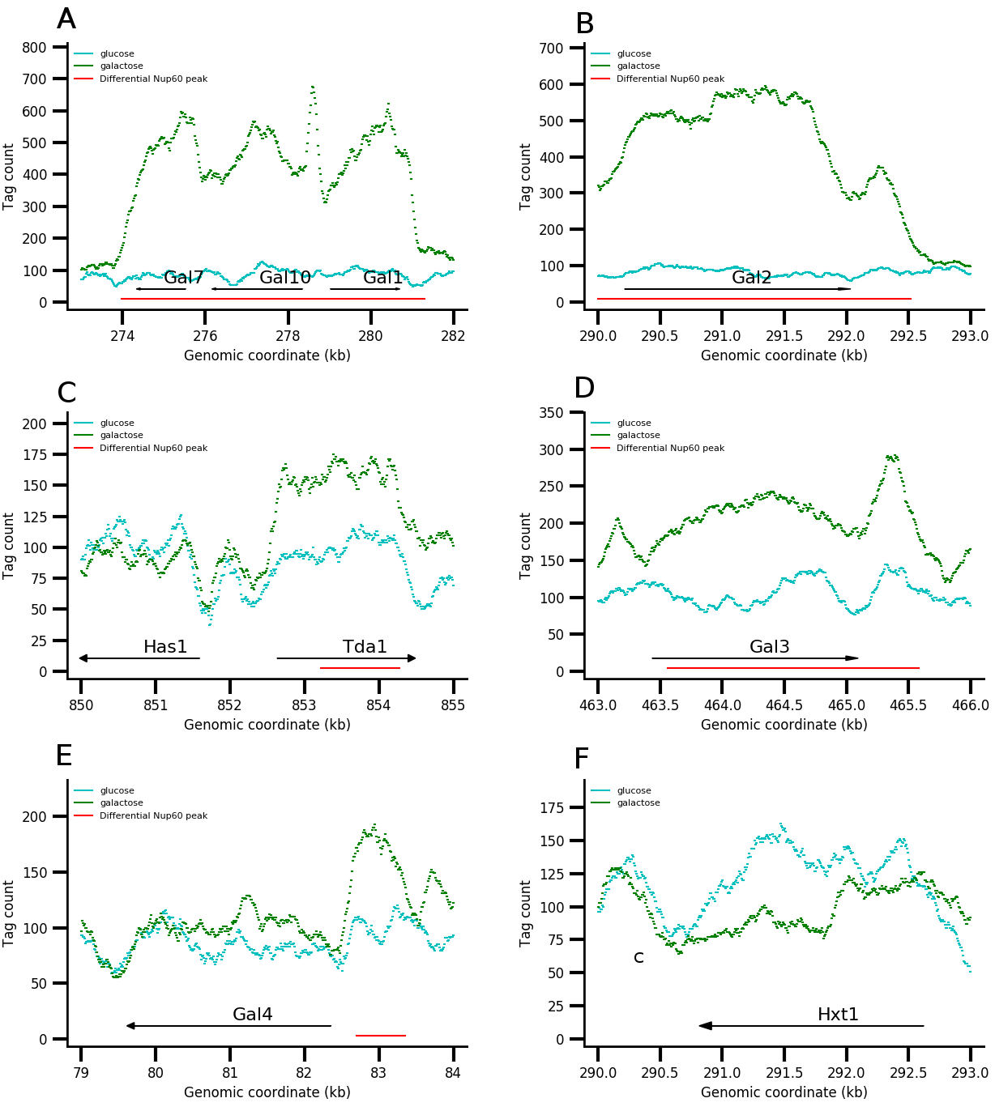

Supplementary Figure 12. Nup60 ChIP-seq tag counts in glucose and galactose conditions at A) Gal1-Gal7-Gal10, B) Gal2, C) Has1-Tda1, D) Gal3, E) Gal4, and F) Hxt1.
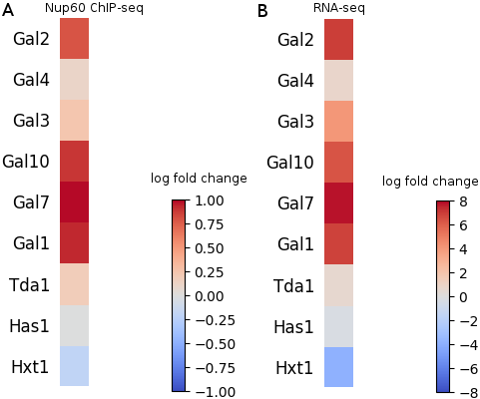
Supplementary Figure 13. Log fold change of A) Nup60 ChIP-seq tag counts and B) RNA-seq counts at selected genes in galactose relative to glucose.
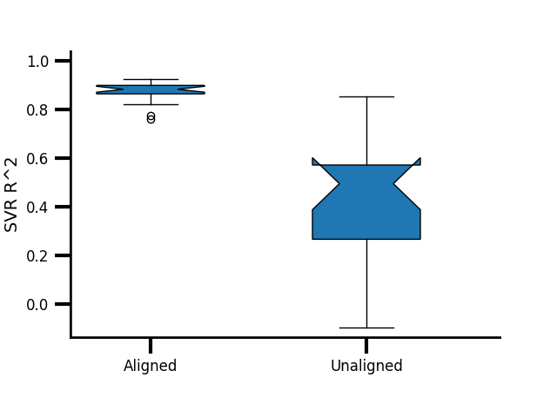
Supplementary Figure 14. SVR coefficient of determination of compartment scores predicted by 3D coordinates for aligned and unaligned GM12878 and K562 structures for each chromosome.
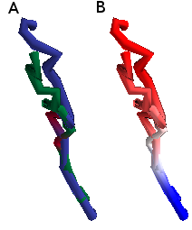

Supplementary Figure 15. chr21:41900000-43900000 aligned to the compartment axis (see Supplementary Fig. 7). A) Blue: GM12878. Green: K562: Red: Mx1/Mx2. B) Compartment scores. Positive scores are plotted in reds, and negative scores are plotted in blues.

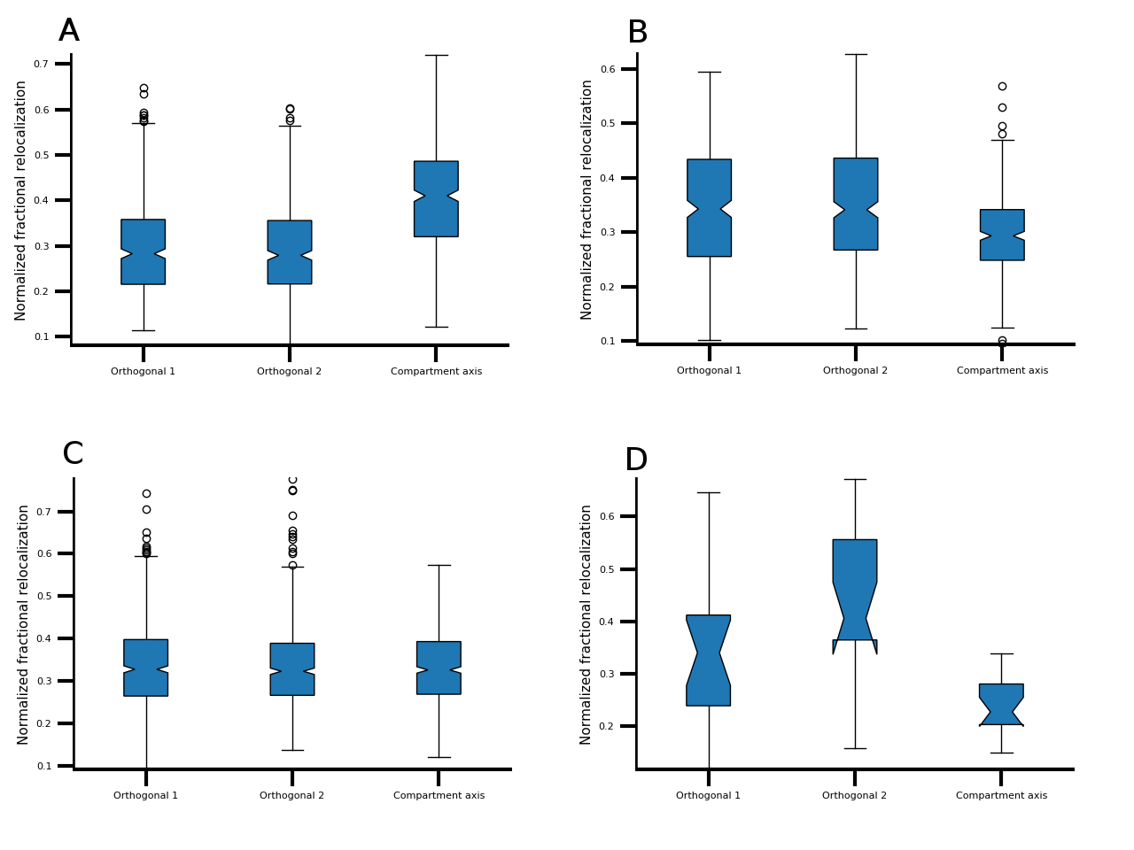
Supplementary Figure 16. Fraction of total relocalization distance along each axis for all chromosomes, calculated from independent structural inference and alignment, for A) ENCODE cell lines, B) mouse cell types, C) LCLs, and D) cohesin KO.
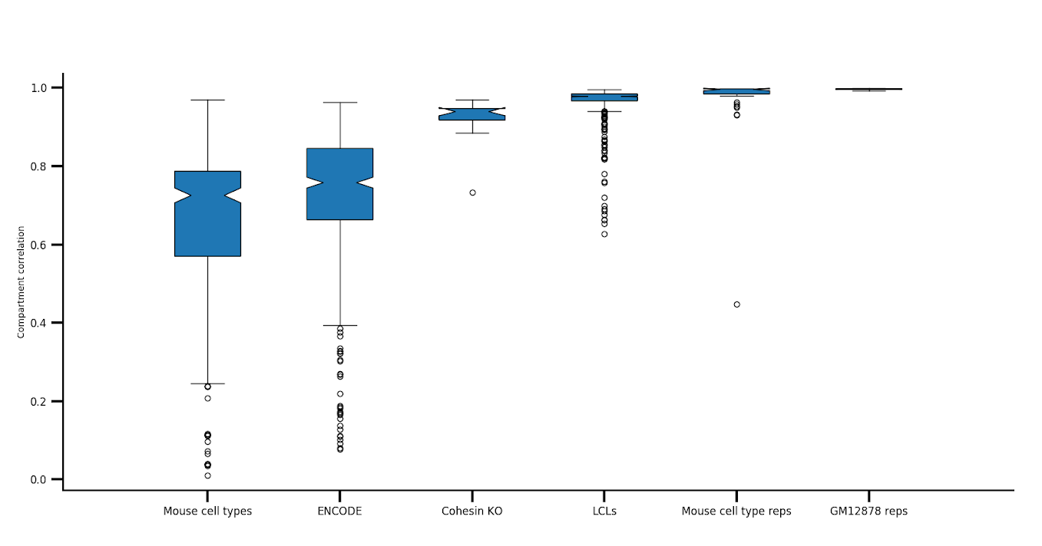
Supplementary Figure 17. Compartment score correlations between each pair of datasets, separated by data type.
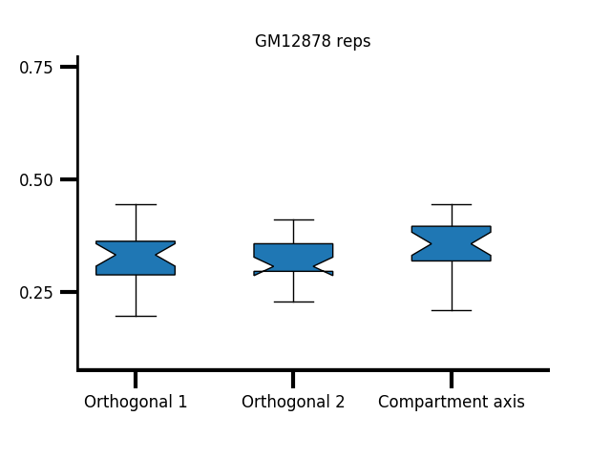
Supplementary Figure 18. Fraction of total relocalization distance along each axis for all chromosomes for GM12878 replicates.
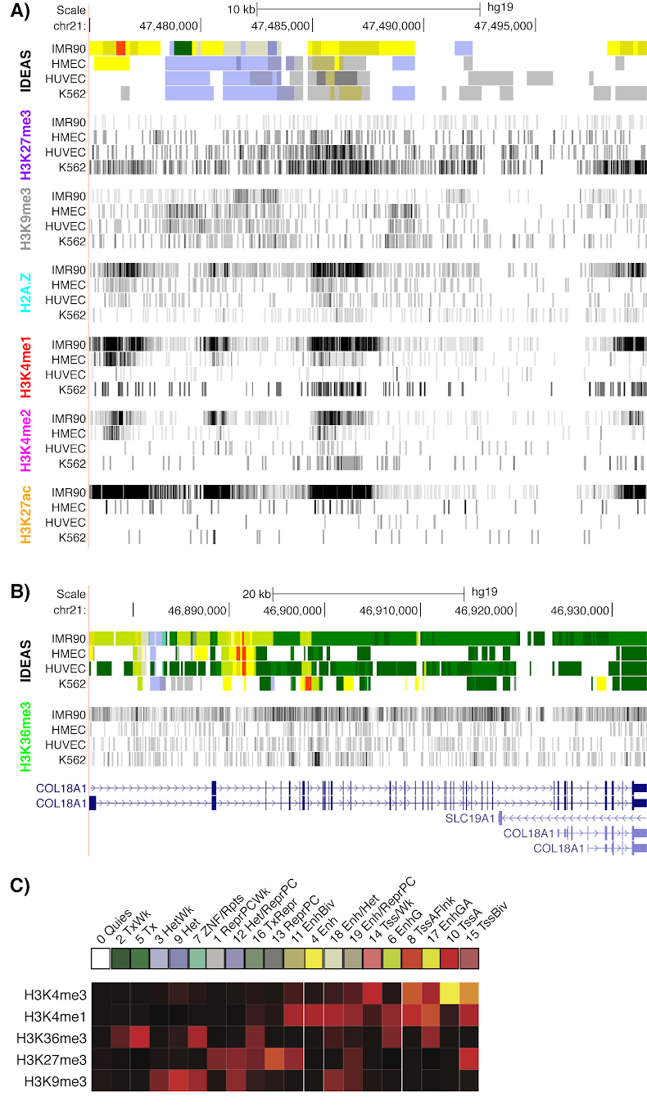

Supplementary Figure 19. A) ChIP-seq data for chr21:47.475-47.5 Mb. B) H3K36me3 ChIP-seq data for COL18A1. C) Emission probabilities for IDEAS states.
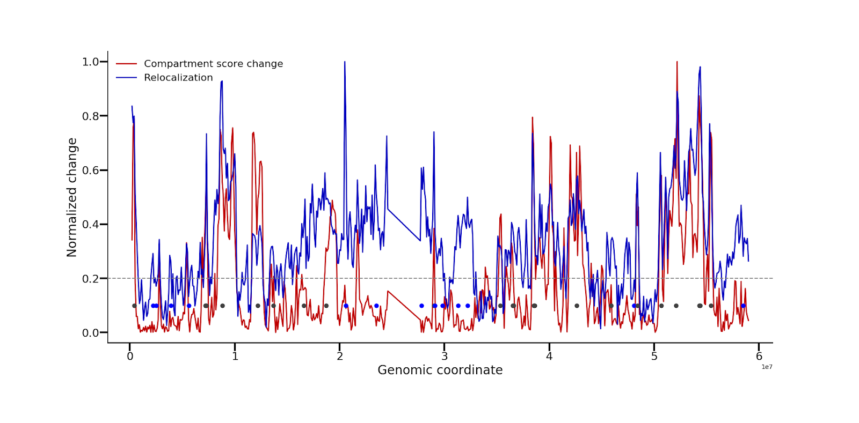
Supplementary Figure 20. Relocalization and absolute compartment score differences between GM12878 and K562 chr19, normalized to 1. For ease of visualization, 100-kb resolution is shown. Gray dashed line is the threshold for compartment-independent relocalizations. Gray dots are compartment-dependent relocalizations, and blue dots are compartment-independent relocalizations.
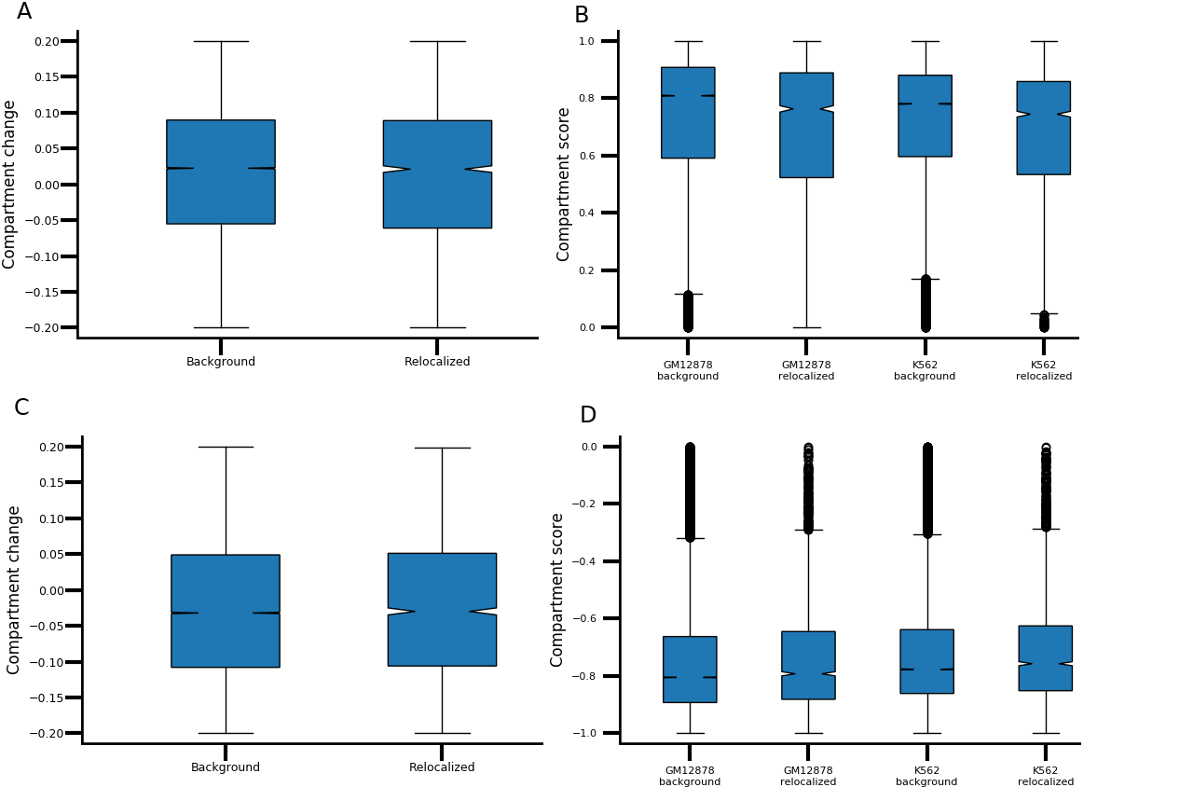

Supplementary Figure 21. Validation that compartment-independent relocalizations are not different from background in compartmentalization. A) Difference in compartment score in 10-kb A compartment bins that did not significantly relocalize and compartment-independent relocalizations. B) Compartment scores for both cell types in 10-kb A compartment bins that did not significantly relocalize and compartment-independent relocalizations. C) Difference in compartment score in 10-kb B compartment bins that did not significantly relocalize and compartment-independent relocalizations. D) Compartment scores for both cell types in 10-kb B compartment bins that did not significantly relocalize and compartment-independent relocalizations.

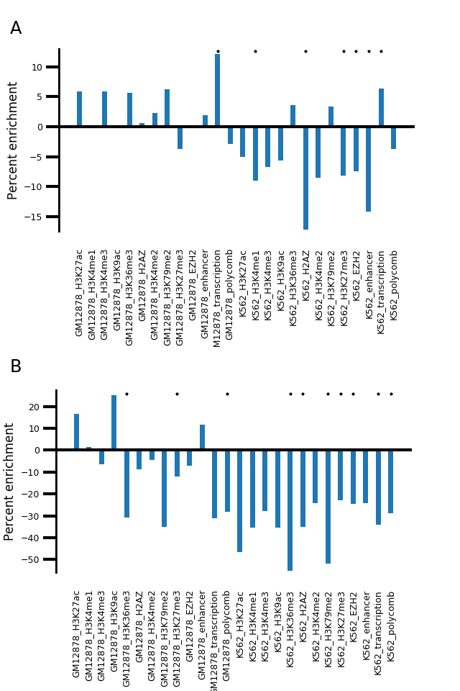
Supplementary Figure 22. A) Enrichment of mean coverage of selected chromatin marks in A compartment loci that relocalize without changing compartment score relative to those that do not relocalize, calculated from independent structural inference and alignment. B) Enrichment of mean coverage of selected chromatin marks in B compartment loci that relocalize without changing compartment score relative to those that do not relocalize, calculated from independent structural inference and alignment.
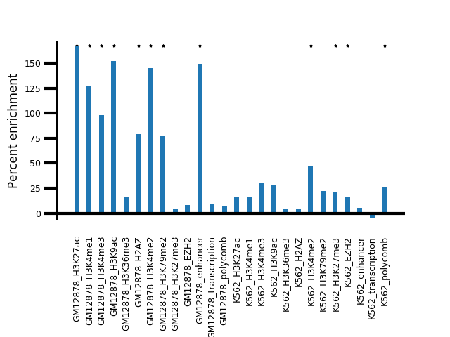
Supplementary Figure 23. Enrichment of mean coverage of chromatin marks in intra-B relocalization peaks relative to background B compartment. Stars represent p<0.01.

Supplementary Figure 24. MultiMDS applied to GM12878 (red) and K562 (cyan) chr21 datasets at 10-kb resolution without distance-decay prior. Compare to Fig. 1A, which is the output of the same analysis with a distance-decay prior of 0.05.

SUPPLEMENTARY TABLE

Supplementary Table 1. Compartment scores at chr21:47.4-47.5 Mb
Cell type | Compartment score
IMR90 | 0.900
HMEC | 0.756
HUVEC | 0.767
K562 | 0.853

