Table S1. Characteristics of the primers and probes as provided by the manufacturer
Kit | Chromosome location (hg19) | Amplicon length | COSMIC ID | Nucleotide change of target mutations | Amino acid changes of target mutations | Probe fluorophore
PrimePCR™ ddPCR™ Mutation Detection Assay Kit: EGFR WT for p.T790M, and EGFR p.T790M, Human | chr7:55249042-55249164 | 80 | COSM6240 | c.2369C>T | p.T790M | FAM/HEX
PrimePCR™ ddPCR™ Mutation Detection Assay Kit: EGFR WT for p.L858R, and EGFR p.L858R, Human | chr7:55259483-55259605 | 73 | COSM6224 | c.2573T>G | p.L858R | FAM/HEX
PrimePCR™ ddPCR™ EGFR Exon 19 Deletions Screening Kit | (-) | (-) | COSM13551, COSM6223, COSM6225, COSM12419, COSM6220, COSM51527, COSM12383, COSM12387, COSM12420, COSM6255, COSM12382, COSM6218, COSM12369 and COSM12370 | 15 deletion mutations in exon 19 (c.2235_2252>AAT, c.2235_2249del15, c.2236_2250del15, c.2238_2252>GCA, c.2238_2255del18, c.2239_2253>CAA, c.2239_2251>C, .2239_2258>CA, c.2239_2252>CA, c.2239_2256del18, c.2239_2248TTAAGAGAAG>C, c.2239_2253del15, c.2239_2247delTTAAGAGAA,  c.2240_2254del15 and c.2240_2257del18) | p.E746_T751>I, p.E746_A750delELREA, p.E746_A750delELREA, p.L747_T751>Q , p.E746_S752>D, p.L747_T751>Q, p.L747_T751>P, .L747_P753>Q, p.L747_T751>Q , p.L747_S752delLREATS , p.L747_A750>P, p.L747_T751delLREAT, p.L747_E749delLRE, p.L747_T751delLREAT and p.L747_P753>S | FAM/HEX
Abbreviations: WT, wild-type.

Table S2. The LOD of the ddPCR assay
Sample # | Blankª |  |  |  |  |  |  | Healthy control^{b}-cfDNA |  |  |  |  |  |  | Healthy control^{b}-exoTNA
 | L858R |  | Exon 19 deletion (ΔE746 - A750) |  | T790M |  |  | L858R |  | Exon 19 deletion (ΔE746 - A750) |  | T790M |  |  | L858R |  | Exon 19 deletion (ΔE746 - A750) |  | T790M
 | Wild-type events | Positive type events | Wild-type events | Positive type events | Wild-type events | Positive type events |  | Wild-type events | Positive type events | Wild-type events | Positive type events | Wild-type events | Positive type events |  | Wild-type events | Positive type events | Wild-type events | Positive type events | Wild-type events | Positive type events
#1 | 0 | 0 | 0 | 1 | 0 | 0 |  | 68 | 0 | 59 | 0 | 51 | 0 |  | 58 | 0 | 82 | 0 | 44 | 0
#2 | 0 | 0 | 0 | 0 | 0 | 0 |  | 89 | 0 | 87 | 0 | 101 | 0 |  | 100 | 0 | 53 | 0 | 50 | 0
#3 | 0 | 0 | 0 | 0 | 0 | 0 |  | 334 | 0 | 282 | 0 | 172 | 0 |  | 236 | 0 | 252 | 0 | 156 | 0
#4 | 0 | 0 | 0 | 0 | 0 | 0 |  | 69 | 0 | 55 | 0 | 51 | 0 |  | 66 | 0 | 51 | 0 | 44 | 0
#5 | 3 | 0 | 5 | 0 | 2 | 0 |  | 94 | 1 | 86 | 0 | 101 | 0 |  | 84 | 1 | 119 | 1 | 50 | 0
#6 | 0 | 0 | 1 | 0 | 0 | 0 |  | 374 | 0 | 185 | 0 | 172 | 0 |  | 288 | 0 | 185 | 0 | 156 | 0
#7 | 0 | 0 | 0 | 0 | 0 | 0 |  | 85 | 0 | 46 | 0 | 27 | 0 |  | 38 | 0 | 60 | 0 | 41 | 0
#8 | 0 | 0 | 0 | 0 | 0 | 0 |  | 233 | 0 | 373 | 2 | 227 | 0 |  | 233 | 0 | 329 | 0 | 69 | 0
Event |  | 0 |  | 1.0 |  | 0 |  |  | 1.0 |  | 2.0 |  | 0 |  |  | 1.0 |  | 1.0 |  | 0.0
Mean |  | 0 |  | 0.1 |  | 0 |  |  | 0.1 |  | 0.3 |  | 0 |  |  | 0.1 |  | 0.1 |  | 0.0
SD |  | 0 |  | 0.3 |  | 0 |  |  | 0.3 |  | 0.7 |  | 0 |  |  | 0.3 |  | 0.3 |  | 0.0
LOB |  | 0 |  | 1 |  | 0
LOD (CLSI EP17-A2) |  |  |  |  |  |  |  |  | 0.5 |  | 1.8 |  | 0.0 |  |  | 0.5 |  | 1.2 |  | 0.0
95% CI upper bound (one-tail Poisson distribution) |  |  |  |  |  |  |  |  | 0.4 |  | 0.6 |  | 0.0 |  |  | 0.4 |  | 0.4 |  | 0.0
ªAnalysis of blank samples without DNA (n = 8)
^{b}Eight healthy subjects were anonymized and studied as control samples.
Abbreviations: LOD, limit of detection; ddPCR, droplet digital polymerase chain reaction; cfDNA, cell-free DNA; exoTNA, exosomal DNA and RNA; SD, standard deviation; LoB, limit of blank.

Table S3. Analytical sensitivity of the ddPCR assay
Reference Materials | Variant | Expected allele frequency (%)ª | Expected copies of wild-type DNA per sampleª | Expected copies of mutant DNA per sampleª | 1st ddPCR in house of |  |  | 2nd ddPCR in house of
 |  |  |  |  | Allele frequency (%) | Copies of wild-type DNA per sample^{b} | Copies of mutant DNA per sample | Allele frequency (%) | Copies of wild-type DNA per sample^{b} | Copies of mutant DNA per sample
1% Multiplex I cfDNA Reference Standard (HD778) | L858R | 0.8239 | 3884 | 32 | 1.3225 | 2344 | 31 | 1.0471 | 2483 | 26
 | Ex19del | 1.2259 | 2284 | 28 | 1.3123 | 1524 | 20 | 1.6033 | 1684 | 27
 | T790M | 1.0081 | 1984 | 20 | 1.1500 | 2087 | 24 | 1.1883 | 2188 | 26
0.1% Multiplex I cfDNA Reference Standard (HD779) | L858R | 0.0942 | 4248 | 4 | 0.0368 | 2718 | 1 | 0.0631 | 3171 | 2
 | Ex19del | 0.0820 | 2440 | 2 | 0.0538 | 1859 | 1 | 0.1109 | 1803 | 2
 | T790M | 0.1361 | 2204 | 3 | 0.0744 | 2688 | 2 | 0.1581 | 2530 | 4
0.02% Multiplex I cfDNA Reference Standard (HD779)^{c} | L858R | 0.0219 | 10942 | 2 | 0.0172 | 11604 | 2 | 0.0152 | 13161 | 2
 | Ex19del | 0.0213 | 9385 | 2 | 0.0299 | 10039 | 3 | 0.0544 | 9195 | 5
 | T790M | 0.0205 | 10242 | 2 | 0.0176 | 11359 | 2 | 0.0092 | 10926 | 1
0.01% Multiplex I cfDNA Reference Standard (HD779)^{c} | L858R | 0.0112 | 10099 | 1 | 0.0000 | 11138 | 0 | 0.0000 | 11383 | 0
 | Ex19del | 0.0128 | 8901 | 1 | 0.0325 | 9232 | 3 | 0.0140 | 7120 | 1
 | T790M | 0.0111 | 9805 | 1 | 0.0115 | 8675 | 1 | 0.0297 | 10118 | 3
0.005% Multiplex I cfDNA Reference Standard (HD779)^{c} | L858R | 0.0051 | 20215 | 1 | 0.0077 | 12915 | 1 | 0.0130 | 15400 | 2
 | Ex19del | 0.0050 | 17811 | 1 | 0.0080 | 12529 | 1 | 0.0000 | 13877 | 0
 | T790M | 0.0057 | 19619 | 1 | 0.0066 | 15154 | 1 | 0.0073 | 13733 | 1
ªExpected mutant allele frequency and copy number values of wild-type and mutant DNA measured using ddPCR were provided by the manufacturer. Expected copy numbers of wild-type DNA in spiked reference materials were calculated with measured copy numbers of fragmented healthy control DNA (~200bp).
^{b}Mean wild-type events of duplicated results at L858R, Ex19del, and T790M were measured using ddPCR.
^{c}cfDNA Reference Standards (Horizon Discovery) with 0.1% mutant alleles were serially diluted to wild-type DNAs.
Abbreviations: ddPCR, droplet digital polymerase chain reaction; Ex19del, exon 19 deletion.

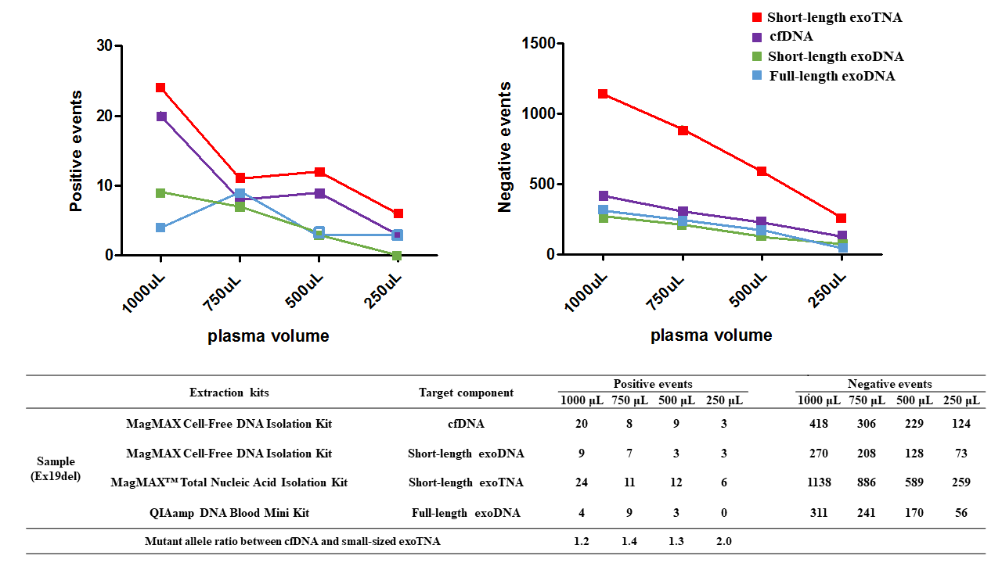Figure S1. Assessment of size-selective target exoNAs related to the sensitivity of EGFR mutation testing.
cfDNA, short-length exoNAs (DNA and TNA), and a full-length exoDNA were extracted using different commercial kits. ddPCR was performed with 250, 500, 750, and 1,000 μL plasma samples to assess plasma volume; Ex19del, exon 19 deletion.

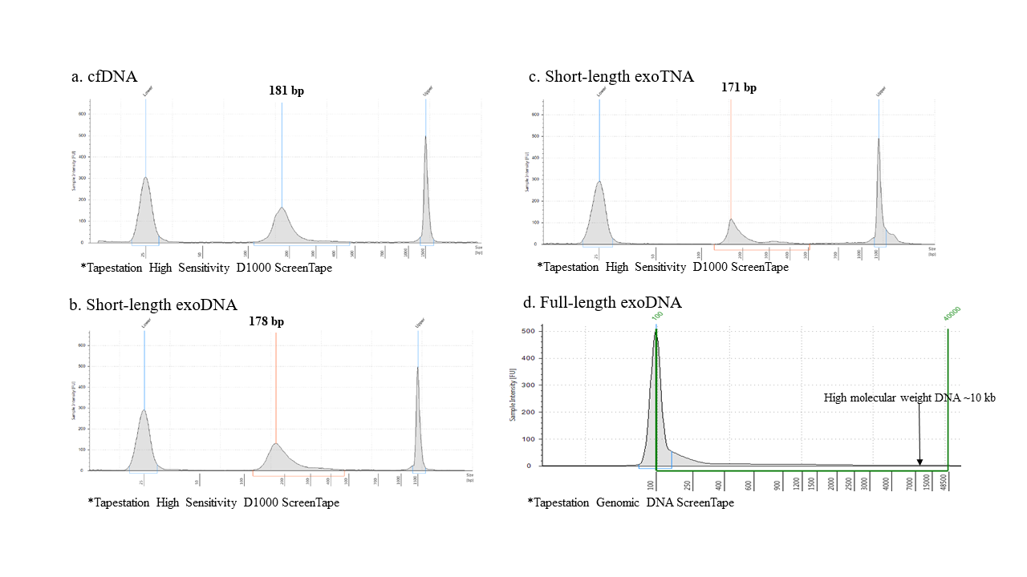Figure S2. The distribution of isolated nucleic acids.
The shorter NAs (~ 200 bp long) were more abundant than high-molecular weight DNA in exosomes. a. cfDNA was extracted using a MagMAX Cell-Free DNA Isolation Kit, b. short-length exoDNA in isolated exosomes from plasma was extracted using a MagMAX Cell-Free DNA Isolation Kit, c. short-length exoTNA in isolated exosomes from plasma was extracted using a MagMAX™ Total Nucleic Acid Isolation Kit, d. full-length exoDNA in isolated exosomes from plasma was extracted using a QIAamp DNA Blood Mini Kit.

