Captions
Table S1 Primers used for the construction of wild-type and mutant UDH
Table S2 Purification of AtUDH
Table S3 Effects of metal ions and chemical reagents on AtUDHs activity
Table S4 Turnover numbers and michaelis constants of UDHs from AtLBA4404, AtGV3103 and AtEHA105
Fig. S1 Amino acid sequences alignment of uronate dehydrogenases. The Rossman fold GxxGxxG motif, △, NAD＋binding residues,▽, catalytic residue, ◇.The GxxGxxG motif is located in the Gly8-to-Gly14 region of the A. tumefaciens LBA4404, GV3101 and EHA105 strains, which have been discovered to have NAD＋binding domains. The YxxxK motif is located between Tyr136 and Lys138 of AtUDH and is the primary motif of the 3-alpha/beta hydroxysteroid dehydrogenase domain.
Fig. S2 SDS-PAGE analysis of AtUDH. The purified UDHs were subjected to electrophoresis in a 12% SDS-PAGE under denaturing conditions. Lane 1, molecular weight markers; lanes 2, 4, 6, crude extract of E. coli BL21(DE3) expression strains of the A. tumefaciens strains LBA4404UDH, GV3101UDH, and EHA105UDH; lanes 3, 5, 7, purified of E. coli BL21(DE3) expression strains of the A. tumefaciens str. LBA4404 UDH, GV3101UDH, and EHA105UDH. Molecular masses (in kDa, equivalent to molecular weights in thousands) are shown to the left.
Fig. S3 Effect of temperature and pH on activity of UDH. Influence of temperature (4a), thermostability (4b, the enzymes were incubated at different temperatures for 20 h) and pH (4c) on the activity of A. tumefaciens str. LBA4404 UDH, GV3101UDH, and EHA105UDH. The activities of AtLBA4404UDH, AtGV3101UDH, and AtEHA105UDH were tested at different temperatures. The value at 30 °C was taken as 100%.
Fig. S4 The evaluation of structure model of the AtLBA4404 UDH on 3D-1D value.
Fig. S5 High-resolution 1H-NMR spectrum of glucaric acid purchased from Sigma-Aldrich (a) and purified glucaric acid made from glucuronic acid (b).

Table S1 List of primer sequences used in this study
Primers | Sequence 5’- 3’
AtLBA4404-F | CGCAAGCTTGGATGAAACGGCTTCTTGTTACC
AtLBA4404-R | CGCTCGAGTCAGCTCTGTTTGAAGATCGGGT
AtGV3301-F | CGCAAGCTTGGATGAAACGGCTTCTTGTTACC
AtGV3301-R | CGCTCGAGTCAGCTCTGTTTGAAGATCGGGT
AtEHA105-F | CGCAAGCTTGGATGAAACGGCTTCTTGTTACC
AtEHA105-R  AtC58-F  AtC58-R  L36F  L36R  A39F  A39R  E79F  E79R  H99F  H99R  H234F  H234R | CGCTCGAGTCAGCTCTGTTTGAAGATCGGGT  CGCAAGCTTGGATGAAACGGCTTCTTGTTACC  CGCTCGAGTCAGCTCTGTTTGAAGATCGGGT  TTGCCGATCTTTCGCCGNNKGATCCTGCCGGACCG  CGGTCCGGCAGGATCMNNCGGCGAAAGATCGGCAA  ATCTTTCGCCGCTCGATCCTGCNNKACCGAACGAGGAATG  CATTCCTCGTTCGGTMNNGCAGGATCGAGCGGCGAAAGAT  ATCGGTGGAGCGGCCTTTCGANNKGATCCTTCACGGT  ACCGTGAAGGATCMNNTCGAAAGGCCGCTCCACCGAT  ATGAGGCGGCCCGCGCCCANNKGCAGCCGCGAATCGT  ACGATTCGCGGCTGCMNNTGGGCGCGGGCCGCCTCAT  AGACTTTCCGGCAGCANNKTGCCGAGACAACACCGC  GCGGTGTTGTCTCGGCAMNNTGCTGCCGGAAAGTCT

Table S2 Purification of AtUDH
Strain name | Step | Total protein (mg) | Specific activity (U mg^{﹣1}) | Total activity (U) | Yield (%) | Purification (-fold)
AtLBA4404UDH | Crude extract | 74 | 34 | 2500 | 100 | 1.0
 | Nickel affitity chromatography | 20 | 84 | 1609 | 64 | 2.5
AtEHA105UDH | Crude extract | 64 | 30 | 1918 | 100 | 1.0
 | Nickel affitity chromatography | 19 | 70 | 1325 | 69 | 2.3
AtGV3101UDH | Crude extract | 69 | 36 | 2480 | 100 | 1.0
 | Nickel affitity chromatography | 21 | 73 | 1530 | 62 | 2

Table S3 Effects of metal ions and chemical reagents on AtUDHs activity
Metal Ion | Concentration (mM) | Relative activity (%)
Control | 0 | 100±2.5
Fe^{2＋} | 2 | 120±3.1
Fe^{3＋} | 2 | 100±2.1
Mg^{2＋} | 2 | 130±2.7
Co^{2＋} | 2 | 98±3.4
Zn^{2＋} | 2 | 97±2.9
Cu^{2＋} | 2 | 98±3.5
EDTA | 5 | 80±2.6
SDS | 5 | 30±3.6
Urea | 5 | 15±1.9
Triton X-100 | 1% (v/v) | 110±2.3

Table S4 Turnover numbers and Michaelis constants of uronate dehydrogenases from AtLBA4404, AtGV3103 and AtEHA105
Strain and substrate | Kinetic parameter
 | kcat(10² s⁻¹) | K_{m}(mM) | kcat/K_{m} (10² s⁻¹mM⁻¹)
A.tumefaciens GV3101
Glucuronate | 1.8±0. 2 | 0.30±0.05 | 6.0
Galacturonate | 1.0±0.1 | 0.16±0.05 | 6.3
NAD+ | 2.0±0.3 | 0.18±0.03 | 11
A.tumefaciens LBA4404
Glucuronate | 1.6±0.3 | 0.20±0.06 | 8.0
Galacturonate | 0.90±0.4 | 0.15±0.05 | 6.0
NAD+ | 1.8±0.2 | 0.17±0.02 | 10.3
A.tumefaciens EHA105
Glucuronate | 1.8±0.5 | 0.34±0.04 | 5.3
Galacturonate | 0.86±0.4 | 0.12±0.03 | 7.2
NAD+ | 1.8±0.5 | 0.19±0.01 | 9.9

Su et al., Fig. S1

Su et al., Fig. S2

Su et al., Fig. S3
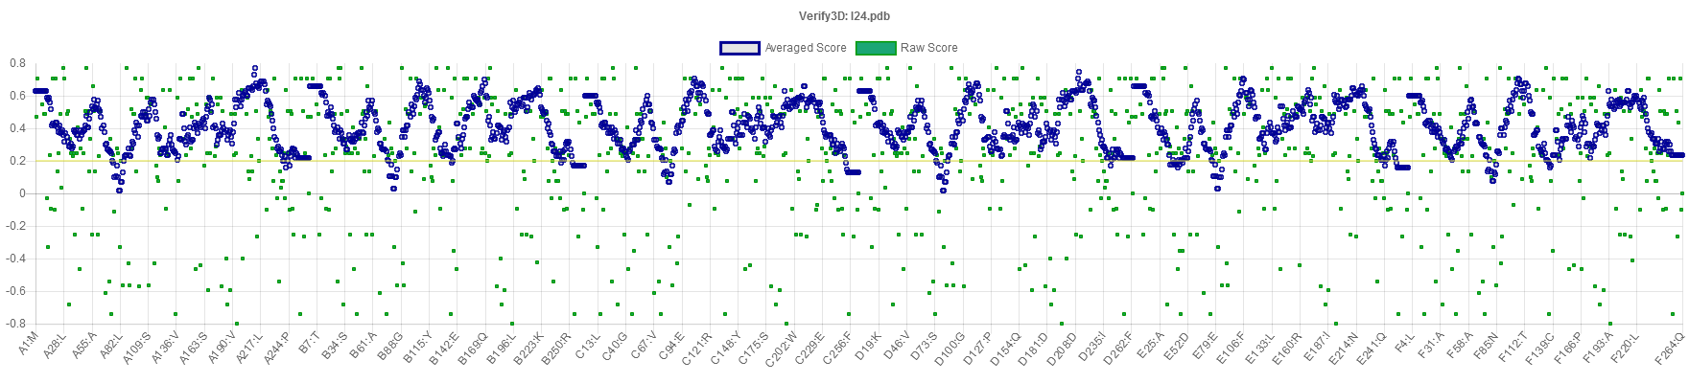
Su et al., Fig. S4

a, Glucaric acid from Sigma-Aldrich
b, Enzymatically synthesized glucaric acid
Su et al., Fig. S5

