Synergistic Exfoliation of MoS₂ by Ultrasound Sonication in a Supercritical Fluid Based Complex Solvent
Xi Tan, Wenbin Kang, Jingfeng Liu, Chuhong Zhang*
State Key Laboratory of Polymer Materials Engineering, Polymer Research Institute of Sichuan University, Chengdu 610065, China
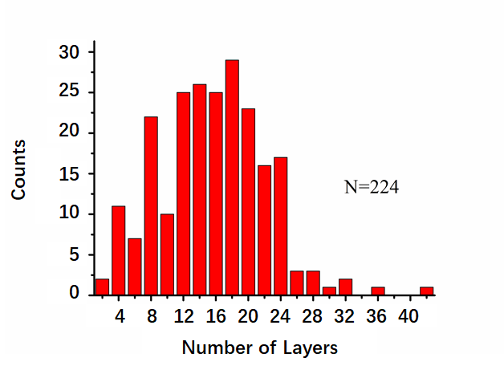
Additional file 1: Figure S1. The distribution plot for the number of layers of exfoliated MoS₂ nanosheets

