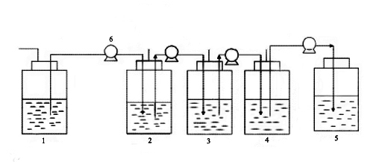

Figure S1 Schematic diagram for three-stage continuous fermentation

(1. Substrate tank 2. Fermenter 3. Fermenter 4. Fermenter 5. Storage tank 6. Peristaltic pump)
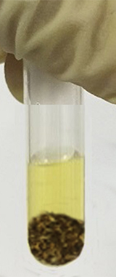
Figure S2 Starch testing of cassava peel with iodine solution
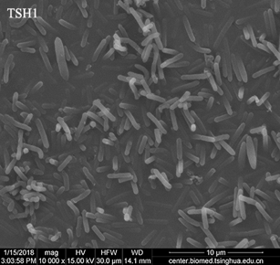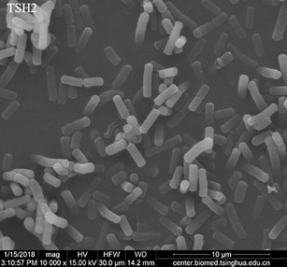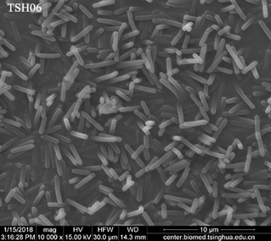
Figure S3 Scanning electron microscope images of C. acetobutylicum (TSH1) , B. cereus (TSH2) and TSH06

