Molecular Detection of Respiratory Pathogens and typing of human rhinovirus of adults hospitalized for exacerbation of asthma and chronic obstructive pulmonary disease.

Fanny Wai-san KO¹, Paul Kay-sheung CHAN², Renee WY Chan³, Ka-Pang Chan¹, April Ip¹, Angela Kwok², Jenny Chun-li Ngai¹, So-Shan Ng¹, Chan Tat On¹, David Shu-cheong Hui¹

¹Department of Medicine and Therapeutics, The Chinese University of Hong Kong
²Department of Microbiology, The Chinese University of Hong Kong
³Department of Paediatrics, The Chinese University of Hong Kong

Supplementary Table 1. Length of hospital stay, readmissions and mortality in relations to types of human rhinovirus identified in the NPA in patients with acute exacerbation of COPD.
 | HRV_A  n=15 | HRV_B  n=3 | HRV_C  n=8 | P-value
Length of hospital stay (days) (Mean ± SD) | 13.1 ± 8.4 | 9.0 ± 8.6 | 6.9 ± 5.0 | 0.18
30-day Readmissions | 1 | 0 | 0 | 1.00
60-day Readmissions | 4 | 2 | 2 | 0.36
In-hospital Mortality | 0 | 0 | 0 | NA
30-Day Mortality | 0 | 0 | 0 | NA
60-Day Mortality | 0 | 0 | 0 | NA
HRV: Human rhinovirus; N/A: not applicable
Data are presented as mean±SD or number

Supplementary Table 2. Length of hospital stay, readmissions and mortality in relations to types of human rhinovirus identified in the NPA in patients with acute exacerbation of asthma.
 | HRV_A  n=6 | HRV_B  n=1 | HRV_C  n=4 | P-value
Length of hospital stay (days) (Mean ± SD) | 9.7 ± 6.9 | NA (only 1 case; length of stay was 3 days) | 7.7 ± 3.4 | 0.63
30-day Readmissions | 0 | 0 | 0 | NA
60-day Readmissions | 0 | 0 | 1 | 0.38
In-hospital Mortality | 0 | 0 | 0 | NA
30-Day Mortality | 0 | 0 | 0 | NA
60-Day Mortality | 0 | 0 | 0 | NA
HRV: Human rhinovirus; N/A: not applicable
Data are presented as mean±SD or number

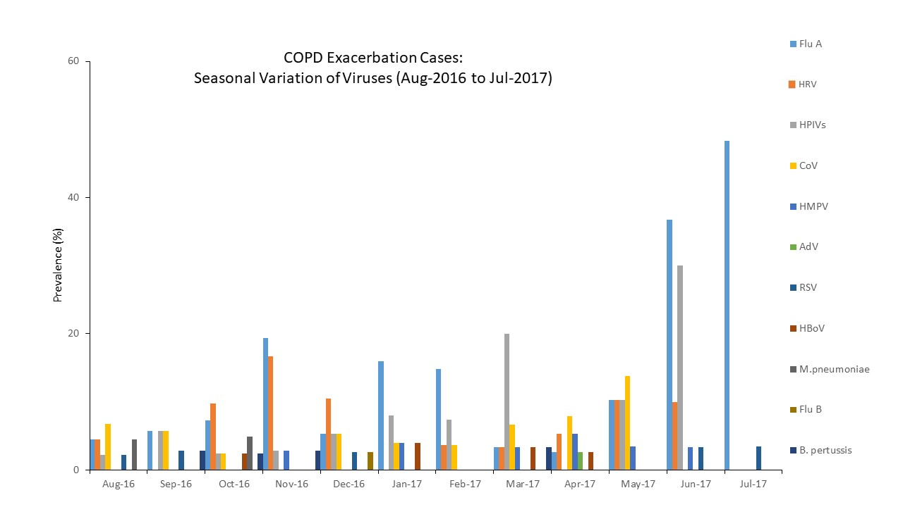

Supplementary Figure 1. NPA results of the COPD exacerbation cases in different months.
The bars represent the % of subjects with the microorganism identified over the total number of subjects recruited in that month.
ADV=adenovirus; B. Pertussis=Bordetella pertussis; CoV=Coronavirus; Flu A= influenza A; Flu B=influenza B; HBoV= Human Bocavirus; HMPV= Human metapneumovirus; HPIV=Human parainfluenza virus; M pneumoniae=Mycoplasma pneumoniae; HRVs= Human rhinovirus; RSV= Respiratory syncytial virus

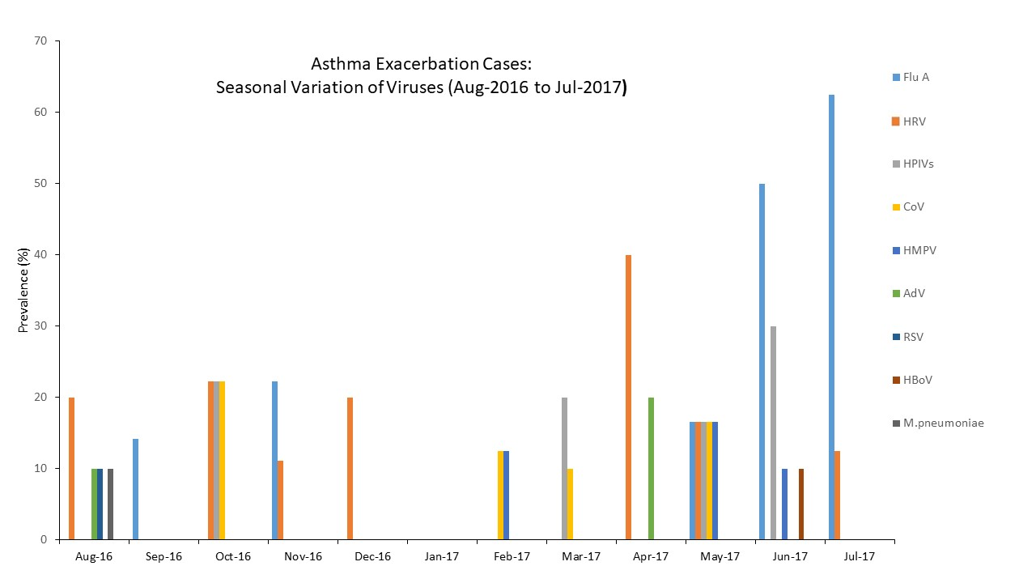

Supplementary Figure 2. NPA results of the asthma exacerbation cases in different months.
The bars represent the % of subjects with the microorganism identified over the total number of subjects recruited in that month.
ADV=adenovirus; CoV=Coronavirus; Flu A= influenza A; HMPV= Human metapneumovirus; HPIV=Human parainfluenza virus; M pneumoniae=Mycoplasma pneumoniae; HRVs= Human rhinovirus; RSV= Respiratory syncytial virus

