Additional file 1
Figures
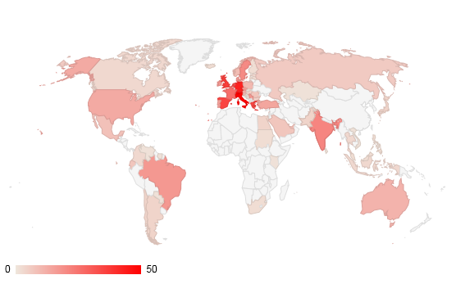
Figure S1 Origin of respondents

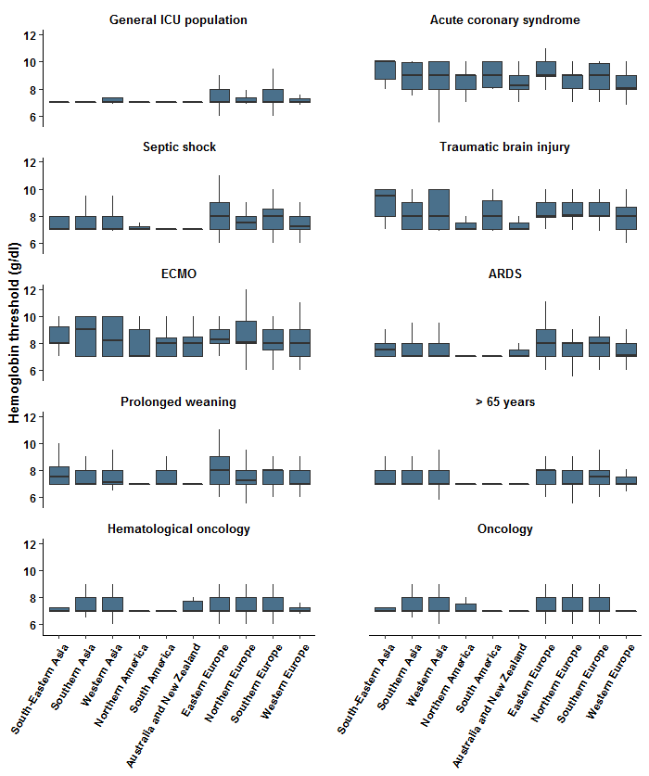
Figure S2. Patients with acute coronary syndrome were transfused at highest Hb levels in South Eastern Asia with a median Hb level of 10 g/dL (8.75-10) while in Western Europe the median reported transfusion threshold was 8.1 g/dL (8-8.1). For patients with traumatic brain injury also respondents from South Eastern Asia reported the highest Hb levels as transfusion thresholds of 9.5 g/dL (8-9.5) and lowest Hb levels were reported in Northern America with a median Hb of 7 g/dL (7-7). In Southern Asia the highest Hb thresholds for patients receiving ECMO were reported with 9 g/dL (7-9), while the lowest Hb levels were reported by respondents working in Northern America with 7 g/dL (7-7).
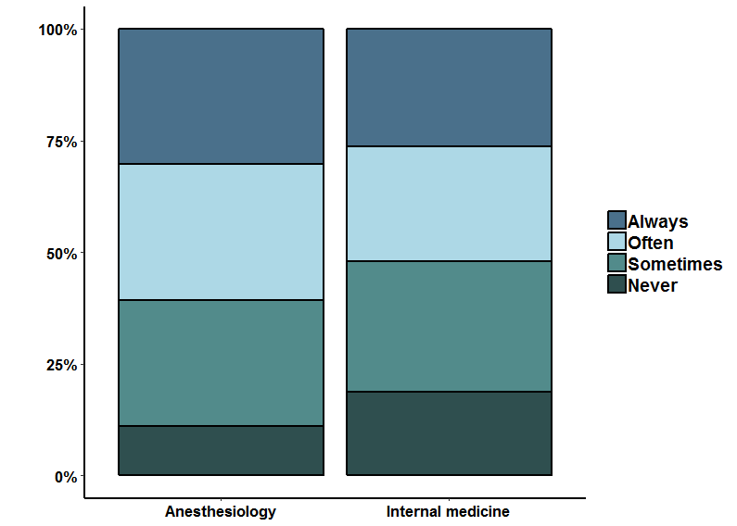
Figure S3. The use of a physiological transfusion trigger in addition to a Hb threshold. Significant differences were observed for anaesthesiology versus internal medicine (p = 0.02).

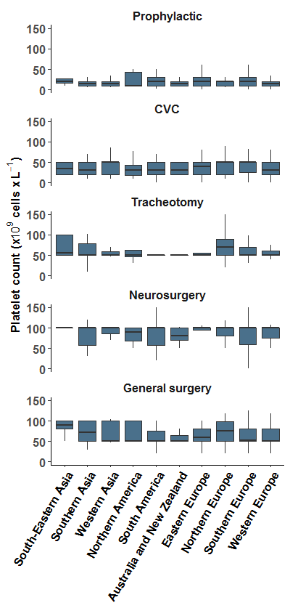
Figure S4. Regional differences of applied platelet thresholds prophylactically without any planned invasive procedure and prophylactically prior to different procedures.
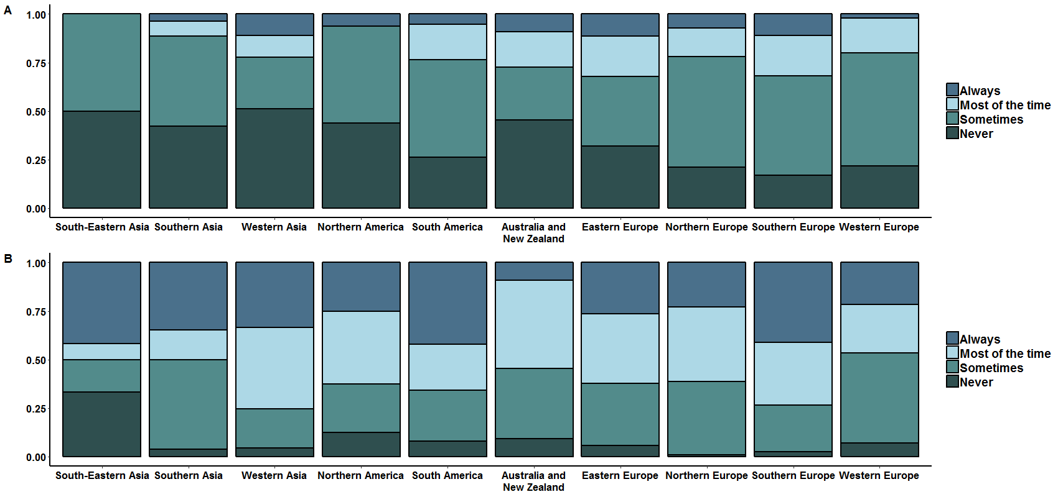
Figure S5. Regional differences of the correction of a vitamin K induced INR >3 (A) prophylactically in the absence of an invasive procedure and (B) prior to an invasive procedure.

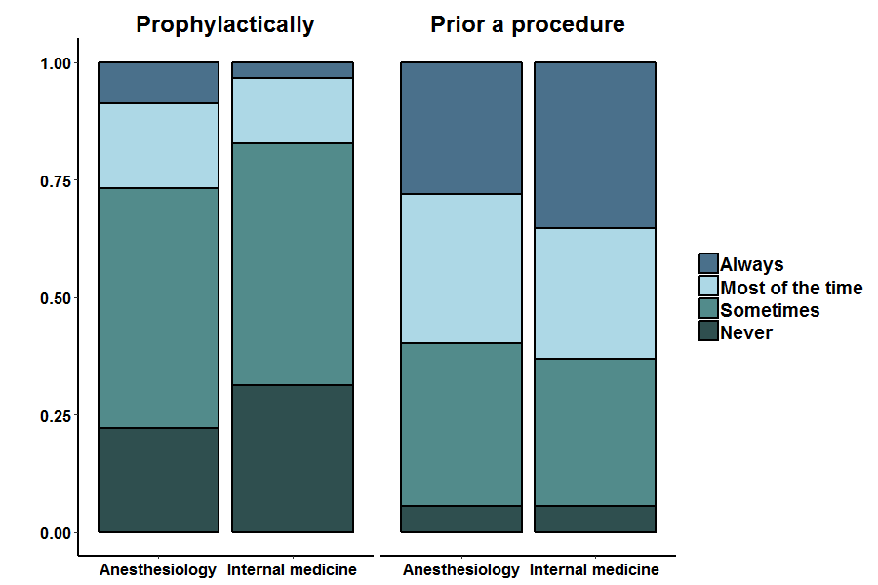

Figure S6.
Effect of base specialty of ICU doctor on the correction of a vitamin K induced INR >3 (A) prophylactically in the absent of an invasive procedure (p= 0.0272) and (B) prior to an invasive procedure (p=0.03983).

Table S1

World region | n =
Australia and New Zealand | 11
Caribbean | 1
Central America | 8
Central Asia | 1
Eastern Africa | 2
Eastern Asia | 4
Eastern Europe | 53
Northern Africa | 6
Northern America | 16
Northern Europe | 109
South-Eastern Asia | 12
South America | 38
Southern Africa | 2
Southern Asia | 26
Southern Europe | 197
Western Asia | 45
Western Europe | 184

Table S2
 | ICU specific guideline
 | Available | Not available | p value
General ICU population | 7(7-7.5) | 7(7-7.5) | 0.1341
Acute coronary syndrome | 9(8-9.7) | 9(8-9.6) | 0.1009
Septic shock | 7.3(7-8) | 7.5(7-8) | 0.389
Traumatic brain injury | 8(7-9) | 8(7-9) | 0.9795
ECMO | 8(7-9) | 8(7.5-9) | 0.2455
ARDS | 7(7-8) | 7.5(7-8) | 0.0517
Prolonged weaning | 7.5(7-8) | 7.4(7-8) | 0.9892
Age ≥65 years | 7(7-8) | 7(7-8) | 0.6015
Haematological oncology | 7(7-8) | 7(7-8) | 0.2184
Oncology | 7(7-8) | 7(7-8) | 0.8695

Table S3
 | (not-ICU specific) Guideline
 | Available | Not available | p value
General ICU population | 7(7-7.5) | 7(7-7.9) | 0.0283
Acute coronary syndrome | 9(8-9.7) | 9(8-9) | 0.8161
Septic shock | 7.3(7-8) | 7.5(7-8) | 0.2662
Traumatic brain injury | 8(7-9) | 8(7-9) | 0.783
ECMO | 8(7-9) | 8(7-9) | 0.2794
ARDS | 7(7-8) | 7.5(7-8) | 0.262
Prolonged weaning | 7.1(7-8) | 7.5(7-8) | 0.1283
Age ≥65 years | 7(7-8) | 7(7-8) | 0.0649
Haematological oncology | 7(7-8) | 7(7-8) | 0.3209
Oncology | 7(7-8) | 7(7-8) | 0.191

Table S4
 | Main specialty
 | Anaesthesiology | Internal medicine | p value
General ICU population | 7(7-8) | 7(7-7) |  | 0.0452
Acute coronary syndrome | 9(8-9.7) | 9(8-9.9) |  | 0.3662
Septic shock | 8(7-8) | 7(7-8) |  | < 0.001
Traumatic brain injury | 8(7.8-9) | 8(7-9) |  | 0.036
ECMO | 8(7.7-9) | 8(7-9.5) |  | 0.5545
ARDS | 8(7-8.2) | 7(7-8) |  | < 0.001
Prolonged weaning | 8(7-8) | 7(7-8) |  | < 0.001
Age ≥65 years | 7.2(7-8) | 7(7-7.7) |  | 0.0003
Haematological oncology | 7(7-8) | 7(7-7.4) |  | 0.0224
Oncology | 7(7-8) | 7(7-7.2) |  | 0.0459

Table S5
 | ICU specific transfusion guideline
 | Available | Not available | p value
Prophylactic | 20(10-20) | 20(10-30) | 0.2827
Prior to CVC placement | 30(20-50) | 45(20-50) | 0.1299
Prior to tracheotomy | 50(50-70) | 50(50-71) | 0.7226
Prior to general surgery | 50.5(50-93) | 50(50-80) | 0.8616
Prior to neurosurgery | 100(67.5-100) | 100(75-100) | 0.3684

Table S6
 | (not-ICU specific) transfusion guideline
 | Available | Not available | p value
Prophylactic | 20(10-25) | 20(10-30) | 0.8973
Prior to CVC placement | 45(20-50) | 40(20-50) | 0.5185
Prior to tracheotomy | 50(50-71) | 50(50-70) | 0.1976
Prior to general surgery | 50(50-80) | 53(50-90) | 0.4122
Prior to neurosurgery | 100(70-100) | 100(75-100) | 0.1442

Table S7
 |  | Main specialty
 | Anaesthesiology  Platelet count |  | Internal medicine  Platelet count | p value
Prophylactic | 20(10-30) |  | 10(10-20) | 0.0052
Prior to CVC placement | 48.5(20-50) |  | 30(20-50) | 0.0023
Prior to tracheotomy | 50(50-80) |  | 50(50-51) | 0.0069
Prior to general surgery | 51(50-80) |  | 50(50-81) | 0.3439
Prior to neurosurgery | 100(75-100) |  | 100(80-100) | 0.9409

Appendix 1: Overview collaborating societies

- Australian and New Zealand Intensive Care Society (ANZICS)
- Czech Society of Anaesthesiology, Resuscitation & Intensive Care (CSARIM)
- Hellenic Society of Intensive Care (HSIC)
- Societa Italiana di Anestesia Analgesia Rianimazione e Terapia Intensiva (SIAARTI)
- Intensive Care Society of Ireland (ICSI)
- Lebanese Critical Care Society (LCCS)
- Nederlandse Vereniging voor Intensive Care (NVIC)
- Serbian Association of Anaesthesiologists & Intensivits (SAAI)
- Slovenian Society of Intensive Medicine (SSIM)
- Swedish Society of Anaesthesiology & Intensive Care Medicine (SFAI)
- Swiss Society of Intensive Care Medicine (SGI-SSICM)
- Turkish Society of Anesthesiology and Reanimation (TARD)
- Intensive Care Society (ICS, United Kindom)

Appendix 2: Static version questionnaire
Demographics:
- In which country do you work?
- What is your intensive care certification level
  - Intensivist
  - Resident, specialist in training
  - Specialist non intensivist practising ICU
  - Nurse
  - Student
  - Other, please specify
- What is your primary medical specialty
  - Anaesthesiology
  - Cardiology
  - Internal medicine
  - Neurology
  - Paediatrics
  - Pulmonology
  - Surgery
  - Other, please specify
- Type of intensive care unit (ICU)
  - Medical ICU
  - Surgical ICU
  - Mixed ICU
  - Other, please specify
- Number of ICU beds
  - <10
  - 10-15
  - 16-20
  - >20
- Annual number of patients treated in the ICU
  - <500
  - 500-1000
  - 1001-1500
  - 1501-2000
  - >2000
- Type of institution
  - University hospital
  - University affiliated hospital
  - Non-university public hospital
  - Private hospital
  - Other, please specify
- Do you have a transfusion protocol in your hospital?
  - Yes
  - No
  - I don’t know
  - Other, please specify
- Do you have a transfusion protocol specific for the intensive care unit in your hospital?
  - Yes
  - No
  - I don’t know
  - Other, please specify

Red blood cell transfusion
- Which unit do you use to measure hemoglobin levels?
  - g/dL
  - g/L (=mg/ml)
  - mmol/L
- What is your overall threshold for blood transfusion in a general population of anemic critically ill patients?
- What is your threshold for blood transfusion in anemic critically ill patients with acute coronary syndrome?
- What is your threshold for blood transfusion in anemic critically ill patients with septic shock?
- What is your threshold for blood transfusion in anemic critically ill patients with traumatic brain injury?
- What is your threshold for blood transfusion in anemic critically ill patients receiving ECMO?
- What is your threshold for blood transfusion in anemic critically ill patients with ARDS?
- What is your threshold for blood transfusion in anemic critically ill patients with prolonged weaning from mechanical ventilation?
- What is your threshold for blood transfusion in anemic critically ill patients >65 years?
- What is your threshold for blood transfusion in anemic critically ill patients with a hematologic malignancy?
- What is your threshold for blood transfusion in anemic critically ill oncology patients?
- Do you check hemoglobin levels after transfusion of one unit red cell concentrates before transfusing a second unit in non-bleeding critically ill patients?
  - Always
  - Most of the time
  - Sometimes
  - Never
- Do you also use physiological transfusion triggers (e.g. tachycardia) in addition to a hemoglobin threshold?
  - Always
  - Often
  - Sometimes
  - Never
- Which physiological transfusion triggers do you use in non-bleeding patients? (multiple answers possible)
  - Tachycardia
  - Hypotension
  - Arrhythmia
  - Significant ECG changes
  - SvO₂ (mixed venous saturation of oxygen) < 65 %
  - ScvO₂ (central venous oxygen saturation) < 65 %
  - Lactate >2 mmol/L
  - Acidosis
  - Other, please specify
- How would you rank the following triggers of importance to you? (1 means most important)
  - All triggers ticked by respondent in previous question are mentioned.
- Which of the following treatment options do you use to prevent transfusion of red cell concentrates in anemic critically ill patients with iron deficiency? (multiple answers possible)
  - Iron suppletion
  - Erythropoietin (epo) suppletion
  - Iron suppletion in combination with erythropoietin (epo)
  - None of the above
  - Other, please specify
- Which measures are available in your ICU to minimize the amount of red cell concentrate transfusion? (multiple answers possible)
  - Closed loop sampling
  - Computer decision making program
  - Microtube sampling
  - None
  - Other, please specify

Platelets
- What is your threshold for prophylactic platelet transfusion in thrombocytopenic non-bleeding patients on the ICU (thus not prior to an invasive procedure)? (10^9 cells/L)
- What is your threshold for platelet transfusion in non-bleeding thrombocytopenic patients prior to placing a central line on the ICU? (10^9 cells/L)
- What is your threshold for platelet transfusion in critically ill non-bleeding thrombocytopenic patients prior to a tracheotomy? (10^9 cells/L)
- What is your threshold for platelet transfusion in thrombocytopenic non-bleeding critically ill patients prior to neurosurgery? (10^9 cells/L)
- What is your threshold for platelet transfusion in thrombocytopenic non-bleeding critically ill patients on the ICU prior to general surgery? (10^9 cells/L)
- Do you check thrombocyte count after transfusion of one unit thrombocyte concentrate (1 unit is approx. 300 x 10^9 platelets) before transfusing a second unit in non-bleeding critically ill patients?
  - Always
  - Most of the time
  - Sometimes
  - Never

Plasma
- Which coagulation tests are available as standard care on your ICU? (multiple answers possible)
  - PT/INR
  - aPTT
  - Fibrinogen
  - Rotational thromboelastometry (ROTEM)
  - Thromboelastography (TEG)
  - Other, please specify
- Do you check the INR after transfusion of one unit of plasma before transfusing a second unit in a non-bleeding patient with plasmatic coagulopathy (INR>3.0) who used vitamin K antagonists?
  - Always
  - Most of the time
  - Sometimes
  - Never
  - Not applicable
- How do you correct a plasmatic coagulopathy (INR>3.0) prophylactically in non-bleeding patients who used vitamin K antagonists on the ICU? (multiple answers possible)
  - Vitamin K
  - Cofact (prothrombin complex)
  - Plasma
  - Other, please specify
- Do you correct a plasmatic coagulopathy (INR >3) in non-bleeding critically ill patients on the ICU prior to an invasive procedure (e.g. placing a central line) who used vitamin K antagonists?
  - Always
  - Most of the time
  - Sometimes
  - Never
- How do you treat plasmatic coagulopathy (INR >3.0) prior to an invasive procedure in non-bleeding patients who used vitamin K antagonists on the ICU? (multiple answers possible)
  - Vitamin K
  - Cofact (prothrombin complex)
  - Plasma
  - Other, please specify
- Do you check the INR after transfusion of one unit of plasma before transfusing a second unit in a non-bleeding patient with plasmatic coagulopathy (INR >3.0) prior to an invasive procedure on the ICU who used vitamin K antagonists?
  - Always
  - Most of the time
  - Sometimes
  - Never
  - Not applicable
- If you decide to transfuse a non-bleeding critically ill patient, what type of plasma do you use? (multiple answers possible)
  - Pooled plasma (e.g. Omniplasma)
  - FFP (fresh frozen plasma)
  - Other (please specify)

