Additional file
Carbonized metal-organic frameworks with trapped cobalt nanoparticles as biocompatible and efficient azo-dye adsorbent

Martyna Trukawka¹, Krzysztof Cendrowski^{1*}, Magdalena Peruzynska², Adrian Augustyniak^{3,4}, Pawel Nawrotek³, Marek Drozdzik² and Ewa Mijowska^{1*}
¹ Department of Nanomaterials Physicochemistry, Faculty of Chemical and Environment Engineering, West Pomeranian University of Technology, Al. Piastow 45, 70-311 Szczecin, Poland
² Department of Experimental & Clinical Pharmacology, Pomeranian Medical University, Powstancow Wlkp. 72, 70-111 Szczecin, Poland
³ Department of Immunology, Microbiology and Physiological Chemistry, Faculty of Biotechnology and Animal Husbandry, West Pomeranian University of Technology, Szczecin, Al. Piasow 45, 70-311 Szczecin, Poland
⁴ Building Materials and Construction Chemistry, Technische Universität Berlin, Gustav-Meyer-Allee 25, 13-355 Berlin, Germany

*: Corresponding authors. Tel: (+48) 91 449 60 33
kcendrowski@zut.edu.pl
emijowska@zut.edu.pl

Captions:
Figure S1. The nitrogen adsorption isotherm of carbonized CoOF
Figure S2. The pseudo-second-order kinetics of adsorption AR18 onto carbonized and purified CoOF
Figure S3. Intraparticle diffusion model of the AR18 adsorption onto carbonized and purified CoOF
Table S1. Comparison of the pseudo-first-order and pseudo-second-order models for various initial concentrations of AR18
Figure S4. Langmuir-Freundlich adsorption isotherm of the AR18 onto carbonized and purified CoOF
Table S2. Langmuir- Freundlich parameters for the adsorption of the AR18 onto carbonized and purified CoOF
Figure S5. Effect of temperature on adsorption (A) of the AR18 onto carbonized and purified CoOF and Van't Hoffa isotherm (B)
Table S3. Thermodynamic parameters for the adsorption of the AR18 onto carbonized and purified CoOF
Figure S6. FTIR spectrum of carbonized CoOF before and after dye adsorption at different pH (A) of the carbonized and acid purified CoOF after dye adsorption at pH 3 and 5 (B).
Figure S7. Size histogram of the CoOF synthesised from the pritine and recycled substrates.
Figure S8. Optical Density (OD) of cultures after 24 hours of incubation with nanomaterials in comparison to the control sample
Figure S9. Viability of cells in alamarBlue® assay in relation to the control sample
Figure S10. The pseudo-second-order kinetics of adsorption AR18 (at concentration 25 mg/L) onto carbonized and purified CoOF (with line) and CoOF from recycled substrates (red line).
Table S4. Comparison of the pseudo-second-order models for carbonized and purified CoOF and CoOF from recycled substrates.

Figure S1. The nitrogen adsorption isotherm of carbonized CoOF

Adsorption capacity
For the adsorption capacity at equilibrium q_{e} (mg/g) was used following equation (1):

(1)

where C₀ (mg/L) is the initial dye concentration, C_{e} (mg/L) is the dye concentration at equilibrium point, V (L) is the volume of the solution and m (g) is the mass of the adsorbent.

Pseudo-first-order and pseudo-second-order kinetic model
The pseudo-first-order kinetic model was calculated according to following equation (2):
(2)
the linear form of pseudo-first-order kinetic model equation:
(3)
In the presented equation, following values represents: k₁ (min⁻¹) - first-order rate constant adsorption; q_{e} and q_{t} - adsorption capacity; and t is the selected time.

The pseudo-second-order kinetic model was expressed by following equation (2):
(4)
The linear form of pseudo-second-order kinetic model equation:
(5)
In the presented equation, following values represents: k₂ (g mg⁻¹ min⁻¹) - rate constant for the pseudo-second-order adsorption kinetics; q_{e} and q_{t} - adsorption capacities; and t is the selected time.

The results obtained from the pseudo-first-order and the pseudo-second-order kinetic models together with the corresponding correlation coefficients R² values are given in Table S1. According to the correlation coefficient, the adsorption of Acid Red 18 is described by the pseudo-second-order kinetic model (Figure S3). The correlation coefficient in this model (R²>0.99 for all studied concentrations) was higher than the one counted for the pseudo-first order (R²=0,98÷0,84). Differences in values between experimental and calculated qt for the pseudo-second-order kinetic model are insignificant for all studied concentrations. The equations used to evaluate these models are presented in the supporting information.
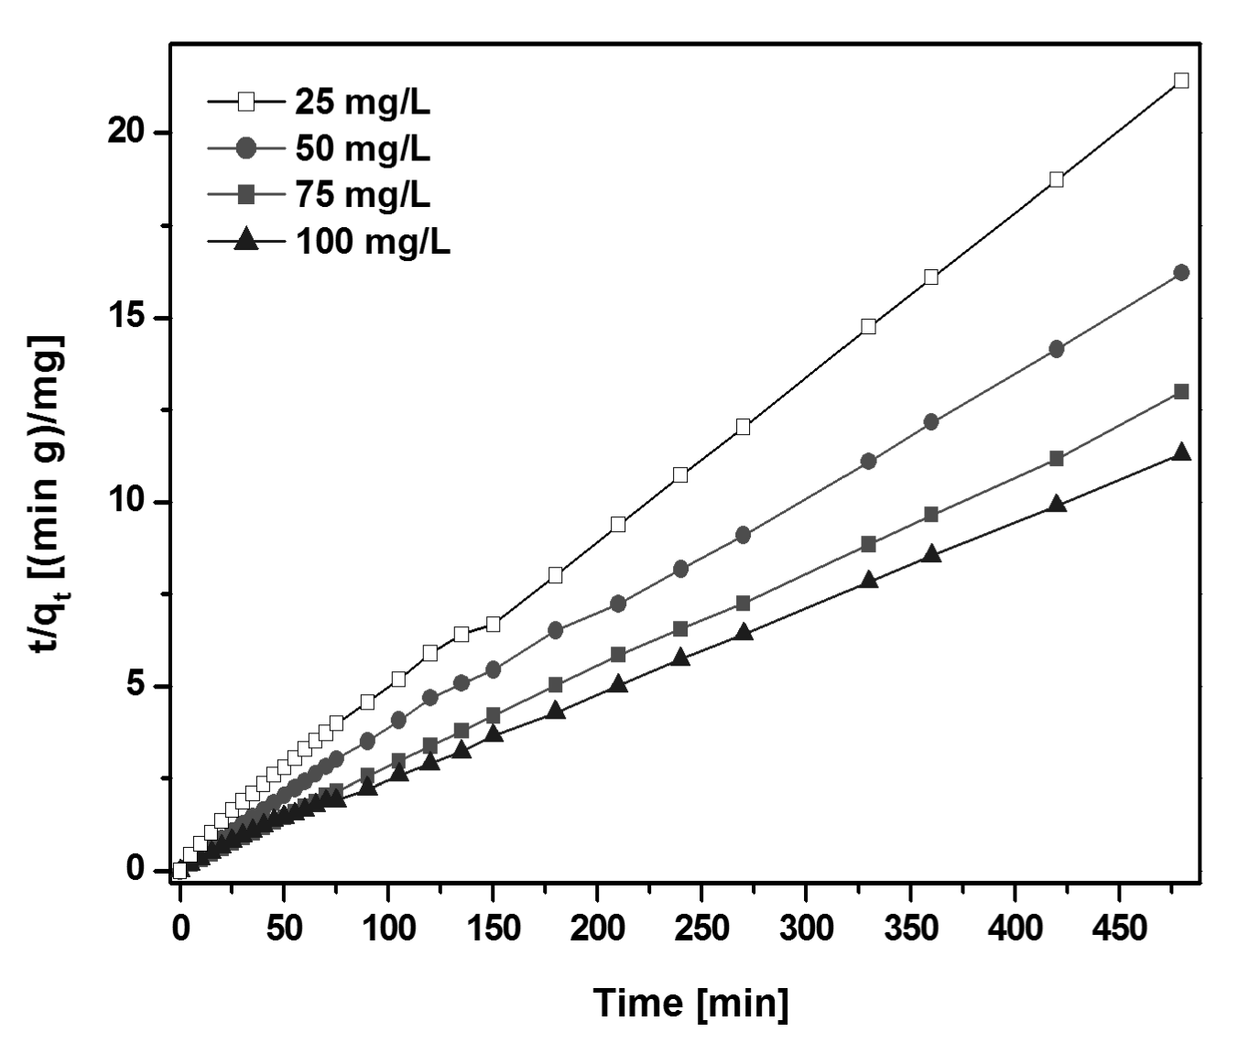
Figure S2. The pseudo-second-order kinetics of adsorption AR18 onto carbonized and purified CoOF

Intraparticle diffusion model
The intraparticle diffusion model, was used in the following equation, proposed by the Webber and Morris (3) :
In the presented equation, following values represents: C (mg/g) is the intercept and k_{p} (mg/g · min) is the intraparticle diffusion rate constant. The intraparticle diffusion kinetic model (R² ⩽ 0.828) is lower than calculated pseudo-second-order kinetic model.

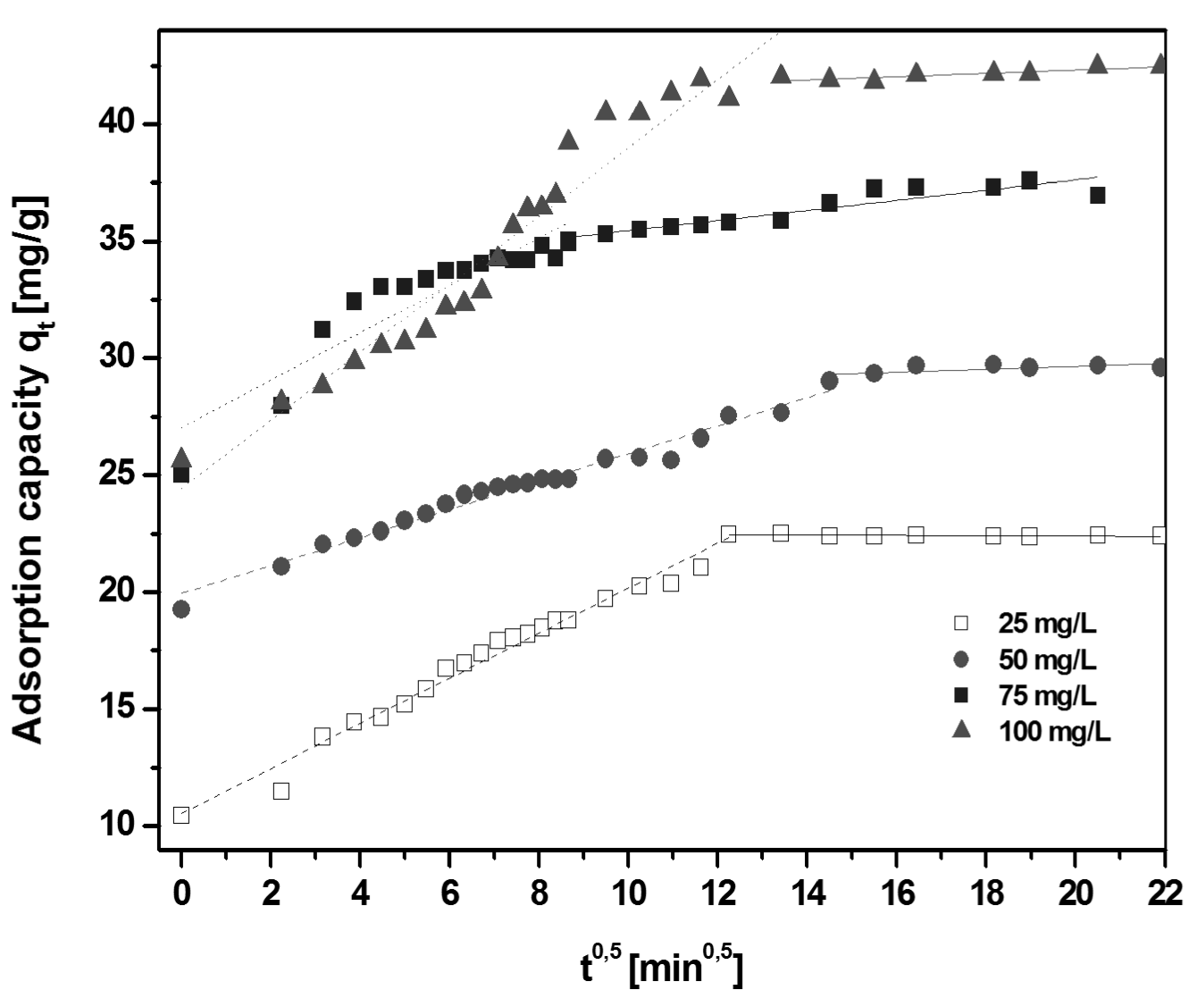
Figure S3. Intraparticle diffusion model of the AR18 adsorption onto carbonized and purified CoOF

The regression was linear but did not pass through the origin (see Figure S2). Since in the Figure S2 are presented two linear sections with different slopes, the interparticel diffusion in not independently controlling rate. It means that the diffusion of dye onto CoOF occurs in two stages. The first and faster linear section (dashed line) is equivalent for the boundary diffusion effect. The second section (solid line) was attributed to the intraparticle diffusion and limits step of adsorption. These two phases suggested that the adsorption process had proceeded by the surface adsorption and the intraparticle diffusion. Wang et al. (Wang at al. 2007) and Dogan et al. (Dogan et al. 2009) had similar observations. In the beginning part of the plot indicated the boundary layer effect. In the second linear part of the plot was caused by the diffusion of intraparticle or pore.

Table S1. Comparison of the pseudo-first-order and pseudo-second-order models for various initial concentrations of AR18
PSEUDO-FIRTS ORDER
C₀ | A=LnQ_{e} | B=k₁ | q_{e} | k₁ | R | R²
25 | 2.3379 | 0.01494 | 10.35946 | 0.01494 | -0.99 | 0.99
50 | 2.28221 | 0.01116 | 9.798311 | 0.01116 | -0.95 | 0.90
75 | 1.63298 | 0.01143 | 5.119107 | 0.01143 | -0.92 | 0.85
100 | 3.07365 | 0.02699 | 21.62067 | 0.02699 | -0.95 | 0.91
PSEUDO-SECOND ORDER
C_{o} | A=1/k₂q_{e}² | B=1/q_{e} | q_{e} | k₂ | R | R²
25 | 0.50885 | 0.04325 | 23.12139 | 0.003676 | 1.00 | 1.00
50 | 0.35306 | 0.03305 | 30.25719 | 0.003094 | 1.00 | 1.00
75 | 0.12046 | 0.02667 | 37.49531 | 0.005905 | 1.00 | 1.00
100 | 0.2004 | 0.02309 | 43.30879 | 0.00266 | 1.00 | 1.00

Langmuir and Freundlich adsorption isotherms
The Freundlich isotherm linear form is represented by following equation (4):
In the presented equation, following symbols represents: K_{F} (mg/g(L/mg)1/n) and n are Freundlich constants, which represent adsorption capacity and adsorption strength, respectively. The linear form of Langmuir isotherm:
Where symbols: Q₀ (mg/g) is the monolayer adsorption capacity and b (L/mg) is a constant related to the energy of adsorption.
Second form of Langmuir isotherm, expressed as a equilibrium parameter (R_{L}) (dimensionless), is defined by the following equation:
Symbols b (L/mg) is Langmuir constant and C₀ (mg/L) is the highest initial concentration of the adsorbate. The value of R_{L} indicates the type of the isotherm to be either unfavorable (R_{L} > 1), linear (R_{L} = 1), favorable (0 < R_{L} < 1) or irreversible (R_{L} = 0).(5) The R_{L} values in range of 0-1 representing favorable adsorption conditions.

Figure S4. Langmuir-Freundlich adsorption isotherm of the AR18 onto carbonized and purified CoOF

Table S2. Langmuir- Freundlich parameters for the adsorption of the AR18 onto carbonized and purified CoOF
Dye | Langmuir Isotherm |  |  |  |  | Freundlich Isotherm
 | Q₀ (mg/g) | b (L/mg) | R_{L} | R² |  | K_{F} ((mg/g)(L/mg)^{1/n}) | n | R²
Acid red 18 | 44.267 | 0.167 | 0.056 | 0.98 |  | 18.076 | 5.181 | 0.95

Thermodynamics parameters
In order to study the thermodynamics of adsorption of Acid Red 18 onto CoOF, three basic thermodynamic parameters, enthalpy (ΔH°), entropy (ΔS°) and Gibbs free energy (ΔG°), were calculated according to the following equations (6):

Where symbols: T is the solution temperature (K), K_{a} is the adsorption equilibrium constant, and R is the gas constant. Enthalpy (ΔH°) and entropy (ΔS°) were calculated from the slope and intercept from the plot of lnq_{e}/C_{e} versus 1/T.

The thermodynamic parameters was measured at three temperatures: 30, 40, 60 °C, with initial dye concentration at 25 mg/L and pH=7. The results are presented in Figure S4. The adsorption capacities of the CoOF were 24.0, 20.0 and 9.5 mg/g at 30, 40, and 60 °C respectively. We observed that the adsorption capacities of the AR18 decreased when the temperature was increased. The calculated thermodynamic parameters are presented in Table S3. The negative value of ΔH° (-105.23 kJ/mol) indicates that the AR18 was adsorbed onto the CoOF in an exothermic reaction (Wang and Zhu 2007). The negative value of entropy ΔS° (-320.91 J/mol*K) suggested that the degree of freedom decreases at the solid/solution interface during the adsorption of the AR18 onto CoOF. Negative value of ΔS indicated a decrease in the degrees of freedom during the adsorption. Gibbs’ free energy (ΔG°) of the AR18 adsorption at 30 and 40 °C was negative and at the level of -8.6 kJ/mol and -3.68 kJ/mol, respectively. At 60 °C ΔG° value rise to 1.29 kJ/mol. Presented data shows that above 40 °C the value of Gibbs energy changed from negative to positive, which indicated a decrease in feasibility of adsorption at higher temperatures.

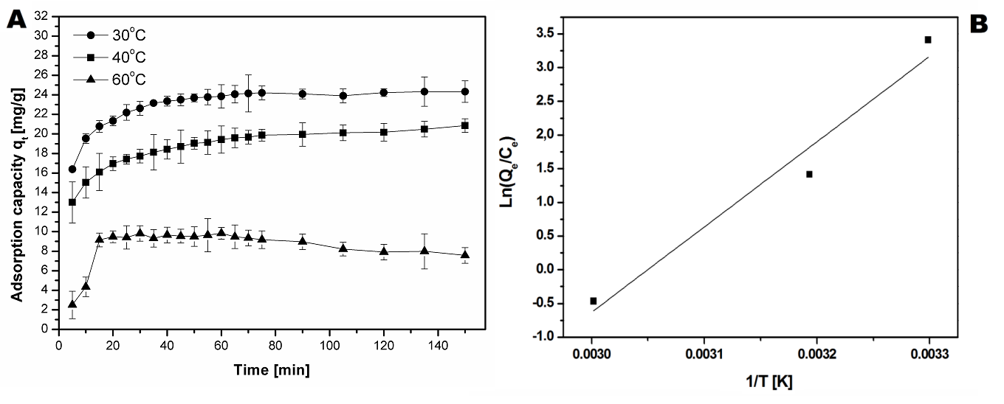
Figure S5. Effect of temperature on adsorption (A) of the AR18 onto carbonized and purified CoOF and Van't Hoffa isotherm (B)

Table S3. Thermodynamic parameters for the adsorption of the AR18 onto carbonized and purified CoOF

Dye | Concentration  (mg/L) | ΔH°  (kJ/mol) | ΔS°  (J/mol K) | ΔG°  At temperature (°C) (kJ/mol)
Acid Red 18 | 25 | -105.23 | -320.91 | 30 | 40 | 60
 |  |  |  | -8.60 | -3.68 | 1.29

FT-IR of the CoOF structures.
On the FT-IR (Figure 5S) spectrum after dye adsorption in the pH range from 5 to 11, no new peaks were observed. This testifies that no chemical reaction occur during the adsorption of AR18 onto CoOF. FT-IR spectrum collected at the pH=3 shows that peaks at 1620 cm⁻¹ disappeared and instead appeared new peak with strong intensity at 1598 cm⁻¹. Peaks with strong intensity at around 1598 cm⁻¹ can be attributed to the stretching mode of phenyl group. Along with peak from the phenyl groups, at 1399 cm⁻¹ appeared new that can be attribute to the stretching mode of the sulfonic acid group (Balamurugan and Berchman 2015). Changes in the FT-IR spectrum indicate that occurs chemical reaction with the adsorbent and adsorbate.
Figure S6. FTIR spectrum of carbonized CoOF before and after dye adsorption at different pH (A) of the carbonized and acid purified CoOF after dye adsorption at pH 3 and 5 (B).

CoOF structures comparison synthesised from the recycled DMF.
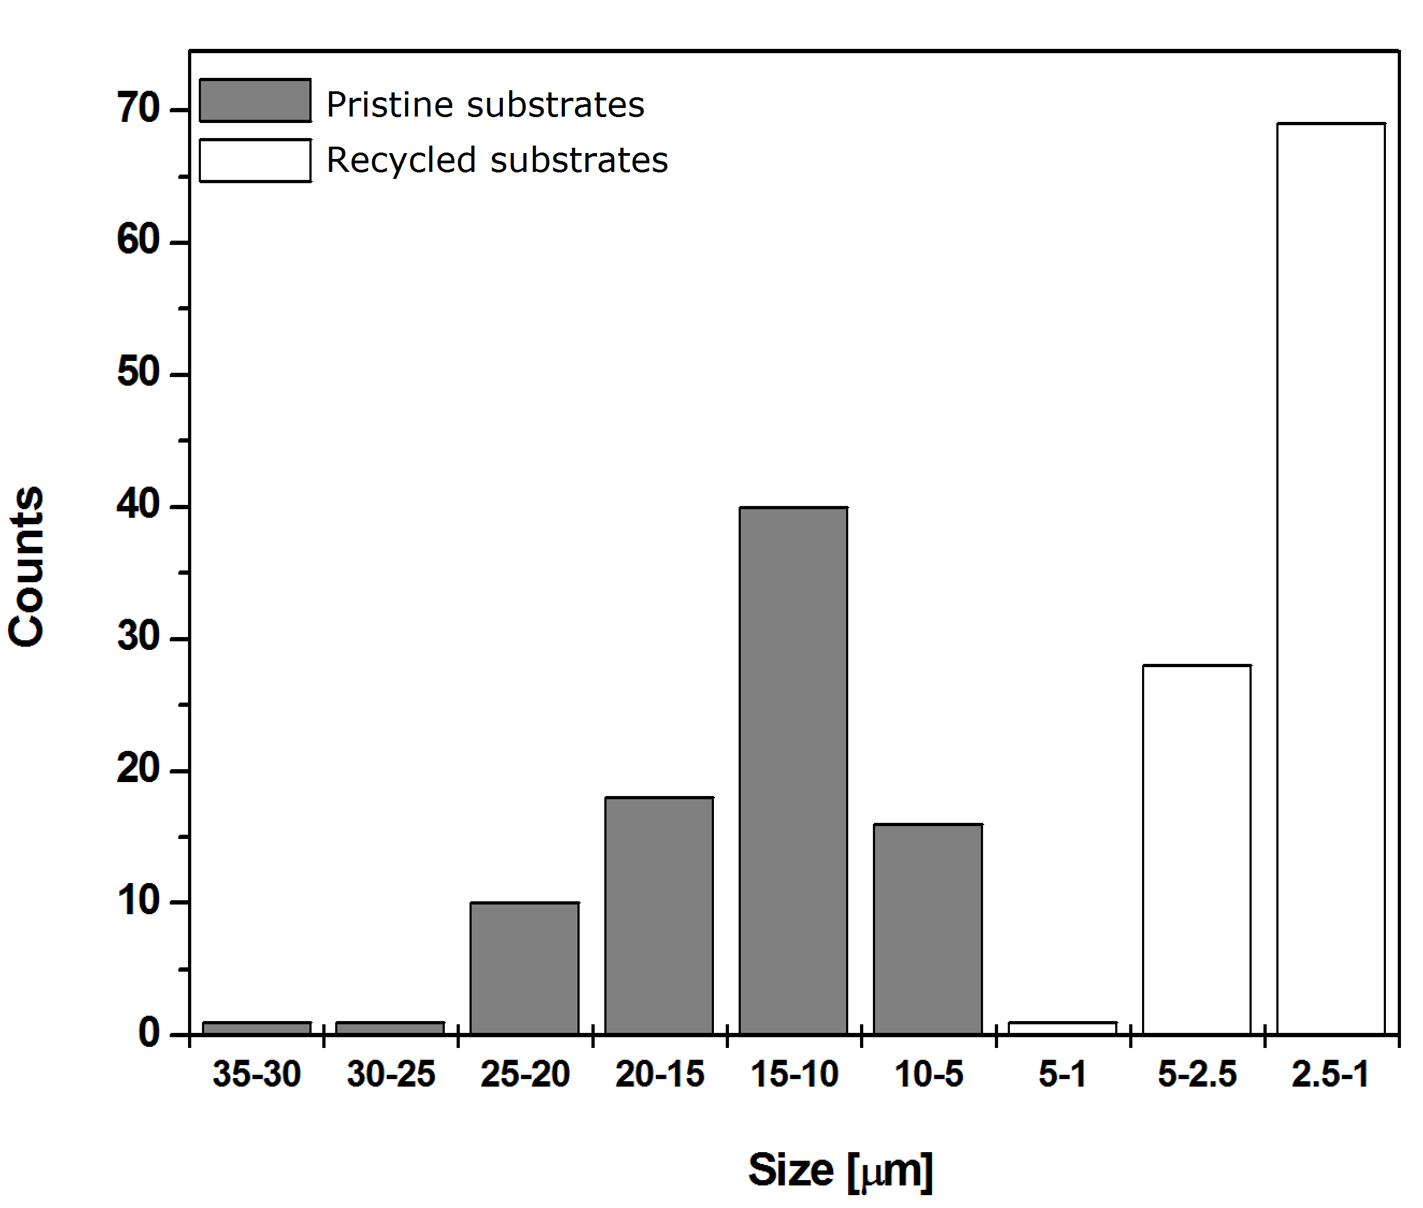
Figure S7. Size histogram of the CoOF synthesised from the pritine and recycled substrates.

Cytotoxicity on microbial models
CoOF before purification showed relatively higher toxicity against P. aeruginosa. However, for both studied bacteria minimal inhibitory concentration (MIC) was observed in samples, where the concentration of nanomaterials was 50 µg/mL. Considering the activity of CoOF after purification, MIC for P. aeruginosa was 100 µg/mL, whereas it was not obtained for S. aureus. The measured OD results are shown in Figure S8.
Figure S8. Optical Density (OD) of cultures after 24 hours of incubation with nanomaterials in comparison to the control sample

The viability of cells (metabolic activity) measured in alamarBlue® assay confirmed results revealed in the OD measurements. Likewise, the nanomaterial containing cobalt nanoparticles (on surface) showed higher toxicity to the studied bacteria. Surprisingly, CoOF after purification that did not contain cobalt nanoparticles on their surface, showed reduced activity against P. aeruginosa cells. Despite OD observations for Staphylococcus aureus with the highest concentration of purified CoOF, the relative metabolic activity remained comparable to the control sample. Results are shown in Figure S9.

Figure S9. Viability of cells in alamarBlue® assay in relation to the control sample

Adsorption Acid Red 18 on to carbonized CoOF synthesised from recycled organic substrates
Figure S10. The pseudo-second-order kinetics of adsorption AR18 (at concentration 25 mg/L) onto carbonized and purified CoOF (with line) and CoOF from recycled substrates (red line).

Table S4. Comparison of the pseudo-second-order models for carbonized and purified CoOF and CoOF from recycled substrates.
PSEUDO-SECOND ORDER
C_{o} | A=1/k₂q_{e}² | B=1/q_{e} | q_{e} | k₂ | R | R²
25 | 0.50885 | 0.04325 | 23.12139 | 0.003676 | 1.00 | 1.00
25 recycling | 0.46757 | 0.04568 | 21.89141 | 0.004698 | 1.00 | 1.00

