Additional file 1: Table S1 Exercise equipment for The EFIBAR study.

Equipment(Brand) | Number | Characteristics | Photo
Spalier  (Azafit) | 2 | -Colour: Black. | 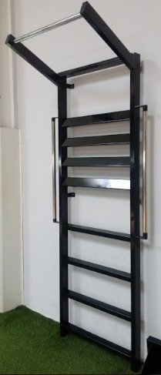
Fitness mat  (Salter) | 9 | -Colour: Blue | 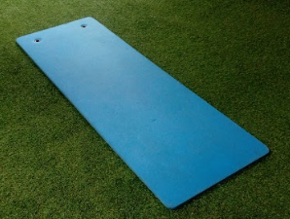
Bosu  (Amaya sport) | 3 | -Colour: Blue | 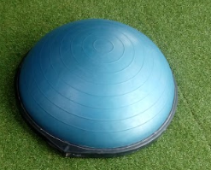
Box  (Azafit) | 1 | -Colour: Black.  -Measurements: 60 x 50 x 40 cm | 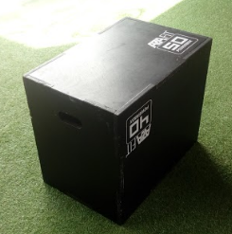
Medicine Ball  (Azafit) | 3 | -Colour: Black and Grey.  -Weight: 3/6/9 kg | 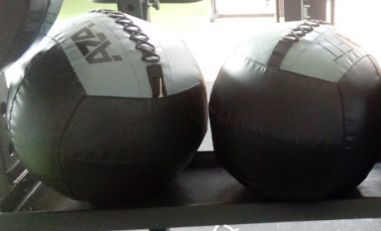
Rack  (Azafit) | 1 | -Colour: Black.  -Supports: Adjustable supports to hold the bar in the rack and safety brackets for the cage. | 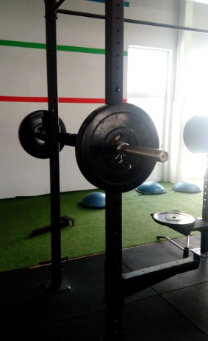
Fitball  (Amaya sport) | 1 | -Colour: Grey.  -Diameter: 65 cm. | 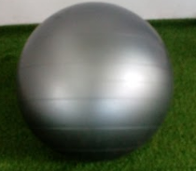
Fitness bar  (Azafit) | 3 | -Colour: Grey.  -Weight: 20 kg. | 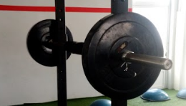
Iron Bumper plate (Azafit) | 20 | -Colour: Black.  -Weight: 20/10/5 kg
Multipower  (Ffittech) | 2 | -Colour: Black.  -Types of grip: Open bar, closed grip and the rope grip. | 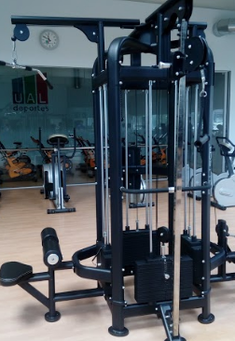
Treadmill  (Salter) | 4 | Model: M836 (2) | 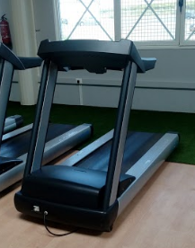
Stationary bicycle  (Salter) | 3 | Model: M353 | 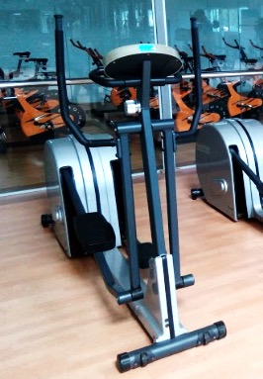
Multipower  (Ffittech) | 2 | -Colour: Black.  -Types of grip: Open bar, closed grip and the rope grip. | 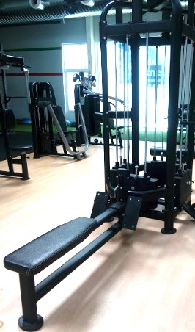
Banks  (Ffittech) | 3 | -Colour: Black.  -Postions: 5 inclinations. | 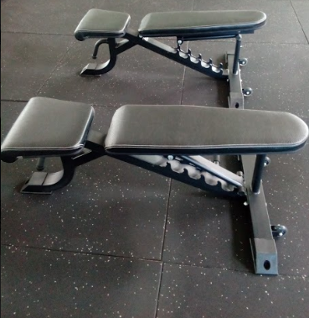
Kettlebells  (Azafit) | 5 | -Colour: Black  -Weight: 4/ 8/ 12/ 18/ 20 kg | 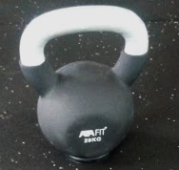
Dumbbells  (Azafit) | 16 pairs | -Colour: Black.  -Weight: 1/ 2/ 3/ 4/ 5/ 7.5/ 10/ 12.5/ 15/ 17.5/ 20/ 22.5/ 25 kg | 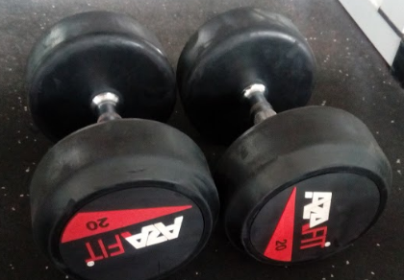
Dumbbells  Salter | 5 pairs | -Colour: Black.  -With bearings.  -Weight: 26/ 27/ 28/ 29/ 30 kg | 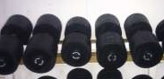
Bars  (Salter) | 21 | -Colour: Grey.  -Weight: 2.15 kg | 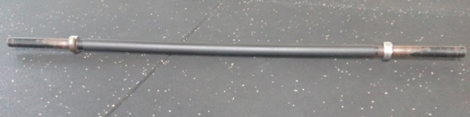
Bars  (Salter) | 3 | -Colour: Grey.  -Weight: 10 kg. | 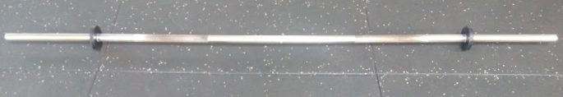
Bumper Plate  (Salter) | 44 | -Colour: Black.  -Weight: 1.25/ 2.5/ 5/ 10/ 15/ 20 | 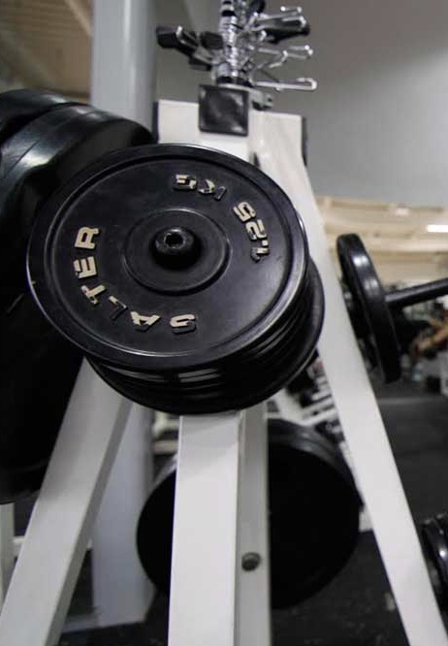
Resistance Bands  (AFW) | 2 | -Yellow: Low resistance.  -Green: Medium resistance.  -Blue: High resistance. | 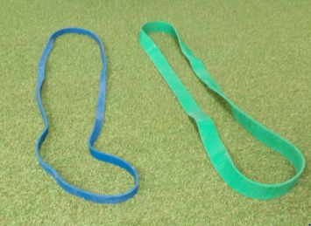
Therabands  (AFW) | 3 | -Yellow: Low resistance.  -Green: High resistance. | 