Additional file 1
Supplementary Table 1. Search strings and terms
Database | Search query | Number of found records | Number of found records without duplication
Embase.com | ('controlling nutritional status score'/de OR 'controlling nutritional status'/de OR ('serum albumin'/de AND 'cholesterol blood level'/exp AND 'lymphocyte count'/exp) OR ('Controlling Nutritional Status' OR conut OR (albumin NEAR/10 cholesterol NEAR/10 lymphocyte NEAR/10 (count* OR serum* OR concentrat*))):ab,ti) AND ('stomach tumor'/exp OR 'gastrectomy'/exp OR (((gastric* OR stomach) NEAR/3 (tumor* OR tumour* OR cancer* OR malign* OR carcinom* OR adenocarcinom* OR surg* OR resect*)) OR gastrectom* ):ab,ti) | 27 | 26
Medline Ovid | ((Serum Albumin/ AND exp cholesterol/bl AND exp Lymphocyte Count/) OR (Controlling Nutritional Status OR conut OR (albumin ADJ10 cholesterol ADJ10 lymphocyte ADJ10 (count* OR serum* OR concentrat*))).ab,ti.) AND (Stomach Neoplasms/ OR gastrectomy/ OR (((gastric* OR stomach) ADJ3 (tumor* OR tumour* OR cancer* OR malign* OR carcinom* OR adenocarcinom* OR surg* OR resect*)) OR gastrectom* ).ab,ti.) | 18 | 2
Web of science | TS=((("Controlling Nutritional Status" OR conut OR (albumin NEAR/10 cholesterol NEAR/10 lymphocyte NEAR/10 (count* OR serum* OR concentrat*)))) AND ((((gastric* OR stomach) NEAR/2 (tumor* OR tumour* OR cancer* OR malign* OR carcinom* OR adenocarcinom* OR surg* OR resect*)) OR gastrectom* ))) | 16 | 8
Cochrane CENTRAL | (('Controlling Nutritional Status' OR conut OR (albumin NEAR/10 cholesterol NEAR/10 lymphocyte NEAR/10 (count* OR serum* OR concentrat*))):ab,ti) AND ((((gastric* OR stomach) NEAR/3 (tumor* OR tumour* OR cancer* OR malign* OR carcinom* OR adenocarcinom* OR surg* OR resect*)) OR gastrectom* ):ab,ti) | 3 | 1
Google scholar | "Controlling Nutritional Status"|conut "gastric|stomach tumor|tumour|cancer|malignancy|carcinoma|resection"|gastrectomy | 30 | 24
Total |  | 94 | 61

Supplementary Table 2. The Newcastle-Ottawa scale for quality assessment of include studies.
Study | Selection |  |  |  | Comparability | Outcome |  |  | Total score
 | Representativeness  of the exposed  cohort | Selection  of the  non-exposed  cohort | Ascertainment  of exposure | Demonstration  that outcome  of interest was  not present at  start of study | Comparability  of cohorts on  the basis of  the design or  analysis | Assessment  of outcome | Was follow-  up long  enough for  outcomes to occur | Adequacy  of follow  up of  cohorts
Total score | 1 | 1 | 1 | 1 | 2 | 1 | 1 | 1 | 9
Kuroda [7] | 1 | 1 | 1 | 0 | 0 | 1 | 1 | 1 | 6
Zheng [8] | 1 | 1 | 1 | 0 | 1 | 1 | 1 | 1 | 7
Liu [9] | 1 | 1 | 1 | 0 | 0 | 1 | 1 | 1 | 6
Ryo [13] | 1 | 1 | 1 | 0 | 1 | 1 | 1 | 1 | 7
Suzuki [14] | 1 | 1 | 1 | 0 | 0 | 1 | 1 | 1 | 6

Supplementary Figure 1. Funnel plots demonstrating primary endpoint in terms of low CONUT versus high CONUT score. (a) OS; (b) CCS; and (c) RFS.
a. OS
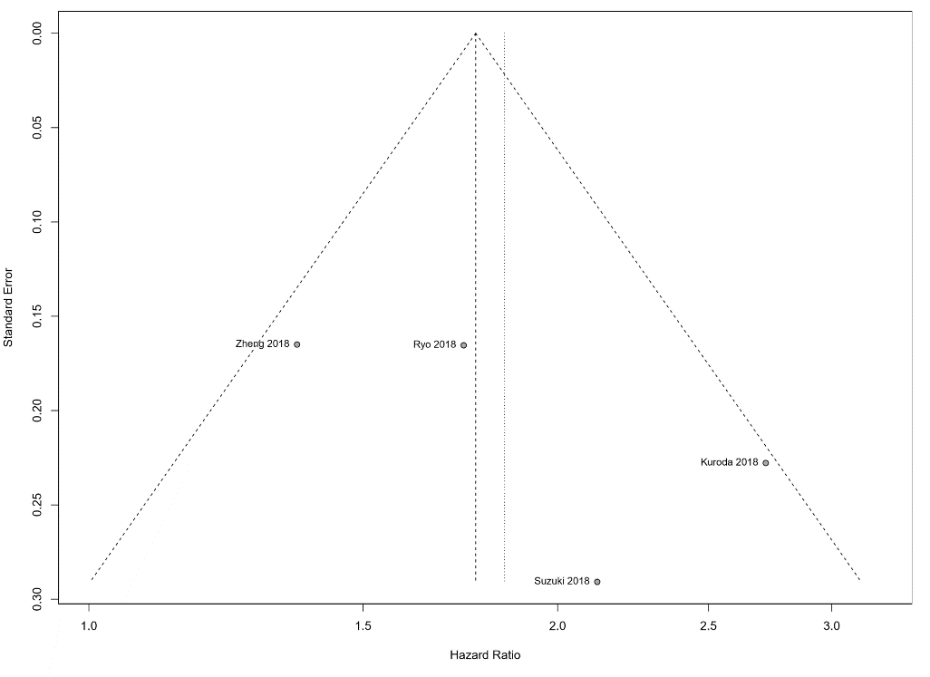
b. CCS
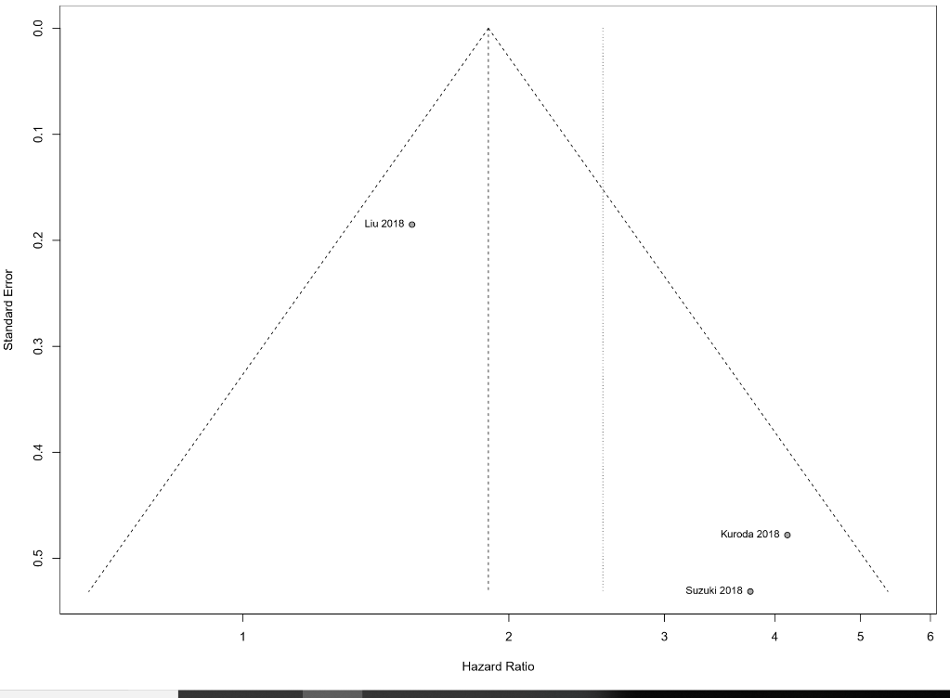
c. RFS
