Additional file 4
A Sensitivity Analysis patients with wrist arthritis, without n=6 with never wrist arthritis
Table, LMM for Poznanski, BA and BMD
Poznanski adjusted for age and symptom duration
Patients | 54
X rays | 105
 |  | Β (95% CI) | P
Arm 3 |  | ref | -
Arm 2 |  | 0.076 (-0.43; 0.58) | 0.771
Arm 1 |  | 0.16 (-0.30; 0.61) | 0.498
Time |  | 0.0036 (-0.0047; 0.012) | 0.391
Arm 3 * Time |  | ref | -
Arm 2 * Time |  | -0.0058 (-0.018; 0.0066) | 0.359
Arm 1 * Time |  | -0.0058 (-0.018; 0.0061) | 0.337

Bone Age adjusted for symptom duration
Patients | 37
X rays | 72
 |  | Β (95% CI) | P
Arm 3 |  | ref | -
Arm 2 |  | 0.99 (0.31; 1.68) | 0.005
Arm 1 |  | 0.34 (-0.31; 0.98) | 0.304
Time |  | -0.014 (-0.022; -0.0053) | 0.001
Arm 3 * Time |  | Ref
Arm 2 * Time |  | 0.0092 (-0.0029; 0.021) | 0.136
Arm 1 * Time |  | 0.014 (0.0016; 0.027) | 0.027

Bone Mineral Density adjusted for symptom duration
Patients | 53
X rays | 104
 |  | Β (95% CI) | P
Arm 3 |  | ref | -
Arm 2 |  | 0.077 (-0.67; 0.82) | 0.841
Arm 1 |  | 0.84 (0.16; 1.51) | 0.015
Time |  | 0.028 (0.017; 0.039) | <0.001
Arm 3 * Time |  | ref | -
Arm 2 * Time |  | -0.0054 (-0.022; 0.011) | 0.524
Arm 1 * Time |  | -0.029 (-0.045; -0.013) | <0.001

LMM linear mixed model, arm 1: initial sequential monotherapy, arm 2 initial MTX with prednisolone bridging 6 weeks, arm 3 initial MTX with etanercept. BMD Bone Mineral Density; B: β ; 95%CI: 95%Confidence Interval

Additional file 4 B Sensitivity Analysis Polyarticular JIA patients only
Table, LMM for Poznanski, BA and BMD adjusted for age and/or symptom duration
Poznanski
Patients | 50
X rays | 99
 |  | Β (95% CI) | P-value
Arm 3 |  | ref | -
Arm 2 |  | 0.227 (-0.035-0.81) | 0.444
Arm 1 |  | 0.219 (-0.34-0.77) | 0.44
Time |  | 0.0035 (-0.0049; 0.012) | 0.415
Arm 3 * Time |  | ref | -
Arm 2 * Time |  | -0.0041 (-0.016 ; 0.0075) | 0.493
Arm 1 * Time |  | -0.0042 (-0.016; 0.0078) | 0.491

Bone age adjusted for symptom duration
Patients | 34
X rays | 68
 |  | Β (95% CI) | P-value
Arm 3 |  | Ref | -
Arm 2 |  | 0.89 (0.18;1,61) | 0.015
Arm 1 |  | 0.45 (-0.28 ; 1.17) | 0.225
Time |  | -0.012 (-0.023; -0.0017) | 0.023
Arm 3 * Time |  | Ref | -
Arm 2 * Time |  | 0.0086 (-0.0056; 0.023) | 0.24
Arm 1 * Time |  | 0.015 (-0.0003; 0.03) | 0.055

Bone Mineral Density adjusted for symptom duration
Patients | 50
X rays | 100
 |  | Β (95% CI) | P-value
Arm 3 |  | ref | -
Arm 2 |  | 0.37 (-0.38 ; 1.12) | 0.33
Arm 1 |  | 0.64 (-0.08 ; 1.36) | 0.082
Time |  | 0.027 (0.015 ; 0.038) | 0
Arm 3 * Time |  | Ref | -
Arm 2 * Time |  | -0.10 (-0.026 ; 0.0053) | 0.20
Arm 1 * Time |  | -0.026 (-0.043 ; -0.010) | 0.001

LMM linear mixed model, arm 1: initial sequential monotherapy, arm 2 initial MTX with prednisolone bridging 6 weeks, arm 3 initial MTX with etanercept. BMD Bone Mineral Density; B: β ; 95%CI: 95%Confidence Interval

Additional file 4C MeanJADAS10score over time
Poznanski adjusted for age and symptom duration
Patients | 60
X rays | 117
 |  | Β (95% CI) | P-value
meanJADAS10 * Time |  | 0.0010 (-0.00038-0.0024) | 0.15

Bone Age adjusted for symptom duration
Patients | 41
X rays | 80
 |  | Β (95% CI) | P-value
meanJADAS10 * Time |  | -0.00017 (-0.0018-0.0014) | 0.84

Bone Mineral Density adjusted for symptom duration
Patients | 59
X rays | 116
 |  | Β (95% CI) | P-value
meanJADAS10 * Time |  | 0.00069 (-0.0012-0.0026) | 0.48

LMM linear mixed model; meanJADAS10: mean Juvenile Arthritis Disease Activity Score with up to max 10 joints, over 2 years’ time; B: β ; 95%CI: 95%Confidence Interval

Predicted Z-scores RM/M2 (Poznanski score) over time, for different meanJADAS10 scores
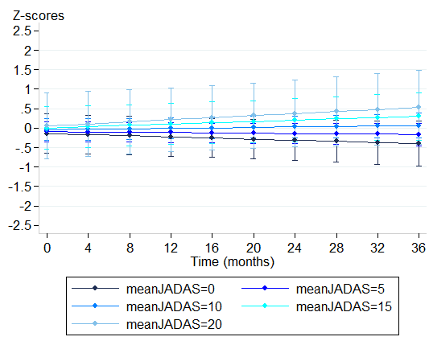

Predicted Z-scores for Bone Age over time for different meanJADAS10scores
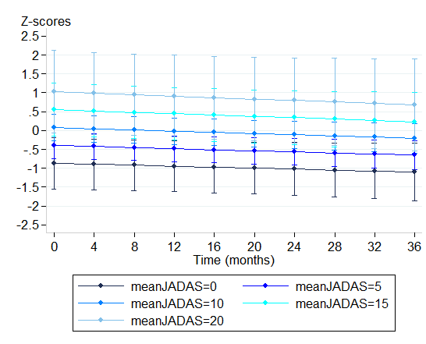

Predicted Z-scores for Bone Mineral Density over time for different meanJADAS10scores
All predictions are from Linear Mixed Models, corrected for age and symptom duration for Poznanski score, corrected for symptom duration for Bone Age and Bone Mineral Density

